**SAINT ANDREWS UNITED METHODIST CHURCH**

**522 Missouri Avenue – Fort Worth, TX 76104**

**Rev. Carol Grant Gibson – Senior Pastor**

[**www.standrewsftw.org**](http://www.standrewsftw.org)

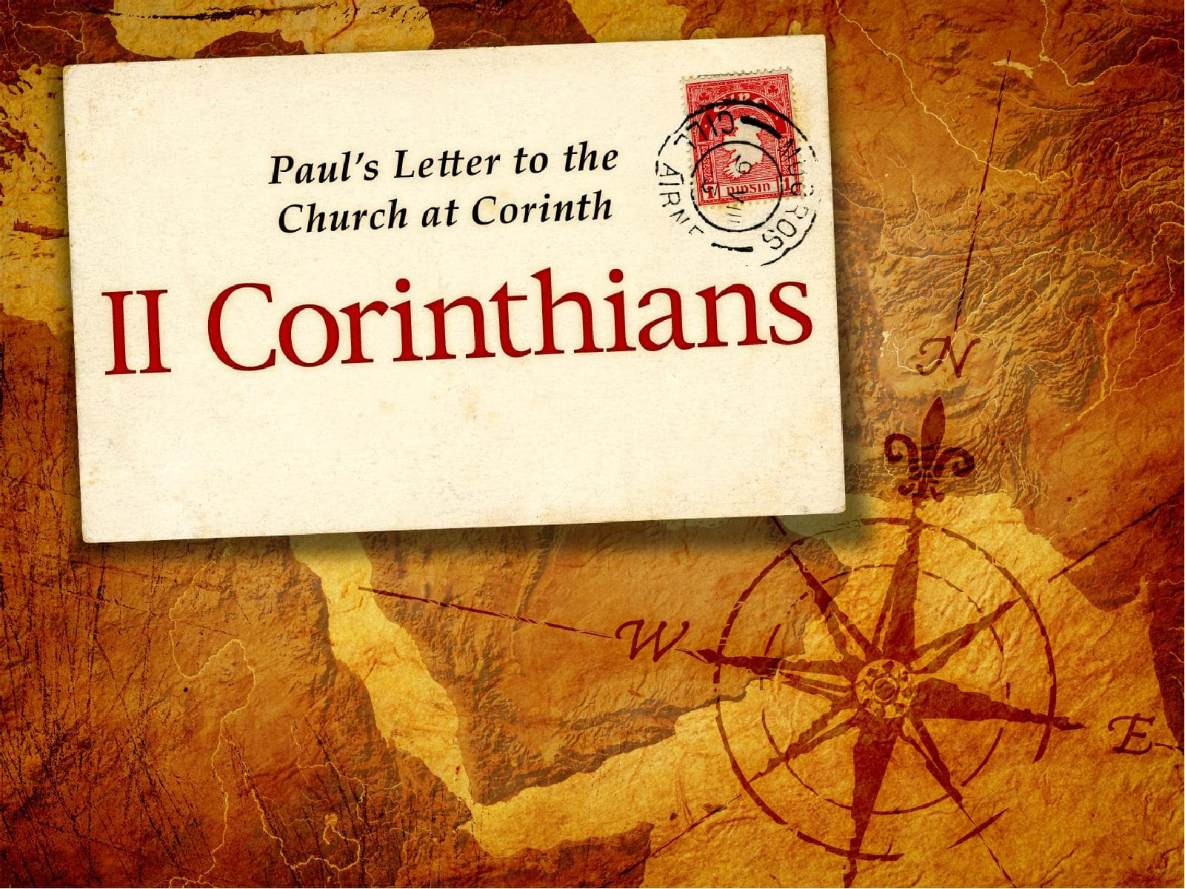

**Fall Bible Study**

**Wednesdays at 6:30 pm**

**October 1 – December 17, 2025**

**Zoom**

**Meeting ID: 951 7916 9014 / Passcode: 906461**

**Introduction to 2 Corinthians**

**Who**

The Apostle Paul, along with Timothy, is the author of 2 Corinthians. It’s addressed to the church in Corinth, a diverse and often troubled congregation in southern Greece.

**What**

2 Corinthians is a pastoral epistle—a letter that blends theology, personal reflection, and practical instruction. It defends Paul’s apostolic authority, encourages generosity, and explores themes of suffering, reconciliation, and divine strength in human weakness.

**When**

Paul likely wrote this letter around 55–56 CE, during his third missionary journey, probably from Macedonia after receiving news from Titus about the Corinthian church’s response to his earlier letter.

**Where**

The recipients were in Corinth, a cosmopolitan port city known for its wealth, immorality, and spiritual diversity. Paul had previously spent significant time there planting the church.

**Why**

Paul wrote 2 Corinthians to:

• Reaffirm his love and commitment to the church despite tensions

• Defend his ministry against critics who questioned his authority and suffering and re-establish his role as leader

• Encourage reconciliation and unity within the community amid dissension and false teachings and personality conflicts

• Promote generosity in support of struggling believers in Jerusalem

• Reveal the paradox of Christian leadership—that God’s power is made perfect in weakness

**Chapter 1**

1. Who joins Paul in writing this epistle? (1)
2. What two groups of people does Paul address in his salutation (1)
3. What qualified Paul as an apostle? (1)
4. How does Paul describe the God and Father of our Lord Jesus Christ? (3)
5. What is the proper use of comfort we receive from God? (4)
6. What two things abound in Christ? (5)
7. Where had Paul experienced some trouble and what kind of suffering did Paul endure? (8-11)
8. What does vs. 9 say about the power of God? (9)
9. What had worked together with God in providing deliverance? What other effect did it have? (11)
10. In what could Paul "boast"? (12)
11. Was Paul saying the Corinthians had a low level of understanding? (13)
12. What could Paul and the brethren in Corinth look forward to boasting in, when Christ comes again? (14)
13. What is the Day of the Lord Jesus? (14)
14. What appears to be the reason Paul's integrity was in question? Why was Paul so defensive about his change of plans? (15-17)
15. Paul professes that his word is as faithful as what two things? (18-20)
16. Can we take all God’s promises as our own? (20)
17. Why say “Amen” when we pray? (20)
18. What is a seal of ownership? (22)
19. Why had Paul changed his plans about coming to Corinth? (23)