SAINT ANDREWS UNITED METHODIST CHURCH
522 Missouri Avenue – Fort Worth, TX 76104
Rev. Carol Grant Gibson – Senior Pastor
www.standrewsftw.org
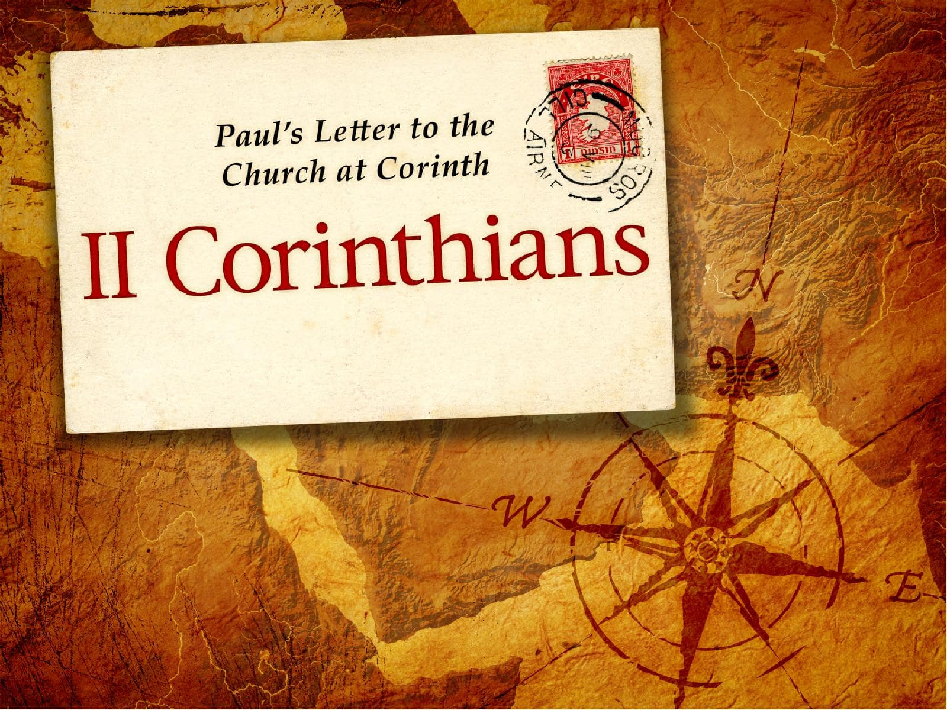
Fall Bible Study
Wednesdays at 6:30 pm
October 1 – December 17, 2025
Zoom
Meeting ID: 951 7916 9014 / Passcode: 906461
Introduction to 2 Corinthians

Who
The Apostle Paul, along with Timothy, is the author of 2 Corinthians. It’s addressed to the church in Corinth, a diverse and often troubled congregation in southern Greece.

What
2 Corinthians is a pastoral epistle—a letter that blends theology, personal reflection, and practical instruction. It defends Paul’s apostolic authority, encourages generosity, and explores themes of suffering, reconciliation, and divine strength in human weakness.

When
Paul likely wrote this letter around 55–56 CE, during his third missionary journey, probably from Macedonia after receiving news from Titus about the Corinthian church’s response to his earlier letter.

Where
The recipients were in Corinth, a cosmopolitan port city known for its wealth, immorality, and spiritual diversity. Paul had previously spent significant time there planting the church.

Why
Paul wrote 2 Corinthians to:
• Reaffirm his love and commitment to the church despite tensions
• Defend his ministry against critics who questioned his authority and suffering and re-establish his role as leader
• Encourage reconciliation and unity within the community amid dissension and false teachings and personality conflicts
• Promote generosity in support of struggling believers in Jerusalem
• Reveal the paradox of Christian leadership—that God’s power is made perfect in weakness

Chapter 1
- Who joins Paul in writing this epistle? (1)

- What two groups of people does Paul address in his salutation (1)

- What qualified Paul as an apostle? (1)

- How does Paul describe the God and Father of our Lord Jesus Christ? (3)

- What is the proper use of comfort we receive from God? (4)

- What two things abound in Christ? (5)

- Where had Paul experienced some trouble and what kind of suffering did Paul endure? (8-11)

- What does vs. 9 say about the power of God? (9)

- What had worked together with God in providing deliverance? What other effect did it have? (11)

- In what could Paul "boast"? (12)

- Was Paul saying the Corinthians had a low level of understanding? (13)

- What could Paul and the brethren in Corinth look forward to boasting in, when Christ comes again? (14)

- What is the Day of the Lord Jesus? (14)

- What appears to be the reason Paul's integrity was in question? Why was Paul so defensive about his change of plans? (15-17)

- Paul professes that his word is as faithful as what two things? (18-20)

- Can we take all God’s promises as our own? (20)

- Why say “Amen” when we pray? (20)

- What is a seal of ownership? (22)

- Why had Paul changed his plans about coming to Corinth? (23)

Chapter 2
- What was Paul’s emotional state as he penned this letter? (4)

- What did Paul want them to do with the man who had sinned, yet repented after their disciplinary action toward him? (7-8)

- Why was Paul so challenging? (9)

- What was Satan scheming that Paul was so willing to forgive the offender once the Corinthians had forgiven him? (10-11)

- Who did he not find that troubled him greatly? Where did he then go? (13)

- What was this triumphal procession that Paul gave God thanks for? (14)

- In what two ways, and to what two groups of people, does Paul describe himself as “the fragrance of Christ’? (15-17)

- How do many misuse the word of God and who was Paul speaking of as doing so? (17)

Chapter 3

- What writing instrument had Paul used to make the Corinthians an "epistle of Christ"? And upon what had he written? (3)

- How does the letter kill? (6)

- Who made Paul sufficient as a minister of the new covenant? (5-6a)

- Of what is the new covenant? And what does it give? (6b)

- How is the "old covenant" described in verses 7-9?

- How is the "new covenant" described in verses 7-9?

- How else are the old and new covenants described in verse 11?

- Who mad the Israelites’ minds dull? (14)

- Who can be seen when the veil is taken away? (16)

- In turning to the Lord, who is it one is actually turning to, and what does one find? (17)

- When will be like Christ? (18)

Chapter 4
- Why does Paul not "lose heart"? (1)

- Why was Paul so defensive? (2)

- To whom is the gospel "veiled"? Who has blinded them? (3-4)

- Who is the God of this age? (4)

- How does Paul describe the gospel, and himself in comparison? (7)

- What four examples does Paul use to describe how God's power had worked in him? (8-9)

- How can we carry the death of Jesus in our bodies? (10)

- Why is life at work in some believers but death at work in others? (12)

- What does it mean that we are wasting away? (16)

- How do troubles achieve an eternal glory? (17)

- Upon what does Paul keep his focus? (18)

Chapter 5
- Why talk about a tent, building and house? (1-5)

- What has God given us as a "guarantee" of the "life" to come? (5)

- What remains our condition while we are "at home in the body"? (6)

- What does our present condition require of us in our daily "walk"? (7)

- Where do we go when we die? (8-9)

- Did some think Paul was out of his mind? (13)

- What motivated Paul to live for Jesus Christ? (14-15)

- What was Christ like from a worldly point of view? (16)

- How is someone in Christ a new person? (17)

- What is the message of reconciliation, and how has God reconciled us to Himself? (19)

- How did Jesus become sin? (21)

Chapter 6
- How can God’s grace be in vain? (1)

- Why did Paul feel the need to commend himself? (4)

- List some of the physical sufferings which commended Paul as a minister of God (4-5)

- List those areas where Paul demonstrated his integrity as a minister of God (6-7)

- List the contrasting experiences Paul had as a minister of God (9-10)

- What had damaged the relationship between Paul and the Corinthians? (12)

- How much can we associate with unbelievers and list the contrasting pair Paul uses to show the incompatibility? (14-17)

Chapter 7
- Can we be perfect in this life? (1) ***Also search out the United Methodist response to this.***

- Why does God want us to be sorrowful? (9)

- What is the difference between “godly sorrow” and “sorrow of the world”? (10)

- Name seven things that demonstrated the Corinthians’ godly sorrow (11)

Chapter 8

- Is giving an indicator of God’s grace in us? (1, 2, 7)

- What was the condition of the church in Macedonia? Yet what did they have in abundance? (2)

- How did they go beyond Paul's expectations? (5)

- What three guidelines does Paul give to govern their giving? (12-14)

- What three men were sent to administer this collection? (16,18,22)

- What did Paul want the Corinthians to show to these men and the other churches? (24)

Chapter 9

- What is the relation between sowing and reaping? (6) Is sowing and reaping an absolute law? (6)

- What kind of giving pleases God? (7)

- What should determine the amount we give? (7)

- Is it better not to give if we are not cheerful about it? (7)

- What is God able to do? (8a)

- What is the purpose of the abundance we receive from God? (8b)

- Why did Paul pray that God supply and multiply the seed sown by the Corinthians? (10)

- How will we be enriched in every way? (11)

- What four things did the administration of this service (the collection) supply? (12-14)

Chapter 10

- With what two qualities of Christ-like character does Paul plead with the Corinthians? (1)

- What does Paul hope would not be necessary when he was with them in person? (2)

- Though Paul walks in the flesh, what does he not do? (3)

- What spiritual weapons do we have and, in what four ways are the weapons of our warfare "mighty in God"? (4-6)

- What were strongholds? (4-5)

- On what basis were some people evidently evaluating Paul? (7)

- Did Paul face congregational power plays? (10-11)

- What did Paul say was an unwise practice? (12)

- In what area was Paul willing to boast? (13-16)

Chapter 11
- Why did Paul refer to himself as a fool? (1, 21)

- What was Paul fearful of concerning the Corinthians? (3)

- What were they seemingly willing to put up with, and why were the Corinthians spiritually vulnerable? (4)

- What practice of Paul evidently was used as a charge against him? (7)

- In what sense did Paul “rob” churches? (8)

- While at Corinth, from whom did Paul receive support? (8-9)

- Why would Paul continue the practice of not accepting support from the Corinthians? (12)

- What sort of deception and falsehood had invaded the church/ (13-15)

- How does Satan often transform himself? And his ministers? (14-15)

- How did Paul view the confidence of boasting? (17)

- Then why does Paul engage in such boasting? (18-19)

- How was Paul using sarcasm here? (16-29)

- In what three ways was Paul equal to his opponents? (22)

- List five things endured by Paul as a minister of Christ (24-25)

- What caused all of these trials and persecutions? (22-33)

- When did Paul escape in a basket? (32-33)

Chapter 12
- Who was Paul talking about? (2)

- What is the third heaven? (2)

- What does Paul boast of in himself and why? (5-6)

- What was Paul’s thorn in the flesh and why was it given? (7)

- How many times did Paul plead with the Lord to remove the thorn? What was the Lord’s response? (8-9)

- Was the Lord being insensitive to Paul’s suffering? (9)

- In what did Paul choose to boast and why? (9-10)

- Why would Paul continue not to be a burden to them? (15)

- Why does Paul sound sarcastic? (16)

- What was the motive behind all that Paul did for the Corinthians? (19)

- What was Paul afraid that might occur when he got to Corinth? (20)

- What was Paul afraid of finding when he got to Corinth? (21)

Chapter 13
- Should two or three witnesses be required today in matters of church discipline? (1)

- How did Paul intend to not spare those who had sinned? (2)

- How do we know if we are in the faith, and what does Paul exhort them to do? (5)

- What was Paul’s prayer for them? (7,9)

- In expressing farewell, what four exhortations does he leave with them? (11)

- If they heed these four exhortations, what blessing will they enjoy? (11)

- What was a holy kiss? (12)

- What three blessings does Paul pray for them as he closes this epistle? (14)

