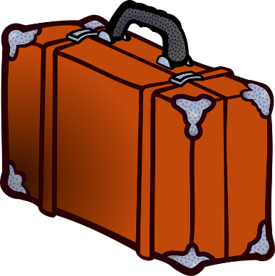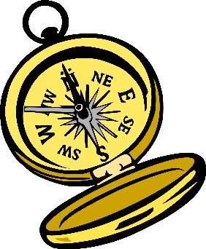

* 7 pr underwear
* 7 pr socks
* 3 pr pants
* 3 pr shorts
* 3 pr lounge pants
* 1 pr swim trunks
* 3 short sleeve t-shirts
* 3 long sleeve shirts
* 6 polo shirts
* 1 sweatshirt
* 2 belts
* 1 warm coat
* 1 rain jacket
* 3 pr shoes (walking, slip on, water)
* Stocking Cap
* Glasses/Sunglasses
* Walking cane
* Fanny-pack
* Reusable shopping bag
* **Travel docs** (Passport, International Drivers License, Insurance Docs, Credit Cards, Prescriptions)
* Medications
* Deodorant
* Toothbrush/toothpaste/floss
* Hairbrush and accessories
* Razor/Electric Beard Trimmer
* Bar shampoo/conditioner/lotion
* Water bottle/filters
* Life straws
* Emergency Med Kit
* 10# magnet hooks
* Laundry sheets
* Washcloth/scrubber
* Ziplocks
* Headphones
* Phone & charger
* Portable batteries
* Airtags
* Jump-drive
* Laptop/mouse/cords
* Keychain flashlight
* Extension cord/ Power adapter/CO2