* 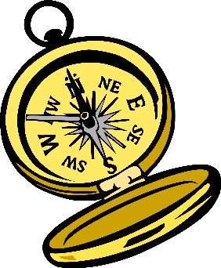7 underwear
* 3 bra (one athletic)
* 7 pr socks
* 2 pr casual pants
* 1 pr lounge pant
* 1 pr leggings
* 1 pr shorts
* 2 skirts/sundresses
* 7 tops (t-shirt/tank/other)
* 3 long sleeve shirt/blouse
* 1 sweatshirt
* 1 cardigan
* 1 swimsuit and cover-up
* 1 pajama
* 1 warm coat
* 1 rain jacket
* 3 pr shoes
* Hat/gloves/scarf
* Slipper socks
* **Travel docs** (Passport, International Drivers License, Insurance Docs, Credit Cards, Prescriptions)
* Cards/dice/coloring
* Glasses/Sunglasses
* 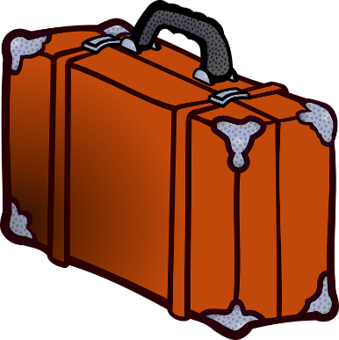Jewelry
* Medications
* Toothbrush/toothpaste/floss
* Hairbrush/bar shampoo/spray
* Deodorant
* Makeup
* Razor
* Refillable water bottle/filters
* Mouthguard/eye mask
* Purse
* Headphones/mini-speaker
* Laundry bag
* Hand sanitizer/wipes/lotion
* Sunscreen
* Washcloth/scrubber
* Ziplock bags
* Portable battery
* Airtags
* Keychain flashlight
* Jump-drive
* Phone/battery charger/cords
* Laptops/tablets/cords
* Snacks