**Sammi Salami’s First Mystery:**

**The Curse of the Clocktower**

**By Dave Alto Ph.D**

**Copyright Page**

**Sammi Salami’s First Mystery**

Copyright © 2025 by Dave Alto, Ph.D.  
All rights reserved.

No part of this book may be reproduced, stored, or transmitted in any form—electronic, mechanical, photocopying, recording, or otherwise—without prior written permission from the publisher, except for brief quotations in reviews or critical articles. All rights reserved. No part of this book may be reproduced, stored in a retrieval system, or transmitted in any form or by any means—electronic, mechanical, photocopying, recording, or otherwise—without the prior written permission of the copyright owner, except in the case of brief quotations used in reviews, articles, or scholarly analysis.

This is a work of fiction. Names, characters, places, and incidents are either the product of the author’s imagination or are used fictitiously. Any resemblance to actual persons, living or dead, events, or locales is purely coincidental.

Cover design by Dave Alto

First Edition

**Chapter 1: The Town That Ticked Too Loud**

El Pueblo de Sol shimmered under the relentless New Mexico sun, its dusty streets winding through a patchwork of adobe houses painted in warm terracotta and vibrant turquoise, their roofs sagging under the weight of history. The air was thick with the rich aroma of roasting chiles wafting from Abuela Rosa’s taqueria, mingling with the earthy scent of fresh tortillas and the faint sweetness of blooming desert flowers that clung to the town’s edges. Sixteen-year-old Sammi Salami leaned against the weathered clocktower in the town square, his dark curls tousled by a warm breeze that carried the distant hum of cicadas. Tall and lean, with olive skin that spoke of his Latino heritage, he wore a faded band tee emblazoned with a local punk band and jeans rolled at the ankles, his sneakers scuffed from endless exploration. His brown eyes, sharp and inquisitive, scanned the crowd with a mix of curiosity and boredom, his fingers idly spinning a yo-yo that whipped through the air like a miniature lasso. El Pueblo was small—barely a blip on the map—but Sammi knew its quiet facade hid secrets, and he thrived on unraveling them.

The clocktower chimed noon, its bell ringing with an unnatural intensity, the sound vibrating through the cobblestones and rattling the windows of nearby shops. Folks paused mid-conversation, their murmurs rising like a wave—old women clutching rosaries, kids exchanging wide-eyed glances. For weeks, the town had buzzed with rumors of a “curse” plaguing the tower: strange noises at night, shadows flickering behind the clock face, and clocks across El Pueblo running backward or stopping entirely. Sammi’s ears perked up as Mrs. Garcia, the town librarian with her silver-streaked bun, gossiped with Mr. Lopez, the grizzled mechanic wiping grease from his hands. “It’s the curse of Señor Vargas,” she whispered, her voice trembling with superstition. “The old clockmaker vanished fifty years ago after a fight with the mayor. His spirit’s back for revenge, mark my words.”

Sammi’s grin flashed, a spark of excitement igniting his adventurous spirit. “Revenge? Sounds like a bad telenovela plot,” he muttered under his breath, his wit cutting through the tension. But his empathy tugged at him, thinking of his abuela, who’d sit on their porch at dusk, her voice soft as she recounted tales of Vargas crafting clocks that “ticked with the 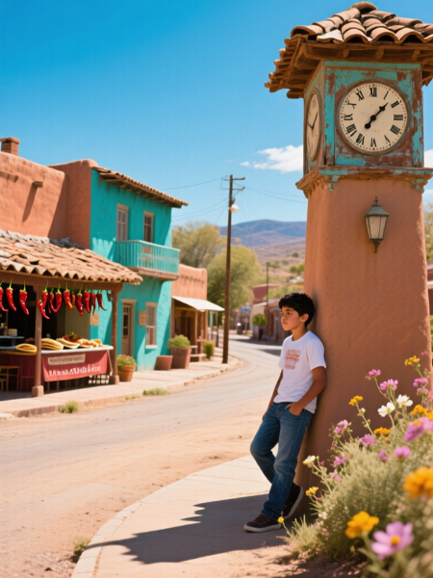 **Sammi Salami leaned against the weathered clocktower**

desert’s soul.” She’d always hinted at a secret tied to the tower, a mystery lost to time. His impulsive streak surged—he’d solve this, prove it was a prank or a broken gear, and maybe ease the town’s fears. He pocketed his yo-yo, its string still warm from his fingers, and slipped through the crowd, his sneakers silent on the cracked pavement, the clock’s off-key chime echoing like a challenge.

At home, a cozy adobe house with a sagging porch adorned with chile ristras hanging like red lanterns, Sammi’s mom, Mrs. Salami, stirred a pot of posole, the steam curling around her like a halo. Her warm smile greeted him, her dark eyes crinkling, but her brow furrowed with maternal instinct. “Sammi, you’re not poking around that clocktower, are you?” she asked, her Latino accent thick as the stew, her wooden spoon pausing mid-stir. She’d heard the rumors too, her worry etched in the lines of her face.

Sammi’s wit sparked, his grin disarming. “Me? Nah, Mom, just grabbing a snack.” He swiped a warm tortilla from the counter, the cornmeal scent filling his nose, but his mind was already mapping the tower’s layout—hidden entrances, creaky gears, perfect for a mystery. His resourcefulness flared; he’d need tools—a flashlight from the junk drawer, his yo-yo for reaching high places, and maybe his cousin Rosa for backup. The clocktower chimed again, off-key and insistent, the sound reverberating through the house like a warning. Sammi’s heart raced, his pulse syncing with the rhythm—the curse was real, or someone wanted it to seem so. His first mystery had begun, and the tower’s secrets beckoned, promising danger  **He swiped a warm tortilla from the counter**

and discovery.

As he munched the tortilla, his mom’s voice followed him to his room. “Be careful, mijo,” she called, her tone softening with love. Sammi nodded absently, his mind already in the tower, imagining shadowy figures and hidden vaults. He rummaged through his desk, pulling out a battered flashlight and a notebook filled with doodles of gears and cryptic symbols—his detective log. The afternoon sun dipped lower, casting long shadows across his room, and he knew the night would bring answers. Rosa would meet him at dusk; she’d always had a knack for spotting clues he missed. The clocktower’s chime faded, but its echo lingered, a riddle waiting to be solved.

**Chapter 2: The Clock That Lied**

The sun dipped below the horizon, painting El Pueblo de Sol in hues of crimson and gold, its adobe houses glowing like embers against the darkening sky. The air cooled, carrying the rich aroma of roasting chiles from Abuela Rosa’s taqueria, now closed for the evening, and the faint sweetness of desert blooms that dotted the town’s edges. Sammi Salami met his cousin Rosa at the taqueria’s back door, her braids tied with colorful ribbons fluttering in the breeze, her dark eyes sparkling with mischief. Fifteen and fearless, she wore a denim jacket over a graphic tee, her sneakers scuffed from their last escapade. “You’re really doing this, primo?” she asked, munching a leftover taco, her voice teasing but laced with excitement. Rosa was his partner in crime, her quick mind a perfect match for his, her Latino fire adding spark to their schemes.

Sammi’s grin flashed, his wit sharp as a blade. “Someone’s gotta, Rosa. The town’s clocks are going loco—backward, stopping, chiming at midnight like a bad horror flick. I’m ending this curse.” His empathy stirred for the villagers, like old Mr. Lopez, whose garage clock had cost him a day’s work, his frustration palpable at the diner. His impulsive streak urged him on, but his resourcefulness kept him cautious—he’d packed a backpack with a flashlight, a notebook, his yo-yo for tight spots, and a pocketknife for emergencies. The clocktower loomed ahead, its silhouette jagged against the twilight, its off-key chime a haunting call.

They slipped into the tower through a loose board at the base, the interior dark and dusty, the air cool with the tang of rust and oil. The whispers from the walls grew louder, a faint chant that buzzed in Sammi’s ears, mingling with the erratic click of gears above. His flashlight beam swept the shadows, revealing old clocks frozen at odd times—3:17, 11:59, 6:42—their faces cracked like spiderwebs, their hands trembling as if alive. “Look at this,” Rosa said, pointing to a dusty table where a ledger lay, its pages yellowed and brittle. “The clockmaker, Señor Vargas, vanished after a feud with the mayor over stolen gems. Says here he cursed the tower.”

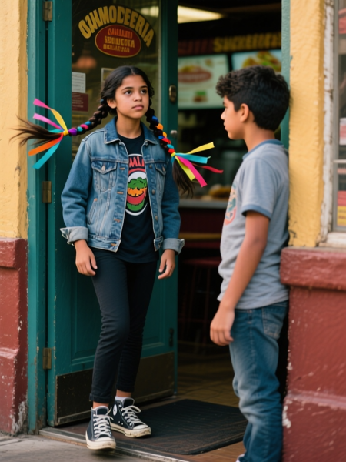**Rosa at the taqueria’s back door, her braids tied with colorful ribbons**

Sammi’s eyes narrowed, his mind piecing the puzzle. “Gems? Like a hidden vault?” His adventurous spirit flared, but a false lead tugged—a shiny object in the corner, a fake diamond glinting under his flashlight. He pocketed it, his heart quickening, but it felt too light, too staged. His *Ali Baba*-style cunning sparked—this was a decoy, a trap to mislead.

A creak echoed, and a shadow moved—a figure lurking near the stairs. Mr. Lopez, the mechanic, stepped into the light, his wrench raised, his eyes wild with panic. “You kids shouldn’t be here,” he snarled, his gruff voice trembling. “This is my family’s business.” Sammi’s wit flashed. “Fixing clocks, Mr. Lopez? Or hiding something?” Lopez bolted, dropping a crumpled note as he fled: “The curse is a lie—follow the gems.”

Sammi’s heart raced, his impulsive streak pushing him to chase, but Rosa’s caution held him. “It’s a trap, primo,” she said, her voice low, her hand on his arm. The clocktower chimed again, off-key and insistent, the gears grinding louder, the whispers swelling into a roar. Sammi’s resourcefulness kicked in—he unfolded the note, revealing a sketch of the mine, but the ledger’s hidden page, uncovered by Rosa’s sharp eyes, showed a different map to an underground vault beneath the square. The plot twisted—the gems were a false trail, and the real nemesis was closer than he’d thought. His grin flashed—he was hooked, the mystery deepening with every clue.

**Chapter 3: The False Trail**

The map from the ledger led Sammi and Rosa to the town’s abandoned mine on the outskirts of El Pueblo, its entrance boarded up with faded warnings: “Danger: Cursed Ground” scrawled in peeling paint. The sun had set, casting long shadows across the dusty path, the air heavy with rust and the earthy scent of sagebrush. Sammi’s leg still throbbed from the well’s scratch, but his adventurous spirit burned, his yo-yo spinning in his hand like a nervous tic. “This has to be it,” he said, his voice low, his eyes scanning the boards for a way in, the fake diamond from the tower weighing in his pocket.

Rosa’s braids swung as she pried a board loose with a rusty crowbar, her eyes sharp and determined. “Or a dead end,” she said, her voice teasing but edged with caution. Her quick mind had spotted the map’s hidden ink, revealed under sunlight—a trick from her abuela’s tales of desert riddles. Sammi’s empathy stirred, grateful for her partnership, her presence a steady anchor against his impulsiveness. He squeezed through the gap first, flashlight beam cutting the dark, the mine’s cool air brushing his skin.

The tunnel sloped downward, its walls propped with rotting timbers that creaked under the weight of decades, the air thick with dust and a faint, sour tang like burnt sugar. Sammi’s heart pounded, his resourcefulness kicking in as he navigated the twists, avoiding loose rocks that could trigger a collapse. “The map shows a vault ahead,” he said, his voice echoing off the damp stone, his mind racing with possibilities. But a glint caught his eye—a cluster of fake gems scattered on the floor, their facets too perfect, like bait in a hunter’s snare.

Rosa paused, her hand on his arm, her instinct sharp. “False lead, primo,” she said, her voice firm. Sammi nodded, his *Ali Baba*-style cunning sparking—this was a trap, a distraction from the real vault. They pressed on, the tunnel narrowing, the air growing colder, but a rumble echoed, and the supreme viper from the well surged from the shadows, its scales shimmering 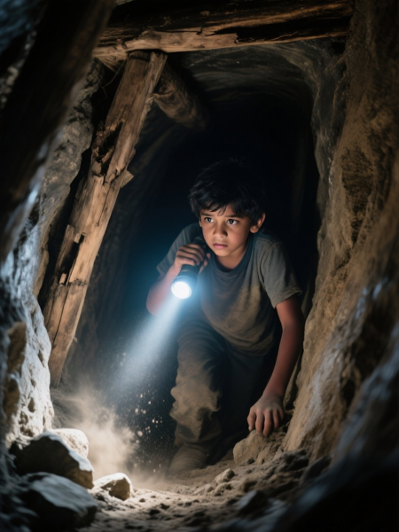. **He squeezed through the gap first, flashlight beam cutting the dark**

like oil, its amber eyes burning with fury. Its hiss filled the tunnel, its tail lashing timbers, collapsing the entrance behind them with a deafening crash.

Sammi’s yo-yo whirled, its string snapping at the viper’s flank, but its fangs grazed his leg again, blood trickling as he stumbled, pain searing through him. His adventurous spirit blazed, unyielding. “Rosa, the vault!” he shouted, dodging as the viper’s tail smashed a timber, rocks raining like a storm. Rosa’s quick mind led them right, spotting a hidden lever etched with the same symbols as the charm, its metal rusted but functional. She yanked it, and a slab slid open, revealing the vault’s entrance.

The viper lunged, its eyes flaring, but Sammi’s resourcefulness surged—he hurled the fake diamond into its path, the beast snapping at it, its jaws closing on air, buying precious seconds. They dove into the vault, the slab slamming shut, the viper’s hiss muffled by the stone. The chamber glowed with emerald runes, its walls lined with real gems and a pedestal holding an ancient scroll—the clockmaker’s diary. Sammi’s heart raced, his pulse syncing with the runes’ pulse—the evil nemesis was closer, the plot twisting with every step.

**Chapter 4: The Nemesis Unmasked**

The vault’s chamber pulsed with the green light of its runes, its walls embedded with glittering gems that cast fractured reflections across the stone floor, the air thick with dust and the faint echo of the viper’s hiss from beyond the slab. Sammi unrolled the scroll with trembling hands, his leg throbbing where the viper’s fangs had grazed, blood staining his jeans, but his adventurous spirit burned brighter than the pain. The diary’s pages were yellowed, inked with the clockmaker’s shaky hand: “The mayor stole my gems, cursed the tower to revenge. The well’s spirit guards the truth—beware the shadow of greed.”

Rosa’s eyes widened, her braids falling forward as she read over his shoulder, her quick mind racing. “The mayor? But he’s been dead for years,” she said, her voice a mix of shock and excitement, her fingers tracing the ink. Sammi’s mind pieced the puzzle, his *Sinbad*-style cunning threading the clues—the false leads of fake gems, the cursed clocks, the viper’s lair. The evil nemesis wasn’t a ghost; it was someone alive, using the curse as a cover for a deeper vendetta.

A creak echoed, and Mr. Lopez burst through a hidden door in the vault’s wall, his wrench raised like a weapon, his eyes wild with desperation. “You kids shouldn’t meddle,” he snarled, his gruff voice trembling, his mechanic’s apron stained with oil. Sammi’s empathy tugged—Lopez was the clockmaker’s grandson, his family’s honor tarnished by the mayor’s theft, his vengeance driving a scheme to expose the truth. But his actions had spiraled, the curse a lie he’d amplified.

Sammi’s wit flashed, his voice steady despite the tension. “Meddle? We’re solving, Mr. Lopez,” he said, holding up the diary, its pages fluttering. Lopez lunged, his wrench swinging in a wild arc, but Sammi’s resourcefulness kicked in—he dodged, his yo-yo whipping out to tangle Lopez’s feet, sending him sprawling across the gem-strewn floor with a grunt. Rosa grabbed the wrench, her quick mind turning the tables, her strength surprising for her frame. “It’s over,” she said, her voice firm, pinning Lopez’s arm.

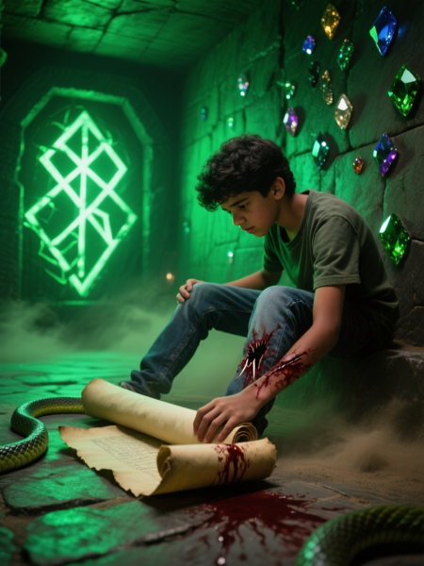**Sammi unrolled the scroll with trembling hands**

Lopez’s shoulders slumped, his punishment self-inflicted—his curse had backfired, exposing his own greed and grief. Sammi’s empathy softened his victory. “We can fix this, Mr. Lopez,” he said, offering a hand, his voice gentle. “The diary clears your abuelo’s name.” Lopez nodded, tears mixing with the dust on his face, the plot twisting to a resolution. The vault’s runes dimmed, the gems losing their glow, the town’s clocks resetting as the curse lifted. Sammi’s heart swelled—the nemesis unmasked, the mystery solved, a happy ending within reach.

**Chapter 5: The Spark of Sammi Salami**

El Pueblo de Sol erupted in celebration under a starlit sky, the clocktower chiming true for the first time in weeks, its bell echoing clear across the square, its sound a balm to the town’s nerves. Sammi Salami stood at the square’s heart, his curls tousled by the warm breeze, his leg bandaged but his grin wide, the silver charm—now curse-free—hanging around his neck like a medal of honor. The air was sweet with honeysuckle and the rich aroma of fresh tortillas from Abuela Rosa’s taqueria, the neon lights of the diner casting a warm glow over the crowd. His mom, Mrs. Salami, hugged him tightly, her eyes teary but proud, her dark hair streaked with silver. “My mystery-solver,” she said, her Latino accent thick with love, her arms squeezing until he laughed.

Rosa bumped his shoulder, her braids adorned with fresh flowers from the square’s vendors, her eyes sparkling with mischief. “We did it, primo,” she said, her voice bright, her quick mind already plotting their next adventure, her denim jacket swaying with her step. Max, Sparky at his feet wagging his tail, adjusted his glasses, his loyalty shining through his torn hoodie. “You’re insane, Sammi,” he said, his voice warm, a grin breaking through his usually serious  **Sammi Salami stood at the square’s heart**

demeanor. “But you saved the town.”

Sammi’s heart swelled, his empathy anchoring him to his friends and El Pueblo, his first mystery solved with a happy ending. His adventurous spirit burned, his wit sharp as ever. “Insane’s my brand, guys. Sammi Salami, curse-buster and mystery-master.” The square cheered, the elder storyteller weaving a new tale of Sammi’s daring, his voice rising above the chatter, painting him as a hero forged in neon and starlight. Kids crowded around, asking for details, while Mr. Lopez, now redeemed, handed out free tacos, his gruff apology accepted with smiles.

The night sky sparkled, the charm’s glow faded but its weight a reminder of his victory. Sammi knelt by the fountain, its basin now sThe night sky sparkled, the charm’s glow faded but its weight a reminder of his victory. Sammi knelt by the fountain, its basin now still, and traced the crescent moon slot where the charm had fit, its runes dimmed. “This town’s got more secrets,” he whispered, his voice soft, his mind racing with possibilities—cursed wells, haunted towers, and mysteries yet to come. His abuela approached, her cane tapping the pavement, her eyes twinkling. “You’ve got your abuelo’s spirit, mijo,” she said, her voice a desert breeze. “But watch for shadowstill, and traced the crescent moon slot where the charm had fit, its runes dimmed. “This town’s got more secrets,” he whispered, his voice soft, his mind racing with possibilities—cursed wells, haunted towers, and mysteries yet to come. His abuela approached, her cane tapping the pavement, her eyes twinkling. “You’ve got your abuelo’s spirit, mijo,” she said, her voice a desert breeze. “But watch for shadows.”

**Sammi knelt by the fountain, its basin now still**

Sammi stood, his yo-yo spinning, his adventurous spirit unbowed. The faint echo of the clocktower’s chime lingered, a whisper of new challenges. His journey had begun, a hero ready to unravel El Pueblo’s secrets, with Rosa and Max by his side.

*{Join Sammi Salami’s Adventures! Coming Soon. Subscribe on the website’s main page to learn when new books are released.]*