**Prelude**

**Omar’s First Quest:**

**The Sand Viper’s Secret**

**By Dave Alto, Ph.D**

**Copyright Page**

Omar’s First Quest

Copyright © 2025 by Dave Alto, Ph.D.  
All rights reserved.

No part of this book may be reproduced, stored, or transmitted in any form—electronic, mechanical, photocopying, recording, or otherwise—without prior written permission from the publisher, except for brief quotations in reviews or critical articles. All rights reserved. No part of this book may be reproduced, stored in a retrieval system, or transmitted in any form or by any means—electronic, mechanical, photocopying, recording, or otherwise—without the prior written permission of the copyright owner, except in the case of brief quotations used in reviews, articles, or scholarly analysis.

This is a work of fiction. Names, characters, places, and incidents are either the product of the author’s imagination or are used fictitiously. Any resemblance to actual persons, living or dead, events, or locales is purely coincidental.

Cover design by Dave Alto

First Edition

**Chapter 1: The Whisper in the Dunes**

The desert sun blazed over Al-Zahra, casting golden light across endless sands that shimmered like molten amber, their surface rippling in the heat. The air carried the sharp tang of tamarind and the dry rustle of palm fronds swaying above the village square. Twelve-year-old Omar, wiry and quick, with unruly curls spilling from under a faded cap, darted through the bustling market, his bare feet kicking up clouds of sand. His heart thumped with a restless hunger for adventure, his dark eyes scanning for the spark of something extraordinary. Merchants hawked saffron and dates, their voices blending with the laughter of children and the clink of copper coins, but Omar’s attention fixed on an elder storyteller perched on a woven rug, his voice like weathered leather weaving tales of *Sinbad the Sailor*—tales of sea monsters, rocs, and hidden treasures.

The elder’s words painted a vivid scene: a viper’s lair buried deep in the dunes, its stone arch carved with ancient oasis motifs, guarding a brass lamp said to hold a curse and a secret. “The sand viper strikes fools who seek its treasure,” the elder warned, his eyes glinting under a turban frayed by time. “Only the boldest hearts dare its wrath.”

Omar’s lips curled into a mischievous grin, his impulsive streak igniting. “Trouble’s my game,” he muttered, his voice low but brimming with excitement. His empathy stirred for the village kids, wide-eyed but tethered to chores, who’d never chase such legends. His whip, a simple leather cord inherited from his father, hung at his belt, untested but itching for action. He adjusted his cap, his adventurous spirit already racing toward the dunes, imagining himself as a young Sinbad, outwitting beasts to claim glory.

As he slipped past a stall piled with pomegranates, Amina caught him, her sharp eyes narrowing beneath braids adorned with desert flowers. At eleven, she was smaller but fierce, her hands planted on her hips. “Omar, you’re not chasing that viper myth, are you?” she asked, her voice a mix of teasing and worry, her brow furrowed like an elder’s.

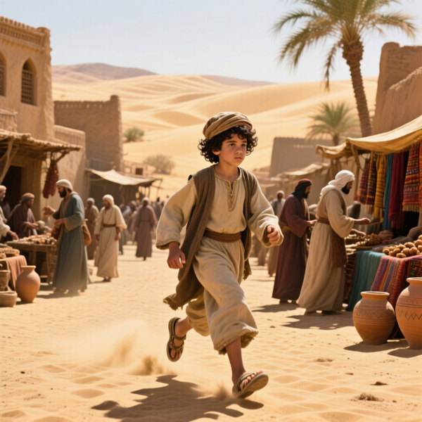**Omar, darted through the bustling market**

Omar’s grin widened, his wit sharp as a scimitar. “Myths? Nah, Amina, I’m hunting glory. Wanna join the legend?” His adventurous spirit gleamed, but her frown deepened, her practicality a counterpoint to his impulsiveness.

“It’s dangerous,” she said, stepping closer, her voice low. “The elder said the viper’s lair curses fools who trespass. You’ll get yourself killed—or worse, cursed.”

Omar’s heart tugged, his empathy catching the concern in her eyes, but his impulsive streak won out. “Fools don’t write legends,” he said, winking. “Stay here if you’re scared, but I’m going.” He sprinted toward the village edge, his sandals slapping the sand, Amina’s exasperated sigh trailing him like a shadow.  **The viper’s lair.**

The dunes rose before him, vast and rolling, their crests casting twisted shadows that danced like serpents. The wind carried a faint, eerie hiss, chilling despite the sun’s heat. Omar’s pulse quickened, his fingers tightening on his whip as he climbed a dune, sand sliding beneath his feet. At its peak, he spotted a stone arch half-buried in the desert, its surface etched with swirling oasis motifs that glowed faintly violet in the fading light. The viper’s lair. His breath caught, his adventurous spirit soaring, but a prickle of doubt crept in—had Amina been right? He shook it off, his impulsive nature urging him forward. The arch loomed, its shadows whispering of danger and destiny, the lamp’s secret calling him deeper into the unknown.

**Chapter 2: The Viper’s Trap**

The lair’s entrance yawned like a dark maw beneath the dunes, its stone walls etched with swirling desert stars that pulsed with an unnatural violet glow. The air inside was thick, steeped in scorched myrrh and the musty scent of ancient stone, pressing against Omar’s chest as he crept forward. His whip coiled in his hand, its leather worn but steady, his eyes wide with adventure. The brass lamp flickered in his mind—a prize to prove his courage, a tale to rival *Sinbad*’s battles with cyclopes and rocs. His empathy stirred, recalling Amina’s warning, but his impulsive streak pushed him deeper, the thrill of discovery drowning out caution.

The tunnel sloped downward, its walls narrowing, the violet glow casting jagged shadows that seemed to writhe. A low hiss sliced through the silence, and Omar froze, his heart pounding. From the darkness surged a sand viper, colossal and sinuous, its scales glinting like polished obsidian, its amber eyes burning like twin suns. Its tail lashed, sending a cascade of sand crashing against the walls, the sound echoing like a desert storm. Omar’s adventurous spirit blazed, his fear swallowed by defiance. “Time to dance, snake,” he muttered, his wit sharp despite the sweat beading on his brow.

He cracked his whip, its snap echoing as it struck the viper’s flank, but the beast’s fangs grazed his arm, blood trickling through his torn sleeve. Pain seared, but Omar gritted his teeth, his resourcefulness kicking in. He dove behind a stone pillar, its surface carved with faded runes, dodging another strike as the viper’s tail shattered a nearby wall, shards raining like daggers. His mind raced, *Ali Baba*-style cunning sparking—an ancient trap, like those in thieves’ caves, must guard the lamp.

Through the dust, he spotted it: a stone pedestal at the tunnel’s end, cradling the brass lamp, its surface etched with glowing runes that pulsed in sync with the viper’s eyes. Omar’s impulsive streak surged, urging him to charge, but his empathy held him back, Amina’s warning echoing. The pedestal was too obvious—a trap. He scanned the chamber, noticing **sand viper, colossal and sinuous**

cracks in the floor, faint lines suggesting a hidden mechanism. “Clever, snake,” he whispered, his wit steadying him.

He darted left, whip cracking to draw the viper’s strike, its fangs sinking into the pillar instead. Violet mist sprayed as it recoiled, and Omar sprinted, leaping over the cracked floor. The viper lunged, its tail whipping, but he rolled under its arc, sand choking his throat. His whip lashed out, wrapping the viper’s neck, yanking hard. The beast thrashed, its eyes flaring, and Omar struck again, aiming for its amber gaze, violet mist bursting as it roared in pain.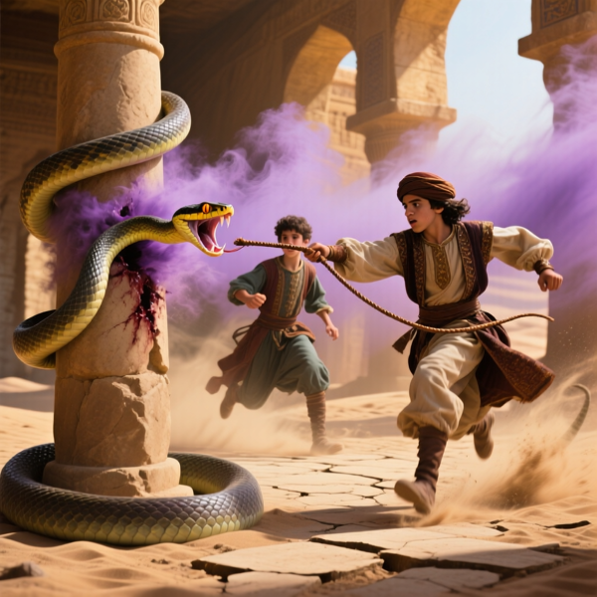 **Omar struck again, aiming for its amber gaze**

The pedestal clicked, and the chamber quaked, sand pouring in like a flood from hidden vents. Omar’s heart raced, his adventurous spirit unyielding. He lunged for the lamp, his fingers closing around its warm, rune-etched surface, but the viper’s tail smashed the ground, triggering more traps. Stone slabs slid shut behind him, sealing the exit. “Not good,” Omar muttered, his wit faltering as sand rose to his knees.

Amina’s voice pierced the chaos from the entrance. “Omar, move!” she shouted, her courage cutting through the dust. She stood at the arch, her small frame silhouetted, a rock in her hand. She hurled it, striking the viper’s flank, buying Omar a heartbeat. He dove through a collapsing arch, lamp clutched tight, sand swallowing the chamber as the viper’s hiss faded into a buried roar.

**Chapter 3: The Spark of a Hero**

Omar tumbled into the open desert, the brass lamp gripped in his hands, its runes glowing faintly as the viper’s lair collapsed in a cloud of sand behind him. The sun dipped low, painting the dunes in fiery hues of crimson and gold, the air now sweet with jasmine and free of the lair’s scorched myrrh. His arm throbbed, blood soaking his sleeve, but his adventurous spirit soared, the lamp’s weight a testament to his triumph. He staggered to his feet, sand caking his curls, his cap lost in the fray, his whip still coiled at his belt.

Amina ran to him, her braids bouncing, her desert-flower adornments glinting in the twilight. Her eyes flashed with relief and frustration, her hands checking his bloodied arm. “You’re impossible, Omar,” she said, her voice thick with worry but softened by pride. “You could’ve died in there.”

Omar grinned, his wit undimmed despite the pain. “Impossible’s just another adventure, Amina. Besides, I got the lamp—legend secured.” He held up the brass lamp, its surface warm, its runes pulsing with a faint, mysterious energy—a whisper of magic he didn’t yet understand, the spark of Genie Jinn Jahan’s presence.  **Amina**, **I got the lamp—legend secured**

His empathetic heart warmed, seeing Amina’s courage in chasing after him, her loyalty anchoring his reckless streak.

The elder storyteller approached from the village, his turban casting a long shadow, his eyes glinting with pride under weathered brows. “You’ve sparked a legend, boy,” he said, his voice like a desert breeze carrying tales of *Sinbad* and *Ali Baba*. “But the viper’s curse lingers in that lamp. Guard it well, for its secrets may summon greater trials.”

Omar’s adventurous spirit flared, his impulsive streak tempered by Amina’s steady gaze and the elder’s warning. He turned the lamp over, its runes catching the starlight, a faint hum stirring within. “For the desert,” he said, his voice resolute, gripping the lamp tightly. Amina nodded, her courage matching his, her hand brushing his arm. “Together,” she said, her eyes reflecting the dunes’ promise, their bond sealed in the face of danger.

The village of Al-Zahra came alive as they returned, the square bustling with torchlight and laughter. Children crowded around, their voices eager for Omar’s tale, while merchants paused their trade, drawn to the boy who’d braved the viper’s lair. The elder’s words wove a new story, painting Omar as a hero born of sand and starlight, his whip a symbol of daring, his heart tied to the desert’s fate. Amina stood beside him, her presence grounding his impulsiveness, her courage a quiet fire.

Omar knelt by a small stone at the square’s edge, a marker for his father, who’d once wielded the whip. “I’m starting, Dad,” he whispered, his empathy swelling, the lamp heavy in his hands. The desert stretched before them, its dunes whispering of trials to come—krakens,

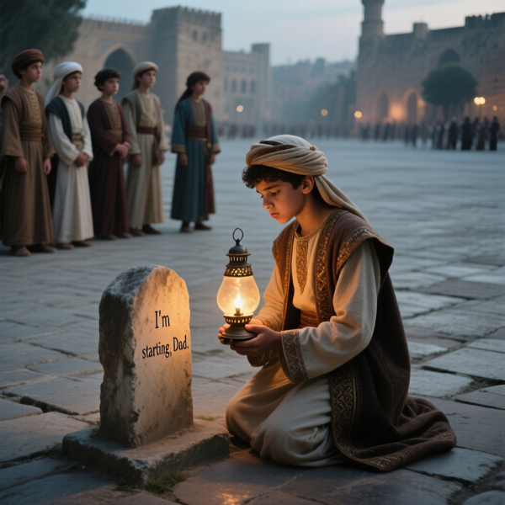rocs, cyclopes, and a Void Emperor named Nyxar. Omar’s journey had begun, a hero forged in the crucible of sand and starlight, with Amina by his side.

**Omar knelt by a small stone at the square’s edge**