**Billie Baloney’s First Freakout:**

**The Curse of the Whispering Well**

**By Dave Alto Ph.D**

**Copyright Page**

Billie Baloney’s First Freakout

Copyright © 2025 by Dave Alto, Ph.D.  
All rights reserved.

No part of this book may be reproduced, stored, or transmitted in any form—electronic, mechanical, photocopying, recording, or otherwise—without prior written permission from the publisher, except for brief quotations in reviews or critical articles. All rights reserved. No part of this book may be reproduced, stored in a retrieval system, or transmitted in any form or by any means—electronic, mechanical, photocopying, recording, or otherwise—without the prior written permission of the copyright owner, except in the case of brief quotations used in reviews, articles, or scholarly analysis.

This is a work of fiction. Names, characters, places, and incidents are either the product of the author’s imagination or are used fictitiously. Any resemblance to actual persons, living or dead, events, or locales is purely coincidental.

Cover design by Dave Alto

First Edition

**Chapter 1: The Gossip That Glows**

The small town of Moth Hollow shimmered under a lazy summer sun, its cracked sidewalks glinting with specks of mica, lined with flickering neon signs advertising greasy diners and secondhand shops. The air was thick with the scent of fried doughnuts from Sal’s Soda Shack, mingling with the sweet tang of blooming honeysuckle that clung to the town’s edges. Billie Baloney, a lanky fourteen-year-old with electric-blue hair that defied gravity and a smirk that screamed trouble, slouched against the diner’s counter, her combat boots tapping an impatient rhythm on the checkered floor. Her hazel eyes, sharp as a hawk’s, glinted with mischief, her wit sharper than the switchblade she’d never admit to wanting because her mom, Mrs. Baloney, would ground her for a decade. The jukebox in the corner blared a pop-punk anthem, its chords vibrating through the sticky air, but Billie’s attention was snagged by a huddle of teens at a nearby booth, their whispers buzzing like static.

“It’s, like, totally haunted,” said Jenna, a cheerleader whose ponytail bounced with every word, her voice low but dripping with drama. “My cousin wished for a new phone at the Whispering Well, and now her selfies glow in the dark. Like, neon green.”

Billie snorted, her sarcastic edge slicing through the chatter. “Glow-in-the-dark selfies? Sounds like a feature, not a curse.” She leaned forward, her elbows smudging the counter’s chrome, her adventurous spirit itching for a mystery to unravel. She’d grown up on tales of *Sinbad the Sailor*—his battles with sea monsters and rocs—told by her grandpa, who swore Moth Hollow’s well was tied to an ancient spirit, a *Sinbad*-style trickster that granted wishes with a nasty twist. Her heart tugged, thinking of her best friend Max, who’d been moping since his scruffy terrier, Sparky, ran off last week. Maybe the well could bring Sparky back, if Billie was brave enough to face its curse.

Max slumped beside her, his glasses fogged with soda steam, his lanky frame buried in a hoodie two sizes too big. His brown eyes, usually bright with nerdy enthusiasm, were dull with worry. “Don’t even think about it, Billie,” he muttered, pushing his glasses up his nose. 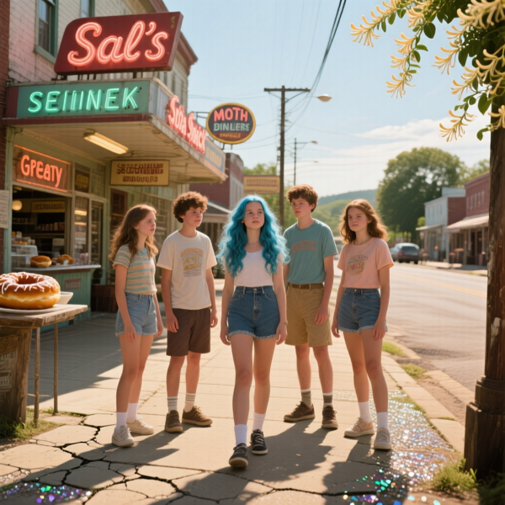 **Moth Hollow shimmered under a lazy summer sun**

“That well’s bad news. My uncle wished for cash, and now his wallet’s stuffed with Monopoly money. He’s still paying off the pizza guy.”

Billie’s grin widened, her wit sparking like a live wire. “Monopoly money’s still money, Max. You just gotta find the right board game.” Her impulsive streak surged, drowning out his caution. She grabbed her backpack, stuffed with a flashlight, a half-eaten candy bar, and a crumpled notebook where she scribbled her wildest ideas—most of which her mom called “reckless nonsense.” “C’mon, let’s check it out. Sparky’s worth a little curse, right?”

Max groaned, his loyalty warring with his nerves. “You’re gonna get us killed, or worse, cursed,” he said, but he slid off the stool, his sneakers scuffing the floor. “Fine, but if we glow green, I’m blaming you.”

Billie smirked, her adventurous spirit blazing. “Deal. Let’s make some legends.” She strode toward the door, the bell jangling as she pushed it open, Max trailing like a reluctant shadow. The summer heat hit them like a wave, the sun dipping low, casting long shadows across Moth Hollow’s dusty streets. They passed the rusted water tower, its faded “Welcome to Moth Hollow” sign peeling, and headed toward the town’s edge, where wild blackberries tangled with gnarled oaks.

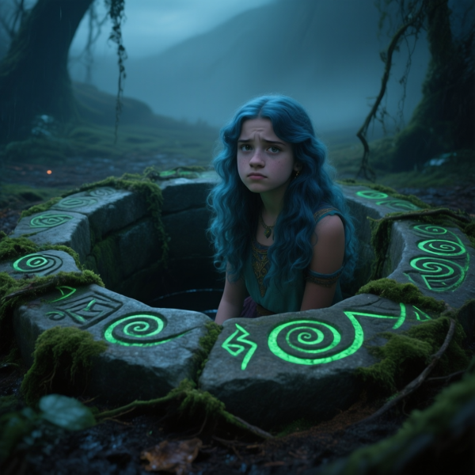**The Whispering Well sat hidden in a clearing**

The Whispering Well sat hidden in a clearing, its stone circle half-buried in vines, moss clinging to its rim like a bad omen. The air grew heavy, tinged with damp earth and a sour note, like burnt sugar, that made Billie’s nose wrinkle. The well’s rim was carved with weird, swirling symbols—almost like the oasis motifs from her grandpa’s *Sinbad* tales—that glowed faintly green in the dusk. A low whisper drifted up, like a voice caught in a breeze, chilling her despite the heat. Billie’s pulse quickened, her boots crunching leaves as she stepped closer, her flashlight beam dancing across the stones. “This is it,” she said, her voice low, her adventurous spirit soaring. The well’s edge beckoned, its shadows whispering secrets—and trouble. She leaned over, her blue hair catching the green glow, her heart pounding with the thrill of the unknown.

**Chapter 2: The Wish That Bites**

The Whispering Well loomed in the twilight, its stone rim slick with moss, the glowing symbols pulsing like a heartbeat in the fading light. The air was thick with burnt sugar and rotting leaves, the whispers growing louder, weaving words Billie couldn’t quite catch—snatches of “wish” and “price” that sent a shiver down her spine. She leaned over the edge, her blue hair falling forward, her flashlight beam slicing through the dark, revealing nothing but a void below. A faint glint flickered deep within, like a coin or a charm, winking like a dare. Her heart raced, her adventurous spirit screaming to dive in, but her empathy tugged, picturing Max’s mopey face and Sparky’s empty leash hanging on his porch.

“Billie, this is a terrible idea,” Max said, his glasses slipping as he peered over her shoulder, his voice tight with worry. “Those whispers aren’t saying ‘welcome.’ They’re saying ‘get lost or get cursed.’ My uncle’s still finding fake $100 bills in his couch cushions.”

Billie’s smirk flashed, her sarcasm sharp as ever. “C’mon, Max, where’s your *Cool Guy swagger*? We wish, we win, we get Sparky back.” Her impulsive streak took over, drowning out his caution. She fished a pebble from her pocket, its surface smooth from years of desert wear, and tossed it into the well, its echo swallowed by the dark. “I wish for Sparky to come home,” she said, her voice bold but trembling at the edges, her empathy anchoring the wish to Max’s loss.

The whispers surged, a guttural chant that shook the ground like a desert quake. The symbols flared green, and a cold wind whipped up, stinging Billie’s face and tangling her hair. A shadow moved below, not a coin but something alive, slithering up the well’s walls with a hiss that made her skin crawl. Her flashlight caught it—a spectral serpent, its scales shimmering like oil, its amber eyes burning like fire, its body coiling endlessly in the dark. It hissed, its voice a whispery rasp. “Wish granted, but payment’s due.”

Billie’s heart pounded, her adventurous spirit undaunted. “Payment? I didn’t sign up for that, snake,” she snapped, her sarcasm biting through her fear. She grabbed a stick from the ground, swinging it like a sword, but the serpent’s tail lashed out, grazing her arm, blood 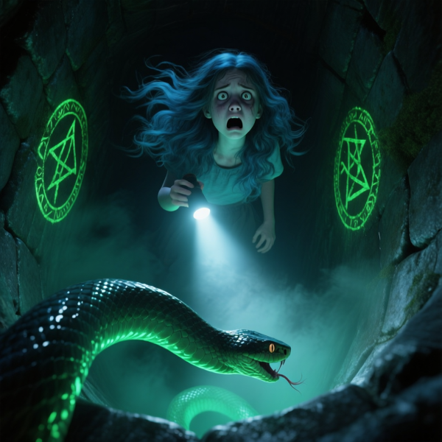**something alive, slithering up the well’s walls**

trickling through her sleeve. Pain seared, but Billie gritted her teeth, her resourcefulness kicking in, her *Ali Baba*-style cunning sparking. She scanned the well’s rim, noticing a loose stone misaligned with the glowing symbols—a trap, like a thief’s vault.

“Max, help me!” she shouted, dodging another strike as the serpent’s fangs snapped inches from her boots. Max, his loyalty fierce despite his shaking hands, grabbed a rock and hurled it, distracting the serpent as it coiled toward him. Billie kicked the loose stone, and the ground quaked, a hidden slab sliding open at the well’s base, revealing a tunnel beneath. The serpent lunged, its eyes flaring, but Billie dove into the tunnel, dragging Max with her, his glasses nearly falling off. The whispers chased them, the serpent’s hiss echoing as the slab slammed shut, plunging them into darkness.

The tunnel was tight, its walls slick with damp earth and etched with more glowing symbols that pulsed like a warning. Billie’s arm throbbed, but her adventurous spirit burned, her flashlight lost but her wits sharp. “Keep moving,” she said, her voice steady, pushing Max forward as the whispers grew louder, the air thick with mold and burnt sugar. The tunnel twisted, its walls narrowing, but Billie’s cunning kept her focused, her eyes searching for a way out—or a clue to break the curse.

**Chapter 3: The Tunnel’s Trick**

The tunnel wound deeper beneath Moth Hollow, its slick walls closing in, the air heavy with mold and the sour sting of burnt sugar. The glowing symbols etched into the stone pulsed green, casting eerie shadows that danced like specters. Billie led the way, her arm throbbing where the serpent’s tail had grazed her, blood soaking her sleeve, but her adventurous spirit burned brighter than the pain. Max stumbled behind, his glasses fogged, his hoodie snagging on jagged rocks, his breath shaky but his loyalty unwavering. “This is worse than the well,” he muttered, his voice a mix of fear and exasperation. “We’re gonna be snake food, Billie.”

Billie’s grin flickered, her sarcasm steadying her nerves. “Snake food? Nah, Max, we’re the main course.” Her empathy flared, sensing his panic, but her impulsive streak pushed her forward, her fingers tracing the symbols, which seemed to shift under her touch, like a puzzle begging to be solved. The whispers hummed, a low chant that buzzed in her ears, urging her deeper despite the danger.

The tunnel opened into a cavernous chamber, its ceiling lost in shadow, its floor littered with broken stones. At its center stood a stone pedestal, cradling a silver charm shaped like a crescent moon, its surface glowing faintly, etched with runes that matched the well’s. Billie’s heart leapt, **a stone pedestal, cradling a silver charm shaped like a crescent moon**

her *Sinbad*-style hunger for treasure kicking in. “That’s gotta be the key to this curse,” she said, her voice low, her eyes narrowing. But her *Ali Baba*-style cunning made her pause—the pedestal was too perfect, like a baited trap in a thief’s vault.

The serpent’s hiss echoed from the tunnel, its coils slithering closer, its amber eyes glinting in the dark. Billie’s resourcefulness surged, and she scanned the chamber, spotting cracks in the floor forming a spiral pattern—a hidden mechanism. “Max, we’ve got a trap to spring,” she said, her voice urgent. They shoved at a loose slab, their hands slipping on damp stone, until it gave way, revealing a rusted lever. Billie yanked it, and the chamber quaked, sand pouring in from hidden vents above, the serpent’s coils caught in the flood.

The serpent thrashed, its eyes flaring, its scales shimmering as it fought the sand. Billie lunged for the charm, her fingers closing around its cold surface, its glow intensifying in her hand. The whispers screamed, a deafening wail, and the pedestal clicked, triggering more traps—stone spikes shot from the walls, grazing her leg, blood trickling as she stumbled. 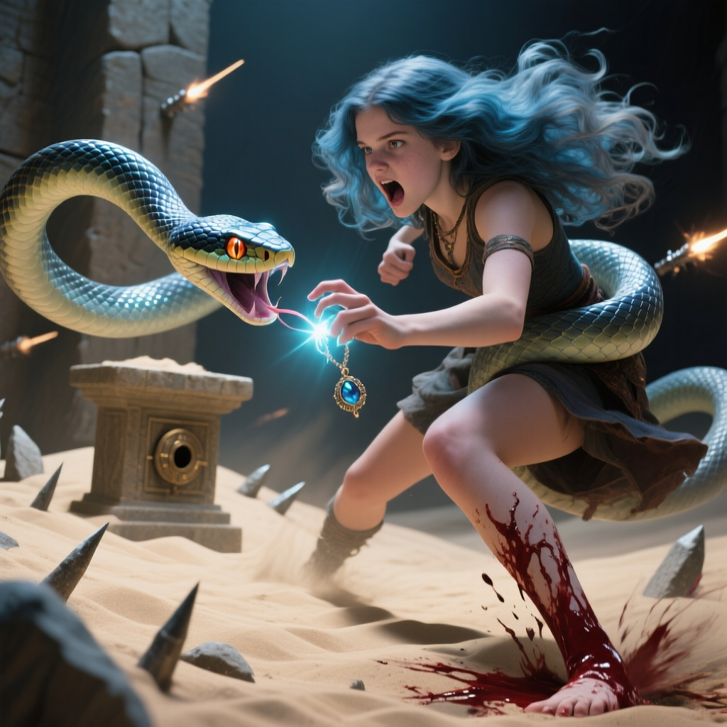 **The serpent thrashed, its eyes flaring, its scales shimmering**

Max grabbed her arm, his loyalty unwavering, and they scrambled back through the tunnel, the charm pulsing like a heartbeat, the serpent’s hiss swallowed by the collapsing chamber.

Billie’s boots skidded on the slick floor, her heart pounding, her adventurous spirit unyielding. The tunnel twisted upward, the air growing lighter, but the whispers clung, warning of a price unpaid. Max’s breath hitched, his glasses fogged with sweat. “What’s that charm even do?” he asked, his voice shaky but curious.

Billie’s wit sparked, her sarcasm a shield. “Probably turns us into glowing superheroes—or cursed toast. Either way, we’re keeping it.” Her empathy kept her grounded, her focus on Max’s fear and Sparky’s return. The tunnel’s end loomed, a faint starlight piercing the darkness, promising escape—or a new danger.

**Chapter 4: The Charm’s Curse**

Billie and Max burst from the tunnel into the starlit desert, the Whispering Well now a pile of rubble behind them, its glowing symbols buried in sand. The air was sweet with honeysuckle, free of the burnt sugar stench, the night sky sparkling over Moth Hollow’s neon-lit skyline. Billie clutched the silver charm, its crescent moon shape pulsing faintly, its warmth buzzing like a warning in her palm. Her leg and arm throbbed, blood caking her jeans and sleeve, but her adventurous spirit soared, her sarcasm masking the pain. “Well, that was a five-star adventure,” she said, her grin shaky but defiant. “Got the charm, saved the day—probably.”

Max adjusted his glasses, his face pale, his hoodie torn from the tunnel’s rocks. “Saved? Billie, we’re cursed,” he said, pointing to the charm’s glow. “That thing’s screaming ‘bad vibe central.’ We should ditch it.” His loyalty held, but his voice trembled with worry.

Billie’s empathy kicked in, her heart aching for his fear, but her wit held firm. “Bad vibes are my specialty, Max. This charm’s our ticket to fixing your dog problem.” She examined the charm, its runes whispering faintly, like the well’s voice, promising power but demanding a price. Her *Ali Baba*-style cunning sparked—this was no ordinary trinket; it was tied to the well’s spirit, a curse that granted wishes with a twist.

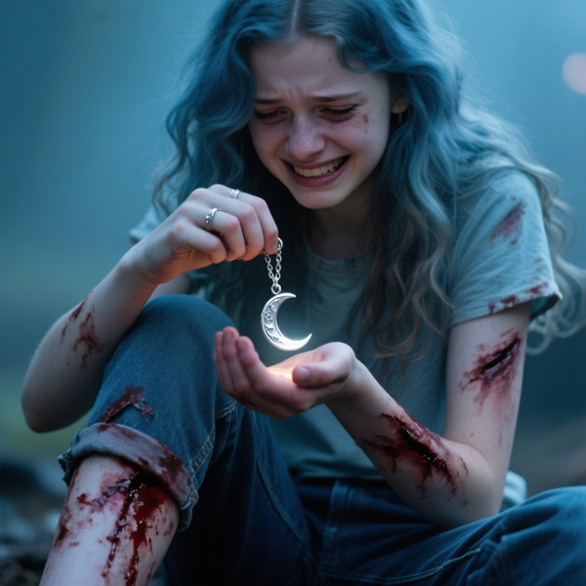**Billie clutched the silver charm, its crescent moon shape pulsing faintly**

A bark broke the silence, and Sparky, Max’s scruffy terrier, bounded from the blackberry bushes, tail wagging, his fur dusty but unharmed. Max’s face lit up, his relief flooding as he knelt to hug the dog, his glasses fogging with tears. “Sparky!” he cried, his voice cracking with joy. Billie’s heart warmed, her impulsive wish fulfilled, but the charm’s glow intensified, and the ground trembled, a faint hiss rising from the rubble.

A shadow loomed—a spectral figure, humanoid but shimmering like oil, its amber eyes burning like the serpent’s, its form rippling with menace. “You took my charm,” it rasped, its voice a whispery curse that chilled the air. “Return it, or pay with your light.” Billie’s adventurous spirit flared, her sarcasm sharp. “Pay? I’m broke, ghost,” she snapped, gripping the charm, her fingers tingling with its power.

The figure lunged, its claws grazing her arm, blood trickling anew through her sleeve. Billie’s resourcefulness surged, her *Sinbad*-style daring kicking in. She tossed the charm to Max, who caught it with a yelp. “Run, nerd!” she shouted, dodging another claw as the figure’s eyes flared. They sprinted toward Moth Hollow, the neon lights a beacon, the figure’s whispers chasing them like a storm. Billie’s mind raced, her cunning plotting—the charm was the key, but where did it belong? The town’s old fountain, its basin carved with faded symbols like the well’s, flashed in her memory. That was their out.

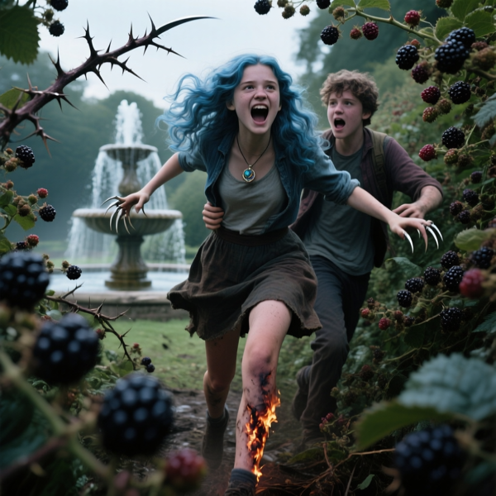**They wove through the blackberry thickets**

They wove through the blackberry thickets, thorns snagging their clothes, the figure’s claws slashing the air. Billie’s leg burned, but her adventurous spirit pushed her forward, her empathy keeping Max close. “Keep that charm safe!” she yelled, her voice steady despite the chaos. The fountain loomed ahead, its water glinting under the neon glow, promising salvation—or another trap.

**Chapter 5: The Spark of Billie Baloney**

Moth Hollow’s neon lights bathed the town square in a kaleidoscope of pinks and blues, the air alive with honeysuckle and the faint grease of diner fries. Billie and Max stumbled to the old fountain at the square’s heart, its basin carved with faded symbols that echoed the well’s glowing runes. Billie clutched her bleeding arm, her leg throbbing, the silver charm now in Max’s hands, its crescent moon shape pulsing green, casting shadows that danced across the pavement. Her blue hair was a mess, her combat boots caked with dirt, but her adventurous spirit burned, her sarcasm a shield against the pain. “We’re not cursed yet, Max,” she said, her smirk defiant. “This charm’s our ticket to legend status.”

Max hugged Sparky, his glasses fogged, his hoodie torn, his voice shaky but loyal. “Legend? Billie, we’re toast if that ghost catches us,” he said, the charm glowing brighter in his hands. “This thing’s gonna turn us into glowing zombies or something.”

Billie’s empathy flared, her heart aching for his fear, but her *Ali Baba*-style cunning took over. “Zombies? Nah, we’re too cool for that,” she said, her wit steadying them both. She scanned the fountain, its central carving—a crescent moon slot—matching the charm’s shape. “That’s our out,” she said, her voice urgent, her eyes locking on the basin as the spectral figure materialized, its oil-like form rippling, its amber eyes blazing.

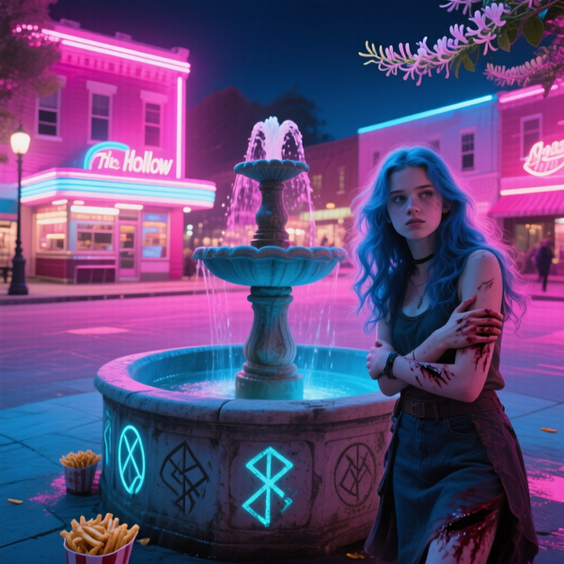**Billie and Max stumbled to the old fountain at the square’s heart**

“You stole my power,” the figure rasped, its claws slashing the air, its whispers a deafening wail. Billie’s resourcefulness surged, and she grabbed the charm from Max, her impulsive streak driving her forward. “Time to end this, ghost,” she snapped, sprinting to the fountain, dodging a claw that grazed her shoulder, blood trickling anew. She pressed the charm into the moon slot, her fingers trembling as the runes clicked, the fountain flaring green.

A gust of wind erupted, swallowing the figure’s wail, its form dissolving into mist as the charm melted into the stone, its glow fading. The fountain’s water stilled, the whispers silenced, the curse broken. Billie staggered back, her breath ragged, her adventurous spirit triumphant. Max clutched Sparky, his relief flooding. “You’re insane, Billie,” he said, his voice warm, a grin breaking through. “But you saved us.”

Billie grinned, her sarcasm sharp. “Insane’s my brand, Max. Billie Baloney, curse-buster.” The square filled with teens, drawn by the fountain’s glow, their whispers turning to cheers as they crowded around, phones snapping pics of Billie’s dirt-streaked triumph. Her heart swelled, her empathy anchoring her to Max, Sparky, and Moth Hollow, her first mystery solved.

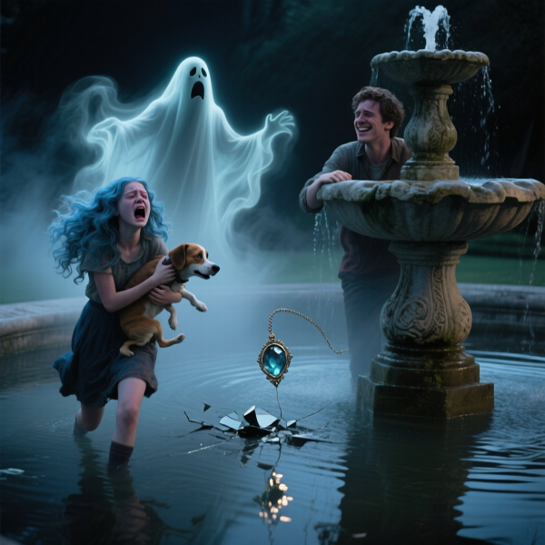**ghost figure’s wail, its form dissolving into mist as the charm melted into the stone**

The night sky sparkled, the neon lights casting a warm glow over the town. The fountain’s symbols dimmed, but a faint whisper lingered, hinting at more mysteries—mothmen, haunted vaults, and adventures to come. Billie’s journey had begun, a hero forged in neon and starlight, ready to tackle whatever Moth Hollow threw her way.

*Join Billie Baloney’s Adventures! On her epic mysteries of magic and horror by purchasing some of her books at BillieBaloney.com*