Trick & Treat
A Halloween-themed Roll-and-Write Puzzle Game

Components (print-and-play digital files)
- Map Sheets. Three neighborhoods to choose from: Creepy Cove, Brambleton Grove, and Rookery Row. Each neighborhood includes a unique backstory and its own Cauldron Column Bonus. Some maps introduce new drawing rules or restrictions.
- Cauldron Bonus Sheet. Each player will use a Cauldron Bonus Sheet to track cauldron bonuses and final scoring.
- Dice Result Sheet. If you use standard six-sided dice instead of making your own custom dice, use this sheet to determine the symbol/shape for each die that is rolled.
- Dice Cutout Sheet. If you wish to make your own custom dice, you can cut out the symbols and affix them to dice.
Ink-friendly versions of the Map Sheets and Cauldron Bonus Sheets are also provided.
Required Components
- Something for each player to write or draw with

Setup
- Choose a Map — All players will use the same map for the game.
- Distribute Sheets — Give each player one Map Sheet and one Cauldron Bonus Sheet. Give each player something to write with.
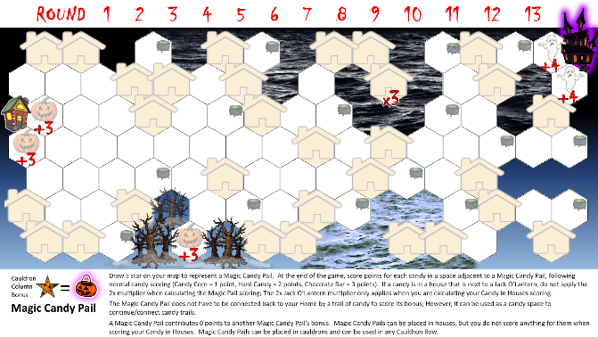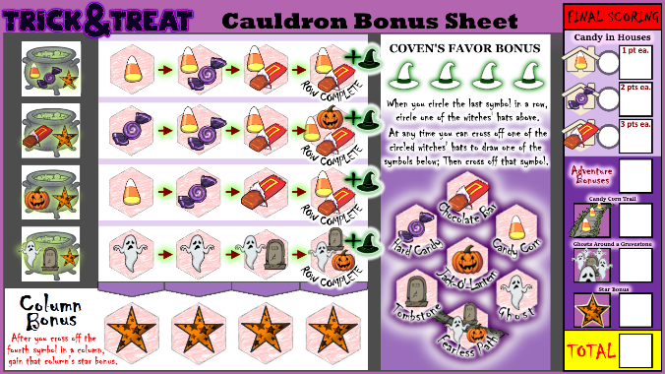
Map Sheet Cauldron Bonus Sheet
- Place the dice within reach of those brave enough to roll them.

Gameplay Overview
The game is played over 13 rounds. Each round, players use the same dice results but draw independently on their own maps.

Round Sequence
1. Roll Dice
Any player rolls all four dice.
- The three Symbol Dice show which symbols (Tricks or Treats) will be drawn this round.
- The Shape Die shows the formation in which those symbols must be drawn.
2. Draw Symbols
Draw all three rolled symbols into hexes according to the shape indicated on the shape die.
Shape Rules:
- Straight. Draw the three symbols into adjacent hexes, in a straight line.
- Curved. Draw the three symbols into adjacent hexes, in a curved line.
- Cluster. Draw the three symbols into a cluster of adjacent hexes (each hex touches each other).
- Fractured shapes. Draw two separate “shapes”, in any order:
    - One shape consists of two adjacent hexes.
    - The other “shape” consists of one hex the other symbol
  - The two shapes can touch each other.
  - You cannot use a bonus after drawing the first of the fractured shapes; you can only use a bonus before drawing any of the fractured shapes or after drawing both of the fractured shapes.
Drawing Rules:
- Each symbol you draw must be drawn in a space adjacent to your Home space or adjacent to a symbol you’ve already drawn on your map.
- You cannot draw on:
  - Your Home space
  - A space already containing a symbol
  - A House space (for Trick symbols only)
- If you can legally draw the rolled shape, you must.
- If you cannot legally draw a rolled shape:
  - Draw any one of the three symbols, following standard adjacency rules (must touch another symbol you’ve placed).
[Diagram suggestion: show examples of each shape type and legal/illegal placements.]

3. Resolve Cauldron Bonuses
If you drew a symbol on a map hex with a Cauldron icon, you earn a Cauldron Bonus which allows you to draw another symbol onto your map for that round.
On the Cauldron Bonus Sheet, there are four rows in the Column Bonus grid. The symbol or symbols shown on the cauldron at the beginning of each row corresponds to whichever symbol you drew on the cauldron space on the map.
Circle the next uncircled bonus in the corresponding row on your Cauldron Bonus Sheet.
- It might be possible to gain two Cauldron Bonuses when drawing one shape (or fractured shapes)
Cross off one circled Cauldron Bonus and draw a symbol on your map sheet
- Some cauldron bonuses show more than one symbol—choose one to use.
- If you draw a bonus symbol on your map in a space with a cauldron symbol, you gain another cauldron bonus (circle the next uncircled bonus in the corresponding row on your Cauldron Bonus Sheet).
You must use all Cauldron Bonuses that you gain in a round before the end of that round.
Column Bonus (Star)
When you circle the fourth Cauldron Bonus in a column, immediately gain the Column Star Bonus.
The map you play with determines how the Star Bonuses function. Refer to your map sheet for instructions on how its Star Bonuses work.
- For Creepy Cove, you immediately draw a star onto your map that will score points based on the candy that is adjacent to that star.
- For Brambleton Grove, you gain a Sacral Sickle to use at any time which allows you to ignore brambles which restricts where you can draw your shapes.
- For Rookery Row, you gain the ability to draw tricks in houses and the ability to draw treats in spooky spaces.
Row Bonus (Coven’s Favor)
After you circle the last cauldron bonus in a row, gain a Coven’s Favor Bonus.
- Circle one of the four witches’ hats. You can use a Coven’s Favor Bonus at any time (except in between drawing two fractured shapes).
- When you want to use a Coven’s Favor Bonus, cross off one of the witches’ hats you had previously circled and choose a favor:
  - The Trick symbols and the Treat symbols allow you to draw a symbol on your map (Candy Corn, Hard Candy, Chocolate Bar, Jack-O’-Lantern, Ghost, Tombstone).
  - The Fearless Path is a special ability that lets you continue a candy trail through one space containing a Trick. Just draw a line through that map space with a Trick in it to connect candy spaces through it. You still would score for the Trick space as normal.
- Cross off the Coven’s Favor Bonus that you have chosen. If you gain another Coven’s Favor, you will not be able to choose the same type of favor since you’ve crossed it off.
Coven’s Favor Bonuses can be used any time, including in future rounds or even after the final round.
[Diagram suggestion: show Cauldron Bonus Sheet, highlighting rows (Coven’s Favor), columns (Stars), and bonuses.]

5. End of Round
Cross off the current round number from the Round Tracker at the top of your Map Sheet.
6. End of Game
- After the 13th round, players may use any remaining Coven’s Favor Bonuses.
- Proceed to Final Scoring.
- The player with the most points wins.
- Tiebreakers:
  - Most points from candy in Houses.
  - If still tied, players share the victory.

Final Scoring
Use the Final Scoring section of your Cauldron Bonus Sheet.
1. Candy in Houses
Score candy in Houses only if they are connected to your Home by a continuous trail of candy.
- Candy Corn = 1 point each
- Hard Candy = 2 points each
- Chocolate Bar = 3 points each
- If a House with candy is adjacent to at least one Jack-o’-Lantern, count that candy as 2 of that candy instead of 1.
Record the count for each candy type in the circle, then multiply by its value.

2. Adventure Bonuses
Add up the point values of all Adventure Bonuses you visited.
- Some require specific symbols to be drawn in their spaces to score.

3. Candy Corn Trail
Score 2 points for each Candy Corn in your longest contiguous trail of Candy Corn.
- You may trace the trail through each space only once.

4. Ghosts in the Graveyards
For each Tombstone, score 2 points for every adjacent Ghost.

5. Star Bonus
Score each Star as described on your Map Sheet.
- Creepy Cove Scoring:
  - +1 point for each Candy Corn adjacent to a Star
  - +2 points for each Hard Candy adjacent to a Star
  - +3 points for each Chocolate Bar adjacent to a Star

6. Special Star Symbol Rules (Creepy Cove)
If you draw a Star on your Map Sheet:
- It can be placed in a hex with a Cauldron and used in any row.
- It counts as candy for connecting candy in Houses back to your Home.
- It does not count as:
  - A candy in a House
  - A Candy Corn for Candy Corn Trail scoring
  - A candy piece when scoring the Star Bonus of an adjacent Star

Winning the Game
The player with the highest total score wins!
If tied, the player with the highest candy-in-house score wins. If still tied, players share the victory.

[Diagram suggestions for scoring section:]
- Example of a connected candy trail scoring to Home
- Example of Jack-o’-lantern doubling a house’s candy
- Example of Ghosts adjacent to Gravestones
- Example of Star adjacency scoring

Would you like me to take this version and reformat it into a professionally styled rulebook layout draft—for example, something you could hand to a graphic designer or include in a prototype PDF (with section headers, page flow, and suggested diagram callouts like “Page 2: Shapes Illustration”)?

