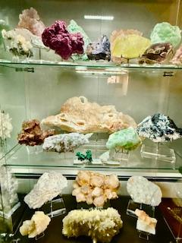

Natural crystals are those that form without human intervention, emerging from geological processes over vast periods. Each crystal carries a story of the environment from which it originated—be it intense heat from volcanic activity or the slow, pooling waters of sedimentary basins. Collectively, they showcase the incredible diversity of Earth’s crust.

* **Formation Conditions**: They often reflect the temperature, pressure, and chemical conditions present at their time of formation.
* **Unique Features**: Natural crystals are often characterized by distinct inclusions, defects, or growth patterns, which can provide clues about their geological history.
* **Aesthetic Qualities**: Many collectors are drawn to the stunning visual properties of natural crystals, with colors and patterns that are often uniquely beautiful. The formation of natural crystals relies heavily on geological processes such as cooling magma or the evaporation of water, leading to the crystallization of minerals. This process can take millions of years, which contributes to the rarity and value of certain specimens among collectors. Natural crystals hold intrinsic values, such as their use in jewelry or decoration, and also exhibit properties that can be harnessed in technology and industry. They are more than just beautiful objects; they represent the interconnectedness of geological processes and human culture.