API Specification for Fluentstock and Shopify Integration

1. **Customer Facing Part**

This document outlines the technical steps necessary to establish a data link between Fluentstock and Shopify for seamless integration.

1. **Creating Shopify credentials**

To allow Fluentstock access to Shopify data, create an Admin API access token, API key, and secret key within Shopify by following these steps:

1. **User Setup**: Create a user in Shopify with admin access to the "Apps and sales channels" module. Designate this user as your developer. Once set up, inform your developer.
2. **Developer Steps**:
   * Log in to the Shopify account with the credentials provided.
   * Navigate to **Settings > Apps and Sales Channels**, and select **Develop Apps** in the upper right corner.

Image „Develop Apps“

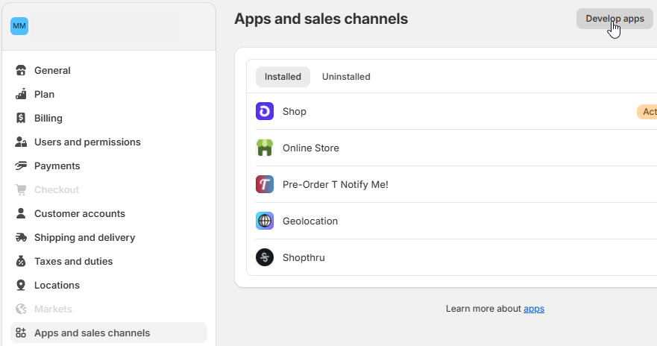

1. **App Creation**:
   * Click **Create an App** and enter the app name as **Fluentstock**, selecting the developer account created.
2. **Define API Scopes**:
   * Click **Configure Admin API Scopes** and assign the following scopes:

* read_products
* read_inventory
* write_inventory
* read_locations

Image „Configure API Scopes“

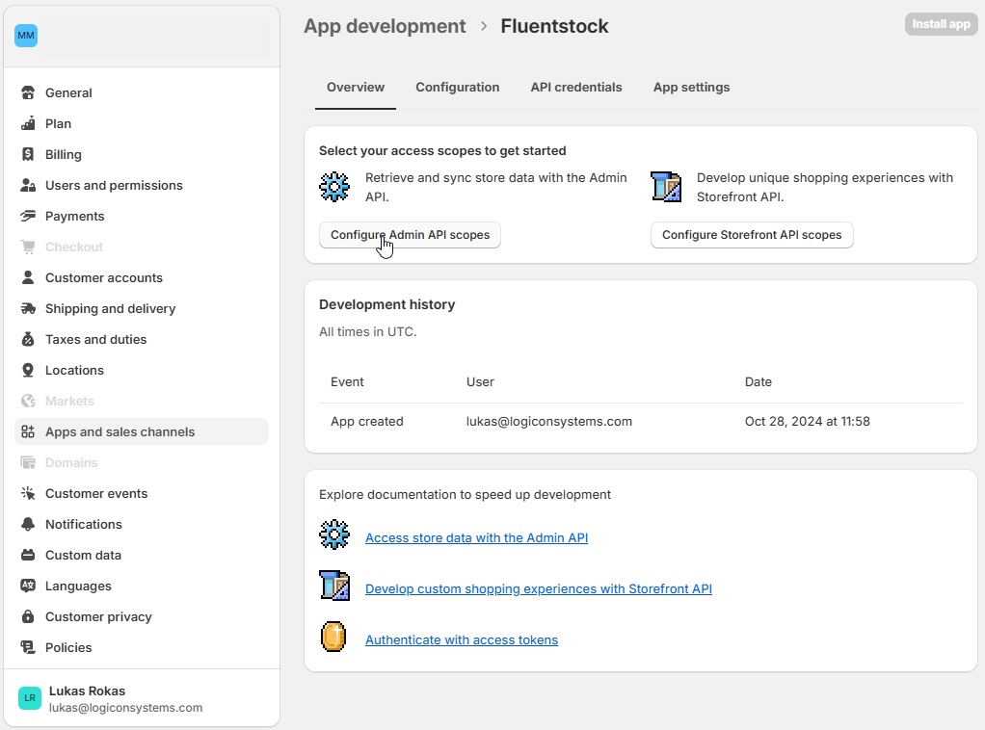

1. After configuring the scopes, click **Save** in the upper right corner to ensure Fluentstock has access to the required Shopify resources.
2. **Install the App** and **Reveal** and copy the Admin API access token, API Key, and API Secret Key.

Image „API access token“

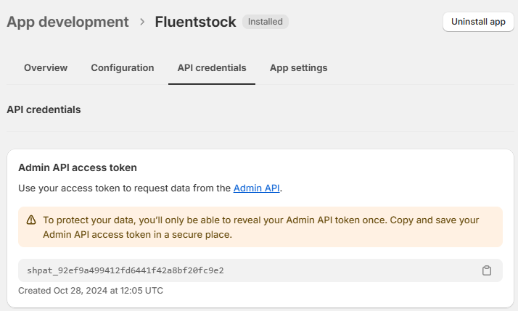

1. **Entering Shopify API Credentials in Fluentstock**
2. Log in to your Fluentstock account and navigate to your profile icon in the upper right corner.
3. Perform the following steps:

* Create an integration and select **Shopify**.
* Enter your Shopify domain name (e.g., for xyz.myshopify.com, enter only "xyz").
* Enter the Admin API access token and click **Verify**.

1. Once your credentials are verified, you will see a green checkmark indicator.
2. **Initial information synchronization**

Once your Shopify connection is set up in the integration settings, you will see an **"Initial Data Sync"** button. Clicking this button will allow Fluentstock to automatically retrieve and sync data from your Shopify store in the following order:

1. **Locations & Warehouses:** Fluentstock will import all locations from Shopify and create warehouses with the same names. The Shopify location ID will be used as the warehouse code in Fluentstock.
2. **Suppliers:** Fluentstock will retrieve vendor names for all stock items in Shopify and create corresponding suppliers in Fluentstock.
3. **Products & Variants:** Fluentstock will import all products and their variants from Shopify and create them in Fluentstock.

| **Synced Data** | **Field** | **Mandatory/**  **Optional** |
| --- | --- | --- |
| Product | SKU Name | Mandatory |
|  | SKU Code | Mandatory |
|  | Dimensions | Optional |
|  | Weight | Optional |
|  | Manufacturer | Mandatory |
| Product Variant | SKU Code | Mandatory |
|  | Warehouse | Mandatory |
|  | Supplier | Mandatory |
|  | Sale Price | Optional |
|  | Purchase Price | Optional |

1. **Stock Quantities:** Fluentstock will sync inventory levels for all product variants across all active and available warehouses based on Shopify data.
2. **Sync Report:** After synchronization, Fluentstock will generate a report summarizing the results of the data sync, which will indicate the number of warehouses, suppliers, and SKUs synced.

Image „Sync Report“

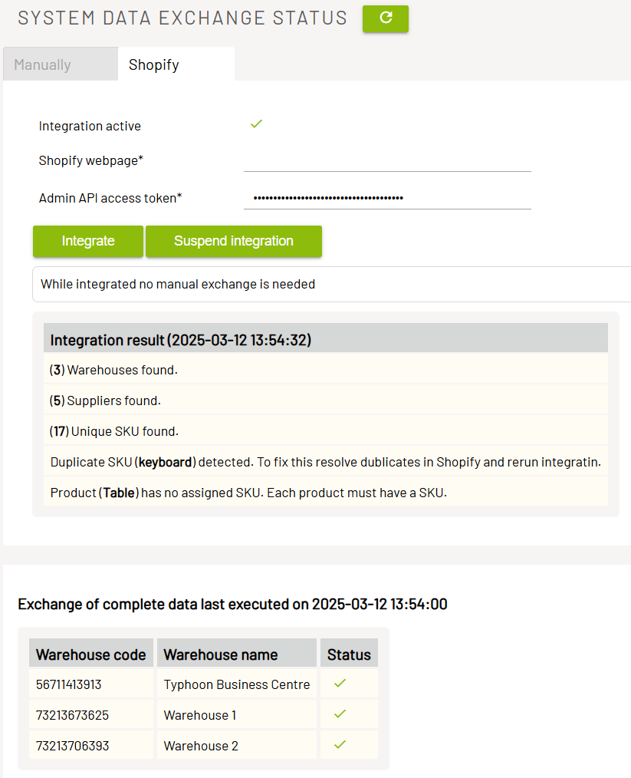

**Possible Error Messages in the Report**

| **Error** | **Message** |
| --- | --- |
| Missing SKU Code | Product(s) “XYZ”, “ABC” (or their variants) could not be created because the required field SKU Code is missing. |
| Duplicate SKU Codes | Product(s) “XYZ”, “ABC” (or their variants) could not be created because of their duplicate SKU codes. |

To correct these mistakes, please follow these steps in Shopify:

1. Navigate to the **Inventory** menu item.
2. Click the **"Search & Filter"** button in the upper right-hand corner.
3. Enter the duplicate SKU provided in the FluentStock report.

Products with the same SKU will appear in the list. Navigate to the product card of one of those items and update the SKU accordingly.

To fill in the SKU for an item that does not have one:

1. Use the same **Search & Filter** function.
2. Enter the product name provided in the FluentStock report.
3. Open the product card and fill in the SKU.

Once these corrections are complete, click **Integrate** when you're ready. The **Integrate** function will process all previously failed products.

Image „Shopify Inventory“

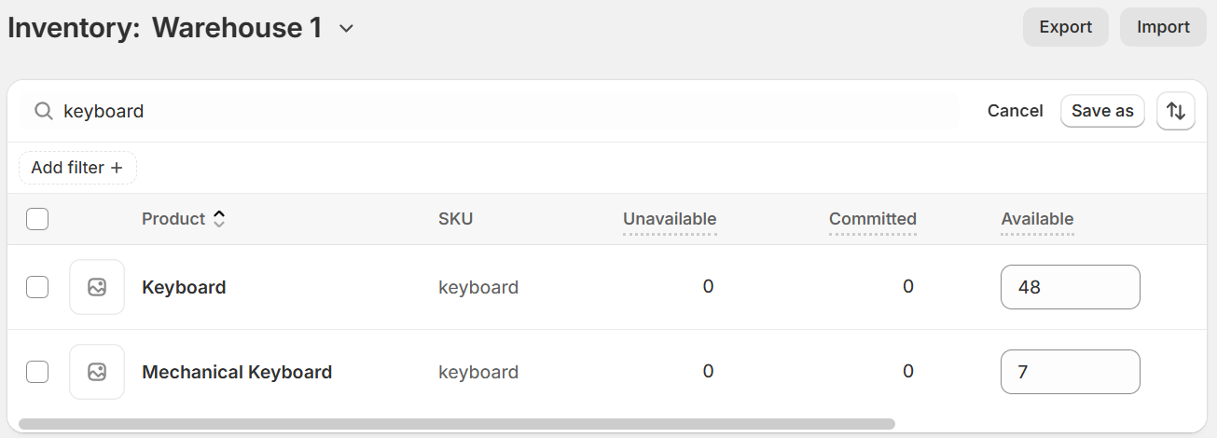

In some cases, your shop may contain many products for which you never needed to fill in SKUs. If this applies to you, follow these steps to efficiently update multiple SKUs at once:

1. Navigate to the **Products** page in Shopify.
2. Export all or selected items from your **Products** page.
3. Shopify will send a template file to your email address.
4. Open the template and fill in the missing SKUs.
5. Once completed, import the updated template back into Shopify.

This method is faster and more efficient when you need to add multiple SKU codes at once.

**Important Note:**

Some plugins installed in your Shopify account may have created "fictional" products to support their functionality. These are often related to shipping plugins or other integrations.

In such cases, you do not need to modify these items by adding SKU codes.

These fictional products can typically be identified by the absence of key details such as product images, descriptions, prices, and other information.

1. **How Shopify and Fluentstock work together**

After the initial sync completes, Shopify and FluentStock automatically exchange data – no extra steps required. These updates might include changes to product names, prices, or stock levels.

**Important Note:**When you try to change the existing SKU code for a product or variant in Shopify, FluentStock will check if the new SKU code already exists:

* **If the new SKU code does *not* exist:** FluentStock will update the item with the new SKU code.
* **If the new SKU code *does* exist**: The change will *not* occur, and you will see an error notification on the initial sync report.

FluentStock instantly reacts to any inventory fluctuations – whether from sales, recounts, or other triggers – ensuring your buffer calculations remain accurate. It will place purchase orders automatically, so you never have to worry about running out of stock again.

Whenever FluentStock automatically places a purchase order or you create one manually, it will appear as “incoming quantity” in your Shopify inventory screen or product card once the purchase order status is set to **“On the way.”**

Image „Incoming Stock – Product Card“

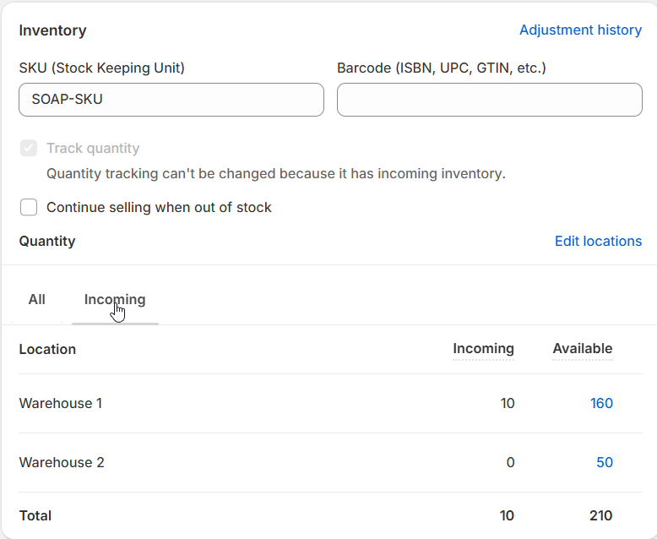

Image „Inventory Screen“

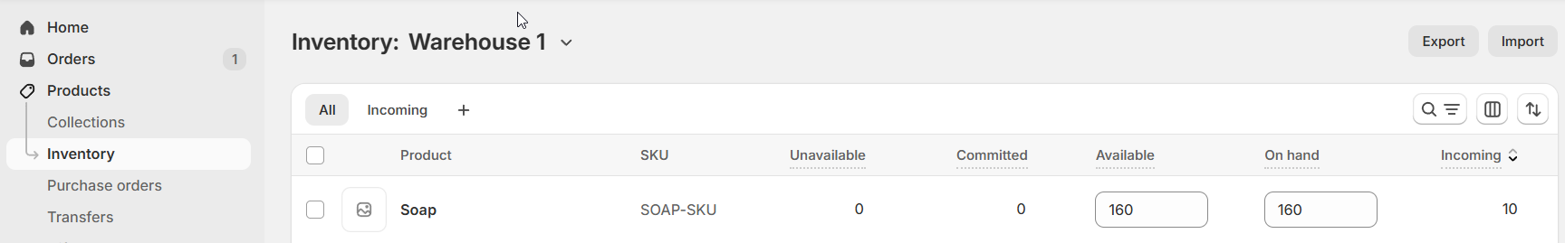

Once the purchase order is completed and recorded in FluentStock, the incoming quantity automatically converts into available stock, ready to sell.

If you update an item’s stock quantity, add a new item, or remove one from the purchase order in FluentStock, these changes will appear in Shopify in real time.