API Specification for Fluentstock and Shopify Integration

**Customer Facing Part**

This document outlines the technical steps necessary to establish a data link between Fluentstock and Shopify for seamless integration.

**Creating Shopify credentials**

To allow Fluentstock access to Shopify data, create an Admin API access token, API key, and secret key within Shopify by following these steps:

1. **User Setup**: Create a user in Shopify with admin access to the "Apps and sales channels" module. Designate this user as your developer. Once set up, inform your developer.
2. **Developer Steps**:
   * Log in to the Shopify account with the credentials provided.
   * Navigate to **Settings > Apps and Sales Channels**, and select **Develop Apps** in the upper right corner.

Image „Develop Apps“

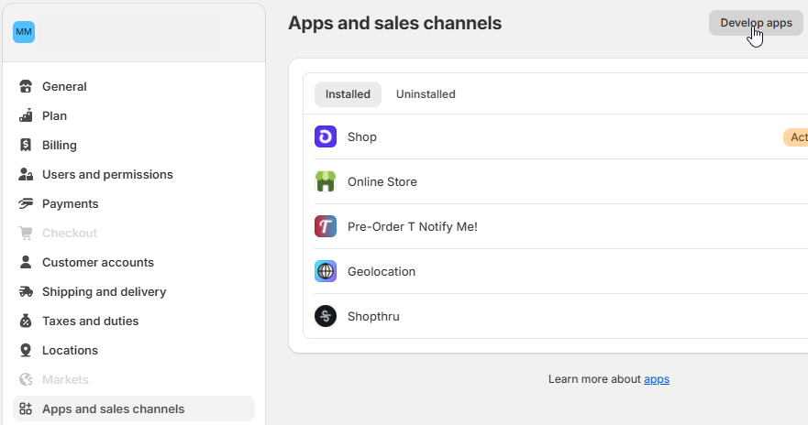

1. **App Creation**:
   * Click **Create an App** and enter the app name as **Fluentstock**, selecting the developer account created.
2. **Define API Scopes**:
   * Click **Configure Admin API Scopes** and assign the following scopes:

* read_inventory
* read_locations
* read_products
* read_assigned_fulfillment_orders
* write_assigned_fulfillment_orders

Image „Configure API Scopes“

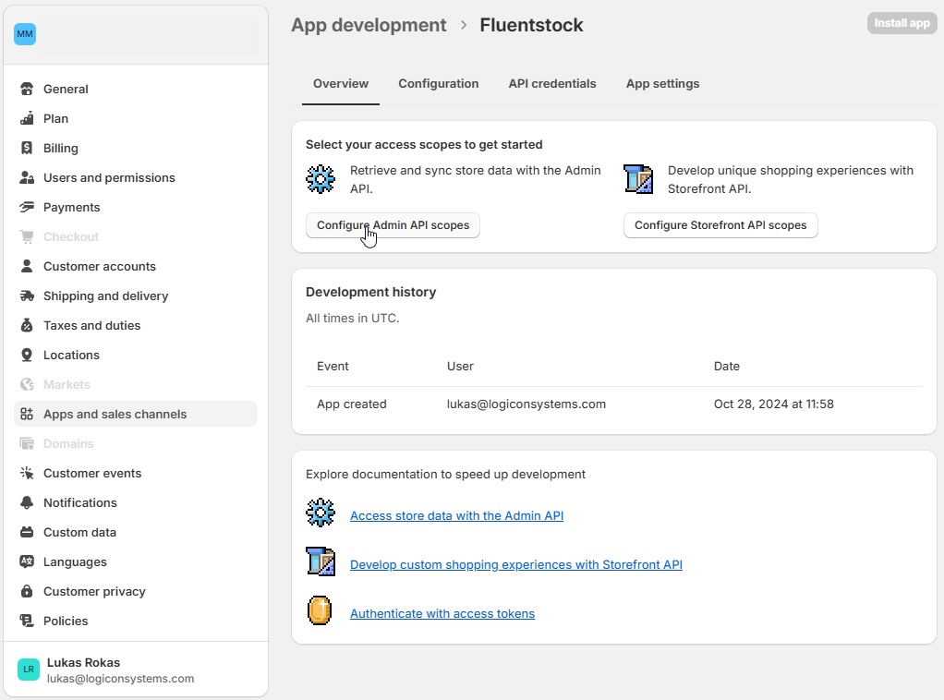

1. After configuring the scopes, click **Save** in the upper right corner to ensure Fluentstock has access to the required Shopify resources.
2. **Install the App** and **Reveal** and copy the Admin API access token, API Key, and API Secret Key.

Image „API access token“

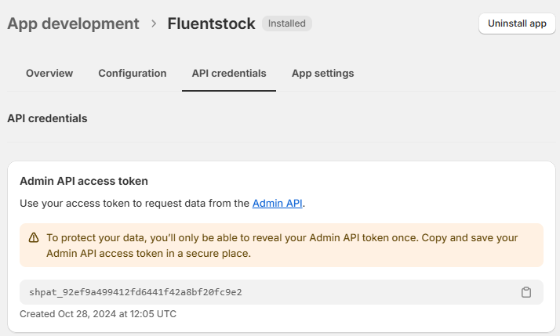

**Entering Shopify API Credentials in Fluentstock**

1. Log in to your Fluentstock account and navigate to your profile icon in the upper right corner.
2. Perform the following steps:

* Create an integration and select **Shopify**.
* Enter your Shopify domain name (e.g., for xyz.myshopify.com, enter only "xyz").
* Enter the Admin API access token and click **Verify**.

1. Once your credentials are verified, you will be prompted to select the location (warehouse) to synchronize with FluentStock.

Note: Depending on your subscription plan, you may synchronize multiple warehouses (for example, the Basic plan allows for one warehouse).

**Initial information syncronization**

Fluentstock will sync all products with their stock quantities from your Shopify account. You will be able to see them straightaway after adding Shopify credentials.

**Development Facing Part**

Below credentials to be used for testing purposes:

* Graph QL End-Point - <https://logiconsystems.myshopify.com/admin/api/2025-01/graphql.json>
* Shop URL - <https://logiconsystems.myshopify.com/>
* API key - c08049c9c49bd0c7af58860bec562052
* API secret key - 553ed87ae472a8974c5499cf7519e86d
* Admin API access token - 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

**API Initialization**

* Client libraries - <https://shopify.dev/docs/api/admin-graphql>
* Authentication details - <https://shopify.dev/docs/apps/build/authentication-authorization/access-tokens/generate-app-access-tokens-admin>
* Get available locations (for customer to select warehouse and map it to FluentStock warehouse) - <https://shopify.dev/docs/api/admin-graphql/2025-01/queries/locations?example=Retrieve+a+list+of+locations>
* Get a list of products - <https://shopify.dev/docs/api/admin-graphql/2025-01/queries/products>

**Setting Up Webhooks**

* Subscribing to topics as a custom app - <https://shopify.dev/docs/apps/build/webhooks/subscribe>
* Create webhook subscription –

<https://shopify.dev/docs/apps/build/webhooks/subscribe/subscribe-using-api>

* Webhook security and occasional bursts - <https://shopify.dev/docs/apps/build/webhooks/subscribe/https>
* Available webhook subsriptions with sample payloads –

<https://shopify.dev/docs/api/webhooks?reference=toml>

Webhook subscriptions which we will need to impliment:

* + products/create
  + products/update
  + products/delete
  + inventory_items/create
  + inventory_items/update
  + inventory_items/delete
  + fulfillments/update

**Example Queries**

Retrieve product variants with their warehouse locations and quantities

* POST URL - <https://logiconsystems.myshopify.com/admin/api/2025-01/graphql.json>
* Headers:
  + Content-Type / application/json
  + X-Shopify-Access-Token / 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
* JSON Request:

{

"query": "query InventoryLevels { productVariants(first: 10) { edges { node { id displayName inventoryItem { sku inventoryLevels(first: 10) { nodes { location { id name } quantities(names: \"available\") { quantity name } } } } } } } }"

}

**Mapping Shopify and Fluentstock SKU parameters**

The table below details how Shopify parameters map to Fluentstock parameters to ensure accurate data synchronization.

Combined table for mapped parameters from both Shopify List Products and Inventory Levels endpoints to FluentStock, with JSON paths and designated endpoints.

**Mapped Parameters from Shopify to FluentStock**

| **Mapped Parameters** | **Shopify JSON Path** | **Shopify Endpoint** | **FluentStock Endpoint(s)** | **FluentStock Parameter** |
| --- | --- | --- | --- | --- |
| **SKU Data** |  |  |  |  |
| UserID |  |  |  |  |
| Warehouse | location_id | Inventory Levels | SKU Data, SKU Body | Warehouse |
| SKU | variants[0].sku | List Products | SKU Data, SKU Header,  SKU Body | sku_code |
| Name | title | List Products | SKU Data, SKU Header | sku_name |
| Supplier Code | tags | List Products | SKU Data, SKU Header | SupplierCode |
| MOQ |  | List Products | SKU Data, SKU Body | MOQ |
| USQ |  |  |  |  |
| Weight | variants[0].weight | List Products | SKU Data, SKU Header | Measure1 |
| UnitOfMeasure | variants[0].weight_unit | List Products | SKU Data, SKU Header | UnitOfMeasure |
| PurchasePrice |  |  |  |  |
| Price | variants[0].price | List Products | SKU Data, SKU Body | SalePrice |
| DisplayBuffer |  |  |  |  |
| Group | vendor | List Products | SKU Data, SKU Header | group_name |
| ASS |  |  |  |  |
| SupplierSKU |  |  |  |  |
| SupplierSKU_Name |  |  |  |  |
| SplitMark |  |  |  |  |
| Buffer |  |  |  |  |
| Manufacturer | vendor |  | SKU Data, SKU Header | Manufacturer |
| SKU Validity | status | List Products | SKU Data, SKU Header | SKU_Validity |
| Extra1 - Extra10 | tags | List Products | SKU Data, SKU Header | extra_1 - extra_10 |
| Sale Price | variants[0].compare_at_price | List Products | SKU Data, SKU Body | PurchasePrice |
| **SKU Header** |  |  |  |  |
| Group | vendor | List Products | SKU Header | group_name |
| Name | title | List Products | SKU Header | sku_name |
| Extra1 - Extra10 | tags | List Products | SKU Header | extra_1 - extra_10 |
| Measure1 | variants[0].weight | List Products | SKU Header | Measure1 |
| UnitOfMeasure | variants[0].weight_unit | List Products | SKU Header | UnitOfMeasure |
| Measure2 | (Not provided in Shopify response) |  | SKU Header | Measure2 |
| FamilyGroupID | (Not provided in Shopify response) |  | SKU Header | FamilyGroupID |
| SKU Validity | status | List Products | SKU Header | SKU_Validity |
| Manufacturer | (Not provided in Shopify response) |  | SKU Header | Manufacturer |
| **SKU Body** |  |  |  |  |
| Available Quantity | available | Inventory Levels | SKU Body | MOQ |
| Warehouse | location_id | Inventory Levels | SKU Body | Warehouse |
| ASS (Activity Status) | (Not provided in Shopify response) |  | SKU Body | ASS |
| Supplier Code | (Not provided in Shopify response) |  | SKU Body | SupplierCode |
| Purchase Price | variants[0].compare_at_price | List Products | SKU Body | PurchasePrice |
| Sale Price | variants[0].price | List Products | SKU Body | SalePrice |
| DisplayBuffer | (Not provided in Shopify response) |  | SKU Body | DisplayBuffer |
| Wextra1 - Wextra7 | (Not provided in Shopify response) |  | SKU Body | Wextra1 - Wextra7 |
| SplitMark | (Not provided in Shopify response) |  | SKU Body | SplitMark |
| Buffer | (Not provided in Shopify response) |  | SKU Body | Buffer |

**Unmapped Parameters from Shopify List Products and Inventory Levels Endpoints**

| **Unmapped Parameters** | **Shopify JSON Path** | **Shopify Endpoint** |
| --- | --- | --- |
| Images | images | List Products |
| Created Date | created_at | List Products |
| Updated Date | updated_at | List Products, Inventory Levels |
| Product Options | options | List Products |
| Published Date | published_at | List Products |
| Product Type | product_type | List Products |
| Body HTML | body_html | List Products |
| Inventory Management | variants[0].inventory_management | List Products |
| Inventory Policy | variants[0].inventory_policy | List Products |
| Fulfillment Service | variants[0].fulfillment_service | List Products |
| Barcode | variants[0].barcode | List Products |
| Template Suffix | template_suffix | List Products |
| Published Scope | published_scope | List Products |
| Admin GraphQL API ID | admin_graphql_api_id | List Products |
| Position | variants[0].position | List Products |
| Requires Shipping | variants[0].requires_shipping | List Products |
| Taxable | variants[0].taxable | List Products |
| Presentment Prices | variants[0].presentment_prices | List Products |
| Option1, Option2, Option3 | variants[0].option1 | List Products |
| Inventory Item ID | variants[0].inventory_item_id | List Products |
| Old Inventory Quantity | variants[0].old_inventory_quantity | List Products |
| Title (for Variant) | variants[0].title | List Products |

**Products JSON response from Shopify**

[

{

"tags": [],

"images": [],

"id": 8249392890009,

"title": "Test",

"body_html": "",

"vendor": "logiconsystems",

"product_type": "",

"created_at": "2024-10-25T09:54:23.000Z",

"handle": "test",

"updated_at": "2024-10-28T14:27:27.000Z",

"published_at": "2024-10-25T09:54:23.000Z",

"template_suffix": "",

"published_scope": "web",

"status": "active",

"admin_graphql_api_id": "gid://shopify/Product/8249392890009",

"options": [

{

"id": 10440957264025,

"product_id": 8249392890009,

"name": "Title",

"position": 1,

"values": [

"Default Title"

]

}

],

"variants": [

{

"barcode": "",

"compare_at_price": null,

"created_at": "2024-10-25T09:54:24.000Z",

"fulfillment_service": "manual",

"grams": 200,

"id": 44917303115929,

"image_id": null,

"inventory_item_id": 47019060527257,

"inventory_management": "shopify",

"inventory_policy": "deny",

"inventory_quantity": 30,

"old_inventory_quantity": 30,

"option1": "Default Title",

"option2": null,

"option3": null,

"position": 2,

"presentment_prices": [

{

"price": {

"amount": "20.00",

"currency_code": "GBP"

},

"compare_at_price": null

}

],

"price": "20.00",

"product_id": 8249392890009,

"requires_shipping": true,

"sku": "SKU1",

"taxable": true,

"title": "Default Title",

"updated_at": "2024-10-28T14:27:27.000Z",

"weight": 200,

"weight_unit": "g"

}

],

"__IMTLENGTH__": 1,

"__IMTINDEX__": 1

}

]