17/01/2024
Compte rendu Mission 2- Semestre 2 SISR
Equipe 4

Mathis SZYDA – Anthony CLAIRET – Aurélien GRAPY
Lycée SUZANNE VALADON

Mission 2 :
Cahier des charges :
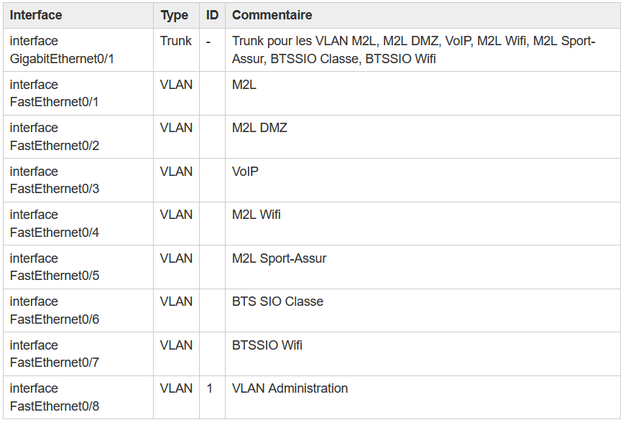

Configuration du switch :

!
! Last configuration change at 11:47:30 UTC Wed Feb 14 2024
! NVRAM config last updated at 09:36:33 UTC Wed Feb 14 2024
!
version 12.2
no service pad
service timestamps debug datetime msec
service timestamps log datetime msec
service password-encryption
!
hostname B513-Cisco2960-04
!
boot-start-marker
boot-end-marker
!
enable secret 5 $1$f1q8$yWcx6PFTvtFTfLVzoCEf2/
enable password 7 106C1D5D41561D
!
username btssio password 7 01111217480209
no aaa new-model
system mtu routing 1500
!
!
ip domain-name 0870019y.lan
!
!
!
!
!
!
spanning-tree mode pvst
spanning-tree extend system-id
!
vlan internal allocation policy ascending
!
ip ssh time-out 50
ip ssh authentication-retries 5
ip ssh version 2
!
!
!
!
interface FastEthernet0/1
switchport access vlan 301
switchport mode access
!
interface FastEthernet0/2
switchport access vlan 317
switchport mode access
!
interface FastEthernet0/3
switchport access vlan 314
switchport mode access
!
interface FastEthernet0/4
switchport access vlan 318
switchport mode access
!
interface FastEthernet0/5
switchport access vlan 319
switchport mode access
!
interface FastEthernet0/6
switchport access vlan 352
switchport mode access
!
interface FastEthernet0/7
switchport access vlan 134
switchport mode access
!
interface FastEthernet0/8
switchport access vlan 2
switchport mode access
!
interface GigabitEthernet0/1
switchport mode trunk
!
interface Vlan1
no ip address
no ip route-cache
!
interface Vlan2
no ip address
no ip route-cache
!
interface Vlan134
ip address 10.187.35.24 255.255.255.0
no ip route-cache
!
interface Vlan301
ip address 192.168.228.24 255.255.255.192
no ip route-cache
!
interface Vlan352
ip address 10.187.37.24 255.255.255.0
no ip route-cache
!
ip http server
ip http secure-server
logging esm config
banner motd Access autorise pour les etudiants et enseignants du BTS SIO seulement !
!
line con 0
password 7 1427324F481325392079
login
line vty 0 4
password 7 04591F151C2843
logging synchronous
login local
transport input ssh
line vty 5 15
login
!
end

Explication :
Configuration initiale d’un commutateur Cisco 2960 :
étape :
- Définir le nom du commutateur
- Sécuriser l'accès à la ligne console
- Sécuriser l'accès au mode privilégié.
- Configurez un mot de passe chiffré pour sécuriser l'accès au mode privilégié.
- Configurer une bannière MOTD (message of the day).
- Enregistrer les fichiers de configuration dans la mémoire NVRAM
- Configuration de l'accès à distance
- Configuration d'un accès distant avec SSH
Le code des étapes ci-dessus est le suivant :
!
! Last configuration change at 11:47:30 UTC Wed Feb 14 2024
! NVRAM config last updated at 09:36:33 UTC Wed Feb 14 2024
!
version 12.2
no service pad
service timestamps debug datetime msec
service timestamps log datetime msec
service password-encryption
!
hostname B513-Cisco2960-04
!
boot-start-marker
boot-end-marker
!
enable secret 5 $1$f1q8$yWcx6PFTvtFTfLVzoCEf2/
enable password 7 106C1D5D41561D
!
username btssio password 7 01111217480209
no aaa new-model
system mtu routing 1500
!
!
ip domain-name 0870019y.lan
!
!
!
!
!
!
spanning-tree mode pvst
spanning-tree extend system-id
!
vlan internal allocation policy ascending
!
ip ssh time-out 50
ip ssh authentication-retries 5
ip ssh version 2
!
!
!
!

Configuration des ports et des Vlans :
interface FastEthernet0/1
switchport access vlan 301
switchport mode access
!
interface FastEthernet0/2
switchport access vlan 317
switchport mode access
!
interface FastEthernet0/3
switchport access vlan 314
switchport mode access
!
interface FastEthernet0/4
switchport access vlan 318
switchport mode access
!
interface FastEthernet0/5
switchport access vlan 319
switchport mode access
!
interface FastEthernet0/6
switchport access vlan 352
switchport mode access
!
interface FastEthernet0/7
switchport access vlan 134
switchport mode access
!
interface FastEthernet0/8
switchport access vlan 2
switchport mode access
!
interface GigabitEthernet0/1
switchport mode trunk
!
interface Vlan1
no ip address
no ip route-cache
!
interface Vlan2
no ip address
no ip route-cache
!
interface Vlan134
ip address 10.187.35.24 255.255.255.0
no ip route-cache
!
interface Vlan301
ip address 192.168.228.24 255.255.255.192
no ip route-cache
!
interface Vlan352
ip address 10.187.37.24 255.255.255.0
no ip route-cache
!
ip http server
ip http secure-server
logging esm config
banner motd Access autorise pour les etudiants et enseignants du BTS SIO seulement !
!
line con 0
password 7 1427324F481325392079
login
line vty 0 4
password 7 04591F151C2843
logging synchronous
login local
transport input ssh
line vty 5 15
login
!
end

