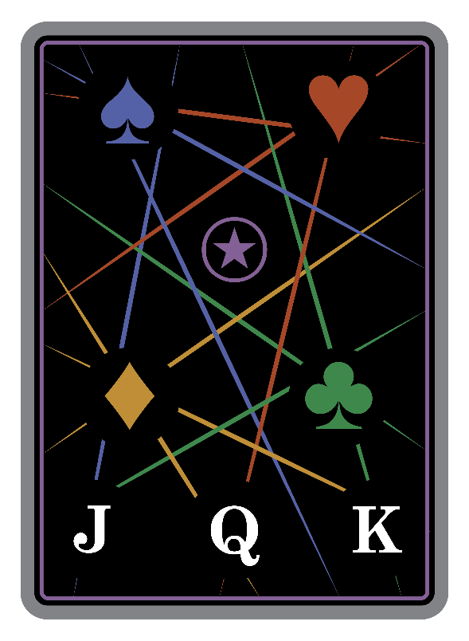

PRICE
OF
INFLUENCE

INTRODUCTION
Price of Influence is a competitive tactical strategy game for 2 players where rival courts test the true cost of power. Recruit Jacks, Queens, and Kings to your banner, arm them with steel and strategy, and manage limited resources to outmaneuver opponents amid shifting momentum and hidden information.
Victory is never singular. Dominate through battlefield strength, economic mastery, or a flawlessly timed tactical gambit. In the end, only one court’s influence will endure.
“Power weighs most on those who know its cost”

THE GAME IN ONE SENTENCE
Build a court of nobles, equip them for battle, and outmaneuver your opponent through combat, economics, or perfect strategy.

COMPONENT LIST
- 1 Teaching Deck & 1 Standard deck of playing cards (52 cards + 2 Jokers)
- 6 Reference / Turn Tracking Cards
- 24 Influence Tracking Coins
- 8 Base Play Tracking Coins

THE BIG PICTURE (30-Second Overview)
- Recruit nobles (Jacks, Queens, Kings) to your court
- Equip them with weapons (♠) and armor (♥)
- Send them to battle against opponent's nobles
- Manage resources with diamonds (♦) and tactics with clubs (♣)
- Win by: Dominating in battle, perfect equipment, or a flawless tactical play. All while managing your resources and not over-leveraging your hand.

SETUP (2 Players) - 2 Minutes
- Separate the deck:
  - Nobles pile (In-Council): All Jacks, Queens, and Kings (12 cards) - place face-down
  - Main deck: Everything else (Ace-10 of all suits + 2 Jokers) - place face-down
- Deal:
  - Shuffle main deck, deal 9 cards to each player
  - Shuffle nobles pile, deal 6 nobles to each player face-down
- Starting actions:
  - Look at your cards and nobles
  - Each player discards 2 cards from hand face-down
  - Reveal discards simultaneously (this forms the discard pile)
  - All future discards are face-up
  - Choose 1 noble to keep, return others face-down to In-Council pile
  - Place chosen noble face-down in READY(↕)(vertical) or REST(↔)(horizontal) Stace, READY Stance(↕) will have to fight on your turn.
  - Flip all nobles face-up (your noble and the In-Council pile)
Maximum Hand Size: 7 cards (including leveraged cards)

Use a fair method to determine who will start as Active Player
HOW TO PLAY - THE BASICS
Your Turn as Active Player Has 4 Simple Phases:
- COUNCIL → Recruit or manage nobles (costs tribute)
- PLAY CARDS → Take turns playing cards for effects
- COMBAT → Your READY Stance(↕) nobles must fight, REST Stance(↔) cannot.
- RESUPPLY → Draw cards and clean up
What Cards Do:
♠ Spades (Weapons) → Equip to nobles for +strength
♥ Hearts (Armor) → Equip to nobles for +strength
♦ Diamonds (Gems) → Resource Management – Save for card-draw and future Tribute Payment, or Spend to recover leveraged cards from hand
♣ Clubs (Tactics) → Steal cards from nearly anywhere
⍟ Jokers (Writs) → Wild cards (count as any suit)
Simple Combat, Active player makes all combat assignments:
- Compare strength (Noble rank + Equipment bonuses)
- Lower strength loses and is "disgraced" (removed from play)
- Ties: Higher rank noble loses
Multiple paths to Victory:
- OUTMANEUVERED – Recruit and properly equip a full court of nobles
- FLAWLESS STRATEGY – Leverage a perfect sequence of tactical options
- BROKEN COMMAND – suffer repeated losses on the battlefield
- ECONOMIC COLLAPSE – mismanagement of your resources
KEY CONCEPTS
Card Locations
- In-Hand: Cards in your hand (hidden unless leveraged)
- Leveraged: Face-up cards stuck in your hand as a penalty (count toward hand limit), track for defeat condition
- Gem Pile: Your personal pile of saved diamonds (face-up, public information)
- Equipped: weapon♠ / armor♥ attached to nobles
- In-Court: Your active nobles in play
- Disgraced: Defeated nobles (flipped face-down, out of play), track for defeat condition
- In-Council: The pile of unclaimed nobles (face-up, public)

Paying Tribute
Council actions cost "tribute" equal to the noble's rank (Jack=1, Queen=2, King=3).
Pay tribute using ANY combination of the following, each action counts as 1 payment:
- Liquidate: Move a diamond♦ from your gem pile to the discard pile
- Leverage: Flip a card in your hand face-up (becomes stuck as leveraged)
- Dismantle: Discard an equipped weapon♠ or armor♥ from your nobles
Tribute Payment Example
Jane wants to Recruit a Queen (Rank=2). She has 1 diamond♦ in her Gem Pile and 1 weapon♠ equipped to her Jack. She Liquidates the diamond♦ (moves to discard) and Dismantles the weapon♠ (moves to discard). Total Tribute paid: 2.
Suit INFLUENCE
Each noble in your court gives you influence in their suit equal to their rank:
- Jack = 1, Queen = 2, King = 3
What INFLUENCE does:
- Every turn you can play 1 card of each suit PLUS your influence in that suit
- Example: You have a Queen♠ (2 spade♠ INFLUENCE) & a Jack♣ (1 club♣ INFLUENCE), you can play a mix of the following: 3 spades♠, 2 clubs♣, 1 diamond♦, 1 heart♥
- Does NOT change the 4-card maximum per turn - only affects the mix of suits
- INFLUENCE increases the power of played card’s suit effects (weapons, armor, tactics, diamond spending)

DETAILED TURN STRUCTURE
Each turn is a set of 4 discrete phases, led by the Active Player. A phase is complete, and you move to the next once all required actions within that phase have been completed.
There are instances where you will move through a phase without taking actions, Combat for example will simply be skipped if all the Active Players Nobles are in REST Stance(↔).

Phase 1: Council (Active Player Only)
Must take at least 1 Action (can repeat or take multiple if you can pay the tribute):
RECRUIT NOBLE
- Select from In-Council pile
- Pay tribute = noble's rank
- Place In-Court in READY Stance(↕) or REST Stance(↔)
- Max 1 of each rank (Jack/Queen/King) in court
CHANGE STANCE
- Switch your In-Court noble between READY Stance(↕) & REST Stance(↔)
- Pay tribute = noble's rank
CHANGE SUIT
- Swap your In-Court noble with same-rank noble from In-Council
- Equipment transfers to new noble
- Pay tribute = noble's rank
- No set bonus triggered by this swap

Phase 2: Play Cards (Both Players)
- Players alternate playing one card at a time
- Active player plays first
- Cards resolve immediately when played
- Each player maximum: 4 cards total
- Suit limits: 1 card per suit + INFLUENCE from your In-Court nobles
- Once you pass, you cannot play more cards this turn
- Continue alternating until both players pass or play 4 cards
Phase 3: Combat (Active Player Only)

Part 1 - Declare Combat:
Mandatory Participation:
- All your READY Stance(↕) nobles must enter combat
- Your REST Stance(↔) nobles cannot enter combat
- If all your nobles are in REST Stance(↔), or your opponent has NO nobles In-Court, skip Combat
Assignment Process:
- Assign each of your READY Stance(↕) nobles to Combat ONE opposing noble
- Opponent noble’s Stance does not restrict combat assignments
- Each noble (yours and opponents) may only be assigned to a single combat
- Each assignment creates a separate one-on-one battle
- If you have more READY Stance(↕) nobles than opponent, you may choose which do not enter Combat

Part 2 - Resolve Combat:
- Compare strength simultaneously but individually
- Strength = Rank + equipped weapon♠ + equipped armor♥ (including INFLUENCE bonuses)
- Lower strength is disgraced
- Ties: Lower rank is disgraced (same rank = both disgraced)
- Disgraced nobles: Flip face-down, equipped weapon♠ & armor♥ are discarded

Combat Assignment and Resolution Example
During Combat, Active Player has Jack (strength of 5), a Queen (strength of 2), and King (strength of 7) in READY Stance(↕).
Opponent has Queen (strength of 7) King (strength of 7) In-Court.

Active Player assigns:
Jack combats Opponent King.
Queen, no assignments (has more READY Stance(↕) nobles than opponent as noble In-Court)
King combats Opponent Queen.

Results:
Active Player Jack is Disgraced (5<7)
Opponent Queen is Disgraced (7=7), In a tie, the Lower Rank Noble is Disgraced.

Phase 4: Resupply (Both Players)
- Draw cards (Active player first):
  - Players Draw 2 cards
  - Then, the player with MORE Disgraced nobles MAY choose one of the following (if tied, skip this Action):
    - Draw 2
    - Select 1 card from the Discard Pile and add it to their hand
- Equipment Restriction Checks (Active player first):
  - Nobles can only keep a # of equipment ≤ their rank
  - Controller chooses what to discard if over limit
- Hand limit (Active player first):
  - Players Discard non-leveraged cards to reach 7 maximum
- Check victory/defeat conditions (in order listed)
- Pass turn

Out of Cards
When deck runs out while drawing cards:
- You must select and leverage 0 cards from your hand.
  - If you have no un-leveraged cards in hand, select one from discard pile.
- Shuffle discard pile to form new deck
  - Track the # of reshuffles, after each, increase the # of leveraged cards required by 1. This can be done with paper & pencil, a dice, or by rotating the deck.
  - This is a fixed clock to the game. Eventually it will end in economic collapse.
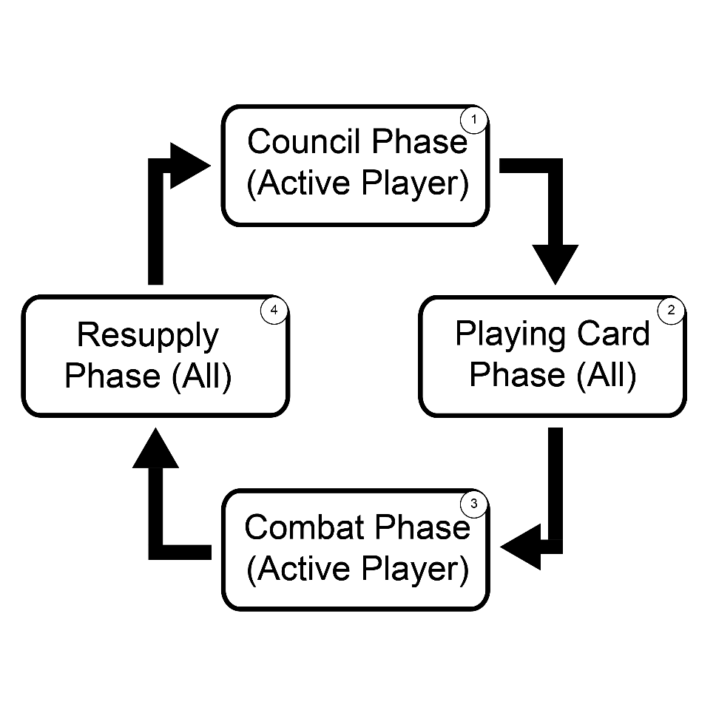
- Continue drawing

CARD EFFECTS IN DETAIL
♠ Spades - Weapons
- Equip to one of your In-Court nobles
- Strength bonus = equipped weapon♠ value + your spade♠ INFLUENCE
- Can be dismantled to pay tribute
- Triggers Set Bonus if noble has matching-value heart
♥ Hearts - Armor
- Equip to one of your In-Court nobles
- Strength bonus = equipped armor♥ value + your heart♥ INFLUENCE
- Can be dismantled to pay tribute
- Triggers Set Bonus if noble has matching-value spade
[⚔️🛡️] Set Bonus
- Triggered when noble gains both ♠ and ♥ of same numerical value (or both Jokers⍟)
- Immediately change stance of ANY one In-Court noble (yours or opponent's)
- Triggers when second matching card is equipped
- Only triggers once per matched pair, but can be broken and reformed across multiple plays
♦ Diamonds - Gems
Choose one when played:
- Save: Place in your gem pile, then Target Player draw 2 cards
  - Can be liquidated to pay tribute
- Spend: Discard this diamond card to recover a leveraged card
  - Target one leveraged card in any player's hand
  - Target's value must be ≤ spent diamond♦ value + your diamond♦ INFLUENCE
  - Targeted leveraged card goes to YOUR hand (un-leveraged and hidden)
♣ Clubs - Tactics
- Target one face-up card
- Target's value must be ≤ played club♣ value + your club♣ INFLUENCE
- Valid targets:
  - Equipment ♠/♥ on any noble
  - Any card in discard pile
  - diamond♦ in any gem pile
  - Leveraged card in any hand
- Targeted card goes to YOUR hand (un-leveraged and hidden)
- The played club♣ goes to discard pile
⍟ Jokers - Writs
- Choose any suit when played, resolves as the chosen suit
- Value = Zero
- When equipped: Affected by BOTH spade♠ AND heart♥ INFLUENCE
- When Saved as diamond♦: Stays in gem pile.
- When Spent as diamond♦: Can target other Jokers⍟, or higher value cards if you have enough diamond♦ INFLUENCE
- Can target other Jokers⍟ when played as club♣, or higher value cards if you have enough club♣ INFLUENCE

WINNING & LOSING

Victory Conditions (Check at end of each turn)
OUTMANEUVERED
- Have all 3 nobles (J/Q/K) In-Court
- Each equipped with weapon♠ OR armor♥ equal to their rank
- (Jack with Ace♠/♥, Queen with 2♠/♥, King with 3♠/♥)
- Ties go to active player
FLAWLESS STRATEGY
- Have Ace♣, 2♣, and 3♣ all leveraged in your hand
- Ties go to active player

Defeat Conditions (Instant once condition met)
BROKEN COMMAND
- 4 or more of your nobles are disgraced
- Ties go to non-active player
ECONOMIC COLLAPSE
- 4 or more cards leveraged in your hand
- Ties go to non-active player

INTERCONNECTED SYSTEMS
Price of Influence is about balancing interconnected systems. Nobles give you both combat strength and suit influence, effecting both the cards you can play and their relative power level. Bringing them into play always costs tribute drawn from your limited economy. Every suit pulls on another: weapons and armor build strength, diamonds manage debt, and clubs disrupt by stealing from nearly anywhere. Victory comes from spotting which path is opening, whether the perfect court, dominance in battle, or forcing collapse, and steering your resources and nobles toward it.

QUICK REFERENCE
Noble Rank: Jack=1, Queen=2, King=3, which determines:
- Tribute Cost
- INFLUENCE: what mix of cards you can play & how powerful each is
- Combat: Strength Calculation & Tie Resolution
- Equipment Restrictions, checked during resupply
Strength Calculation: Rank + (weapon♠ value + spade♠ influence) + (armor♥ value + heart♥ influence)
Turn Order: Council → Play Cards → Combat → Resupply
Play Limits: 4 cards maximum, (1 + INFLUENCE) per suit
Hand Limit: 7 cards including leveraged
Tribute Payment: Any combination of Liquidate/Leverage/Dismantle
Out of Cards: Leverage cards and reshuffle discard pile into deck, escalates over time

“Power isn’t won; it’s paid for.”

