Editing:

**Comprehensive Video Editing Guide with Notes**

**1. Types of Editing**

* **Minimalist Editing**:
  + Ideal for solo creators or content for sophisticated audiences (e.g., B2B, high-ticket products).
  + Focus on:
    - Cutting out mistakes in wording and long pauses.
    - Adding minimal text or graphics for emphasis (e.g., numbered lists, key points, stats (e.g. visuals of wim’s arr to boost authenticity, a TEN SECOND clip of a client talking about their new and improved ticket close rate after Wim talks about how TopLeft has helped them improve it).
    - Avoid unnecessary sound effects, transitions, or animations.
  + Examples: Shane Hummus Unfiltered, Will Chow, Kyle Volaris

**2. Importance Hierarchy in YouTube Content**

1. Uploading consistently.
2. The video idea (using methods like Icahn or Evolution) See: [YouTube Video Idea Stategy - Copy.docx](https://kerkhofftechnologies.sharepoint.com/:w:/r/sites/TopLeft/_layouts/15/Doc.aspx?sourcedoc=%7BF2FF4075-2136-4FCB-B5DF-F9ECCE1F23C4%7D&file=YouTube%20Video%20Idea%20Stategy%20-%20Copy.docx&action=default&mobileredirect=true).
3. The "Holy Trinity": Thumbnail, Title, and Intro.
4. Meeting minimum video quality thresholds:
   * **Audio**: Clear, no background noise.
   * **Lighting**: Adequate and focused on the subject.
   * **Background**: Clean, non-distracting.
5. Scriptwriting.
6. Video editing (last on the priority list).

**3. Essentials of Good Video Editing**

* Seamless transitions between scenes (making it look natural)
* Cutting out silences, mistakes, and unnecessary parts.
* Relevant text, images, or b-roll to reinforce key points (e.g. when wim is talking about how many MSPs are struggling with project visualization, there could be a part where he is talking about how his MSP struggled with keeping track of all his tickets and show a picture of a PSA filled with tickets; after he talks about how the problem was solved with kanban he can show a visual of Topleft’s kanban boards displaying all their tickets).
* Avoid overediting; keep visuals simple and elegant (Visual + text example: after wim talks about how he has 3 successful MSPs, he can show a photo of the companies ARR ONLY IF HE ALLOWS THAT).

**4. Software Recommendations**

* + CapCut (free, intuitive for basic editing).
  + Screenflow (Mac-only, simple workflows).
* **Recording Software**:
  + OBS (free, for direct video recording).
* **Podcast Recording**:
  + Use **Riverside**

**5. Workflow Tips**

* **Organize Project Files**:
  + Create folders: Raw Videos, Edited Files, Graphics, Audio, Final Exports.
* **Basic Steps for Editing**:
  + Import files into editing software.
  + Trim and cut unnecessary parts.
  + Arrange clips in the timeline.
  + Add text, transitions, and audio enhancements.
  + Preview for flow and coherence.
  + Export in the desired resolution (e.g., 4K for YouTube).

**6. Editing Tactics for Beginners**

* Start with **Minimalist Editing**:
  + Meet the basic quality threshold (audio, lighting, clean background).
  + Focus on delivering value rather than flashy visuals.
* Outsource editing as soon as you’re consistently uploading 3+ videos weekly.
* Test various ideas and formats to find what resonates with your audience.

**10. Intros and Outros for YouTube**

* **Intro**:
  + Highlight the problem, solution, and value of the video.
  + Example:
    - "Hello, today I’m going to show you how to implement teams into Autotask. I understand you’re doing this to improve communication. Stick around until the end of this video, because I am going to share extra tips + methodologies to enhance your setup."
  + Add **before-and-after visuals** to emphasize results.
* **Outro**:
  + Encourage engagement:
    - "Thanks for watching! Please like, subscribe, and leave feedback. Feedback means a lot to me. Let me know if there’s anything else you’d like to learn."

**9. Notes on Hiring Video Editors**

* Rates depend on work type:
  + Simple edits: $100–$200 per video (via Fiverr or Upwork).
* Steps to hire:
  + Review their work samples.
  + Message them directly to discuss rates (per minute or per video).
  + Conduct a **test project** before committing.
  + Follow with **behavioral interview questions**, such as:
    - "What are you currently doing for self-improvement?"
* Recommended onboarding materials:
  + Share documents outlining the **Holy Trinity** (Thumbnail, Title, and Intro) and pacing guidelines.

**10. Tips for B2B Content**

* Emphasize **problem-solution-results** in content:
  + Visually show the problem and its emotional impact.
  + Use diagrams or text to explain solutions.
  + Highlight results with metrics (e.g., "Cut ticket resolution time by 50%").
* Create **hot-button videos** for specific segments:
  + Use testimonials or targeted examples in the first 2 minutes.
  + Example: Showcase before-and-after screenshots addressing pain points.
* Include **calls-to-action (CTAs)**:
  + "If you know this is an issue, let’s hop on a call to discuss how our SaaS platform can solve it."
* Position the host as an **authority**:
  + Add additional insights or value beyond what guests mention during podcasts.

**11. Visual Storytelling Tips**

* Mix strategies in different videos:
  + Use storytelling to present the problem (e.g., past experiences).
  + Add diagrams or text during explanations.
  + Show testimonials or PDF guides for solutions (and this can get them on your email list)
* Example:
  + Problem: Show overwhelmed users sorting SLA emails.
  + Solution: Display a clean, organized Kanban dashboard addressing their issue.

**12. Behavioral Psychology in Editing**

* Understand your audience:
  + **Why they watch**: Alleviate boredom or loneliness.
  + **How to engage**: Use minimalist editing to feel relatable or retention editing for dynamic appeal.
* Focus on authenticity:
  + Simplify visuals and storytelling to build trust and connection.

By combining minimalist and retention editing strategies with a focus on storytelling and relevance, you’ll create engaging, high-value videos that resonate with your audience.

**Major Points for Viral Thumbnails**

**1. Importance of Thumbnails**

* Thumbnails are the first point of contact for viewers.
* Viewers process content in this sequence: **Thumbnail → Title → Intro → Video.**
* The **eyes** in the thumbnail are the first element noticed:
  + Bright, visible **whites of the eyes** draw attention.
  + **Facial expressions** (shocked, confident, happy, serious) are next.
  + Text and other elements like props or background come afterward.

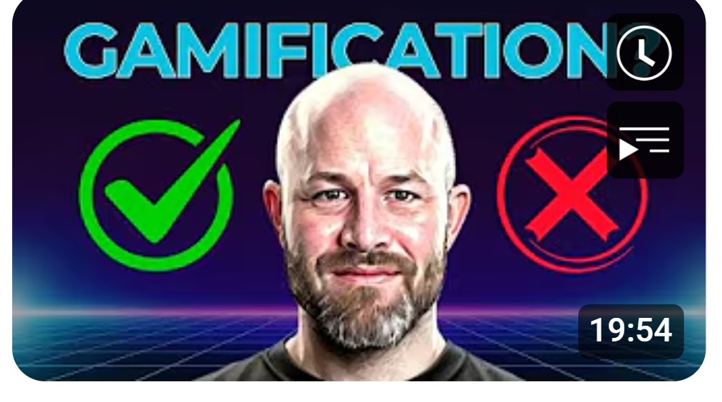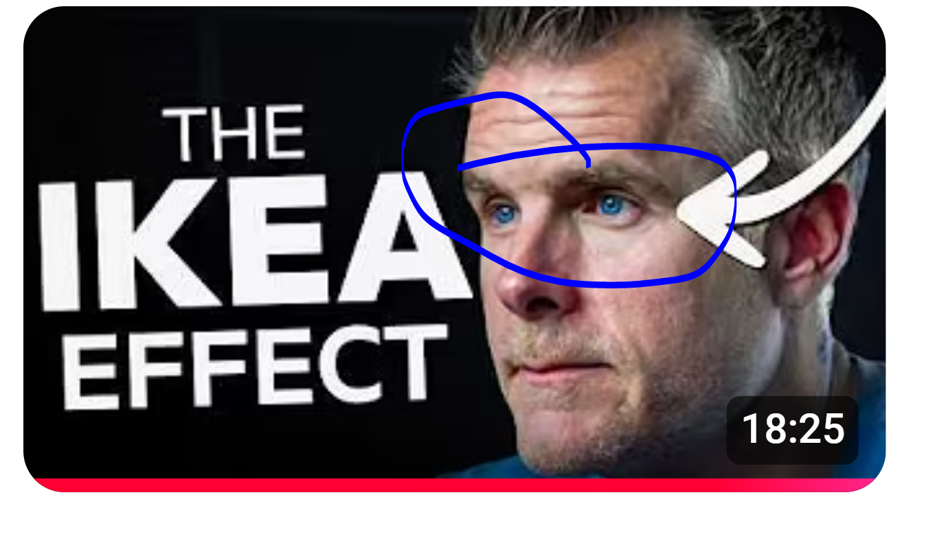

**2. High-Quality Personal Photos**

* Use **high-resolution photos** of yourself with visible facial expressions.
* Expressions to include:
  + **Shocked/Scared:** Easily visible whites of the eyes.
  + **Serious/Disappointed:** Captures authority or urgency.
  + **Happy/Confident:** Builds trust and relatability.
* Use tools like **remove.bg** or Photoshop to remove backgrounds and create PNGs.
* **Typically, most sophisticated audiences only care for happy/confident or neutral emotions.**
* Take photos with a **green or blue background** for easier removal.
* For consistency:
  + Take **multiple photos in one session** using different expressions and hand gestures.
  + Store in a **Google Drive** folder for quick access.

**3. How to Find Thumbnail Ideas**

* **Don’t copy thumbnails** from your direct competitors or muse videos.
  + Doing so can pit your video against theirs in the algorithm, leading to fewer clicks.
  + Avoid creating the impression of being a "ripoff."
* **Steal like an artist:**
  + Draw inspiration from **5–10 different channels** outside your niche but with similar audience demographics.
  + Example:
    - Combine the emotional expression from one channel with the layout or text style from another.
* Tools:
  + Use websites like [Thumbnail Save](https://thumbnailsave.com/) to download thumbnails in high definition.

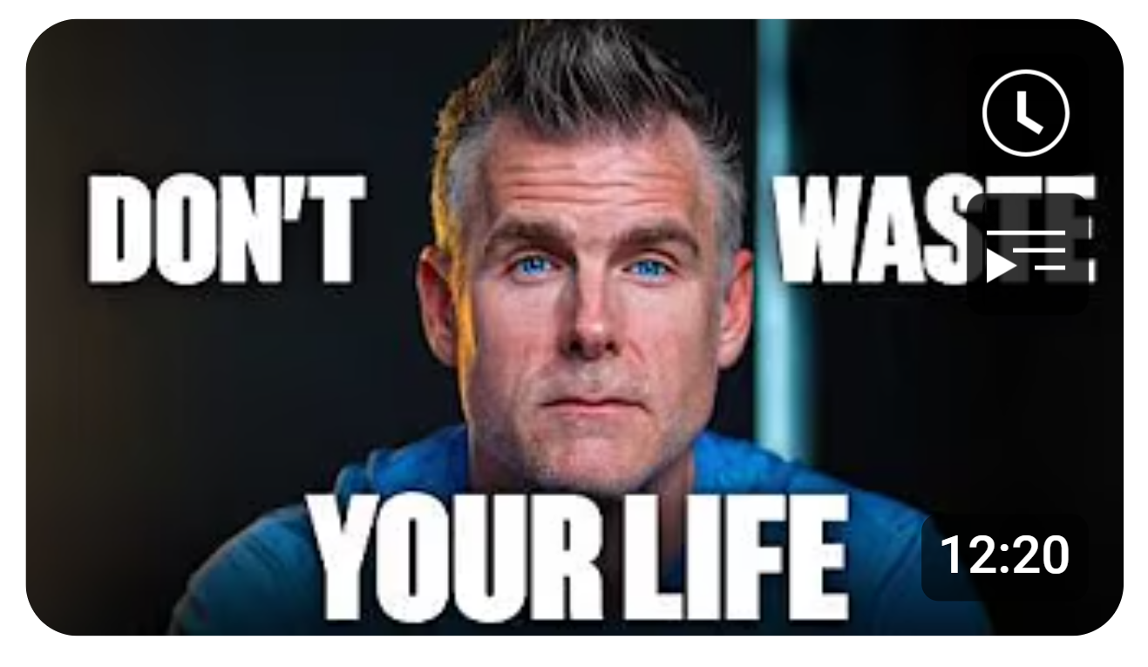



**4. Thumbnail Design Rules**

* **Text**:
  + Minimal text, maximum of **4 words**.
  + Use bold **IMPACT** fonts in ALL CAPS
  + White or yellow text with contrasting outlines performs best.
  + Avoid repeating words/numbers from the title in the thumbnail.

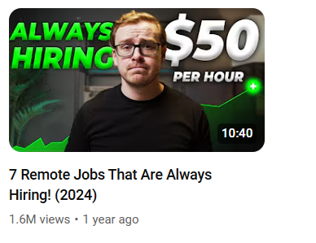

* **Colors**:
  + Stick to **1–3 colors** maximum for a clean look.
  + Use complementary colors via tools like [Color Calculator](https://www.sessions.edu/color-calculator/).

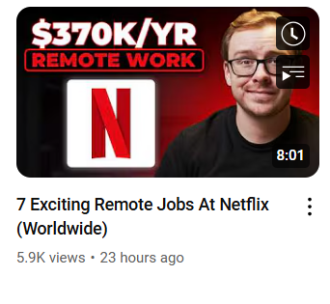

* **Composition**:
  + Use the **rule of thirds**:
    - Place your face in the center or aligned with the intersection points.
    - Balance the open and occupied spaces in the thumbnail.
  + Ensure thumbnails look good when **zoomed out** (most viewers see them on phones).

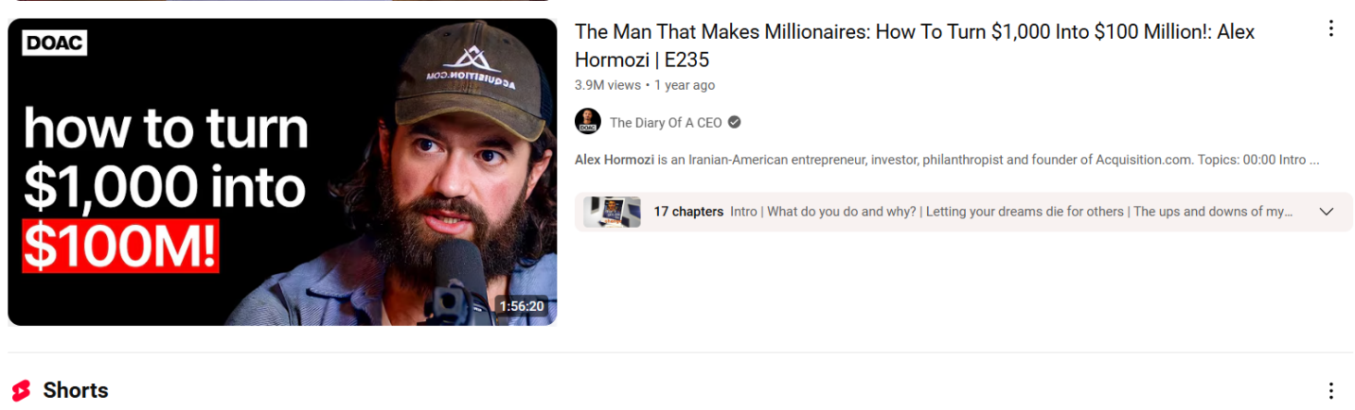

**5. Emotional Connection**

* Thumbnails should:
  + Evoke curiosity and emotion.
  + Tell a story or hint at the video’s value (e.g., before-and-after scenarios).
* Use **props** to complement the emotion or narrative (e.g., graphs, tools, or money visuals).

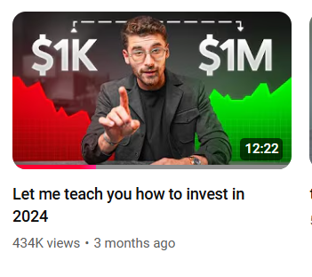

**6. Common Thumbnail Mistakes to Avoid**

* **Too much text:** Keep it minimal and impactful.
* **Busy visuals:** Simple and clean designs work best.
* **Repeating title words:** Use complementary text that adds value.
* **Generic b-roll:** Choose specific, story-driven visuals over generic imagery.

**7. Tools and Software**

* **Remove.bg**: Quickly remove backgrounds from photos.
* **Photoshop/Canva**: For detailed customizations and editing.
* **Thumbnail Save**: For downloading high-resolution examples.

**8. Creating Thumbnails for Sophisticated Audiences**

* For **B2B or high-ticket content**:
  + **Use subtle facial expressions (e.g., slight smile or serious look).**
  + **Avoid extreme emotions that might feel inauthentic.**
  + **Prioritize authority and trustworthiness over entertainment**.
* Example Channels:
  + Kyle, Charlie Morgan
* 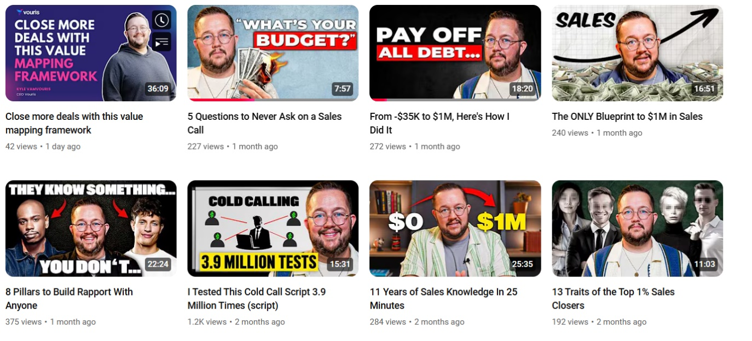

**9. Thumbnails for Mass-Market Audiences (Not as important for topleft)**

* Use bold expressions and bright visuals to catch attention.
* Focus on relatability, urgency, or shock.
* Example Channels:
  + Graham Stephan, Meet Kevin.

**10. Practical Tips for Taking Photos**

* Set up a **camera with a timer** or use a connected app.
* Hire a **professional photographer** if needed.
* Record a high-quality **video of yourself**, pause at the desired frame, and screenshot the expression.

**11. Shapes and Visual Enhancements**

* Use arrows (➚), checkmarks (✔), and X’s (✗) to emphasize key ideas.
* Add contrasting outlines (stroke, shadow, or glow) around:
  + Text.
  + Your figure to make it "pop."
* Use **backgrounds that contrast the text** (e.g., dark backgrounds for light text).

**12. Testing and Optimization**

* Zoom out on your thumbnails during the design process to ensure they remain legible and eye-catching.
* Test different styles to determine what resonates with your audience.

**13. Workflow for Thumbnail Creation**

1. **Conceptualization**:
   * Gather ideas from various channels.
   * Create a basic sketch or outline.
2. **Photo Selection**:
   * Choose high-quality images of yourself or take new ones.
3. **Editing**:
   * Use tools like Photoshop or Canva.
   * Add minimal text, shapes, and effects.
4. **Review and Finalize**:
   * Zoom out and test for clarity.
   * Share with your team for feedback.

By adhering to these principles, you can create thumbnails that captivate your audience and enhance your video’s visibility and click-through rate.

I suggest potentially naming your YouTube – Wim Kerkoff -  TopLeft Technologies. This will increase personal brand presence, **You won’t have to do anything here except record the podcasts, potentially record 15 second intros + conclusions and create some photos of yourself for the thumbnails.** You can take 40 photos in 30 minutes though and the editor can use it in the thumbnail based on my strategy.

You can follow the strategy used by **Shane Hummus** on YouTube ([Shane Hummus - YouTube)](https://www.youtube.com/channel/UCLKZ20yD2tNMBOkSDZo4FeQ). He is my acquaintance, and he helped me market to land this job (and I did catch Plakilla’s eye). Also, his style of content takes very little effort to make but is effective in making sales. With 900k+ subscribers, Shane helps people secure remote jobs in digital marketing and coding through his YouTube channel. He knows what he is doing too, and his consulting was not very expensive. His company also generates 300k per month in MRR. His approach is highly effective, and here's how you can emulate it:

1. **Thumbnails**: Create visually striking yet strong thumbnails with bold text and clean designs that instantly grab attention and spark curiosity (I know how to do this).
2. **Titles**: Use concise, intriguing titles that directly address your target segment’s pain points or goals with a keyword to start.
3. **Intros**: Start each video with a fast-paced, engaging introduction that immediately hooks viewers, uses their language, and sets the tone for the content and makes viewers curious on what’s in store in the video.

This strategy keeps your content fast, compelling, low effort to make, and straight to the point—ensuring maximum appeal to your audience. By adopting this proven formula, you can build a strong personal brand and a highly engaged following and add a lot of people to your email list to warm up.

My recommended strategy is to focus on placing all your top-of-funnel content on a dedicated YouTube channel to attract and engage a broad audience. Once viewers begin to trust you and value your insights, direct them to the TopLeft YouTube channel for middle- and bottom-of-funnel content. This content will provide deeper, more targeted information about solutions and decision-making tools. Use newsletters, blogs, and your top-of-funnel YouTube videos on your Wim Kerkhoff channel to guide your audience toward the TopLeft channel, creating a seamless journey that nurtures trust and leads them closer to conversion.

I also use Shane’s strategy and have a yt channel teaching people how to get freelance clients, and I got a few clients with only 95 subs. Sometimes I get 73 likes per video + 2k views and people sometimes send me connect requests on LinkedIn. This works!

**How to Find Video Ideas for TopLeft**

Finding the right video ideas is crucial for creating content that resonates with your audience, drives engagement, and aligns with your goals for TopLeft. Here's a step-by-step guide on how I generate impactful video ideas (examples are further down in this document):

***1. Start with Keyword Research Using VidIQ***

* **Go to VidIQ.com:** Begin by searching for relevant terms such as *MSP project management* or related keywords that align with TopLeft's value proposition.
* **Look for High-Search Keywords:** Use VidIQ’s keyword tool to identify keywords with high search volumes and manageable competition.
* Example: *"Kanban for MSPs"* or *"Improving project efficiency for service delivery managers."*

***2. Analyze Popular Videos on These Keywords***

* **Search YouTube for Top Videos:** Look up the keywords from VidIQ on YouTube.
* **Identify Videos with High Engagement:** Focus on videos with at least **3x more views than the channel’s subscriber count.**
* *Why?* Videos with this performance indicate high organic reach and content that resonates with your target market. The videos with the most views are being clicked on because your target market is facing the pain points being solved in the video and wants it solved.
* Example: A channel with 5,000 subscribers and a video with 15,000 views is worth analyzing.

***3. Examine the Pain Points Being Solved and User Intent Regarding Why Viewers Click on the Video***

* **Watch the Top Videos:** Pay attention to the specific problems the video addresses.

**Example:** Potential videos could be named “how to integrate microsoft calendar to HaloPSA” or “how to visualize Halopsa tickets in Grafana”. The user's intention on why they are viewing the Grafana video is because they need to keep track of their tickets more effectively. The Microsoft calendar video is viewed fully because MSPs want help making MSP team communication more efficient. BOTH ARE ISSUES TOPLEFT SOLVES BETTER. The thousands of people watching this video are viewing it because they are trying to solve the pain points TopLeft solves. However, TopLeft solves the problems better than how they are being solved in the video.

*Aligning the pain points ensures that the content serves the same audience looking for solutions TopLeft provides.*

***4. Holy Trifecta***

* Now optimize the title, thumbnail and intro of the video to increase click (I know how to do this).
* Just take the idea of the video but make the content based on Wim’s valuable and unique point of view.

***5. Continuously Monitor Trends***

* **Repeat the Process:** Regularly revisit VidIQ + YouTube to update your keyword and topic list based on evolving trends in the MSP project management space.
* **Experiment and Measure:** Test different content style types (listicle, conceptual walkthrough, tutorial, etc) and ways of delivering the value (editing style). Once you see something that works, optimize it.

**Examples in Depth:**

As you can see, this video has 5x more views than subscribers. Viewers are looking for this content. This is 27k potential prospects who viewed his video. (Warning: This video is highly **top-of-funnel** content (podcast topic), targeting individuals considering starting an MSP business. These prospects may or may not end up creating an MSP, but the goal is to position yourself as an agile **MSP consultant** with proven credibility (e.g., managing two MSPs with 7-figure ARR).

The strategy here is to offer **free value** upfront by encouraging viewers to sign up for your email list offering something of free value to them. This approach helps to **warm up potential prospects** and nurture them toward becoming clients even though the audience you are targeting here is quite broad. People are tired of buying products from soulless businesses and would like to think they are buying from a person for once. I**n the awareness stage,** people have no idea who you are so at first, they are more interested in hearing how you can solve their deepest MSP issues rather than offering them something as a product.

This video has 10x more views than subscribers. This video could also serve as **top-of-funnel awareness content. It could also be included as a bulleted topic in your podcast** offering valuable tips while subtly promoting a **visualized Kanban system** as one of the best practices (which you sell), alongside four other actionable tips.

Use the video to position yourself as a **ConnectWise/agile MSP consultant**, showcasing your expertise. At the end of the video, encourage viewers to **join your email list** for more insights and resources. Once subscribed, nurture these prospects by **warming them up** with tailored content, ultimately guiding them further down the funnel. This could be with the capacity planner, then after they take it I could send them loads of content that is directly tailored to their job, msp size, and solving their biggest pains that they scored highest on (pains that TopLeft solves). After they are all warmed up and gain more trust, I can start pitching them TopLeft **(see below for Dev Basu’s email nurturing strategy).**

These videos each have 3x – 6x more views than subscribers. Even though TopLeft does not directly address the specific problems discussed in the video, it is important to understand the **user intent** behind why people are searching for this information. They are seeking ways to **streamline their communication process within their MSP so they do not have to have recurring meetings or unseen messages**, which aligns with the **underlying pain points** that TopLeft does solve.

7k potential Autotask MSPs clicked on that Teams video because they have communication efficiency issues in Autotask, TopLeft’s products help streamline communication, but offers a better solution.

The top-performing videos have **6x more views than the channel's subscriber count**, showing a strong demand for this content.

**Why are users searching for this?** Depends on the video, but for the circled ones, they want better **ticket organization** to finish tasks on time, project overviews, ticket tracking and faster integration services—all pain points TopLeft addresses **differently yet better**. However, most of the 4k - 7k people viewing these videos do not know that yet or care about your paid solution. So, they are going to have to be warmed up.

**The Sales Funnel:**

1. **Create a Related Video**:

* Use the ideas of the most viewed videos, and make the title, thumbnail and intro better. Now, make the content in the video based on Wim’s opinion and indirectly explain TopLeft’s value without mentioning TopLeft’s name.
* An example of this could be to give advice for your audience to get a Kanban system or a tool that views an MSP’s projects and tickets in full. Do this in the awareness stage without mentioning TopLeft, but only as a recommendation.

1. **Offer a Free Lead Magnet**:

* Provide something free + valuable, such as:
* A simple framework on tips to streamline communication in teams.
* A guide on using ChatGPT to solve MSP specific issues.

Use the **Capacity Planner** as a hook to encourage viewers to join your email list. Present it as a must-have tool for MSPs to optimize resource allocation and manage workloads effectively. After they sign up and download the planner, follow up with a short survey or track their engagement with the tool to identify their primary issues. For instance, ask questions about their team size, their biggest operational challenges, and whether they’re focused more on project management or service delivery. Based on these insights, segment your audience into categories such as MSP size, position, and problems, tailoring further engagement to their specific pain points and needs based on these metrics I segmented.

Once segmented, deliver value that resonates with their challenges.

1. **Warm Up Prospects via Email**:

This is Dev Basu’s email nurturing strategy.

* Use your email list to **nurture leads** with content that gradually demonstrates how TopLeft helps:
* **Day 1**: Deliver the lead magnet and thank the customer for their interest. Segment the results and future deliverables based on how they scored on the PMA survey, their job position, company size, and what their specific pain points are based on how they scored on the PMA.
* **Days 3-7**: Based on the results of their PMA survey, send three tailored "hot button" emails addressing specific MSP service delivery or project management pain points that they dealt with based on how they scored on the PMA.
* **Day 14**: Pause to avoid appearing spammy, then follow up with a tailored value-focused email encouraging further engagement.
* **Day 21**: A final email pushes for a demo booking or assigns the lead to a lower-priority list for future engagement.

1. **Partner with MSP Consultants**:

* Collaborate with MSP consultants in the podcast or YT to have them link your blog or content in their articles where relevant.

By aligning your content with user intent and creating value, you can attract and nurture prospects, ultimately positioning TopLeft as the solution to their underlying problems.

By focusing on **high-demand topics**, building a **personal brand**, and using **lead magnets and email nurturing**, you can attract and convert viewers into engaged prospects who see TopLeft as the solution to their challenges.

Muse Video

**Sources:**

Simpletiger.com

Poweredbysearch.com

Hubspot.com