Homepage Copy Revision

Copy Revision 1 (First Variation) 1

------------------------------------------------------------------------------------------------------------------ Copy Revision 2 (Second Variation) 5

# Copy Revision 1 (First Variation)

"MSPs, keep your projects and tickets in your PSA.

Transform messy ticket lists into powerful Connectwise, HaloPSA or Autotask insights that give managers, coordinators, technicians and engineers instant visibility into their priorities, bottlenecks, and timelines.

[Request a Demo]"

Trusted By 150+ MSPs

TopLeft drives results for MSPs of all sizes - from 20 to 200 employees worldwide. One of our clients reported a 57% improved project completion rate, another achieved an SLA performance increase from 60% to over 90%, and others experienced dramatic improvements in dispatch and ticket management.

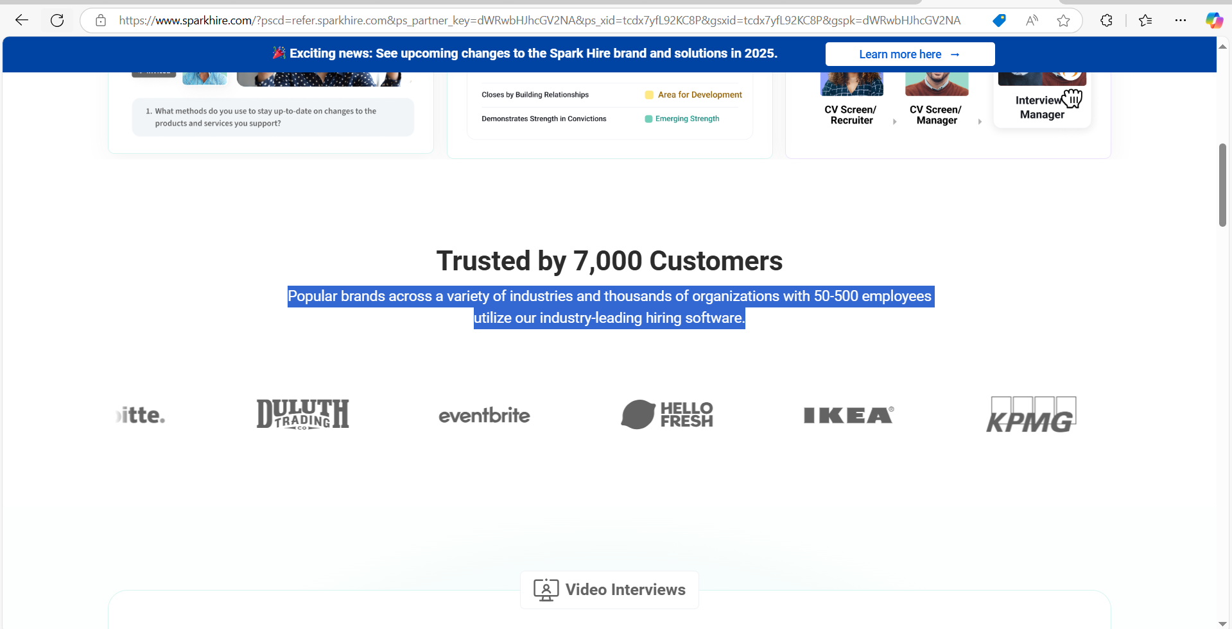

**Other PSA tools aren’t built for effective project management...**

**For Managers**

Managing multiple projects without clear visualization makes it hard to spot bottlenecks and streamline workflows, leaving teams overwhelmed and missing deadlines.

**For Coordinators**

Lack of visual clarity makes prioritizing tasks and ensuring smooth execution a constant struggle, leading to daily firefighting.

**For Technicians**

Disorganized ticket queues make it difficult to see priorities or how tasks fit into the bigger picture, causing wasted time and frustration.

**For Engineers**

Outdated tools lack the clarity to prioritize high-impact work, forcing time on admin tasks instead of solving technical problems.

**Discover TopLeft — A MSP-centric project management tool**  
**that offers all the visibility that technicians and managers need**

**Hear From Our Users:**

**How MSPs are using TopLeft:**

**(Testimonial)**

**Testimonial Examples:**

* **Judi Noell Baker**, Service Desk Manager at Seitel Systems:

"We see value in using TopLeft. We have seen firsthand how it has helped us visualize our workflows, identify bottlenecks, and continuously improve our processes."

[Topleft](https://www.topleft.team/topleft-reviews?utm_source=chatgpt.com)

* **Sarah Ellis**, CIO at Clear Guidance:

"TopLeft turned project management from staring at huge lists, impossible to prioritize, into easily digestible, very visually compelling information."

[Topleft](https://www.topleft.team/topleft-reviews?utm_source=chatgpt.com)

* **Steve Psaradellis**, CEO of TEBA:

"We were able to move our average project delivery from negative efficiency to positive 33% efficiency. So we finish projects now with an average of 1/3 time left over!"

[Topleft](https://www.topleft.team/topleft-reviews?utm_source=chatgpt.com)

* **Chase Effler**, Engineering Manager at Appalachian Network Services Inc.:

"We transitioned from ConnectWise Manage to TopLeft for better ticket management. And we have improved SLA adherence from 60% to 90% within six months."

[Topleft](https://www.topleft.team/topleft-reviews?utm_source=chatgpt.com)

* **Matthew Kaufman**, CEO at KaufmanIT:

"It's weird that this is the exact same data in a new visual form, but suddenly everybody knows which tickets should have been closed when they didn't just with ConnectWise Manage."

[Topleft](https://www.topleft.team/use-cases/for-dispatchers?utm_source=chatgpt.com)

* **Ravi Brounstein**, CEO at Alpha IT:

"This product has changed my life. I'm already sold, just for the benefit that it gives to me."

[Topleft](https://www.topleft.team/use-cases/for-dispatchers?utm_source=chatgpt.com)

* **Frank Hannaford**, Solutions Architect at CoreTech:

"Straight-forward implementation of Kanban for Project Management that is fully integrated with ConnectWise Manage!"

[Topleft](https://www.topleft.team/use-cases/kanban-project-manager?utm_source=chatgpt.com)

* **Alex Anderson**, ex-Project Manager at Helixstorm:

"With TopLeft, it takes much less time for me to communicate, assign, and correct statuses."

[Topleft](https://www.topleft.team/use-cases/kanban-project-manager?utm_source=chatgpt.com)

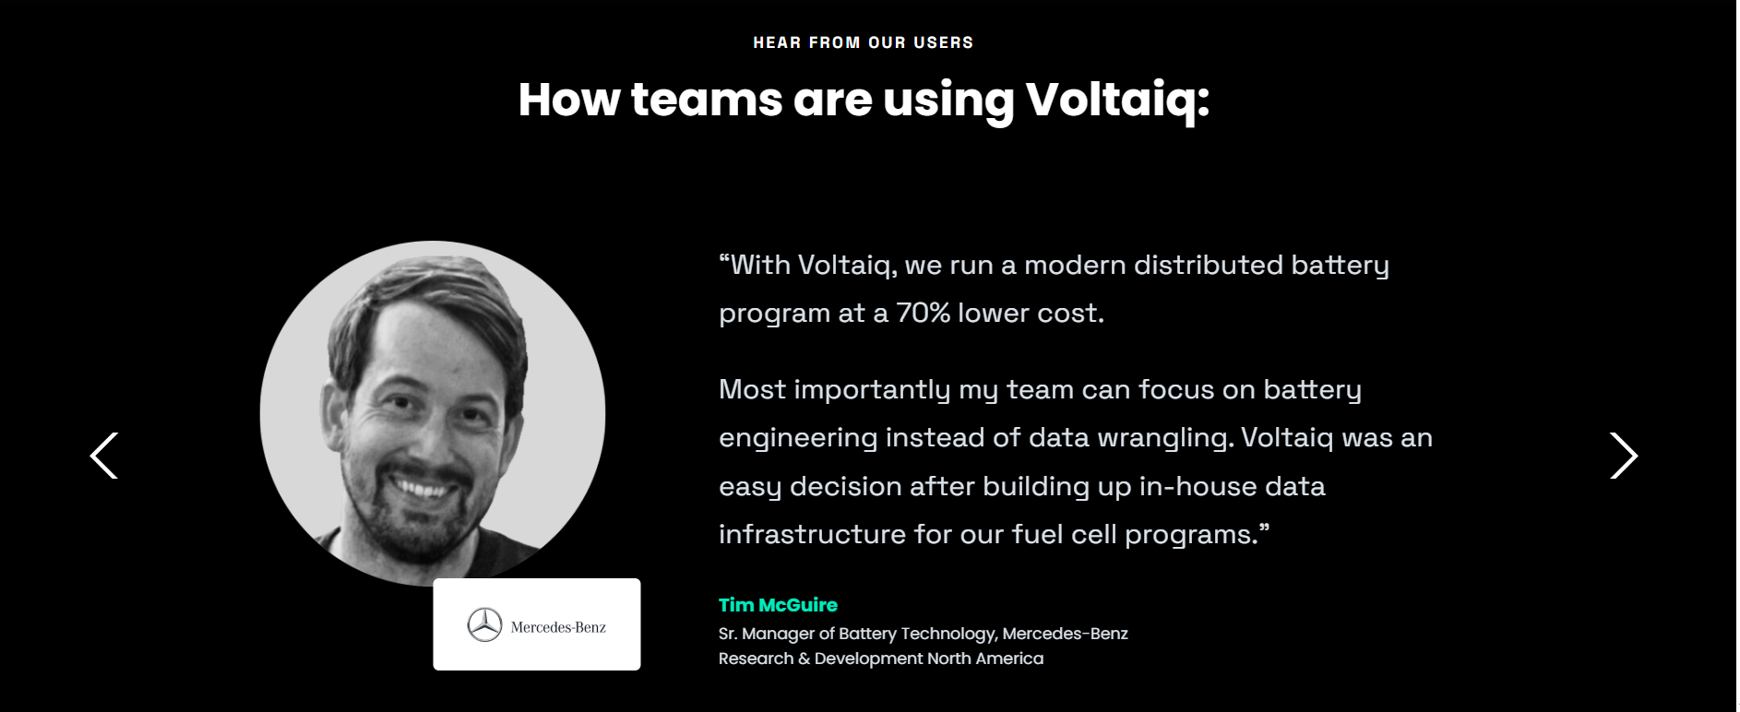

**Use Swimlanes to**  
**Assign Tasks Effectively**

Keep your team on track, quickly see who's available, eliminate dispatching and unnecessary meetings.  Drag & drop cards to quickly reassign work.

(Learn more (Link to features page))

**Visualize Your Workflow  
with Kanban Boards**

Help your engineers easily share their priorities and stay focused on the most important ticket. Drag & drop cards to adjust priorities and update status in the PSA.

(Learn more (Link to features page))

**Effortlessly Track Projects with Swimlanes and Gantt Charts**

Clearly see project statuses, priorities, and timelines, so you always know what projects are on track and what needs your attention.

(Learn more (Link to features page))

**Simplify Time Tracking**

Let technicians and engineers easily log time and notes, pushed instantly back to your PSA and their timesheets

(Learn more (Link to features page))

**(SOC Section)**

# ------------------------------------------------------------------------------------------------------------------ Copy Revision 2 (Second Variation)

"MSPs, keep your projects and tickets in your PSA.

Transform messy ticket lists from Connectwise, HaloPSA or Autotask into powerful insights that give managers, coordinators, technicians and engineers instant visibility into their priorities, bottlenecks, and timelines.

[Request a Demo]"

**TRUSTED BY 150+ SUCCESSFUL MSPs WORLDWIDE (Insert Arrow)**

Judi Noell Baker, a Service Desk Manager at Seitel Systems, utilizes TopLeft's visualization tools to streamline workflows and onboard new team members, enabling rapid process improvements and seamless team integration through intuitive bottleneck identification.

* Steve Psaradellis: "moved from negative efficiency to positive 33% efficiency"
* Chase Effler: "improved SLA adherence from 60% to 90%" and "employee utilization from 30% to 75%"

Alex Anderson: Reduced ticket management time from 45 minutes to 13 minutes (71% reduction)

* Judi Noell Baker, a Service Desk Manager at Seitel Systems, utilizes TopLeft's visualization tools to streamline workflows and onboard new team members



**Other PSA tools aren’t built for effective project management...**

**For Managers**

No clear view of team capacity leads to project bottlenecks.

**For Coordinators**

Scattered project data creates constant firefighting.

**For Technicians**  
 Disorganized tickets lead to wasted time.

**For Engineers**

Admin tasks steal time from technical work.

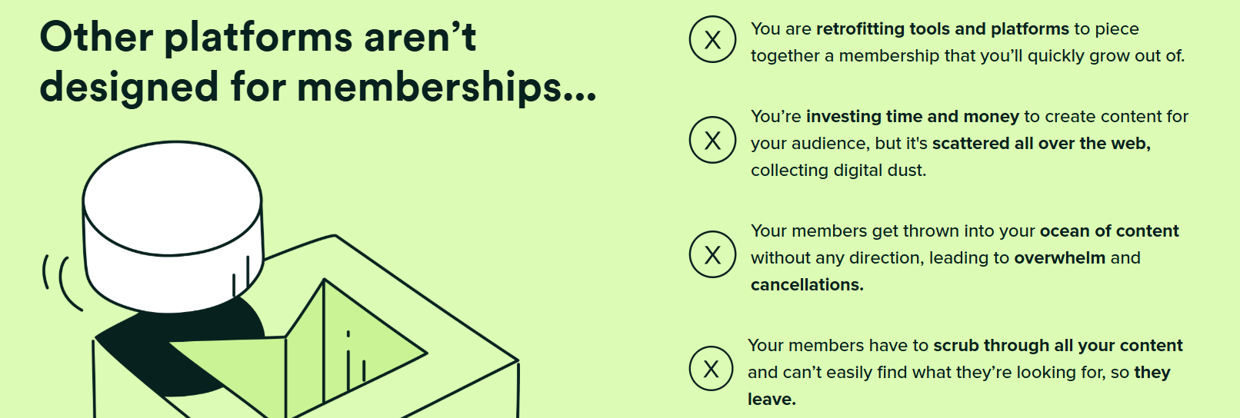

**Discover TopLeft — A MSP-centric project management tool**  
**that offers all the visibility that technicians and managers need**

**Use Swimlanes to**  
**Assign Tasks Effectively**

Keep your team on track, quickly see who's available, eliminate dispatching and unnecessary meetings.  Drag & drop cards to quickly reassign work.

(Learn More (Link to Features Page))

**Visualize Your Workflow**  
**with Kanban Boards**

Help your engineers easily share their priorities and stay focused on the most important ticket. Drag & drop cards to adjust priorities and update status in the PSA.

(Learn More (Link to Features Page))

**Effortlessly Track Projects with Swimlanes and Gantt Charts**

Clearly see project statuses, priorities, and timelines, so you always know what projects are on track and what needs your attention.

(Learn More (Link to Features Page))

**Simplify Time Tracking**

Let technicians and engineers easily log time and notes, pushed instantly back to your PSA and their timesheets

(Learn More (Link to Features Page))

**Hear From Our Users:**

**How MSPs are using TopLeft:**

**(Testimonial)**

**Testimonial Examples:**

* **Judi Noell Baker**, Service Desk Manager at Seitel Systems:

"We see value in using TopLeft. We have seen firsthand how it has helped us visualize our workflows, identify bottlenecks, and continuously improve our processes."

[Topleft](https://www.topleft.team/topleft-reviews?utm_source=chatgpt.com)

* **Sarah Ellis**, CIO at Clear Guidance:

"TopLeft turned project management from staring at huge lists, impossible to prioritize, into easily digestible, very visually compelling information."

[Topleft](https://www.topleft.team/topleft-reviews?utm_source=chatgpt.com)

* **Steve Psaradellis**, CEO of TEBA:

"We were able to move our average project delivery from negative efficiency to positive 33% efficiency. So we finish projects now with an average of 1/3 time left over!"

[Topleft](https://www.topleft.team/topleft-reviews?utm_source=chatgpt.com)

* **Chase Effler**, Engineering Manager at Appalachian Network Services Inc.:

"We transitioned from ConnectWise Manage to TopLeft for better ticket management. And we have improved SLA adherence from 60% to 90% within six months."

[Topleft](https://www.topleft.team/topleft-reviews?utm_source=chatgpt.com)

* **Matthew Kaufman**, CEO at KaufmanIT:

"It's weird that this is the exact same data in a new visual form, but suddenly everybody knows which tickets should have been closed when they didn't just with ConnectWise Manage."

[Topleft](https://www.topleft.team/use-cases/for-dispatchers?utm_source=chatgpt.com)

* **Ravi Brounstein**, CEO at Alpha IT:

"This product has changed my life. I'm already sold, just for the benefit that it gives to me."

[Topleft](https://www.topleft.team/use-cases/for-dispatchers?utm_source=chatgpt.com)

* **Frank Hannaford**, Solutions Architect at CoreTech:

"Straight-forward implementation of Kanban for Project Management that is fully integrated with ConnectWise Manage!"

[Topleft](https://www.topleft.team/use-cases/kanban-project-manager?utm_source=chatgpt.com)

* **Alex Anderson**, Project Manager at Helixstorm:

"With TopLeft, it takes much less time for me to communicate, assign, and correct statuses."

[Topleft](https://www.topleft.team/use-cases/kanban-project-manager?utm_source=chatgpt.com)



**(SOC Part)**

**------------------------------------------------------------------------------------------------------------------**

**Notes:**

I reviewed Fletch PMM client homepages and analyzed their layouts, CTAs and positioning by scraping their homepages using ChatGPT. Here’s the percentage breakdown based on their copy + design layout placements:

**1. Value Proposition:**

* **Placement:** Predominantly featured prominently in the hero section at the top of the homepage.
* **Percentage:** 100% of the websites analyzed present their value proposition immediately to capture visitor attention.

**2. Target Market Identification:**

* **Placement:** Often integrated within the hero section or immediately following it, clearly indicating the intended audience.
* **Percentage:** Approximately 80% of the websites specify their target market early on, either through direct statements or contextual cues.

**3. Pain Points Addressed:**

* **Placement:** Typically highlighted in sections following the value proposition, detailing challenges that the product/service resolves.
* **Percentage:** Around 70% of the websites discuss customer pain points, emphasizing the problems they aim to solve towards the beginning.

**4. Testimonials:**

* **Placement:** Commonly located mid-page or towards the end of the homepage, providing social proof and building trust.
* **Percentage:** 60% of the websites feature testimonials, showcasing customer satisfaction and credibility.

**5. Call to Action (CTA):**

* **Placement:** Strategically placed throughout the homepage, with primary CTAs in the hero section and secondary CTAs interspersed in subsequent sections.
* **Percentage:** 100% of the websites utilize CTAs to guide user engagement, with the majority placing a prominent CTA in the hero section.

**Sources (List)**

https://www.fletchpmm.com/

https://www.voltaiq.com/

https://www.command.ai/

https://www.ag5.com/

https://www.sparkhire.com/?pscd=refer.sparkhire.com&ps_partner_key=dWRwbHJhcGV2NA&ps_xid=tcdx7yfL92KC8P&gsxid=tcdx7yfL92KC8P&gspk=dWRwbHJhcGV2NA

lemlist.com

https://www.generalcollaboration.com/

Membership.io

https://www.kolleno.com/

https://polser.io/