**The Dynamic of Arm Controls in Sudan .**

**July 2024 to 2025**

Ongoing research about Sudan Conflict

**Background to Artrika**

Artrika is a Sudanese organisation that serves as an online data monitoring clearinghouse documenting internal displacement, humanitarian gaps, airstrikes, and aerial bombardment in Darfur. Data is compiled and verified by a team of human rights monitors in Sudan and documented in real-time through coding apps and NASA Agent for Space. Data visualisation provides a comprehensive view of trehe conflict, as well as preserving evidence for future justice and accountability efforts.

Artrika is proud to announce the launch of its Airstrike Monitor, which will be published monthly and include thematic research and data analysis to aid fellow Sudanese organisations, international non-governmental organisations, the media, and concerned policymakers.

In the same time Artrika working in the different project which is focusing on Conflict dynamic

**Introductions**

Artrika Conflict monitoring is our local conflict tracker, an early warning tool designed to help prevent deadly violence. It keeps decision-makers up-to-date with developments in over 18 conflicts and crises every month, identifying trends and alerting them to risks of escalation and opportunities to advance peace. In addition, Artrika Conflict monitoring monitors over 50 situations to offer timely information if developments indicate a drift toward violence or instability.[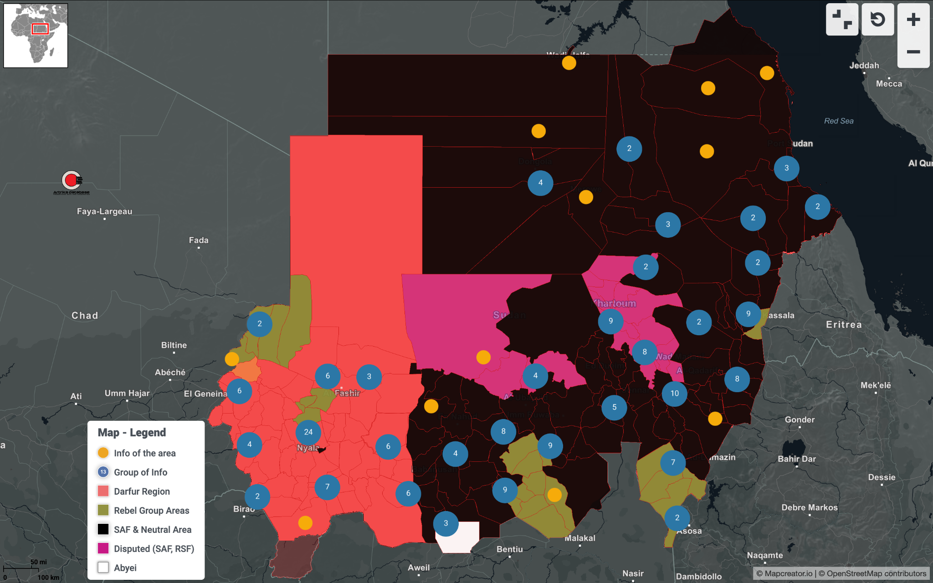](https://dynamic.mc-cdn.io/?id=124c596a406670bb7a2acc3d27a8b0c8&access-token=YKzmygr7C367Dq5rCJ55KXR03BpkzZT9b540aa0d398a4c2e83cdb013a3035c06d1c45049)

[Links of the INTRACTIVE Map](https://dynamic.mc-cdn.io/?id=124c596a406670bb7a2acc3d27a8b0c8&access-token=YKzmygr7C367Dq5rCJ55KXR03BpkzZT9b540aa0d398a4c2e83cdb013a3035c06d1c45049)

In other areas, there’s simply a striking lack of any news at all. This implies to us that the RSF is not present in those areas, because even in very remote or rural areas of RSF activity, some reports normally still come through describing RSF attacks on civilians or SAF airstrikes on RSF positions. This doesn't rule out the possibility that those areas might be home to RSF-allied Arab militias or community governments, but it doesn’t rule out the opposite either.

These incidents are not the first of their kind; the army and allied factions have previously been accused of carrying out revenge operations against civilians.

Last December, the Al-Baraa Bin Malik Brigades, linked to the regime of ousted President Omar al-Bashir, were accused of killing dozens of civilians in the Halfaya area north of Khartoum, after it was retaken from the Rapid Support Forces.

The Special Action Forces, which fought alongside the army, were also accused of carrying out physical liquidation operations against civilians in the old areas of Omdurman, hours after its liberation. Amid mounting condemnation, the Sudanese military issued a statement saying the killings were individual acts carried out by individuals without directives from higher command.

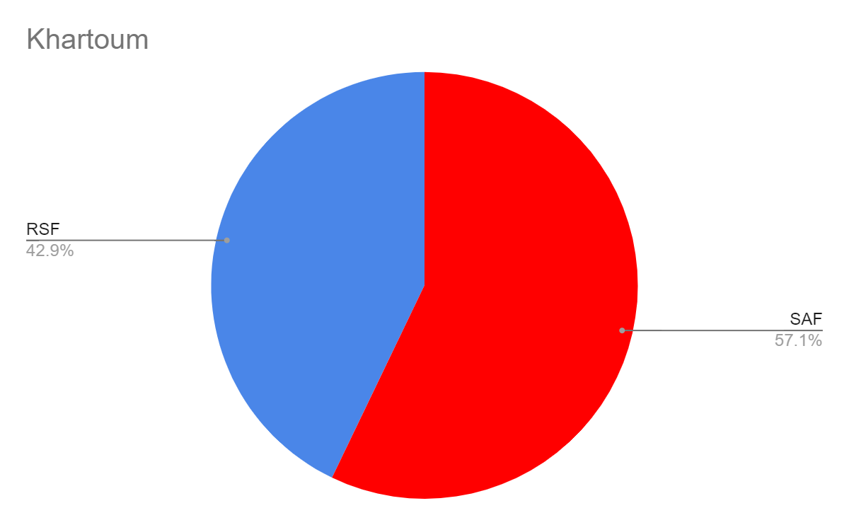

In December 2024 - Al-Jazeera State, which is considered one of the largest agricultural areas in Africa, there lived people of Darfur, Nuba mountain and south Sudan origin known as the “Kanabi people” (Kanabi is the plural of Kanbu and means camp). This people been migrated during the colonial era, eventually ended up there as community from al jazeera,

They settled in small villages lacking basic services, and have been working in agriculture for decades.

As soon as SAF controlled the area at least 70 people been killed from the Kanabi community,

According to the Sudanese people from the African community in other areas of Sudan still not sure about whether the SAF controlled what they do, if the Kanabi scenario can be repeated again.

**Key of the Conflict in Sudan**

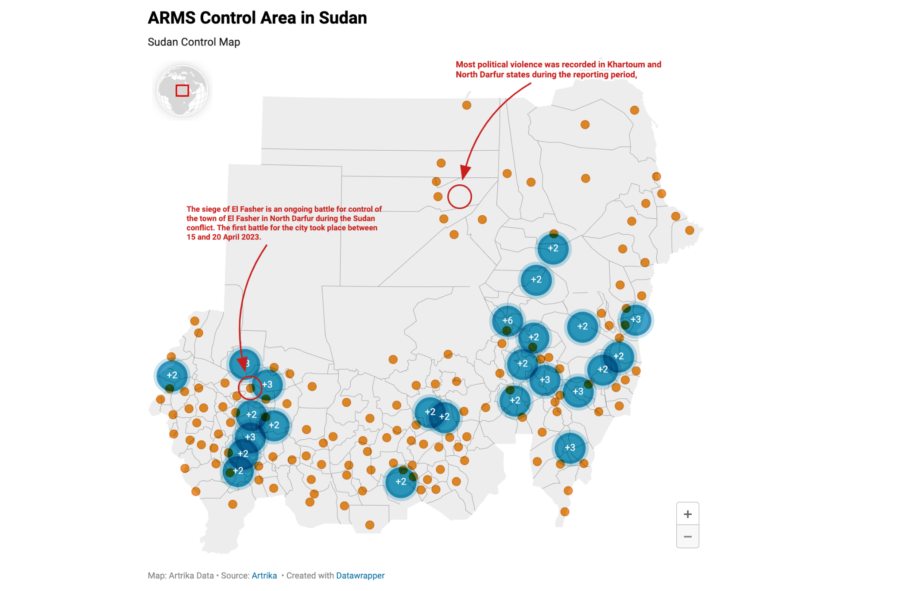

**Government of Sudan SAF and allies**

The Sudanese Armed Forces (SAF) are the official military of Sudan. They also control the country’s internationally-recognized government, headed by the Sovereignty Council, with the SAF’s commander chairing that committee and basically ruling by decree. As a rule, local governments in areas of Sudan not controlled by the RSF (or rebel groups) are affiliated with this administration, which is why even sparsely-populated areas of eastern Sudan are included in this category. Besides the SAF itself, allied forces with an armed presence on the ground include:

Other government-affiliated security forces, such as local police and the Central Reserve Police (Abu Tira)

The pro-SAF faction of the "Joint Force", made up of Darfuri former rebel groups including the SLM-MM, JEM-Jibril, SLM-Tambour, dissident factions of the GSLF and SLM-TC, and one remnant group of the Sudanese Alliance. The Sudanese Alliance, a group of massalit tribes from west darfur. The SLM-MM is believed to control the Umbro area in North Darfur, and together with JEM-Jibril forms the bulk of the pro-SAF forces in El Fasher, as well as (probably) the Tina border crossing.

The portion of the Sudan Revolutionary Awakening Council (SRAC) - a rival “Janjaweed” militia once similar to the RSF - that remains loyal to leader Musa Hilal. Hilal declared his group’s support for the SAF in April, ending a year of speculation on his loyalties.

The Malik Agar faction of the Sudan People’s Liberation Movement–North (SPLM-N Agar), a former rebel group that now governs Blue Nile state and has historically maintained a small force of troops in the northern part of the state and around Ulu village in the south. Agar is a strong supporter of the SAF in its war against the RSF, and a member of the country’s ruling Sovereignty Council. Many of his forces are now more or less integrated into the SAF.

SAF-allied armed groups based in eastern Sudan, such as the shadowy paramilitary National Entity Forces, the Blue Nile Tiger Forces, and prominent religious militias, like the El Baraa Ibn Malik Brigade, that are said to be associated with ousted dictator Omar al-Bashir.

Remnants of the officially-disbanded Bashir-era pro-government “Popular Defense Forces (PDF) militias in South Kordofan

Popular Resistance” militias, including local recruits directly armed by the SAF, but also grassroots Popular Resistance groups formed in eastern Sudan starting in December 2023. Pre-existing kinship-based militias across central and western Sudan may also fall into this category if they’ve sided with the SAF.

Possibly some small rebel groups based around the Eritrean border, drawn from the local Beja people.

**RSF and allies**

The Rapid Support Forces (RSF) are a powerful paramilitary group that officially comprised a wing of Sudan’s armed forces, but has been in rebellion against the SAF since April 2023. Allies of the RSF with a presence on the ground include:

Various local militias, particularly from the Arab communities of the Darfur and Kordofan regions (though others have opposed the RSF or remained neutral)

A portion of the police forces of areas captured by the RSF (others have fled to SAF-controlled areas), as well as those reported to have defected

The Sudan Shield Forces, a large but little-known militia based in Sudan’s southeastern quarter, which may now be integrated into the RSF

Certain factions or members of armed groups including the SRAC, the Third Front/Tamazuj.

**Unaligned opposition**

This category includes three groups that dominate specific territory in defiance of the Sudanese government, while not officially taking sides in the SAF-RSF war. Though they aren’t directly connected to each other, they do share a history of ties to South Sudan (which now has good relations with both the SAF-led government and the RSF).

**SPLM-N El Hilu:**

The Abdelaziz El Hilu faction of the Sudan People’s Liberation Movement–North is the largest rebel group in Sudan that's never made permanent peace with the government. A leftover part of the original SPLM rebel organization, which became the government of South Sudan after that country’s independence, the SPLM-N El Hilu says it’s fighting for a democratic and religion-neutral Sudan, possibly with an option for independence. It controls parts of South Kordofan and Blue Nile states, known as the “Two Areas”, and in recent months has sometimes cooperated with the SAF, but other times fought against it. The other major wing of the SPLM-N, led by Malik Agar, is now a close ally of the SAF and included under “Govt./SAF and allies” on the map.

**SLM-AW:**

The Abdel Wahid El Nur faction of the Sudan Liberation Army is the only Darfuri rebel group that’s maintained a strong presence inside Sudan ever since the rebellion there began in the early 2000s. It’s never made any peace deal with the government, and has continuously held parts of the Jebel Marra, a mountain range in the middle of Darfur, which it calls the “Liberated Territories”. The SLM-AW professes strict neutrality in the SAF-RSF war, being opposed to both sides - though one of its commanders seems to be quietly reinforcing the anti-RSF coalition within El Fasher (but probably not controlling any specific territory). The group is also called SLA-AW, and was part of the same group as the SLM-MM.

**Inside the Conflict**

**From February to March 2024 In South Kordofan**, some reports said SPLM-N El Hilu captured Habila after surrounding the town and attacking RSF forces there, possibly with help from an SAF-affiliated militia (ACLED), while the RSF reportedly raided several villages near the town and killed 24 people. The rebel group also reportedly seized a town just south of Habila from the RSF. However, some reports said they couldn’t confirm whether Habila had been captured by the rebels. A report several weeks later would say that the RSF had indeed “reportedly left” Habila on this date and that the town was under SPLM-N control, while a profile of the area from the following April would imply that the RSF had been in control since February.

Reported RSF raids on surrounding areas would continue over the following weeks, in the Habila area as well as others, including the surroundings of Delling (Dilling, Dalang, Dalanj), Lagawa (Laqawa), and the mountainous area of Jebel Dayir (Jebel El Dayir, Jabal ad Dayr, Jebel Dair, Jebel Al Daier) within North Kordofan state - which some reports said was an SPLM-N El Hilu control area, despite no mention of it in previous reports on rebel presence in the region.

**Nyala South Darfur**

In March 2024

As many as 14 people were killed in an armed robbery southeast of Nyala, on the road to Ed Daein (El Daein, Ad Da'en) in East Darfur state. The attack was allegedly carried out by members of the SLM-MM former rebel group, suggesting that the area lay at the edge of the RSF’s control zone despite being deep within an “RSF-controlled” state. And indeed, it would later be reported elsewhere that SLM-MM fighters were stationed in a village just to the north (ACLED).

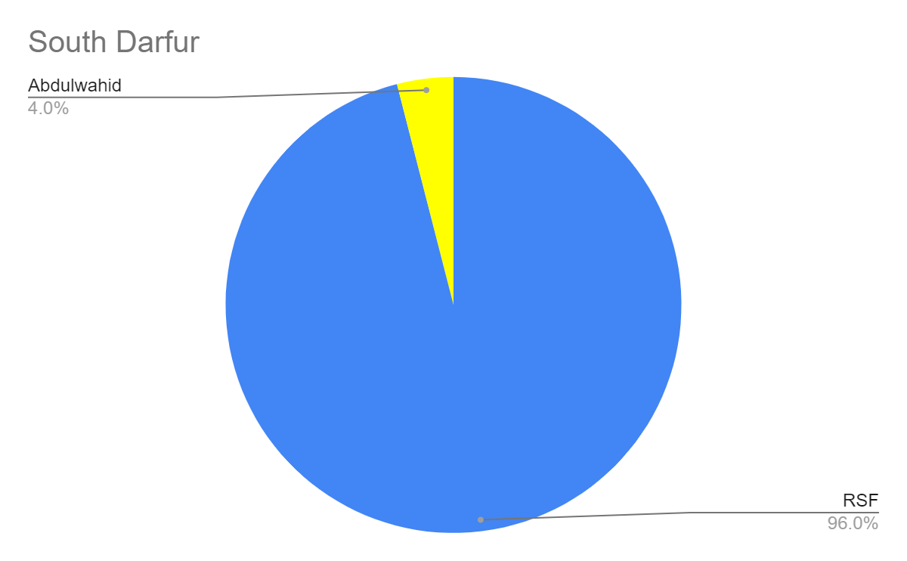

From May 2024 - RSF forces intervened and mediated to end a deadly feud between two rival kinship-based militias in the area straddling the Central-South Darfur border northwest of Rahad El Berdi (ACLED), providing new evidence that RSF presence extended farther into this area from both the Central Darfur and the South Darfur side. Related actions also took place northeast of Rahad El Berdi.

Also Between September 2024 and January 2025 our Airstrike Reports indicate that an airstrike conducted by the Sudanese Air Force (SAF) killed at least five displaced people, including a newborn, and injured three others in the Khamsa Dagayeg camp for displaced people in Zalingei, capital of Central Darfur, on Saturday evening. The Darfur Displaced and Refugee Camps Coordination has strongly condemned the attack, highlighting the ongoing and escalating pattern of aerial and artillery bombardment targeting displaced communities in Darfur.

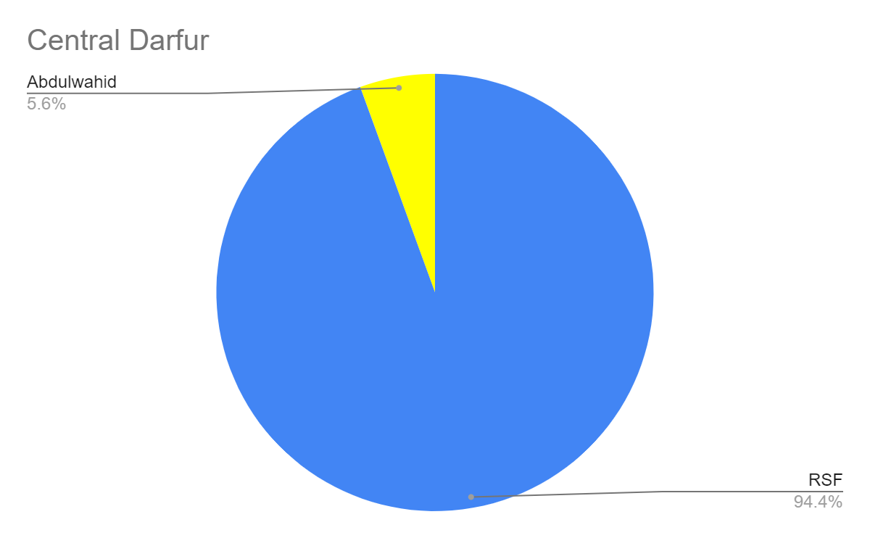

El-Fashir - North Darfur state is most of the Darfuri area that hosted more than 8 Arm Groups and militia, at the same time the conflict scale is increasing daily between each other, SAFGroups and RSF Groups, are fighting inside A-Fashir Town. it cost Displacement, War crime.

From June 2024 - Fighting resumed in El Fasher after a period of relative calm, with the RSF claiming to have captured the Al-Wahda neighborhood in the city’s south, while the Joint Force said it had repelled the attack with help from the SAF and Popular Resistance fighters. At least 11 civilians were killed amid the clashes. The newest wave of clashes took place largely in western and southeastern parts of the city. The following day, another 12 people were reported killed in RSF shelling within the city, as public services and commerce collapsed and much of the population attempted to flee.

During the same period, battles also reportedly occurred in the Zurrug area of North Darfur and another area that, according to historical maps, seems to be north of Ayn Siro and southwest of Zurrug.

Ongoing fighting in the northern and eastern parts of Al Fasher, together with attacks on villages to the west of the city, have pushed civilians towards the city where they now reportedly shelter in extremely overcrowded gathering sites throughout the southern neighbourhoods of the town. And Zamzam IDPs camp west south of El Fashir town.

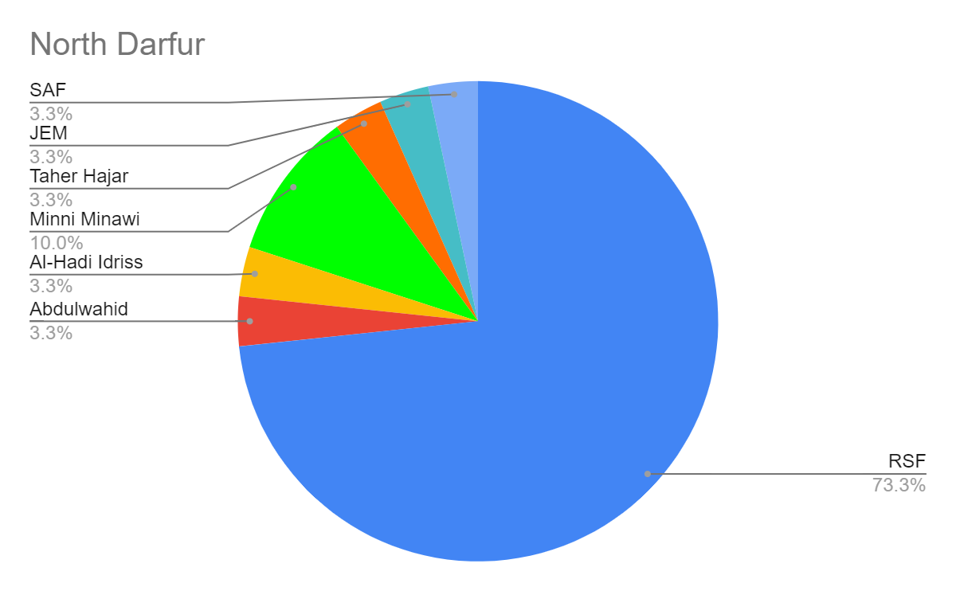

West Darfur from December 2023 to 2025

The Rapid Support Forces, an independent military force in armed conflict with the Sudan military, and their allied mainly Arab militias, including the Third-Front Tamazuj, an armed group, targeted the predominantly Massalit neighborhoods of El Geneina in relentless waves of attacks from April to June. Abuses escalated again in early November. The attackers committed other serious abuses such as torture, rape, and looting. More than half a million refugees from West Darfur have fled to Chad since April 2023. As of late October 2023, 75 percent were from El Geneina.

Still some areas in West Darfur are controlled by Darfuri rebel groups, Abbas Jable moon and Sudanese Alliance in the Northern side of west Darfur .

