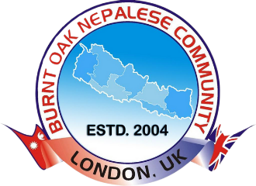

Burnt Oak Nepalese Community
London, United Kingdom

Review and Feedback Form

Date:
Name (Optional):
Event/Activity Name:
Role (if applicable): [e.g., Participant, Volunteer, Parent, Teacher]

1. Overall Experience
- ☐ Excellent
- ☐ Good
- ☐ Average
- ☐ Poor

2. Specific Feedback Areas
a) Content/Program:
Was the content or activity engaging and relevant?
- ☐ Excellent
- ☐ Good
- ☐ Average
- ☐ Poor
Comments: ____________________________
b) Organisation:
Was the event well-organised and smoothly executed?
- ☐ Excellent
- ☐ Good
- ☐ Average
- ☐ Poor
Comments: ____________________________
c) Environment and Facilities:
Did the venue meet your expectations in terms of safety, cleanliness, and comfort?
- ☐ Excellent
- ☐ Good
- ☐ Average
- ☐ Poor
Comments: ____________________________
d) Staff/Volunteers:
Were the staff or volunteers helpful and professional?
- ☐ Excellent
- ☐ Good
- ☐ Average
- ☐ Poor
Comments: ____________________________

3. Suggestions for Improvement
What could we do better in the future?

4. Future Participation
Would you like to participate in similar activities or events in the future?
- ☐ Yes
- ☐ No
- ☐ Maybe
If yes, what types of activities/events would you be interested in?

5. Additional Comments
Please share any other thoughts or feedback:

Thank you for your time and feedback! Your input helps us improve and create better experiences for our community.

