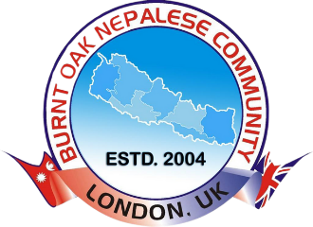

Burnt Oak Nepalese Community

**London, United Kingdom**

|  |  |  |
| --- | --- | --- |
|  | **SUBJECT: BONC Monthly Meeting minutes** |  |
|  | **Type: Hybrid Date and Time:** |  |
|  |  |  |

|  |  |  |  |  |  |  |
| --- | --- | --- | --- | --- | --- | --- |
|  | ATENDEES |  |  |  | NOTES |  |
|  |  |  |  |  |  |  |
|  |  |  |  |  |  |  |
|  |  |  |  |  |  |  |
|  |  |  |  |  |  |  |
|  |  |  |  |  |  |  |
|  |  |  |  |  |  |  |
|  |  |  |  |  |  |  |
|  |  |  |  |  |  |  |
|  |  |  |  |  |  |  |
|  |  |  |  |  |  |  |
|  | KEY POINTS |  |  |  |  |  |
|  |  |  |  |  |  |  |
|  |  |  |  |  |  |  |
|  |  |  |  |  |  |  |
|  |  |  |  |  | SUMMARY |  |
|  |  |  |  |  |  |  |
|  |  |  |  |  |  |  |
|  |  |  |  |  |  |  |
|  |  |  |  |  |  |  |



**https://bonc.org.uk/**

**info@bonc.org.uk**

**Watling Community Centre 143 Orange Hill Rd, Edgware HA8 0TR**

|  |  |  |  |
| --- | --- | --- | --- |
| Action Item | Responsible Person | Due | Progress |
|  |  |  |  |
|  |  |  |  |
|  |  |  |  |
|  |  |  |  |
|  |  |  |  |
|  |  |  |  |