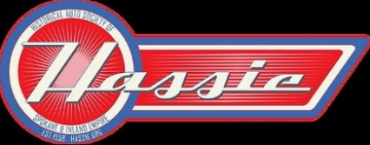
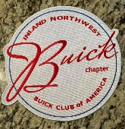

2026 BUICK OPEN CAR SHOW – REGISTRATION
September 12, 2026 | 10:00 AM–3:00 PM | Mirabeau Park Meadows

Name: ____________________________ Spouse: __________________________

Address: _____________________________________________________________

City / State / ZIP: _________________________________________________

Cell Phone: _______________________ Home Phone: _____________________

Email: _______________________________________________________________

Club Affiliation: ____________________________________________________

Note: Your email will be the primary way we contact you.

Registration Type:
[ ] $25.00 Registration Fee [ ] $1.00 Registration Fee (Age 25 and Under)

Total Enclosed: $____________________________________________________

Vehicle Information:

Make: ____________________________ Model: ____________________________

Year: _____________________________

Award Class (check one):

[ ] 1939 and Older

[ ] 1940 thru 1949

[ ] 1950 thru 1959

[ ] 1960 thru 1969

[ ] 1970 thru 1979

Your spot will be reserved. If not prepaid, please pay at the sign-in table the day of show.

