

**WATER OAK VETERANS CLUB Inc.**

**November 9th, 2025**

**Supporting Our Veterans**

**The Defenders of Freedom**

**In cooperation with**

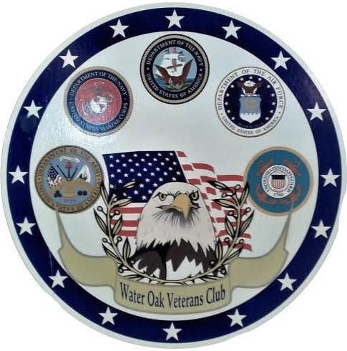

**W.O.V.C. is staffed by volunteers and receives NO Government Funding.**

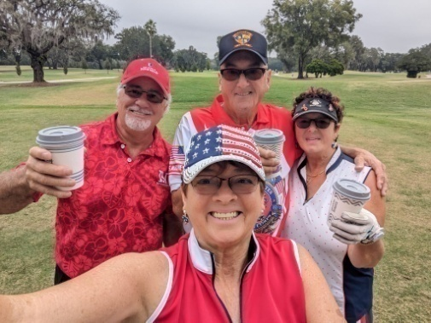

**Web Site:** [**www.wovets.org**](http://www.wovets.org)

**or**

**Email: svdirish@gmail.com**

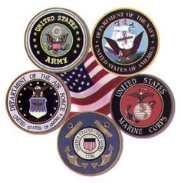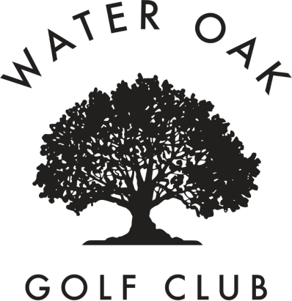

Water Oak Veterans Club Inc. a 501(c)3 organization is making plans for the annual Veterans Golf Tournament and Dinner on November 9th, 2025 to be held at Water Oaks Country Club 645 Hickory Hill Lady Lake, FL. The money we raise each year goes to focusing on service to veterans, service members, and our veterans in surrounding local communities.. We provide needed medical equipment and financial assistance to those in need just to name a few.

**Platinum Sponsorship**

**$2,500 Donation**

* Company Name and Logo in all Promotional Material
* Event Signage, Banners, Tee Boxes, Carts & at Dinner
* Opportunity to provide promotional items for Goody Bags
* Golf for 1 Foursome Included in Tournament
* Display table at the event
* Company Executive to present at Awards Ceremony
* Business Category Exclusivity
* Company Name and Logo on all Par 3 Holes

**Hole Sponsorship**

**$250 Donation**

* Small Company Logo Recognition as Hole Sponsor on Tournament Webpage
* Opportunity to station personnel at hole during the Tournament
* Opportunity to provide promotional items for Goody Bag
* Par 3 holes eligible for Hole In One contest
* Company Logo at Hole

Sponsorship Donation

*  **Platinum Sponsorship**
*  **Gold Sponsorship**
*  **Silver Sponsorship**
*  **Hole Sponsorship**

 Name ____________________________________________________________

 Address __________________________________________________________ City ______________________________

St. ___ Zip ______

Phone_________________________ **Thank you**

***Align yourself with a great event and support our veterans.***

***Make sure you sign up early as we have deadlines for all advertising!***

Last year we reached over 10,000 plus individuals locally through our advertising, which includes: [wovets.org](http://wovets.org/), Facebook, flyers, news articles and newspaper ads.  We rotate sponsors in our Water Oak Voice newsletter monthly. Be part of what makes this so successful!

The Water Oak Veteran Club golf charity has sold out for the last several years and we are still growing.  Although the golf event fills up fast, our dinners are ever growing so come join the excitement.  Last year we had 250+ people enjoying a delightful dinner, dancing, and wonderful raffle prices. What a party!

It takes generous sponsors and many volunteers to make this such a successful event.

**Thank you in advance for your support!**

**Gold Sponsorship**

**$1,500.Donation**

* Company Name and Logo in all Promotional Material
* Event Signage, Banners, & on easel board
* Opportunity to provide promotional items for Goody Bags
* Golf for twosome Included in Tournament
* Display table at the event
* Company Name and Logo on 2 Par 3 Holes

**Silver Sponsorship**

**$500 Donation**

* Recognition as Dinner Sponsor on all print and media promotions
* Small Company Logo on Tournament Website
* Company Banner Displayed at Dinner
* Opportunity to provide promotional items for Goody Bags

The success of this event is credited largely to those businesses who lend their support to this event.

**Mail Payment to;**

**Water Oak Veterans Club Inc.**

**102 Evergreen Lane**

***LADY LAKE, FL 32159***