Proverbs 5:15-21
Drink waters out of thine own cistern, and running waters out of thine own well. (16) Let thy fountains be dispersed abroad, and rivers of waters in the streets. (17) Let them be only thine own, and not strangers' with thee. (18) Let thy fountain be blessed: and rejoice with the wife of thy youth. (19) Let her be as the loving hind and pleasant roe; let her breasts satisfy thee at all times; and be thou ravished always with her love. (20) And why wilt thou, my son, be ravished with a strange woman, and embrace the bosom of a stranger? (21) For the ways of man are before the eyes of the LORD, and he pondereth all his goings.

- Rejoice = thankful

- The biggest problem for most couples is that they don’t know how to biblically solve problems.
- A peaceful, happy marriage is not a marriage that has no problems (they don’t exist)
- When we add our depravity to an already volatile situation, we only compound the problem.
- Your goal should never be to “win the argument.”

- Principles of Communication
- Speak up
- Speak the truth
- Speak Lovingly

- Refreshed = satisfied

- God’s Goal for Marriage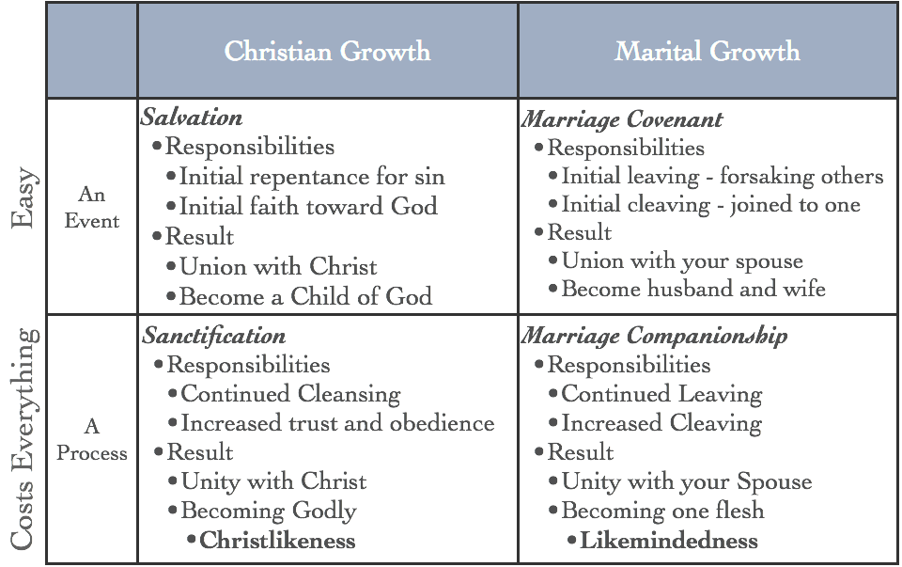

- Ravished = intoxicated

- Sex
- The primary goal is to meet the needs and desires of your spouse
- Need = your need is to meet your spouses desires

- God created the physical relationship
- for procreation
- for pleasure
- for protection
- for promoting the glory of God

