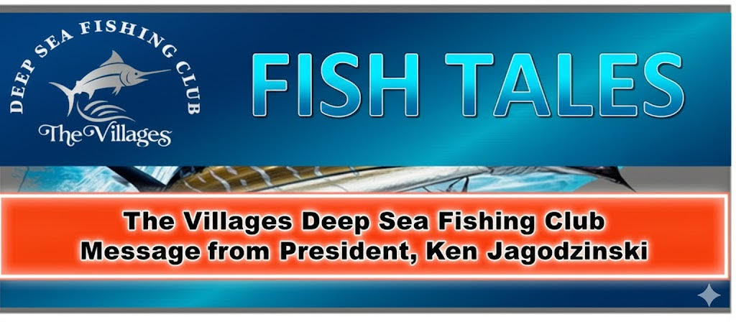

Who’s ready to go fishing?
We’ve had our share of windy weather so far in 2026, but things are about to change for the better. In April, our Club organized 31 charter trips, of which 22 actually left the dock. Nine (9) were cancelled due to the weather. The early spring brings warmer days, warming water, greater fish activity, and lots of great fishing options. Depending on what species or type of trip you are looking for, our Club most likely has a charter for you.
Don’t forget about our 44-hour trips on the Gulfstar Endurance. There are a few spots left.
Available Trips:
June 12–14: American Red Snapper
September 4–6: Gag Grouper

We’ve secured a preferred club rate of $875, which covers almost everything: charter, food, tackle, bait, ice, and fish cleaning (tip is additional).
Contact Joe Italiano at 203-648-2173 or joeitalianojr@gmail.com

Monthly meeting time!
The Villages Deep Sea Fishing Club is excited to welcome a terrific speaker for our May meeting on Monday, May 4th. The meeting will be held at the Everglades Recreation Center.
Our speaker for the May 4th meeting will be Bryan Strawn, owner of Reel Hard Fishing in Ocala. He will present a seminar on fishing gear maintenance. He will bring different types of reels and explain their use and how to keep them cleaned to maximize longevity. Bryan will also answer your questions on rod building and repair. If you own your fishing gear, you don’t want to miss this meeting!
Doors open: 6:00 PM
Meeting begins: 6:30 PM
See you there!
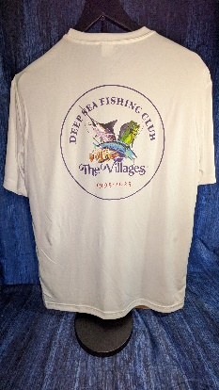
Fishing Club Apparel Clearance Sale
Missed out on our 30th Anniversary gear earlier this year? Here’s your chance to score some great Club apparel—and save at the same time.
One night only — Monday, May 4th meeting
Enjoy 40% OFF all Club merchandise, including:
- Polo shirts
- Long- and short-sleeve t-shirts
- Hats
Limited sizes and quantities available—shop early!

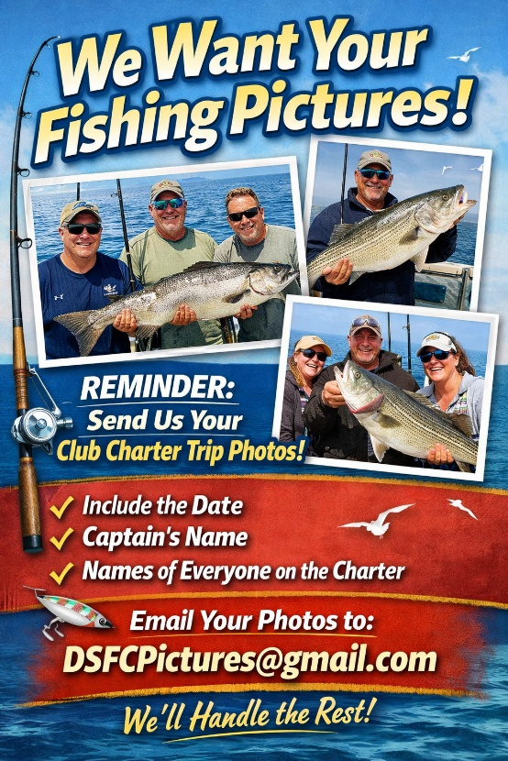

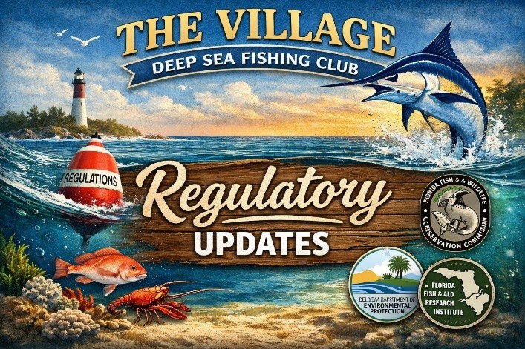

NOAA Announces a 93-day 2026 Recreational Fishing Season for Gag in the South Atlantic Region
The 2026 recreational fishing season for Gag Grouper in federal waters of the South Atlantic will start on May 1, 2026, and end on August 2, 2026. This is the longest Gag Grouper season in recent years and offers an incredible opportunity to get out and catch some Gags. Our Club will have trips that you can take advantage of. Check out our website for details or learn more at our monthly meetings.

Until Next Month
Tight Lines!
Ken Jagodzinski

