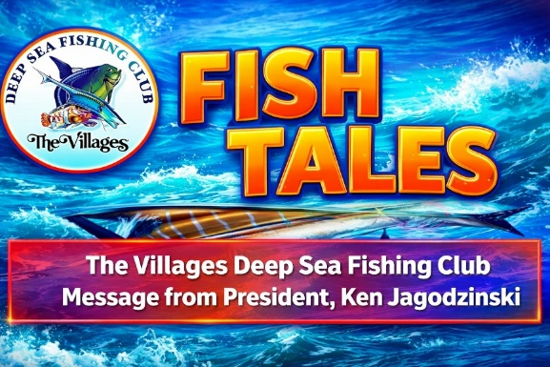

Just some thoughts!
It’s amazing how maddening the Florida weather can be. After 12 years as a full-time Florida resident, I can’t remember a winter this cold—or this windy. The conditions have definitely limited our time on the water. Of the 40 charters our Club scheduled in January and February, 18 were cancelled due to cold or wind. The good news, we’ve turned the corner, and better days are ahead.

The next several months should bring outstanding fishing opportunities for our members. March marks the opening of Snook season, with the action really heating up in April and May—prime time for landing a slot-sized Snook. We’re also keeping our best positive thoughts that the weather cooperates so that our 4-day Club trip on March 9th on The American Patriot gets to go.

April and May also welcome the return of our migratory species from the south, especially Cobia and Tarpon. Cobia typically will start showing up around mid-April, and soon after, Tarpon begin appearing in many of the same areas. How about the angler’s perfect dream day - land a Snook, Redfish, Trout, Cobia, and Tarpon all on a single trip!

Our Club Captains will be offering trips to make the most of these opportunities, so be sure to check the website for upcoming availability.

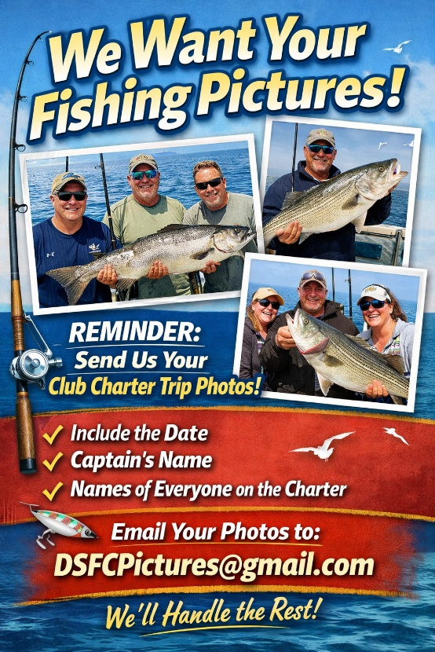

Captain Leiza Fitzgerald to speak at March’s meeting
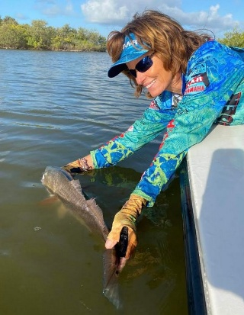
If you missed her presentation to our Club last fall, here’s your second chance! Captain Leiza Fitzgerald will be joining us tomorrow to share her tips and techniques for catching more fish, choosing the right tackle, and much more. This promises to be an informative, engaging, and valuable session for anglers of all experience levels.
Doors open: 6:00 PM
Meeting begins: 6:30 PM
See you there!

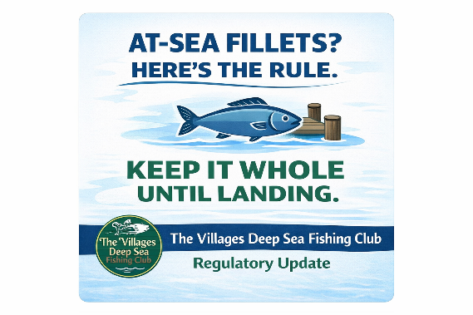
At Sea Fish filleting – to be or not to be!
At February’s monthly meeting, the question was asked of Paul Forsberg, owner of The Gulfstar Endurance fishing boat, as to why at-sea filleting of fish is not allowed and if the rule could be changed. I agreed to investigate this and respond to the Club.
After consulting with Senior FWC leadership in Tallahassee, FL, I received the following response:

“Under existing Florida rules, most species must remain in whole condition until they are landed. This requirement ensures that size limits, bag limits, and species identification can be accurately verified by law enforcement. With only a few limited exceptions for certain federally managed species, at-sea filleting is generally not permitted in state waters or for species regulated by the state.
We understand the operational challenges you described, particularly during multi-day or high-capacity charter trips where fish cleaning can take considerable time once vessels return to the dock. We also recognize that many anglers prefer to bleed their catch and place it on ice immediately to maintain the highest possible quality. These handling practices are fully compatible with current regulations, provided the fish remain whole and identifiable until landing.
It’s also important to note that any changes to federal regulations allowing additional at-sea processing would need to move through the appropriate regional fishery management councils. Those councils—rather than the state—have the authority to develop and approve amendments to federal rules governing species managed in federal waters. As a result, even if Florida were to consider adjustments on the state side, any parallel changes for federally managed species would require council action and subsequent approval by NOAA Fisheries.”

The Club’s position is straightforward: we will NOT pursue further efforts to request a rule change. Given the limited number of trips that our Club operates each year on vessels where this issue applies, we recognize that our Club does not have sufficient standing to drive a regulatory change on our own.

Accordingly, we will refer this matter to the high-capacity charter boat industry to determine whether they wish to advance a rule change. If they choose to move forward, our Club will fully and actively support their efforts to ensure our collective voice is heard in the process.

Last call for dues renewal
Any member who has not renewed their dues
will be dropped from our mailing list on April 1st.

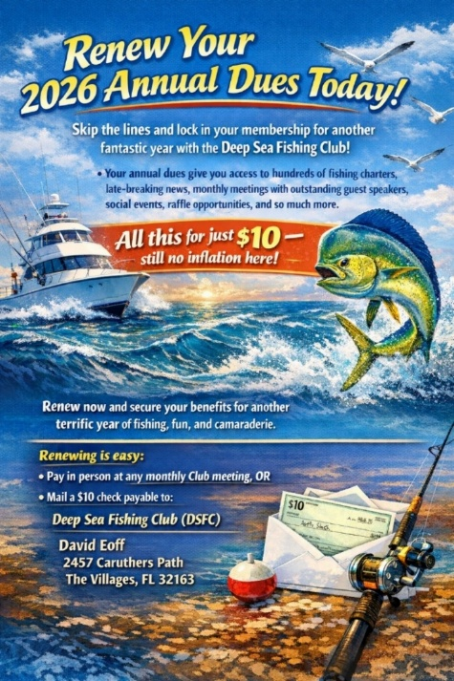

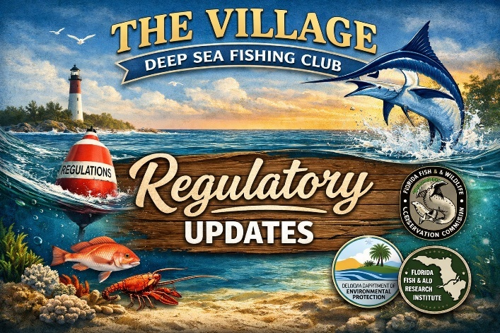

Voice your opinion on Red Snapper Management in the Atlantic Ocean

NOTE: Long read, but worth the time! If you want more Red Snapper fishing days in the Atlantic, please take action.
The South Atlantic red snapper fishery (Florida, Georgia, South Carolina, and North Carolina) has been a frustrating debacle for anglers for well more than a decade. Despite a population that has been declared the most robust in recent history, recreational seasons have been measured in days…sometimes a single day. In 2025, the season was just two days, and NOAA Fisheries was promoting plans to close the bottom in some areas to prevent any take of red snapper, even as bycatch!

Recognizing the flaws with federal management of red snapper, proposals have been submitted for Exempted Fishing Permits (EFP). The permits would allow the states to test data collection and management improvements that would significantly increase recreational access to Atlantic red snapper this year, with Florida planning a 39-day season while the other states propose 62-day seasons.

NOAA Fisheries has opened a public comment period for these EFP proposals. This gives anglers the chance to leave feedback in support of these proposals and explain how their communities would benefit from them.
CLICK HERE to be taken to the comment page, and feel free to use the talking points below to add to your own views and experience in lending your support to these state management proposals:
- I support approval of the South Atlantic state EFPs to test data collection and management strategies for Atlantic red snapper.
- The Atlantic red snapper population is the healthiest it has been in decades. The EFPs would help break the cycle of extreme access limitations for this abundant fishery while testing much-needed data collection improvements.
- Federal management of red snapper has been based on inaccurate catch and effort estimates from the Marine Recreational Information Program, which is ineffective for tracking Atlantic red snapper catches.
- The states propose recreational data collection improvements that would provide critical baseline data to better inform future management decisions.
- Longer recreational red snapper seasons better balance conservation with harvest opportunities and will benefit anglers by significantly increasing harvest opportunities compared to NOAA’s two-day season in 2025.

Until Next Month
Tight Lines!
Ken Jagodzinski

