
Flying Eagles Inc.
Newsletter for September 2020

Date: August 31, 2020

http://www.flyingeaglesinc.org

Next Meeting: Monday September 7, 2020

Location: The meeting will be held at the field, 5710 S Mackinaw Rd (first drive on west side of Rd south of Salzburg). Club meetings are open to the general public.

Time: TBD (during or after the 10am Labor Day picnic)

2020 CLUB OFFICERS ARE:

President: Mike Massey
VP: Mike Young
Treasurer: John Potts
Recording Secretary: John Wright
Safety Coordinator: Eric Evans

Club Trustees:
John Wright
Mike Young
Pat Dauer
Paul Robinson
Gary Schmidt

Visitors are always welcome to the club meetings and to join us at the club flying field. The flying site is located at 5710 S. Mackinaw Rd., Bay City, MI.

MEETING MINUTES

Mike Massey started the meeting on 8/3/2020 at 6:15pm at the field, 8 members were present, no visitors.

Minutes from the previous meeting were accepted as printed in the newsletter.

Treasurer’s Report – 27 paid members, June income- 3 members dues 1 upgrade, June expenses- $61.45 tractor oil/weed killer/oil filter. July income- 3 member dues, July expenses- $45.00 porta john cleaning - Current balance
$2024.70

Safety report – 1 airplane lost control, no injuries

Web report – No report this month

Board report – No report this month

Old Business: o Labor Day picnic, same as Memorial day will start at 10am lunch at noon.

New Business: o A lookout tower for the corn was proposed. An estimate for materials will be prepared and discussed with the landowner.

Airplane Contest:
Last month – The winners of the airplane contest for the last newsletter will be announced at the Sept meeting

Show and Tell:
Mike M brought his Flite Test P 40
Pat brought his Das Ugly stick V2 from Hobby king

Meeting adjourned at 6:24pm

** Notes from the editor: Please submit any content you may have for the newsletter. Do you have a spring project in your workshop? Take a couple pictures and email them to me. I would love to beef up the newsletter and make it a much more interesting read!

AIRPLANE CONTEST

** Sorry, due to the editors tardiness, we will pick up again next month with the contest.

Airplane Contest Rules:
Only paid members of the Flying Eagles Inc. Radio Control Club are eligible to win. All entries must be emailed to kwww68@charter.net the day before the meeting (Sunday or earlier please). The winner will be drawn from all correct entries that have been received by that date and presented during the regular meeting (need not be present to win, even if you have won previously, you are still eligible to enter every month).

Visit us on the internet at http://flyingeaglesinc.squarespace.com
We have some picture submissions this month!

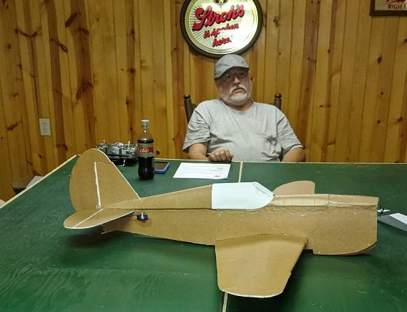
Cheer up Mike! It’ll fly!

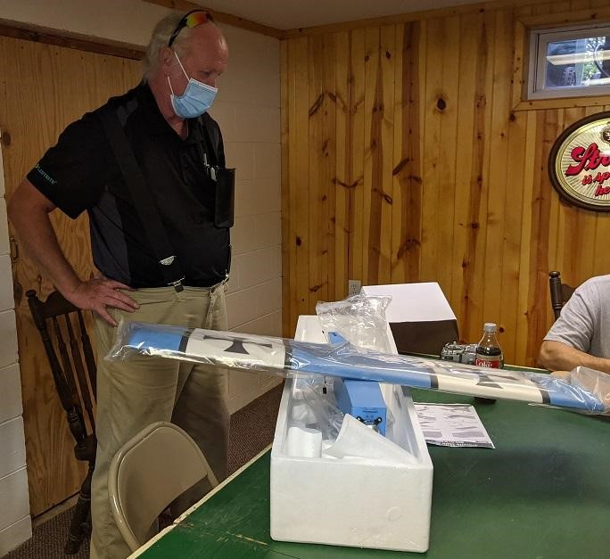

Hey Pat, did you intend for your mask to match the plane?

