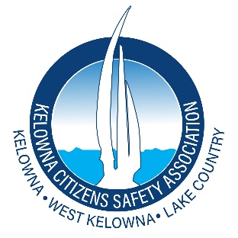
PRESS RELEASE
March 5, 2026
KCSA Raises Environmental and Transparency Concerns Over Kelowna Springs Rezoning
Kelowna, BC — The Kelowna Citizens Safety Association (KCSA) is raising environmental and transparency concerns ahead of the upcoming public hearing on the proposed rezoning of the Kelowna Springs Golf Course lands at 480 Penno Road.
The proposal would convert roughly 55 acres of the 106 acre property into an industrial business park, while the remaining portion would continue operating as a nine hole golf course.
KCSA says the land still holds significant ecological and hydrological value, including ponds, mature trees, wildlife habitat, and permeable open space within the Mill Creek floodplain.
“Once this land is industrialized, it is gone forever,” said Lloyd Manchester, President of the Kelowna Citizens Safety Association. “This is over 50 acres of open space within the Mill Creek floodplain, containing mature trees, water features, and permeable land that currently provides ecological and hydrological value. Council must carefully consider the long term environmental and financial implications before approving a permanent conversion of this scale.”
KCSA has identified several issues that it believes require careful scrutiny before Council proceeds with the rezoning.
The association has raised concerns about:
• Floodplain grading and long term flood mitigation impacts
• Loss of green space and habitat areas
• Increased industrial traffic and servicing demands
• Infrastructure costs and cumulative impacts on neighbouring agricultural lands
• The precedent of amending the Official Community Plan for a major private land use shift
In addition, questions have been raised regarding transparency surrounding a proposed municipal land exchange connected to the project. City officials have referenced a swap involving approximately 9.5 acres of industrial land on Hollywood Road and a portion of the Kelowna Springs lands, however the valuation and appraisal information for the properties involved has not been publicly released.
“The proposed exchange constitutes a disposition of municipal property under Section 26 of the Community Charter,” Manchester said. “That legislation requires public notice and sufficient detail to allow meaningful public scrutiny of the transaction. No transparent valuation or comparative appraisal has been released.”
KCSA has submitted a letter to the City Clerk requesting that the public hearing be postponed until the required valuation and appraisal information related to the proposed land exchange is disclosed.
KCSA is also calling for the hearing to be postponed until the public is provided with complete environmental and economic information related to the proposal.
“The City should not proceed with a decision of this magnitude until the public has access to the full picture,” Manchester said. “That includes the valuation details of the proposed land exchange, environmental assessments related to floodplain grading and habitat impacts, stormwater and servicing plans, and a clear economic analysis of future infrastructure and public costs. The responsible course is to postpone the hearing, release the relevant information, and reconvene once the public has had a fair opportunity to review the facts. Ultimately, the best long term solution for this property is for the land to be protected for public benefit, including consideration of expropriation to preserve the ecological and hydrological values of the site rather than allowing permanent industrial development.”
Public Hearing
Kelowna City Hall
May 10, 2:00 PM
Media Contact
Lloyd Manchester
President
Kelowna Citizens Safety Association (KCSA)

