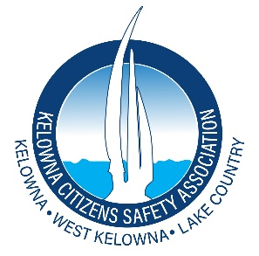
Kelowna Citizens Safety Association
Kelowna BC

TO: Chair and Board of Directors
Regional District of Central Okanagan (RDCO)

January 13, 2026
Subject: Urgent: Immediate Repeal of DRIPA Required to Restore Land and Economic Certainty Across the Central Okanagan
Dear Chair and Members of the Board,
The Kelowna Citizens Safety Association (KCSA) is writing to advise the Regional District of Central Okanagan that we have formally written to Members of the Legislative Assembly and to the Premier of British Columbia regarding the growing land title and economic uncertainty arising from the Declaration on the Rights of Indigenous Peoples Act, SBC 2019, Chapter 44 (DRIPA), and recent related court decisions.
Although DRIPA is provincial legislation, its impacts are being felt directly at the regional and municipal levels. Ongoing uncertainty around land title security, property rights, and reconciliation processes is affecting planning, zoning, development approvals, infrastructure investment, taxation, borrowing, and long-term capital planning across the Central Okanagan. These impacts extend beyond government and are being felt by homeowners, renters, developers, lenders, and local governments throughout the region.
Recent court decisions, including the Cowichan/Richmond ruling and the Gitxaala decision, combined with DRIPA’s requirement that all provincial laws and future Government actions be brought into alignment with DRIPA, have introduced expanding uncertainty across British Columbia’s land and governance systems. This creates cascading risk for Regional Governments that must coordinate infrastructure, service delivery, and long-term planning across multiple jurisdictions.
Regional districts depend on a single, clear, and dependable land title system to function effectively. When that certainty is undermined, regional governments face increased financial exposure, planning risk, delayed projects, higher costs, and reduced public confidence. These are risks regional governments cannot control but are nevertheless expected to manage.
-2-

KCSA is calling on the RDCO to formally advocate to the Province for decisive action. This includes urging the immediate repeal of DRIPA and supporting strong and timely appeals of recent court decisions, including the Cowichan/Richmond and the Gitxaala decision. These rulings critically undermine land title certainty in BC and in Canada.
We respectfully request that the RDOC considers passing a resolution or otherwise formally communicating to the Province the Regional/Municipal concerns regarding the real and potential impacts of DRIPA. Attached for the RDOC’s reference is our letter to the Members of the Legislative Assembly which sets out five specific action items. We request that the RDCO take these action items into account when determining your response to the Province.
We would welcome the opportunity to present to the RDOC on the Municipal and Regional impacts of DRIPA and the recent court decisions, We appreciate your attention to the serious implications raised by DRIPA and look forward to an early response, including the opportunity to speak directly to the RDCO on DRIPA.
Sincerely,
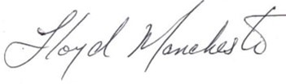
Kelowna Citizens Safety Association
Lloyd Manchester
President
Kelowna, British Columbia
Email: Nodripa_kcsa@proton.me

Cowichan Tribes v Canada (Attorney General), 2025 BCSC 1490 (CanLII)
Gitxaala v. British Columbia (Chief Gold Commissioner), 2025 BCCA 430 (CanLII)

