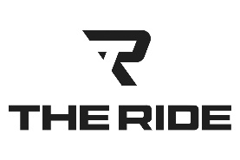 | 2026 PRO  FOOTBALL PACKAGES
740-972-2334 | ROUND TRIP SERVICE  (Gratuity for driver not included in pricing)  The Elite  Up to 6 Passengers  Bengals / Browns - $925.00  Steelers / Colts - $1,195.00  The Event / The Excursion / The Echelon  Up to 14 Passengers  Bengals / Browns - $1,425.00  Steelers / Colts - $1,750.00  The Boss  Up to 23 Passengers  Bengals/Browns - $2,300.00  Steelers / Colts - $2,700.00  TAILGATES  (Gratuity for driver & Parking Fee/Pass not included in pricing)  All-Inclusive Services Include:  ● Exterior TV & Audio / Exterior Awning or 10x10 Tent / 2x4 Serving Tables / Bag Chairs / Plates, Cups, Flatware  ● 3 ½ Hour Tailgate service  ● Tailgate area management  The Excursion or The Event – Up to 14 Passengers  Bengals / Browns - $1,800.00  The Boss – Up to 22 Passengers  Bengals / Browns - $2,650.00
  kris@TheRideColumbus.com
  TheRideColumbus.com
  Ride In Style
  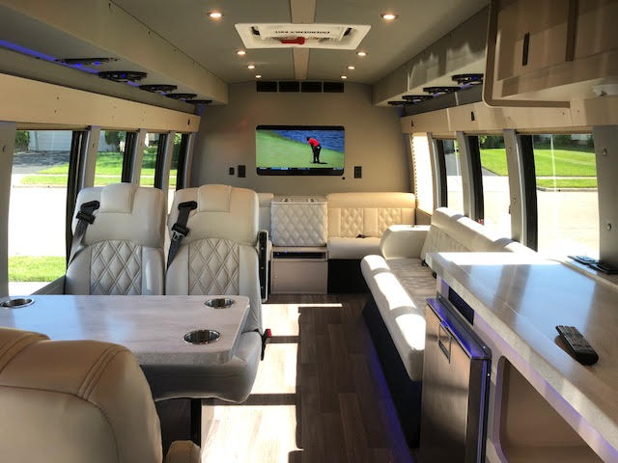
  2 Flat Screen TV’s
  Premier Sound System
  Serving Station
  Playing Table
  Captain Chairs
  Luxury Sofa Seating
  Tailgate Center w/ 65” TV
  