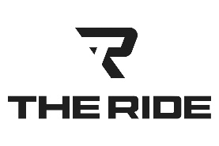 | OHIO STADIUM TAILGATE PACKAGES
740-972-2334 | Standard Package  ● Guest pick-up at designated location  ● Complete Tailgate Set-up  RV Parking Pass / Custom Bus with Audio / Video Tailgate Center /  12’x12’ Tent or Built-in Awning / Tables / Plates, Cups, Flatware / Folding Chairs  ● 4 Hour Tailgate Service & Area Management  ● Tear down of tailgate while you’re at the Event  ● Return trip home following event  Not Included in Pricing:  Food & Beverages / Driver Gratuity  The Excursion / The Event / The Echelon  14 Passenger Custom Coaches  $1,695.00  The Boss  23 Passenger Custom Coach  $2,050.00  Add-on Options  Private Porta John  $200.00  Tailgate Grill(s) with Hospitality Service  $500.00  Food & Beverage Personal Shopper and Cooler Use/Stocking  $150.00  Golf Cart Shuttle to Event  $250.00
  kris@TheRideColumbus.com
  theridecolumbus.com
  