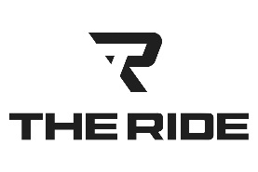 | CAVS GAME PACKAGES
740-972-2334 | Round Trip Service  Guest pick-up at designated location  Departure Time – 3 hours before game time  Return trip home following event.  Gratuity Not Included in Pricing:  6 Passenger SUV  $925.00  6 Passenger SUV Premium  $1,050.00  Early Departure Add-On  ● Pre-game Plans?  $60.00/hour  14 Passenger Custom Coach  $1,425.00  14 Passenger Custom Coach Premium  $1,625.00  Early Departure Add-On  ● Pre-game Plans?  $125.00/hour  22 Passenger Custom Coach  $2,195.00  Early Departure Add-On  ● Pre-game Plans?  $160.00/hour
  kris@TheRideColumbus.com
  theridecolumbus.com
  