  740-972-2334  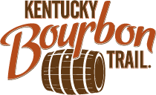    The Event      The Excursion  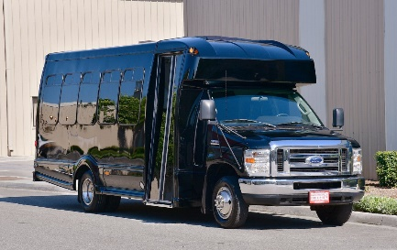   | Northern Region  ● Boone County Distillery ● Neeley Family Distillery  ● Augusta Distillery  8 – 10 Guests: $275/person  Central Region  ● Woodford Reserve ● 4 Roses Distillery  ● Larrikin Bourbon Company  8 – 10 Guests: $310/person  Lexington Region  ● Hartfield & Co. ● Bespoken Distillery  ● RD1 Distillery  8 – 10 Guests: $265/person  Bardstown Region #1  ● Lux Row ● Preservation Distillery  ● Willett Distillery  8 – 10 Guests: $300/person  Bardstown Region #2  ● Limestone Branch ● Maker’s Mark  ● Log Still Distillery  8 – 10 Guests: $305/person  Louisville Region  ● Rabbit Hole Distillery ● Angel’s Envy  ● Stitzel-Weller Distillery  8 – 10 Guests: $310/person
  kris@theridecolumbus.com
  theridecolumbus.com
  BOURBON TRAIL TOURS
  Included in price: Travel, Tour/Tasting Fees, Pizzas for trip home
  Not Included in Price: Concierge’s Gratuity

