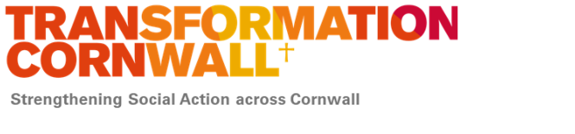

Annex A: Food Bank Case Study: Consent Form Template (Draft v1 23/02/26)
Produced by Rosaleen allcott Transformation consultant
This form ensures that the person sharing their story understands how their information will be used and that they are giving fully informed, voluntary consent.
Purpose of this form: Food banks sometimes collect short, anonymised stories (case studies) to help demonstrate the impact of their support. These stories may be used in reports to funders, supporters, Transformation Cornwall, the Trussell Trust, partner agencies, or for staff/volunteer training. Stories are always anonymised in line with Toolkit Section 2.
**Please read each statement and tick to confirm:**
☐ I understand that sharing my story is voluntary and will not affect any support I receive.
☐ I agree that my story can be written and used anonymously.
☐ I understand that no real names, addresses, or identifying details will be included.
☐ I understand that my anonymised story may be shared with the food bank, Transformation Cornwall and/or the Trussell Trust (depending on consent settings).
☐ I understand I can withdraw consent at any time, and future use of my story will stop.
**Optional Quote:** If you are happy to share a short quote in your own words, please write it here.
__________________________________________________________________________
__________________________________________________________________________
**Your initials or case code (not full name):** __________________________
**Date:** ____ / ____ / ________
**Staff/Volunteer Obtaining Consent:**
Name: ____________________________________________
Signature (optional): ______________________________

This consent form must be stored securely in line with the food bank’s data protection policy.

