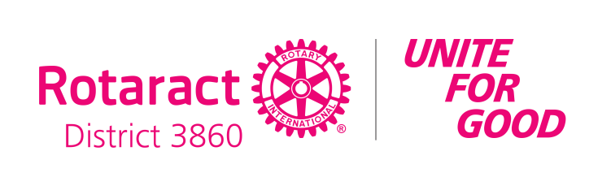

**HANDOVER OF BELL & GAVEL**

President **<NAME OF NEWLY INDUCTED PRESIDENT>**, as the outgoing president of the Rotaract Club of <CLUB NAME>, I am handing over this gavel and medallion to you as a symbol of authority.

Please wield it steadfastly but righteously, with courage but with humility, with determination but with compassion and understanding.

As you accept this gavel and medallion and the authority that goes with it, may God bless you, guide, and help you in all your undertakings as the new president of our club.

May you serve this club well and successfully.

President **<NICKNAME OF NEWLY INDUCTED PRESIDENT>**, I know and I believe that you will be an outstanding president.

Remember, because of you... your diligence in reporting and active participation and support to all our activities, you made our club outstanding too.

I promise you that I will be there for you and for our club.

Congratulations, President **<NICKNAME OF NEWLY INDUCTED PRESIDENT>**.



**ACCEPTANCE OF BELL & GAVEL**

President **<NAME OF OUTGOING PRESIDENT>**, I do hereby accept this gavel and medallion as the symbol of authority vested upon myself as the president of the Rotaract Club of **<CLUB NAME>** for the Rotary Year 2025-2026 with Rotary International Presidential Message “Unite for Good”.

I do hereby pledge to wield this gavel and medallion steadfastly but righteously, with courage but with humility, with determination but with compassion and understanding. And, I thank you and all the other officers and members of this club for giving me this opportunity and your trust in me.

President **<NICKNAME OF OUTGOING PRESIDENT>**, I assure you and the members of the club that the Rotaract Club of **<CLUB NAME>** will be in good hands... especially if you hand over to me the funds that are left in your term. I will check your attendance to ensure that you live up to your promise to be there for me and the club. I will also encourage more fellowship under the new normal because it is in fellowship that we serve.

Thank you.