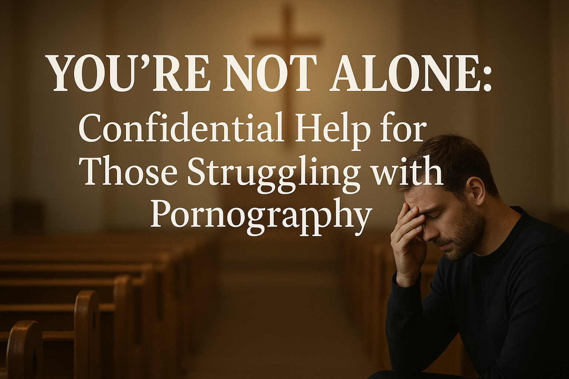

**You’re Not Alone: Confidential Help for Those Struggling with Pornography**

One of the hardest parts of struggling with pornography is the **sense of isolation**. Many feel trapped in shame and fear of judgment. But there is hope, and help is available.

Recovery begins with a single step: reaching out for support. Programs like **Redemption Road Mentoring, supported by NALC leadership**, provide confidential, anonymous, Christ-centered mentoring tailored to individuals seeking freedom from pornography addiction. You don’t have to navigate this path alone.

Remember, **healing is possible**. With the right guidance, accountability, and encouragement, individuals can experience restored relationships, renewed faith, and a life of freedom. Take that courageous first step—confidential support is just a click away.