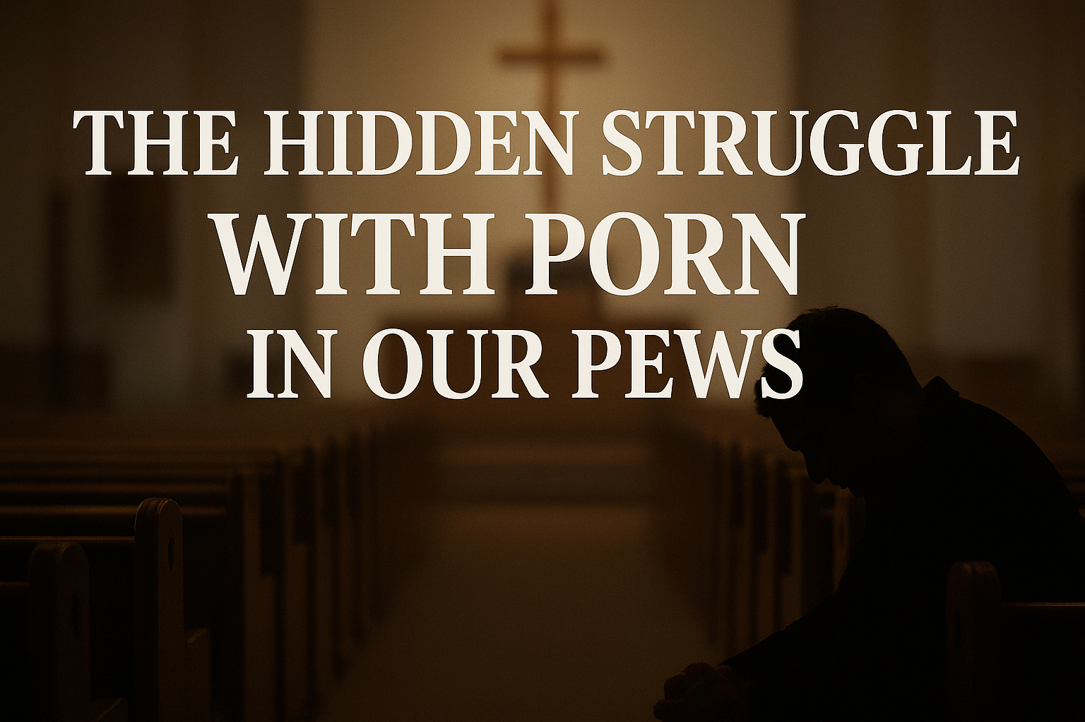

**The Hidden Struggle in Our Pews: Facing the Reality of Pornography**

Many in our congregations quietly struggle with issues that are rarely spoken aloud, and pornography addiction is one of them. Despite its prevalence, it often remains hidden due to shame, guilt, and fear of judgment. Studies suggest that nearly **64% of men and 15% of women in Christian communities** regularly view pornography, yet few feel able to talk about it.

Pornography can affect marriages, families, and personal spiritual life, creating a sense of isolation and despair. Recognizing this hidden struggle is the first step toward healing. Churches can be a safe haven where individuals find support, understanding, and hope, rather than judgment.

If you—or someone you know—is struggling, help is available **confidentially and anonymously** through [Redemption Road Mentoring](http://www.redemptionrd.com), a faith-based program supported by **NALC leadership**. Their Christ-centered mentoring offers guidance and recovery support in a safe and confidential environment. Remember, no one has to face this battle alone.

**“For I can do all things through Christ, who gives me strength”**Philippians 4:13

[**www.redemptionrd.com**](www.redemptionrd.com)

