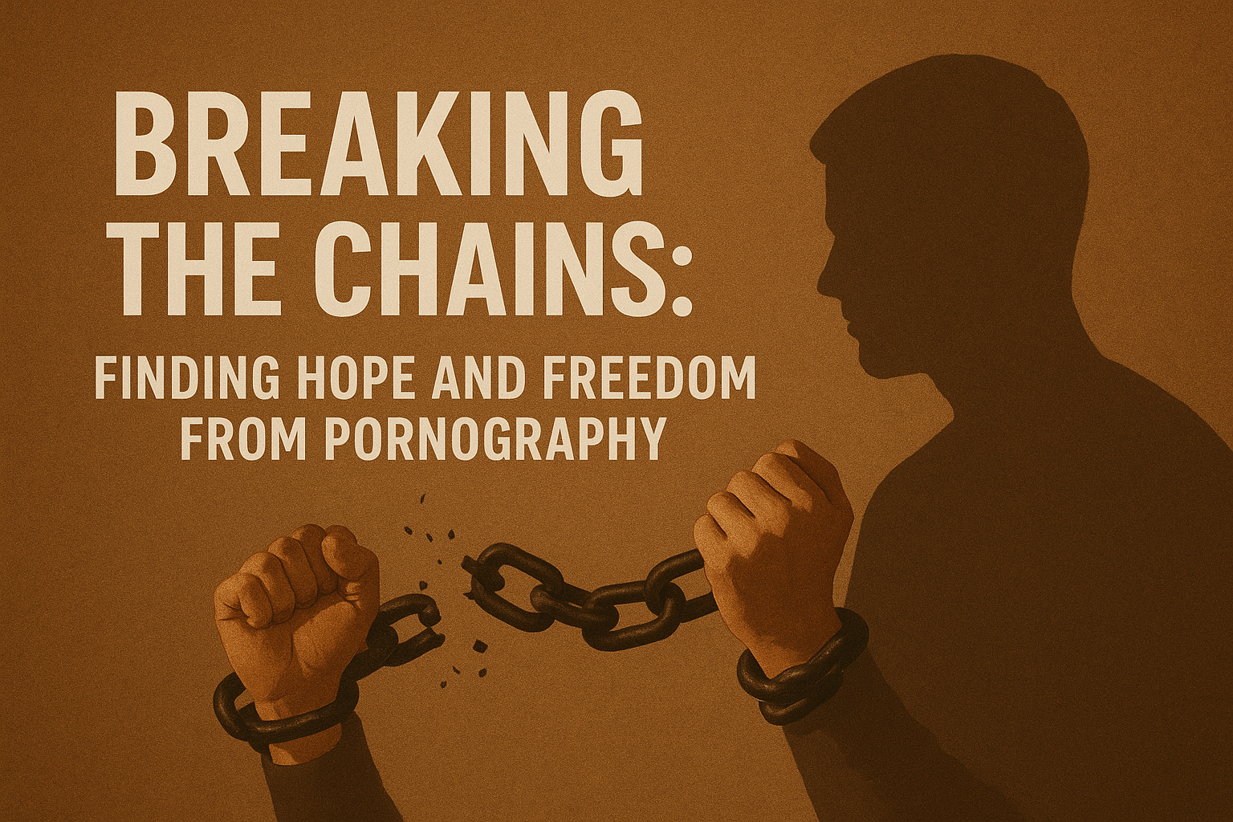

**Breaking the Chains: Finding Hope and Freedom from Pornography**

Struggling with pornography is not a moral failing—it’s a challenge that many face, often silently. The good news is that **freedom and healing are possible** through Christ-centered mentoring and support.

Recovery begins with acknowledgment. Without it, shame and secrecy can dominate our lives, but connecting with trained mentors who have walked the path of recovery provides understanding, accountability, and guidance. Individuals who engage in confidential, one-on-one mentoring often experience restored hope, strengthened marriages, and a renewed sense of purpose.

If you are struggling, know that you **are not alone**. Help is available in a safe, confidential, and anonymous manner through [**Redemption Road Mentoring**](http://www.redemptionrd.com)**, a program supported by NALC leadership**. Their faith-based approach provides personalized support to guide you toward freedom and spiritual healing.

**“For I can do all things through Christ, who gives me strength”**Philippians 4:13

**www.redemptionrd.com**

