Curl Around Pre School-Registration Form
FOR OFFICE USE:
Return date of form:
Deposit paid:
Confirmation sent:
Signed:

Registration fee and deposit
Registration Fee & Deposit
Prior to entry a registration fee of £40 and a deposit of £100 are required. The £100 deposit is refunded if all our Terms & Conditions are met.
(for funded only places this will be refunded after 6 weeks of attendance)
Acceptance: The parent/guardian has read and understood the terms and conditions in this pack

Required start date:
Child’s surname: Other names:
Boy / Girl:
Date of birth: Religion: Ethnic Origin:
Parent/ Carer 1’s Name: Parent / Carer 2’s Name:
Address:

Postcode: Home telephone:
Parent/Carer 1’s work telephone: Parent/Carer 2’s work telephone:

Parent/Carer 1’s mobile: Parent/Carer 2’’s mobile:

Parent/Carer 1’s email: Parent/Carer 2’s email:

Please tick boxes below for days/sessions required:
Extended Day (not funded 8:15-9am / 3:00-4:15pm) (38 weeks) excludes voluntary contributions | Monday | Tuesday | Wednesday | Thursday | Friday
8:15-4:15 (funded session 9-3) (30hrs funded) - £20.00 per day |  |  |  |  | N/A
8:45-4:15 (funded session 9-3) (30hrs funded) - £15.00 per day
8:15-4:15 (funded 8:45-11:45 or 12:15-3:15) (15hrs funded) £45.00 per day |  |  |  |  | N/A
8:45-4:15 (funded both 8:45-11:45 & 12:15-3:15) (30hrs funded) £17.00 per day |  |  |  |  | N/A
Funded sessions - Within 8:45-3:15 (not funded 8:15-9/3-3:15) excludes voluntary contributions  15hrs or 30 hrs (18mths + working parents) (15hrs 2yrs plus) (38wks term) | Monday | Tuesday | Wednesday | Thursday | Friday
8:15-11:45 (funded 8:45-11:45) (15hrs funded) - £7 per session
8:15-3:15 (funded 8:45-11:45 or 12:15-3:15) (15hrs funded) - £39.00 per day
8:45am – 11:45am. - (15 hrs funded) - £0 per session
12:15pm – 3:15pm. - (15 hrs funded) - £0 per session
12:15pm-4:15pm (funded 12:15-3:15) (15hrs funded) - £10 per session |  |  |  |  | N/A
8:15-3:15 (funded 9am-3pm) (30hrs funded). - £10 per session
9:00 am –3:00 pm – (30hrs funded) - £0 per session
 | Monday | Tuesday | Wednesday | Thursday | Friday
Agreed Services – (e.g. Snacks) - £1.00 per session
Consumables (e.g. nappies, wipes, suncream) - £1.00 per session
Additional voluntary services – e.g. trips, music & movement, yoga, etc.) - £1 per session
 | Monday | Tuesday | Wednesday | Thursday | Friday
Lunch Club (non-funded) 11:45 – 12:15pm - £7.00 per session
 | Monday | Tuesday | Wednesday | Thursday | Friday
Non- Funded sessions (38wks tt only)
8:45am – 11:45am - £25 per morning
8:15am – 4:15pm - £70.00 per day |  |  |  |  | N/A
8:45am – 4:15pm - £64.50 per day |  |  |  |  | N/A
12:15pm-3:15pm - £25 per afternoon
12:15pm-4:15pm - £36 per afternoon |  |  |  |  | N/A
Afternoon Club 3:00-4:15 - £10 per session |  |  |  |  | N/A
Breakfast Club 8:15-8:45 - £7 per session
Ad hoc additional hours - - £12 per hour

Fees will be invoiced on a termly basis but payable monthly on the first day of each month.
Any changes to sessions are subject to a half-term’s notice as per our terms and conditions.
By completing and/or signing this form you are agreeing to Curl Around Childcare Ltd’s terms & conditions & Policies, which form part of the contract
Signature  (Parent / Carer) | Date

Record form

Child’s Name: |  | Date of Birth:
Parent/Guardian Name: |  | Parent/Guardian Name:
Occupation: |  | Occupation:

Home Address
Postcode:
Home Phone No:

Please indicate with an asterisk your preferred emergency contact no:
Password: …………………………………………….. |  | Security question: ……………………………………
Parent / Carer 1’s mobile contact number:
Parent / Carer 2’s mobile contact number:
Preferred email address:
Who has parental responsibility for your child (please tick as appropriate) |  | Joint: ……. Parent/Carer 1: …... Parent/Carer 2: ….… Other……..  ……………………
Who has legal responsibility for your child (please  tick as appropriate) |  | Joint: ……..Parent/Carer 1: ….... Parent/Carer 2: ….… Other…….  Other ……………………
People authorised to pick up your child.
(preferably with photographs):
What is the main language spoken at home:
What festivals do you celebrate at home?
Emergency alternative contact name:
Emergency alternative contact number:
Doctor’s Name:
Doctor’s Telephone Number:
If we cannot get hold of you and your child’s temperature is over 38.5°C, are you happy for us to administer Calpol?
Does your child have any allergies? If yes, please give details.
Does your child have any dietary requirements?
If yes please give details.
Does your child take any daily medication? If yes, please give details.
Does your child have any medical conditions we should be aware of?
If yes please give details.
Does your child have any birth marks or distinguishing marks?

marks?

Is your child registered with a dentist?
Is your child up to date his/her inoculations? If not, please give details.
Has your child had the following inoculations? |  | Has your child had:
Chicken Pox Measles Mumps Rubella  Whooping Cough  Other: | Y/N  Y/N  Y/N  Y/N | Whooping Cough  Asthma Attacks  Chickenpox | Y/N  Y/N  Y/N
Signed: |  | Date:

Profile Form

Child’s Name: Date of Birth:

People authorised to pick up your child, photos please if available:

Other lanuages spoken at home:

Does your child have any special dietary requirements:

What are your child’s favourite foods?

Would your child be entitled to free school meals? Yes / No (please delete as appropriate)

Is your child used to being away from you? Is he/she used to being in a nursery environment?

Does your child attend another setting? if so which setting and for how many days?

Do you have a nanny or child-minder? If so for how many days? Will they be picking your child up?

What does your child enjoy doing, both indoors and outdoors?

What does your child dislike doing?

What frightens your child?

What frustrates your child?

How do you comfort/calm your child? Does he/she sleep with a comforter?

Is there anything else you would like to tell us about your child?

Signature:  Parent/Guardian | Date:

All about me…..
Name…………………………………………………………………………………………………………………
Preferred name…………………………………...………………………………………………………..
Age………………………………………………………………………..…………………………….…………...
Home Language………………………………………………………………………………….….……….

Has your child had any recent illnesses? If so please give details below ……………………………………………………………………………………………..……………….
………………………………………………………………………………..………………………….…………....
Things that I am good at………………………………………..………………..……………….
……………………………………………………………………………………..………………..………………..
………………………………………………………………………………………………………..……………....
……………………………………………………………………………………………………..………………….
…………………………………………………………………………..…………………………………………….

Who is in my family……………………………………………………………………….…………….
……………………………………………………………………………………………………………….…………
My favourite things are………………………………………………………………………………
What is important to me………………………….………………………………….……………..
…………………………………………………………………………………………………………….……………

Nursery Parental Consent Form

Name of Child: ………………………….………………………………… Date: ………………………………………

In order to comply with the requirements of Ofsted, the Government Inspectorate Body, we would ask you to complete and return this form to us.

- I do / do not give permission for photos of my child to be displayed on boards within the Pre-School.
Name of Parent/Carer (Print): ……………………….………...……….. Signature of Parent / Carer:………………………..……………….

- I do / do not give permission for photos of my child to be displayed around the Pre-School.
Name of Parent/Carer (Print): ………………….…………….…………. Signature of Parent / Carer:…………………..…………………….

- I do / do not give permission for photos of my child to be used in theirs and other children’s personal profiles.
Name of Parent/Carer: (Print): ……………….………….………………. Signature of Parent / Carer:……………………..………………….

- I do / do not give permission for photos of my child to be used by students for training purposes.
Name of Parent/Carer (Print): …………………….…….………………. Signature of Parent / Carer:…………………..…………………….

- I do / do not give my permission for photos of my child to be emailed.
Name of Parent/Carer (Print): ………………..…………………………. Signature of Parent / Carer::……………………..………………….

- I do / do not give my permission for photos of my child to be on the monthly newsletter. I understand the newsletter will be emailed to all parents.
Name of Parent/Carer (Print): ………………….…………….…………. Signature of Parent / Carer:………………………………..……….

- I do / do not give my permission for photos of my child to be used on the nursery website / Facebook page or brochure to show activities they have done during the day.
Name of Parent/Carer (Print): …………………….…….………………. Signature of Parent / Carer::…………………..…………………….

- I do / do not give my consent for photos of my child to be used by the individuals who run the extra-curricular activities for marketing purposes on their website or in local newspapers.
Name of Parent/Carer (Print): …………………….………….…………. Signature of Parent / Carer::…………………………..…………….

- I do / do not give permission for my child to receive emergency treatment or medical advice should the need arise by a qualified person at the nursery or at hospital, on the understanding that every effort is made to contact myself or one of my emergency contacts as quickly as possible.
Name of Parent/Carer (Print): …………………………….…….………. Signature of Parent / Carer::………………..……………………….

- I do / do not give my permission for my child to have their face painted at Pre-School during a dress up day; charity event or special occasion in the setting.
Name of Parent/Carer (Print): …………………………….….…………. Signature of Parent/ Carer:………………..………………….

- I do / do not give permission for my child to participate in supervised activities on the bouncy castle when age or stage appropriate.
Name of Parent/Carer (Print): …………………………….…….………. Signature of Parent / Carer:………………………………..……….

- Weather permitting and properly supervised, I give my consent / I do not give my consent for my child to go on short educational outings outside the nursery, e.g. to the local library.
Name of Parent/Carer (Print): …………………………….….…………. Signature of Parent / Carer::……………………..………………….

- When my child leaves the setting to start at another setting or school I do / do not give my permission for their latest development record to be passed onto the new setting or school.
Name of Parent/Carer (Print): …………………………….……….……. Signature of Parent / Carer::………………………..……………….

- I do / do not give my permission for the staff at Curl Around Pre-School to apply sun cream that the setting is providing to my child as needed. I understand that Curl Around Pre-School provide Nivea sun cream and I do / do not give my permission for them to administer it
Name of Parent/Carer (Print): ……………………………….…………. Signature of Parent / Carer::……………………..………………….

- I do / do not give my permission for the staff at Curl Around Pre-School to contact my child’s previous setting / new setting / school / other professionals / childminder / nanny as required if applicable.
Name of Parent/Carer (Print): ………………………...………………. Signature of Parent Carer::………………………..……………….

NON PRESCRIBED MEDICINE

The ‘Early Years Foundation Stage Statutory Framework’ states:

” Medicines should not usually be administered unless they have been prescribed for that child by a doctor, dentist, nurse, or pharmacist. Non-prescription medication i.e. pain, and fever relief may be administered, but only with the prior written consent of the parent and only when there is a health reason to do so.”

At Curl Around Pre-School the only non- prescribed medicines that we will administer are Calpol and nappy cream and we will only administer the above medicines if you have completed and signed the form below.

Child’s name. . . . . . . . . . . . . . . . . . . . . . . . . . Child’s D.O.B. . . . . . . .. . . . . . . . . . . . . . . . . . . …… I . . . . . . . . . . . . . . . . . . . , give my consent for the staff at Curl Around to administer 2.5 ml, 5 ml, 7.5ml or 10ml (please circle appropriate) dose of Calpol to my child in the event that he or she needs it for pain relief or fever. Signature:……………………………………………………….

I understand Calpol will be provided by the Pre-School unless I say otherwise.

I . . . . . . . . . . . . . . . . . . . . . . also give my consent for staff to increase this amount as my child reaches the next age bracket. Signature:………………………………………………………….
I . . . . . . . . . . . . . . . . . . . . . . . . . . . . . . . . . . . . . understand that I must give verbal permission over the phone for the staff at Curl Around to administer Calpol unless my child’s temperature is over 38.5C and I am un-contactable. Signature:……………………………………………………….
The recommended guideline for calpol dosage is as follows:
(2-3 months old 2.5 ml) (3 – 6 months old 2.5 ml)
(6 – 24 months old 5ml) (2 – 4 years old 7.5 ml) (4 – 6 years old 10 ml)

I, . . . . . . . . . . . . . . . . . . . . . . . . . . . . . . . . . . . . . . . . . , give my consent for the staff at Curl Around to apply the following nappy cream. . . . . . . . . . . . . . . . . . . . . .(name of nappy cream) if applicable. Signature:………………………………………………………….

Please note that in ALL cases Curl Around Pre-School will ‘phone you prior to administering Calpol, to gain the verbal consent of a parent. Upon picking up your child from Curl Around, you will also be required to sign the medication book.

We will not administer Calpol without this form being completed and returned to us.

I understand that by signing this consent form, I am agreeing to Curl Around administering Calpol and nappy cream named above to my child and that my child is not allergic to, or has ever had any allergic reaction to any of the above.

Signed . . . . . . . . . . . . . . . . . . . . . . . . . . .. .... . Print Name . . . . . . . . . . . . . . . . . . . . . . .
Date . . . . . . . . . . . . . . . . . . . . . . . . . . . . . . . . . . .

Famly Agreement – Curl Around Pre-School

At all times the safety and welfare of the children is paramount whether that be within the nursery or the wider parameters of the online world. We use an online system called ‘Famly” to record the children’s learning journeys and store personal information and files. We want to ensure the information stored on the system is as secure and protected as possible. So we are asking all parents to sign this agreement below prior to us giving log-in details. Our team are also signing an Agreement to ensure everything they input into the system is appropriate and that they have checked the relevant consents.

Child’s Name…………………………….................. Child’s Date of Birth……………………………….

I …………………………………………...… (full name) agree to keep my login details to the Famly system confidential. I will only share this with family members as appropriate.

I …………………………………………...… (full name) agree for my child’s personal details to be input onto the Famly online system. (Inclusive of any information that may be included on my record forms when joining the setting.)

I …………………………………………...… (full name) agree not to log in to other children’s learning journeys.

I …………………………………………...… (full name) agree not to share any photographs uploaded onto the Famly app on social media, in order to protect the privacy of other children and to maintain the security of the setting.

I would / would not be happy for my child’s photo to be in other children’s learning journeys if they were in the same photo as my child (please delete as appropriate)

I would / would not be happy for a video clip that my child was in with other children to be shared in another child’s learning journey. (please delete as appropriate)

I would / would not be happy for photos of other children to be in my child’s learning journey, if they were in the same photo. (please delete as appropriate)

I would / would not be happy for video clips with other children in to be in my child’s learning journey if they were in the same video. (Please delete as appropriate)

I …………………………………………...… (full name) am happy to log in to my child’s learning journey online, on the secure server and agree to abide by the above terms and conditions related to this.

Signed………………………………………………………. (parent / carer) Date………………………………………

Key carer name………………………………………. Key carer Signature……………….……….……………….

Famly – Information

Famly
www.famly.com
(There is also a parent app available to download)

How is it accessed by staff:

Staff are not able to access Famly on an unauthorised device outside of the setting. The system only allows for access on devices that have been authorised by Management at the setting; these include the iPads that remain on site, at the Nursery, and the computers in the staff offices.

What information will be stored on Famly?

- Personal details including full name, date of birth, address.
- Family contact information for parents including names addresses and contact phone numbers.
- Any information regarding allergies or health conditions.
(Any information that you include on your record forms when singing up/joining the setting, may be used on the Blossom Educational system).

What do we use Famly for?

Learning Journals: Famly will be used for collecting and recording observations on the children and using them to support key workers in making assessments and monitoring development.
The parent app allows for access to this so that you can see the photographs of your child and the observations that have been created. You can also upload photographs alongside comments, to share the things that your child has been doing outside of the setting.

Diary: The diary function will allow you to see what your child has eaten and to access other updates such as nappy and toileting times/ sleep times.

Registers: Children will be signed in using the register on the Famly system – this should be done in the reception area on your way in and on your way out, at pick up.

Children’s Records Consent Form

The ‘Early Years Foundation Stage Statutory Framework’ states:

“All Early Years Providers must keep a copy of all records relating to individual children for a reasonable period of time, (three / four years) after they have left the provision. There should be a suitable secure area for the storage of confidential information. This should only be accessible to those who have a right or professional need to see them.”

At Curl Around Pre-School we are asking for written permission for this paperwork to be kept in our locked and secure storage unit, where it will be kept confidential, and for which only a director has a key.

The paperwork will all be kept for four years and then will be shredded and destroyed.

As a setting we are registered with the Information Commissioner’s Office (ICO) under the Data Protection Act 1998 and Freedom of Information Act 2000.

I/ We give our permission for .................................(child’s name) records to be kept secure and locked in a storage unit. I understand that four years after my child has left the setting the records will be completely destroyed.

Name of Parent / Carer (Printed): ……………...…………………………………….…............

Signature of Parent /Carer: …………………...............................................................

Date:..................................................................................................................................

Authorised to pick up

Name of child:.........................................

Password:........................................

Photo

Name:........................................

Relation to child:.............................

Photo

Name:........................................

Relation to child:.............................

Photo

Name:........................................

Relation to child:.............................

Photo

Name:........................................

Relation to child:.............................

Photo of child

Health Care Plan

Child's name |  |  |  |  | Date of Birth
Name of room |  |  |  |  | Name of key carer
Child's Address
Medical Diagnosis or Conditions
Family contact details
Name and relationship to child |  |  |  | Name and relationship to child
Phone 1  (Work/home/mobile) |  |  |  | Phone 1  (Work/home/ mobile)
Phone 2  (Work/home/mobile) |  |  |  | Phone 2  (Work/home/ mobile)
Phone 3  (Work/home/mobile) |  |  |  | Phone 3  (Work/home/ mobile)
Clinic/ Hospital
GP Information
Name |  |  |  |  |  | Phone Number
Describe medical needs of child and give details of child's symptoms:

Details of daily care requirements (Including action and time/situation in which care is needed):

Give details of what constitutes an emergency for the child:

What action/s should be taken if this occurs (List in the order the actions that should be taken):

Who is responsible in an emergency:

Parent's Signature |  |  |  |  | Managers Signature
Date |  |  |  |  | Review Date
Form copied to Parents/ Office/ other please state:

Term Dates 2025/26

 | Open morning of: | Close end of afternoon on:
Autumn 2025 | Thursday 4th September  Monday 3rd November | Friday 24th October  Thursday 18th December (1pm finish)
Spring 2026 | Tuesday 6th January  Monday 23rd February | Friday 13th February  Friday 27th March (1pm finish)
Summer 2026 | Tuesday 14th April  Tuesday 2nd June | Friday 22nd May  Wednesday 22nd July (1pm finish)
Inset Days |  | Sept 2025-July 2026  2025-3/9  2026-5/1, 13/4, 6/3, 1/6
Staff Training  (Inset Day) | Friday 6th March | Closed for Staff Training

Curl Around Pre School: Terms and Conditions:

- Registering your child for a place at the Pre-School requires you to complete and to sign a Registration Form. By registering your child at the nursery and/or signing the form you agree to all the terms and conditions set out below; and to adhere to our policies.

- A place is only secured once the Registration Form has been completed, signed and returned to the Pre-School with a non-refundable registration fee of £40 and a refundable deposit of £100 (which is subject to all notice periods being met – see below).

- For clarity throughout these Terms & Conditions, a calendar month means each of the twelve named periods into which a year is divided (January, February, etc.). A half-term means one of the six periods in the Buckinghamshire schools academic year. A term means one of the 3 terms (Autumn, Spring & Summer) in the Buckinghamshire schools academic year.

- Following receipt of a Registration Form, the start date can only be delayed once, and only be delayed by one month, before the child’s reserved place will be open to others and the child’s name added to the waiting list. Notice of the delay must be in writing. If the notice to delay is less than one month from the original start date, then fees are due from the original start date until the end of one full calendar months’ notice (to coincide with the end of a calendar month). The refundable deposit will be forfeited if the child subsequently does not start at the nursery (see 5. below).

- If you cancel your child’s place without the child starting at the Pre-School the refundable deposit is forfeited. If you cancel within one full calendar month of the due start date fees are also payable for the period between the due start date and the end of the next calendar month - for clarity, if notice is given between the 2nd and the last day of a month then the notice period goes to the last day of the following month.

- The £100 deposit is refundable when your child leaves the Pre-School subject to half-term’s notice in writing by the first day of the half-term for children to leave on the last day of that half-term.

- If this notice is not given, then fees continue to be payable. If any fees are outstanding when your child leaves the Pre-School the refundable deposit is forfeited. For clarity if notice is given after the start of a half term, then the notice period continues until and including the last day of the next half term.

- A half-term’s notice in writing is required by the first day of the half-term should you wish to give notice for your child to leave the Pre-School. Failure to give this notice will result in fees being charged on the existing number of sessions for the half-term. For clarity, at least a half-term’s notice is required to leave the Pre-School, with the notice commencing at the start of the next term or half-term.

- A half-term’s notice in writing is required by the first day of the half-term to reduce the number of sessions attended. Failure to give this notice will result in fees being charged on the existing number of sessions for the half-term. For clarity, at least a half-term’s notice is required to reduce sessions, with the reduction commencing at the start of the next term or half-term.

- Children in receipt of funding will only be allowed to change sessions at the start of a new term (and cannot change session during a term) subject to the correct notice in writing being given.

- 48 hours’ notice 2 working days before the session, i.e. where a working day is Monday – Friday only) in writing is required for cancelling additional sessions. If this notice is not given, then the session continues to be chargeable.

- No refund or reduction of fees is made if your child is absent from the Pre-School (e.g. holiday; illness).

- No reduction / refund is made if the Pre-School is closed for reasons beyond our control, or the service we provide is restricted, (e.g. adverse weather conditions; forced closure by the Government or a Public Authority). This means that the usual full fees are still liable for payment during any closure. If we are closed/providing a restricted service for a period of a month or longer and we are unable to provide any service for you during this period then, at our discretion, we may reduce the fees payable during the period we are closed/providing a restricted service; though, if we do not, then full fees will still be liable. If during such period you want to give notice and we are unable to provide any service for you during this period then, at our discretion, we may reduce the notice fees to 50% (or any other rate we may decide) of that month’s fees that would normally have been due had we provided the service to you, but notice period fees will still be due to be paid either at the full rate or our discretionary rate.

- The Pre-School closes for Bank Holidays.

- Fees are calculated on either a 38-week year. No refund is given for Bank Holidays.

- Our opening times are from 8:15am to 3:15pm, Monday to Friday. We are unable to take responsibility for children outside these times as your child is not covered by our insurance.

- Fees:
- Fees for all children are payable monthly in advance by the first day of each month.
- The first month’s fees for new starters are due in full one month before the start date.
c. Fees for additional sessions are due before the sessions.
d. For fee calculations please see our fee sheet.
e. If the fees have not been paid in full (for clarity “in full” means the entire monthly fees and does not mean if the fees have been part paid or underpaid, as this is not “in full”) and showing in our bank account by 9am on the 10th of a month, then a late payment charge of £10 per day will be applied to your account (per child). The £10 per day late fee payment, will continue to be added each day until all the outstanding fees, to include all late payment costs incurred, are paid in full and showing in our bank account. If the fees are subsequently paid, and not the late fee payments, then the £10 per day will be added until the late fee payments are also settled in full. The daily interest will automatically be added to your account at 9 am each day. There will be no exceptions to the above.
f. If any fees are outstanding after 9am on the 20th of a month we reserve the right to immediately cancel your child’s place. The outstanding fees, all late payment charges, including the appropriate notice period will still be payable and you will forfeit your deposit. When necessary, we will take legal action to recover outstanding fees with interest and costs.

- If a child becomes ill at Pre-School, you or your named emergency contact will be telephoned. Therefore, it is your responsibility to inform us of any changes to your details (e.g. mobile phone; address).

- Any child suffering from an infectious illness must not be brought into Pre-School until a doctor has certified that the child is no longer infectious. For sickness and diarrhoea, it is a 48-hour exclusion from the last bout from either or both.

- Please do not bring any personal possessions (e.g. jewellery; money) into the Pre-School as we cannot take responsibility for any loss or damage.

- Please label ALL items of clothing. We cannot take responsibility for unlabelled items.

- Please try to be punctual when collecting your child. It is very important to collect your child at the correct time; otherwise, some distress could be caused. We appreciate there may be times when this is unavoidable, but you could incur extra charges if it were to happen frequently. These will be £10 for every 5 minutes late. If you are going to be late then please telephone the Pre-School

- If a person other than the parent or guardian has to collect your child, please inform a member of staff in advance. It is Pre-School policy not to allow any child to leave with an unnamed person. We prefer to have seen the nominated person before collection. If this is not possible, we will use a password scheme to identify your nominated collector.

- We reserve the right to refuse admission.

- We reserve the right to amend the terms and conditions.

29. Failure to give this notice will result in fees being charged on the existing number of sessions
Dated: 21st February 2024
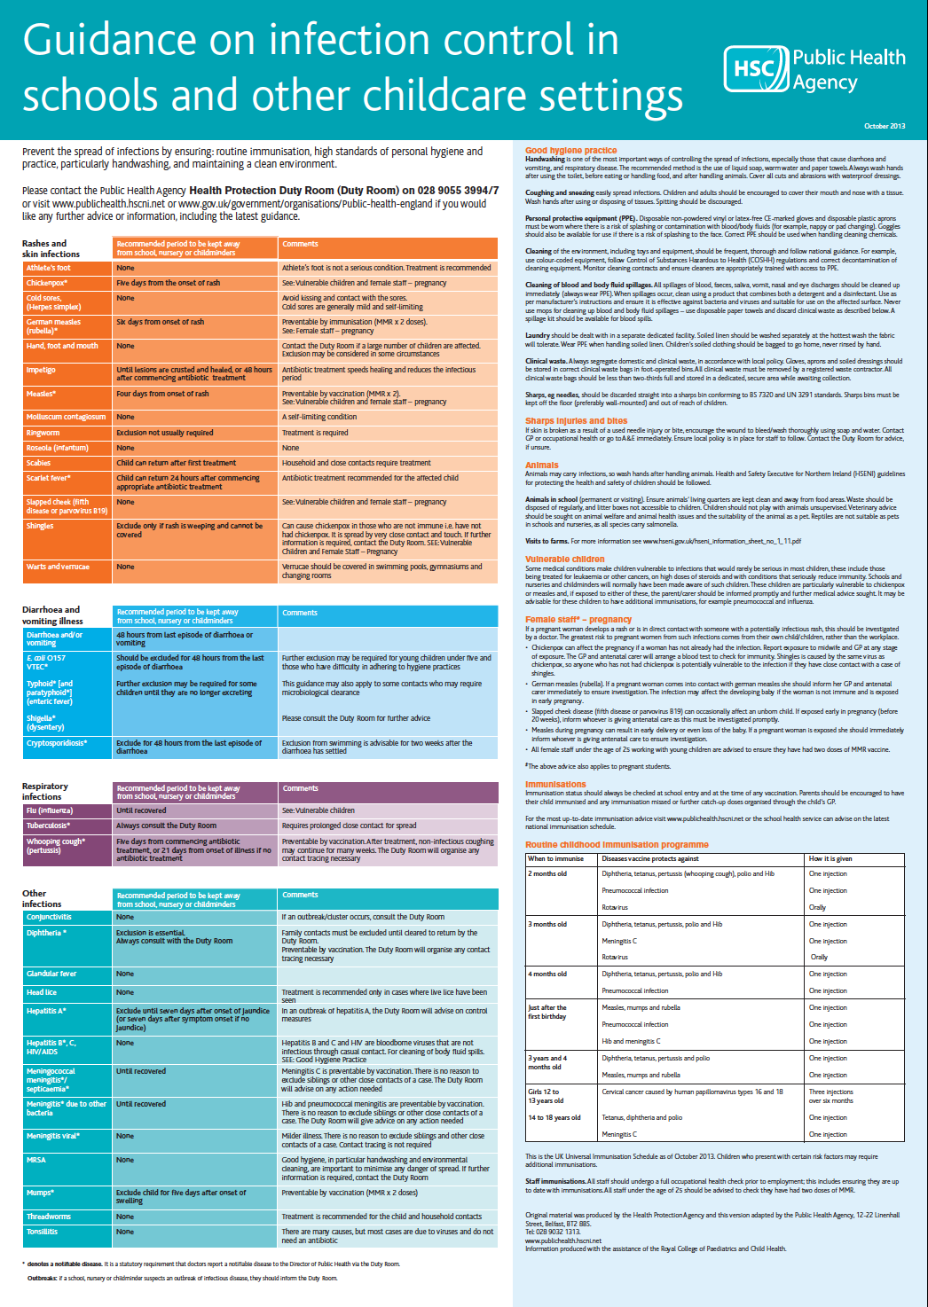
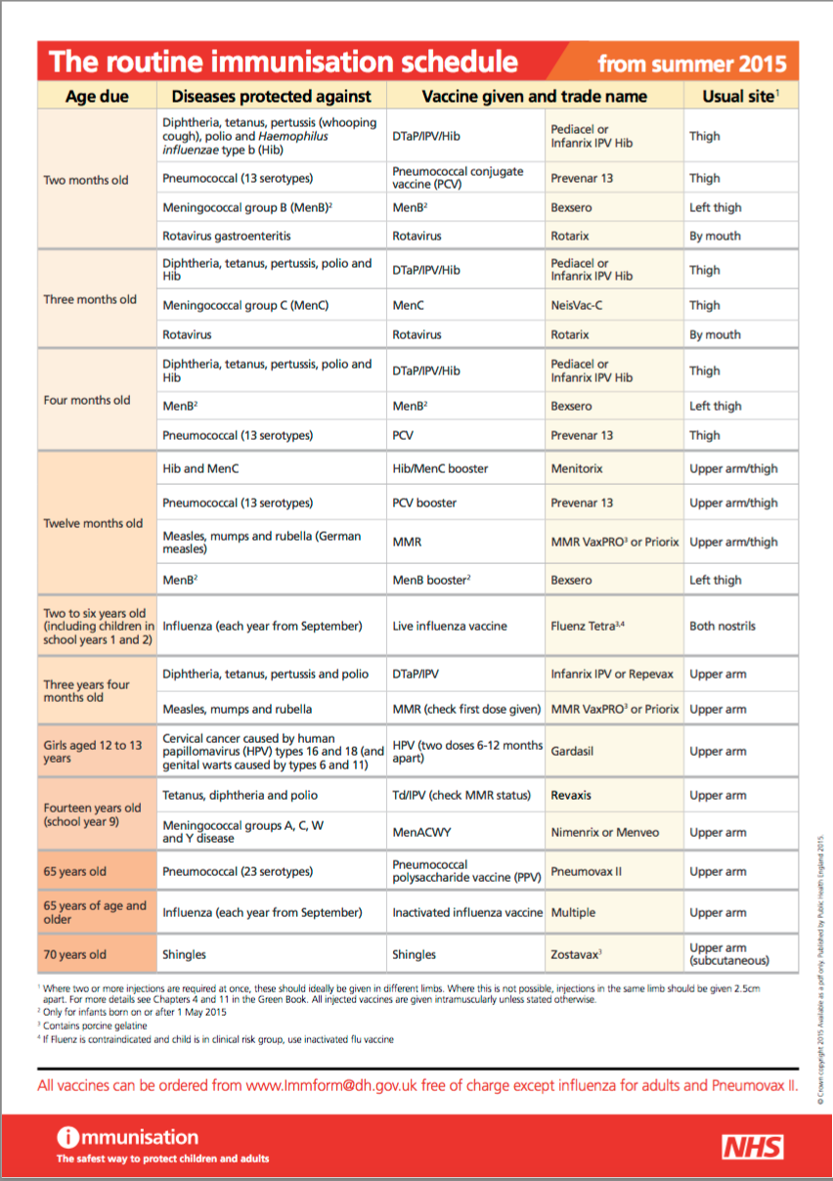
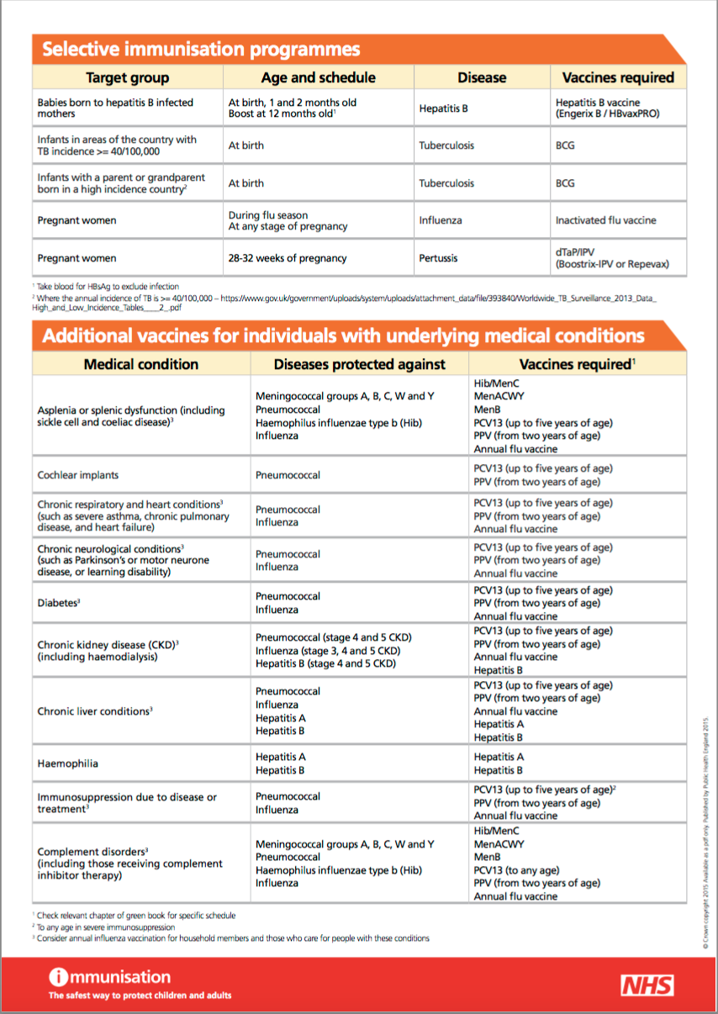
Curl Around Childcare GDPR Privacy Notice

WHAT IS THE PURPOSE OF THIS DOCUMENT?
Curl Around Childcare is committed to protecting the privacy and security of your personal information. This privacy notice describes how the setting collects and uses personal information about employees of the setting, children attending the setting and the parents of the children in accordance with the General Data Protection Regulation (GDPR).

Curl Around Childcare is a “data controller”. This means that we are responsible for deciding how we hold and use personal information about you. We are required under data protection legislation to notify you of the information contained in this privacy notice.

This notice applies to employees, children and parents. This notice does not form part of any contract of employment or other contract to provide services. We may update this notice at any time but if we do so, we will provide you with an updated copy of this notice as soon as reasonably practical.

It is important that employees, children and parents read and retain this notice, together with any other privacy notice we may provide on specific occasions when we are collecting or processing personal information about you, so that you are aware of how and why we are using such information and what your rights are under the data protection legislation.

DATA PROTECTION PRINCIPLES

We will comply with data protection law. This says that the personal information we hold about you must be:
1. Used lawfully, fairly and in a transparent way.
2. Collected only for valid purposes that we have clearly explained to you and not used in any way that is incompatible with those purposes.
3. Relevant to the purposes we have told you about and limited only to those purposes.
4. Accurate and kept up to date.
5. Kept only as long as necessary for the purposes we have told you about.
6. Kept securely.

THE KIND OF INFORMATION WE HOLD ABOUT YOU
Personal data, or personal information, means any information about an individual from which that person can be identified. It does not include data where the identity has been removed.

There are “special categories” of more sensitive personal data which require a higher level of protection, such as information about a person’s health or sexual orientation.

Employees:

We will collect, store, and use the following categories of personal information about Employees:

- Personal contact details such as name, title, addresses, telephone numbers, and personal email addresses.
- Date of birth.
- Gender.
- Marital status and dependants.
- Next of kin and emergency contact information.
- National Insurance number.
- Bank account details, payroll records and tax status information.
- Salary, annual leave, pension, and benefits information.
- Start date and, if different, the date of an employee’s continuous employment.
- Location of employment or workplace.
- Copy of driving licence (where applicable).
- Recruitment information (including copies of right to work documentation, references and other information included in a CV or cover letter or as part of the application process).
- Employment records (including job titles, work history, working hours, holidays, training records and professional memberships).
- Personnel files and training records including performance information, disciplinary and grievance information, and working time records.
- Information about your use of our information and communications systems.
- Records of any reportable death, injury, disease, or dangerous occurrence.
We may also collect, store, and use the following “special categories” of more sensitive personal information:

- Information about an employee’s race or ethnicity.
- Information about an employee’s health, including any medical condition, accident, health, and sickness records, including:
- where an employee leaves employment and under any share plan operated by a group company the reason for leaving is determined to be ill-health, injury or disability, the records relating to that decision.
- details of any absences (other than holidays) from work including time on statutory parental leave and sick leave; and
- where an employee leaves employment and the reason for leaving is related to their health, information about that condition needed for pensions and permanent health insurance purposes.

Children:

We will collect, store, and use the following categories of personal information about children:
- Name
- Date of birth
- Home address
- Dietary requirements
- Attendance information
- Photographs and video clips of the child to signpost children to where their belongings are stored at the nursery, and also for general display purposes.
- Emergency contact should parents be unavailable and the emergency contact’s contact details.
- Online learning journey for each child containing observations about the child’s development whilst at the setting from employees of the nursery, specific examples of the child’s progress, photographs demonstrating the child’s development whilst at the nursery, and personal details of the child (e.g. their date of birth)
- Records relating to individual children e.g. care plans, common assessment frameworks, speech and language referral forms.
- Accidents and pre-existing injuries forms
- Records of any reportable death, injury, disease, or dangerous occurrence
- Observation, planning and assessment records of children.
We may also collect, store and use the following “special categories” of more sensitive personal information:
• Information about a child’s race or ethnicity, spoken language and nationality.
• Information about a child’s health, including any medical condition, health and sickness records.
• Information about a child’s accident or incident reports including reports of pre-existing injuries.
• Information about a child’s incident forms / child protection referral forms / child protection case details / reports.
Parents:

We will collect, store, and use the following categories of personal information about Parents:
- Name
- Home address
- Telephone numbers, and personal email addresses.
We will collect and use the following categories of personal information about Parents:
- National Insurance number (only required for 30 hour code checks for funding purposes).
- Bank account details (only required for when refunds are due to parents)
We may also collect, store and use the following “special categories” of more sensitive personal information:
• Information about a parent’s race or ethnicity, spoken language and nationality.
• Conversations with parents where employees of the setting deem it relevant to the prevention of radicalisation or other aspects of the governments Prevent strategy.
HOW IS YOUR PERSONAL INFORMATION COLLECTED?

Employees:

We collect personal information about employees through the application and recruitment process, either directly from candidates or sometimes from an employment agency or background check provider. We may sometimes collect additional information from third parties including former employers, credit reference agencies or other background check agencies.

We will collect additional personal information in the course of job-related activities throughout the period of when an employee works for us.

Children and Parents:
We collect personal information about children and parents from when the initial enquiry is made by the parents, through the enrolment process and until the children stop using the setting’s services.

HOW WE WILL USE INFORMATION ABOUT YOU
We will only use your personal information when the law allows us to. Most commonly, we will use your personal information in the following circumstances:
1. Where we need to perform the contract, we have entered into with you.
2. Where we need to comply with a legal obligation.
3. Where it is necessary for our legitimate interests (or those of a third party) and your interests and fundamental rights do not override those interests.
We may also use your personal information in the following situations, which are likely to be rare:
1. Where we need to protect your interests (or someone else’s interests).

Situations in which we will use employee personal information

We need all the categories of information in the list above (see employee section within the Paragraph entitled ‘The Kind of Information We Hold About You’) primarily to allow us to perform our contracts with employees and to enable us to comply with legal obligations. The situations in which we will process employee personal information are listed below.

- Making a decision about an employee’s recruitment or appointment.
- Checking an employee is legally entitled to work in the UK. Paying an employee and, if an employee is an employee or deemed employee for tax purposes, deducting tax and National Insurance contributions (NICs).
- Providing any employee benefits to employees.
- Enrolling you in a pension arrangement in accordance with our statutory automatic enrolment duties.
- Liaising with the trustees or managers of a pension arrangement operated by a group company, your pension provider and any other provider of employee benefits.
- Administering the contract, we have entered into with an employee.
- Conducting performance and/or salary reviews, managing performance and determining performance requirements.
- Assessing qualifications for a particular job or task, including decisions about promotions.
- Gathering evidence for possible grievance or disciplinary hearings.
- Making decisions about an employee’s continued employment, engagement.
- Making arrangements for the termination of our working relationship.
- Education, training and development requirements.
- Dealing with legal disputes involving employees, including accidents at work.
- Ascertaining an employee’s fitness to work.
- Managing sickness absence.
- Complying with health and safety obligations.
- To prevent fraud.
- To monitor your use of our information and communication systems to ensure compliance with our IT policies.
- To ensure network and information security, including preventing unauthorised access to our computer and electronic communications systems and preventing malicious software distribution.
- Equal opportunities monitoring.
Some of the above grounds for processing will overlap and there may be several grounds which justify our use of an employee’s personal information.
Situations in which the nursery will use personal information of children.
We need all the categories of information in the list above (see children section within the paragraph entitled ‘The Kind of Information We Hold About You’) primarily to allow us to perform our obligations (including our legal obligations to children. The situations in which we will process personal information of children are listed below.

- Upon consent from the parents, personal data of children will be shared with schools for progression into the next stage of their education.
- Personal information of children will be shared with local authorities without the consent of parents where there is a situation where child protection is necessary.
- The personal information of children will be shared with local authorities without the consent of parents for funding purposes.
- Ofsted will be allowed access to the nursery’s systems to review child protection records.
- To ensure we meet the needs of the children.
- To enable the appropriate funding to be received
- Report on a child’s progress whilst with the nursery.
- To check safeguarding records
- To check complaint records
- To check attendance patterns are recorded.
- When a child’s progress report is given to its parent in order for that parent to pass the same progress report to a school for application or enrolment purposes
Situations in which the nursery will use personal information of parents.
We need all the categories of information in the list above (see parents’ section within the paragraph entitled ‘The Kind of Information we Hold About You’) primarily to allow us to perform our contracts with parents and to enable us to comply with legal obligations. The situations in which we will process personal information of parents are listed below.

- The personal information of parents will be shared with local authorities without the consent of parents for funding purposes.
- To report on a child’s attendance
- To be able to contact a parent or a child’s emergency contact about their child.
- To ensure Pre-School fees are paid
- To make any refunds due to parents, i.e. deposit refunds or overpayments of fees.

If employees and parents fail to provide personal information

If employees and parents fail to provide certain information when requested, we may not be able to perform the respective contracts we have entered into with employees and parents, or we may be prevented from complying with our respective legal obligations to employees, children, and parents.

Change of purpose

We will only use your personal information for the purposes for which we collected it, unless we reasonably consider that we need to use it for another reason and that reason is compatible with the original purpose. If we need to use your personal information for an unrelated purpose, we will notify the employee, child, or parent, as is appropriate in the circumstances, and we will explain the legal basis which allows us to do so.

Please note that we may process an employee’s, a child’s or a parent’s personal information without their respective knowledge or consent, as relevant to the circumstances, in compliance with the above rules, where this is required or permitted by law.

HOW WE USE PARTICULARLY SENSITIVE PERSONAL INFORMATION
“Special categories” of particularly sensitive personal information require higher levels of protection. We need to have further justification for collecting, storing, and using this type of personal information. We have in place an appropriate policy document and safeguards which we are required by law to maintain when processing such data. We may process special categories of personal information in the following circumstances:
1. In limited circumstances, with employee or parent explicit written consent.
2. Where we need to carry out our legal obligations or exercise rights in connection with employee employment.
3. Where it is needed in the public interest, such as for equal opportunities monitoring or in relation to our occupational pension scheme.

Less commonly, we may process this type of information where it is needed in relation to legal claims or where it is needed to protect an employee, a child, or a parents’ interests (or someone else’s interests) and the employee, child or parent as is appropriate is not capable of giving consent, or where the employee or parent has already made the information public.

The Nursery’s obligations as an employer

We will use particularly sensitive personal information of employees in the following ways:

- We will use information relating to leaves of absence, which may include sickness absence or family related leaves, to comply with employment and other laws.
- We will use information about the physical or mental health of an employee, or their disability status, to ensure employee health and safety in the workplace and to assess the fitness of employees to work, to provide appropriate workplace adjustments, to monitor and manage sickness absence and to administer benefits including statutory maternity pay, statutory sick pay, pensions, and permanent health insurance.
- We will use information about an employee’s race or national or ethnic origin, religious, philosophical, or moral beliefs, or an Employee’s sexual life or sexual orientation, to ensure meaningful equal opportunity monitoring and reporting.
Do we need employee consent?

We do not need the consent of employees if we use special categories of personal information in accordance with our written policy to carry out our legal obligations or exercise specific rights in the field of employment law. In limited circumstances, we may approach employees for their written consent to allow us to process certain particularly sensitive data. If we do so, we will provide employees with full details of the information that we would like and the reason we need it, so that employees can carefully consider whether they wish to consent. Employees should be aware that it is not a condition of their contract with the nursery that they agree to any request for consent from us.

INFORMATION ABOUT CRIMINAL CONVICTIONS
We may only use information relating to criminal convictions where the law allows us to do so. This will usually be where such processing is necessary to carry out our obligations and provided, we do so in line with our data protection policy. Less commonly, we may use information relating to criminal convictions where it is necessary in relation to legal claims, where it is necessary to protect the interests of You (or someone else’s interests) and you are not capable of giving your consent, or where an employee or a parent, as is relevant to the circumstances, has already made the information public.

We envisage that we will hold information about criminal convictions.

We will only collect information about criminal convictions if it is appropriate given the nature of the role and where we are legally able to do so, which includes but is not limited to Disclosure and Barring Service (“DBS”) checks. Where appropriate, we will collect information about criminal convictions as part of the recruitment process or we may be notified of such information directly by you in the course of you working for us. We will use information about criminal convictions and offences in the following ways:

- To conduct a DBS check on each employee, to record the date of the DBS check and the number of the DBS check.
We are allowed to use your personal information in this way to carry out our obligations. We have in place an appropriate policy and safeguards which we are required by law to maintain when processing such data.

AUTOMATED DECISION-MAKING
Automated decision-making takes place when an electronic system uses personal information to make a decision without human intervention. We are allowed to use automated decision-making in the following circumstances:
1. Where we have notified employees or parents of the decision and given the employee of the parent as is appropriate 21 days to request a reconsideration.
2. Where it is necessary to perform the contract with an employee or a parent and appropriate measures are in place to safeguard the employee’s, the child’s, or the parent’s rights as is appropriate.
3. In limited circumstances, with explicit written consent from the employee or the parent, as is appropriate, and where appropriate measures are in place to safeguard employee or parent rights.

If we make an automated decision on the basis of any particularly sensitive personal information, we must have either explicit written consent from an employee or a parent as is appropriate, or it must be justified in the public interest, and we must also put in place appropriate measures to safeguard an employee or a parent’s rights as is relevant in the circumstances.

You will not be subject to decisions that will have a significant impact on you based solely on automated decision-making, unless we have a lawful basis for doing so and we have notified the employee or the parent as is appropriate in the circumstances.

DATA SHARING
We may have to share employee, child or parent data with third parties, including third-party service providers and other entities in the group.

We require third parties to respect the security of your data and to treat it in accordance with the law.

Why might the nursery share employee, child or parent personal information with third parties?

We will share your personal information with third parties where required by law, where it is necessary to administer the working relationship with you or where we have another legitimate interest in doing so.

Which third-party service providers process my personal information?

” Third parties” includes third-party service providers (including contractors and designated agents), local authorities, regulatory bodies, schools, and other entities within our group. The following third-party service providers process personal information about you for the following purposes:

- Local Authorities – for funding and monitoring reasons (e.g. equal opportunities and uptake of funded hours)

- Regulatory bodies – for ensuring compliance and the safety and welfare of the children.

- Schools – to provide a successful transition by ensuring information about the child’s progress and current level of development and interests are shared.

We will share personal data regarding your participation in any pension arrangement operated by a group company with the trustees or scheme managers of the arrangement in connection with the administration of the arrangements.

How secure is my information with third-party service providers and other entities in our group?

All our third-party service providers and other entities in the group are required to take appropriate security measures to protect your personal information in line with our policies. We do not allow our third-party service providers to use your personal data for their own purposes. We only permit them to process your personal data for specified purposes and in accordance with our instructions.

What about other third parties?

We may share your personal information with other third parties, for example in the context of the possible sale or restructuring of the business. In this situation we will, so far as possible, share anonymised data with the other parties before the transaction completes. Once the transaction is completed, we will share your personal data with the other parties if and to the extent required under the terms of the transaction.

We may also need to share your personal information with a regulator or to otherwise comply with the law.

DATA RETENTION

How long will you use my information for?

We will only retain your personal information for as long as necessary to fulfil the purposes we collected it for, including for the purposes of satisfying any legal, accounting, or reporting requirements. Details of retention periods for different aspects of your personal information are available from the Director. To determine the appropriate retention period for personal data, we consider the amount, nature, and sensitivity of the personal data, the potential risk of harm from unauthorised use or disclosure of your personal data, the purposes for which we process your personal data and whether we can achieve those purposes through other means, and the applicable legal requirements.

In some circumstances we may anonymise your personal information so that it can no longer be associated with you, in which case we may use such information without further notice to you. Once you are no longer an employee, or a child benefiting from the nursery’s services or a parent, as is appropriate, we will retain and securely destroy your personal information in accordance with applicable laws and regulations.

RIGHTS OF ACCESS, CORRECTION, ERASURE, AND RESTRICTION

Your duty to inform us of changes.
It is important that the personal information we hold about you is accurate and current. Please keep us informed if your personal information changes during your working relationship with us.

Your rights in connection with personal information

Under certain circumstances, by law you have the right to:

- Request access to Your personal information (commonly known as a “data subject access request”). This enables You to receive a copy of the personal information we hold about you and to check that we are lawfully processing it.
- Request correction of the personal information that we hold about you. This enables you to have any incomplete or inaccurate information we hold about you corrected.
- Request erasure of your personal information. This enables employees or parents to ask us to delete or remove personal information where there is no good reason for us continuing to process it. You also have the right to ask us to delete or remove your personal information where you have exercised your right to object to processing (see below).
- Object to processing of your personal information where we are relying on a legitimate interest (or those of a third party) and there is something about your particular situation which makes you want to object to processing on this ground. You also have the right to object where we are processing your personal information for direct marketing purposes.
- Request the restriction of processing of your personal information. This enables employees or parents, as is appropriate, to ask us to suspend the processing of personal information about you for example if you want us to establish its accuracy or the reason for processing it.
- Request the transfer of your personal information to another party.
If you want to review, verify, correct or request erasure of your personal information, object to the processing of your personal data, or request that we transfer a copy of your personal information to another party, please contact the manager in writing.

No fee usually required.

You will not have to pay a fee to access your personal information (or to exercise any of the other rights).

What we may need from you

We may need to request specific information from you to help us confirm your identity and ensure Your right to access the information (or to exercise any of Your other rights). This is another appropriate security measure to ensure that personal information is not disclosed to any person who has no right to receive it.

RIGHT TO WITHDRAW CONSENT

In the limited circumstances where you may have provided your consent to the collection, processing and transfer of your personal information for a specific purpose, you have the right to withdraw your consent for that specific processing at any time. To withdraw your consent, please contact the Director, Sarah Fahey (sarah@curlaroundchildcare.co.uk). Once we have received notification that you have withdrawn your consent, we will no longer process Your information for the purpose or purposes You originally agreed to, unless we have another legitimate basis for doing so in law.

CHANGES TO THIS PRIVACY NOTICE
We reserve the right to update this privacy notice at any time, and we will provide you with a new privacy notice when we make any substantial updates. We may also notify you in other ways from time to time about the processing of your personal information.

If you have any questions about this privacy notice, please contact Sarah Fahey (sarah@curlaroundchildcare.co.uk

21st February 2024

