**Maxess FlexFit**

Non-rated Plastic Access Panel

For installations in walls and ceilings

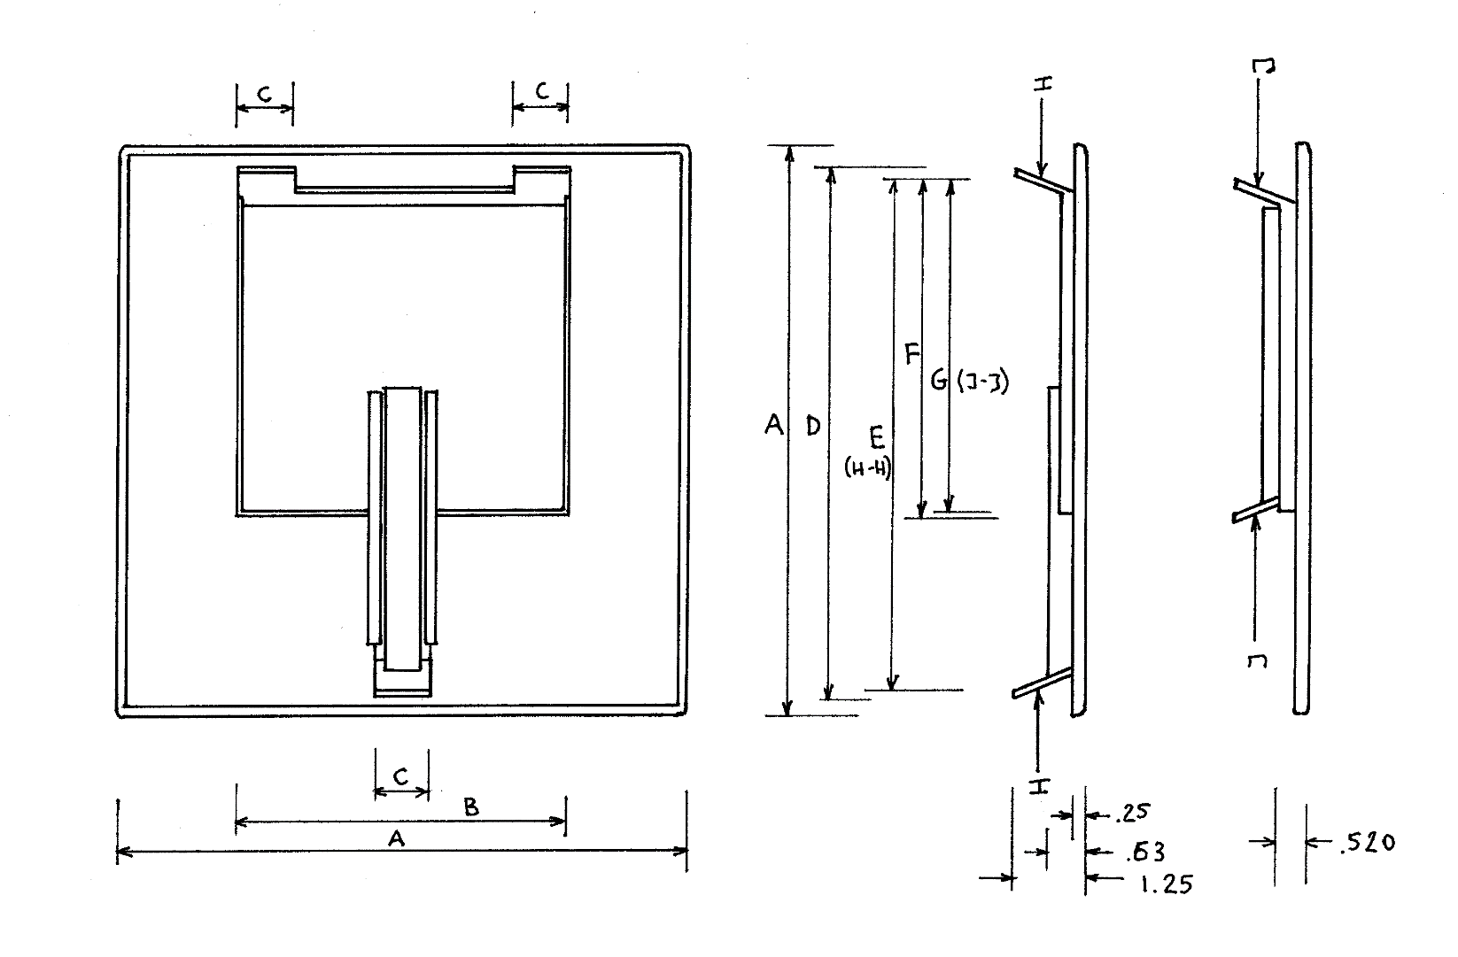

|  |  |  |  |  |  |  |  |  |  |  |  |
| --- | --- | --- | --- | --- | --- | --- | --- | --- | --- | --- | --- |
| **CODE** | **SIZE** | **WEIGHT** | **A** | **B** | **C** | **D** | **E**  **MAX OPENING**  **SIZE (H-H)** | **F** | **G**  **MIN.**  **OPENING**  **SIZE (J-J)** | **MIN.**  **SPRING**  **TENSION** | **MAX**  **SPRING**  **TENSION** |
| **APF 8** | **8”** | ½ LB  230 G | 10”x10”  254x254  MM | 6”x6”  150x150  MM | 1”  25.4  MM | 9 ½”  240  MM | 8¾“x8¾“  220x220  MM | 6”  150  MM | 6” x 6”  150x150  MM | 2 LB  1000 G  AT MAX  OPENING | 5 LB  2500 G  AT MIN  OPENING |
| **APF12** | **12”** | 1 LB  450 G | 14”x14”  355x355  MM | 10”x10”  254x254  MM | 1”  25.4  MM | 13.5”  343  MM | 12¾“x12¾“  324x324  MM | 10”  254  MM | 10”x10”  254x254  MM | 2 LB  1000 G  AT MAX  OPENING | 5 LB  2500 G  AT MIN  OPENING |

**MATERIAL:** HIGH IMPACT STYRENE

**FINISH:** TEXTURED OUTER SURFACE

**COLOR:** WHITE

**PROPERTY OF:** NOVERA PRODUCTS INC. [www.noveraproducts.ca](http://www.noveraproducts.ca)