01
Determining ISO-classifications
There are 6 different ISO-construction classes in North America (US and Canada). There are some carriers in Canada who do not use the ISO-classifications and instead will use the IBC-classifications. Here are the ISO-classifications with equivelant IBC-classification:
- ISO 1 (IBC-6) – Wood Frame
- ------ (IBC-5) – Masonry-Veneer
- ISO 2 (IBC-4) – Joisted Masonry
- ISO 3 (IBC-3) – Non-Combustible
- ISO 4 (IBC-2) – Masonry Non-Combustible
- ISO 5 ------- – Modified Fire Resistive
- ISO 6 (IBC-1) – Fire Resistive

There are 3 questions you must always ask yourself to properly identify the ISO-classifacation of a building.
- What is the material holding up the walls?
- What is the material holding up the roof?
- What material is the floor construction on a multi-story building (above ground floor)?
Below is just a quick reference flow chart:
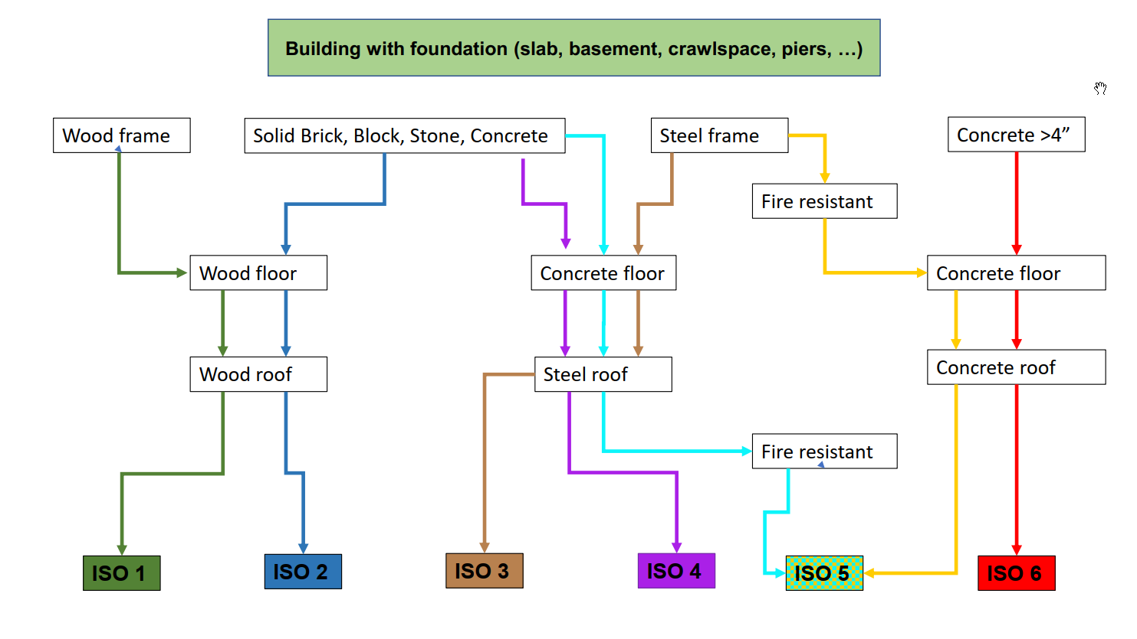
- What if the building is a mix of ISO-classifications:
  - Identify all the different ISO-classifications.
  - Report the ISO-classification as mixed and provide the % of that class based upon its SF.

Identifying the ISO-class can be difficult at times. What should you do if you are unable to make that determination?
- Take close-up pictures of the following:
  - Windows to show the thickness of the walls.
  - Exterior walls to show the wall components.
  - Above ceiling tile to show the underside of the roof/floor deck. (Have insured remove the ceiling tile for you)
  - Look for rooms in buildings such as utility/maintenance/mechanical rooms which are often unfinished.
  - When you get home from your appointment-Call your Regional Development Manager for assistance or use the loss control chat message in Teams.

