**l**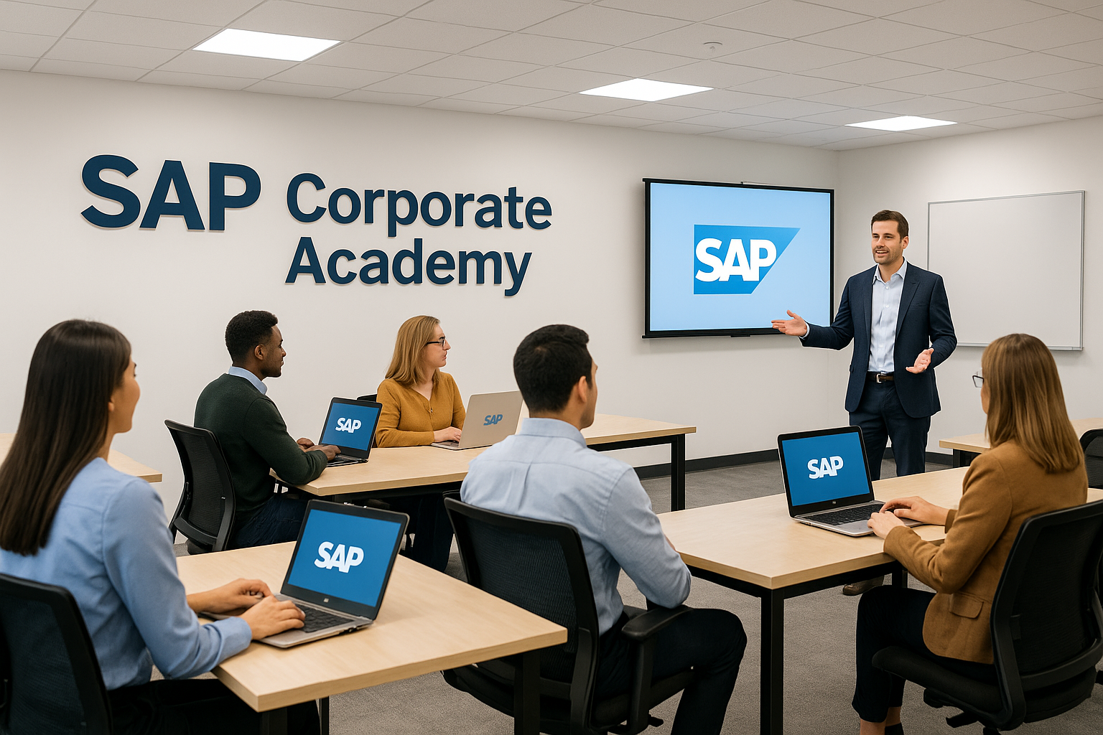

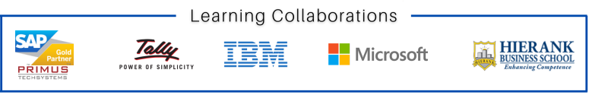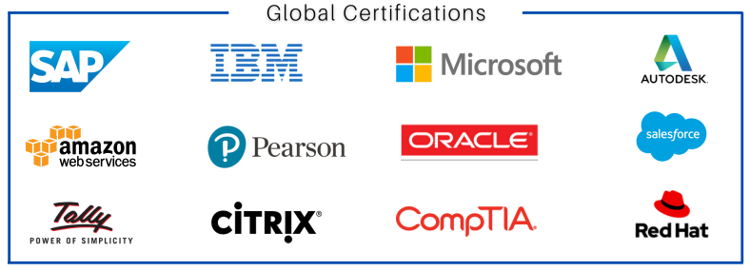

### **SAP MM Course – Materials Management Module**

#### **Course Overview:**

**SAP MM (Materials Management) is one of the core modules in the SAP ERP system that manages procurement and inventory functions. This course trains professionals in handling all activities related to material procurement, inventory management, and invoice verification in SAP.**

#### **Objectives:**

* **Understand SAP MM concepts and real-time business processes**
* **Configure SAP MM settings for procurement and inventory**
* **Execute end-to-end purchase cycle and inventory transactions**
* **Integrate MM with other SAP modules like SD, FICO, and WM**

#### **Modules Covered:**

1. **Introduction to SAP MM**
   1. **SAP Overview and Architecture**
   2. **SAP Navigation & GUI**
   3. **Organizational Structure in MM**
2. **Master Data Management**
   1. **Material Master**
   2. **Vendor Master**
   3. **Purchasing Info Records**
   4. **Source List and Quota Arrangement**
3. **Procurement Process**
   1. **Purchase Requisition**
   2. **Request for Quotation (RFQ)**
   3. **Quotation and Comparison**
   4. **Purchase Order (PO) Processing**
   5. **PO Release Strategy and Approvals**
4. **Inventory Management**
   1. **Goods Receipt (GR)**
   2. **Stock Transfer and Transfer Posting**
   3. **Physical Inventory Process**
   4. **Special Stock Handling (Subcontracting, Consignment, etc.)**
5. **Invoice Verification**
   1. **Logistics Invoice Verification (LIV)**
   2. **Blocking & Releasing Invoices**
   3. **Integration with Accounts Payable (FI)**
6. **Valuation and Account Determination**
   1. **Price Control (Standard vs Moving Average)**
   2. **Automatic Account Determination**
   3. **Material Valuation**
7. **MM Integration with Other Modules**
   1. **MM-SD Integration (Sales & Distribution)**
   2. **MM-FI Integration (Finance & Controlling)**
   3. **MM-PP Integration (Production Planning)**
8. **Reports and Analytics**
   1. **Standard MM Reports (Stock, Vendor, PO)**
   2. **Reporting Tools in SAP**
   3. **Custom Report Creation (Basics)**

#### **Hands-On Practice:**

* **Real-time procurement cycle execution**
* **Material and vendor master setup**
* **Inventory transactions in SAP GUI**
* **Document flow analysis**

#### **Certification Guidance:**

* **SAP Certified Application Associate – Procurement with SAP ERP / S/4HANA**
* **Mock tests and interview prep included**

#### **Course Duration:**

**6–8 Weeks (Flexible: Weekday & Weekend Options)**

#### **Mode of Training:**

**Online Live / Classroom / Self-paced**

#### **📞 Contact Information:**

**Institute: SAP Corporate Academy**  
 **Phone: +91 93100 50979**

