**l**

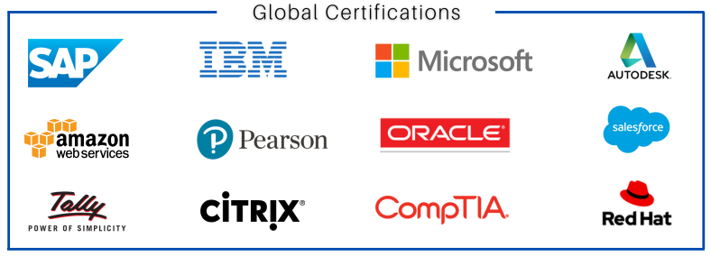

### **SAP BASIS Course – System Administration & Technical Foundation**

#### **Course Overview:**

**SAP BASIS is the technical foundation that enables SAP applications to function. It includes administration of the SAP system such as installation, configuration, performance tuning, user administration, and database management. This course is designed for professionals who want to pursue a career in SAP system administration and support.**

#### **Course Objectives:**

* **Understand SAP system architecture and landscape**
* **Learn SAP BASIS administration tasks and tools**
* **Manage users, roles, and authorizations**
* **Perform system installation, configuration, and monitoring**
* **Get hands-on with transport management and performance tuning**

#### **Modules Covered**

1. **Introduction to SAP BASIS**
   1. **Overview of SAP Architecture & Components**
   2. **SAP Landscape (Development, QA, Production)**
   3. **SAP GUI and Navigation**
2. **SAP System Installation**
   1. **Pre-requisites & Media Preparation**
   2. **Installation using SWPM**
   3. **Post-Installation Activities**
3. **Client Administration**
   1. **Client Creation, Copy, Delete**
   2. **Remote Client Copy and Transport**
   3. **Logical Systems Configuration**
4. **User Administratio**
   1. **Creating Users and Roles**
   2. **Role Maintenance (PFCG)**
   3. **Authorization Object and Profile Management**
5. **Transport Management System (TMS)**
   1. **Configuring Transport Routes**
   2. **Import/Export of Transports**
   3. **STMS Monitoring**
6. **Job Scheduling & Background Processing**
   1. **Creating Background Jobs (SM36/SM37)**
   2. **Monitoring and Troubleshooting**
7. **System Monitoring & Performance**
   1. **Workload Analysis (ST03N)**
   2. **Performance Tuning (ST02, ST06)**
   3. **Buffer Management and Memory Analysis**
8. **Database Administration**
   1. **SAP with Oracle, HANA, or SQL DB (Basics)**
   2. **Backup and Recovery**
   3. **DB Monitoring Tools**
9. **Patch and Kernel Updates**
   1. **Applying Support Packages**
   2. **Kernel Upgrade Steps**
   3. **SPAM/SAINT Administration**
10. **SAP Security Overview (Intro)**

* **Security Concepts**
* **Audit Logs and Trace**
* **User Locking and Authorization Issues**

1. **SAP HANA Basis (Optional Add-on)**

* **HANA Architecture**
* **HANA Studio Basics**
* **Backup/Restore and Monitoring in HANA**

#### **Hands-On Practice**

* **SAP ECC and S/4HANA environment access**
* **System installations, user setup, and job scheduling**
* **Real-time troubleshooting and system logs**

#### **Certification Guidance:**

* **SAP Certified Technology Associate – SAP BASIS / NetWeaver / S/4HANA Administration**
* **Mock tests, real-time interview questions, and resume assistance provided**

#### **Course Duration:**

**6–8 Weeks (Weekday & Weekend Batches Available)**

#### **Training Mode:**

**Online Live / Classroom Training / Self-paced Video**

#### **📞 Contact Details:**

**Institute: SAP Corporate Academy**  
 **Phone: +91 93100 50979**  
 **Website:** [**sapcorporateacademy.org**](https://sapcorporateacademy.org/)

