5 Profitable Steps To Info Product Creation!

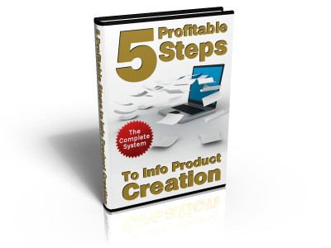

Thank You For Purchasing this report. Please note that you have full PLR rights to this report so you can put your name on it.
Please feel free to sell it, use it as content for your articles or newsletters or give it away!

Enjoy the report.

For The First Time Ever:

“The Web’s First Ever... Breakthrough Software Uncovers More Than A Billion Red-Hot Buyer Keywords In 50,000 Money-Making Niches”

Click Here To Discover How Software Works

Attention Online Income Seeker:

Discover A FREE, Push Button,
Simple Way To Make Money...



…Almost On Command!

Click Here For This Limited Time Free Offer!

Contents:

Introduction

Step 1: The Right Mindset Means Alot!

Step 2: Finding That Hungry Niche!

Step 3: How To Be Sure Your Product Will Make Money!

Step 4: How To Create Your Killer Product With Least Amount Of Fuss!

Step 5: The Secret To Writing Content For Your Ebook With Ease!

Bonus:

Putting It All Together!

Introduction

First of all, let me say thank you for purchasing this report. I am sure you will find the content in this report invaluable when looking to create your own products.

The reason I have created this report is to help other people get started with product creation as this can seem like a daunting task But believe me when I say it is also the most profitable step you can take!

There is a lot of information on the web about how to create your own products, but not many of these sources provide a clear and concise step by step guide so you can get your product out there and making money in the quickest time possible!

So that is what I am going to attempt to do here.

I am confident if you follow the steps within this report you will have your very own killer product that will bring in sales for years to come.

Step 1: The Right Mindset Means A Lot!

Welcome to Step 1. The reason I thought I would include this step (which really has nothing to do with product creation) is because you will need the right mindset to get the most out of this report.

The hardest thing I found and probably many other people do when getting started with any aspect of Internet marketing is the hard work it involves.

I am not sure how you got interested in Internet marketing, but if you are like me, you have probably been pulled in at some point, by all the websites out there that promise untold riches for 5 minutes of work!

Don't get me wrong, this is indeed possible, but in my experience not when you are getting started. It is indeed a reality if you have a list of 3,000 responsive buyers that you can send out an email to that will make you thousands of dollars within a few days.

Although to start off you need to create that product and build that list and unfortunately that will require some good old fashioned elbow grease!

So you will need the correct mindset and I am not going to write pages and pages of motivation for you, except to answer the number one question that stops people from taking action or makes them give up, in my experience.

I know this question comes up and can be very hard to overcome because I have asked myself the same question plenty of times when I was getting started with Internet marketing.

Here is the question or questions I found myself asking when I was getting started:

“Is this going to work?”

“Is all this work worth it?”

“Will my product sell?”

These are the three main questions that I found myself asking when I was creating my own product.

Well take it from me, the answer to all those questions is “Yes, yes, and yes!”.

If you follow the steps within this guide, you will see that Internet marketing does not have some SECRET formula to riches!

All you have to do is see things through to the end, have the ability to follow a series of steps, and probably most importantly, take action!

This report will do you no good whatsoever if it is just gathering dust on your hard drive, and please, I implore you not to wait for the next best thing that promises riches!

Take action today and you will see results and I am here to help if you need it.

Whether it takes you 2 days or 2 weeks to follow these steps, see them through to the end and I guarantee you will make money online!

All you have to do is take a leap of faith with these steps once to create your own product and once that is pulling in money, you can do the same thing over and over to build a virtual empire.

YOU CAN DO IT AND YOU WILL SUCCEED!

So let's get started!

Step 2: Finding That Hungry Niche!

This is one of the most talked about subjects in IM and can be like the search for the Holy Grail! :)

The good news is it really does not have to be that difficult and you can find hungry niches with ease--it just requires you to think a bit outside the box.

This step is the exact method I use to find hungry niches and is quite easy to do!

The first thing you need to do, especially with your first product, is find a niche that interests you.

This is not always the case and there will be plenty of profitable niches that you do not really interest you at all, but with your first product it is a good idea to find a niche that you have some sort of interest in.

If you are having difficulty thinking of a good niche that you have interest in, the best thing to do is think about your hobbies.

The first niche I can think of for you is “How to make money online” as you are reading this guide.

Just think of things that you enjoy doing like cooking, playing computer games, fishing, DIY, eBay, collecting stamps, etc...

The other thing I should mention here is try not to spend too much time thinking about this as it can prevent you from taking action!

Once you have thought of a niche that you have some interest in, settle on that niche and get started.

Obviously I will not know what niche you have picked so for the purposes of this report, I will go through the niche research steps with the “Dog Training” niche.

Ok, so once you have got your niche, the first thing you need to do is see if it is profitable and people are looking for it!

Remember don't spend too much time on this. Just think of something you have an interest in and move on to the next step.

The next thing you need to do is go to Overture and check out how many people are searching for your niche.

The site I use is Pixelfast.com as it lets you see the amount of Google results and the amount people are paying for bids on Overture.

Here is what the tool brought up for the keyword “dog training”:

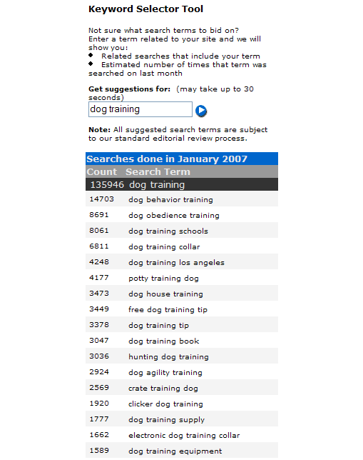
There were more results, but for the sake of this guide you should be concerned with just the top 20 results.

As you can see, this is a VERY popular niche with lots of people typing in some very profitable phrases. Don't worry if your niche does not bring up this many results, as dog training is a heavily saturated market.

Do bear in mind though that your niche search results should have more than 500 searches per month at the very least.

This works out at about 16 unique searches per day on Overture. Overture is a search engine that is not as big as Google, so you can times the results by 4 to get a more accurate view of how many people are searching for a certain phrase.

As you can see, the main phrases that would interest here are:

dog behavior training
dog potty training
dog training book
dog training tips
dog obedience training

So you should now do the same and pick the top 5 phrases that are being most searched for in your niche.

If you followed the above steps and your niche has less than 500 searches per month, then you will need to find another I'm afraid as it may not be worth putting the work in if there are so few looking for it!

So if you have a very small niche, try and think of another niche with more search results.

If you have found a niche with a decent amount of search results move onto Step 3 where we will find out if your niche will make you money!

Step 3: How To Be Sure That Your Product Will Make Money !

Ok, so you have your niche and have picked out the top 5 phrases that people are searching for in that market.

The next thing we need to find out is if the niche will make you any money!

Bear in mind that there are no guarantees that you will make money with your product, however if you follow this step, it should make you 99% sure that there is a market for the taking!

What you should do now as well is make a folder on your Desktop to keep all your work together.

Just call it your “niches name” product, for example, “Dog Training Product”.

To find out if you will make money from your product we need to ascertain that all the people who are searching for your 5 phrases are buying as well!

There are many different ways to do this, but this is the way I do it:

First of all, go to http://www.google.com and type in your top phrase (the one with the most searches). For instance, I would type in “dog training”.

This is what Google brought up for me:

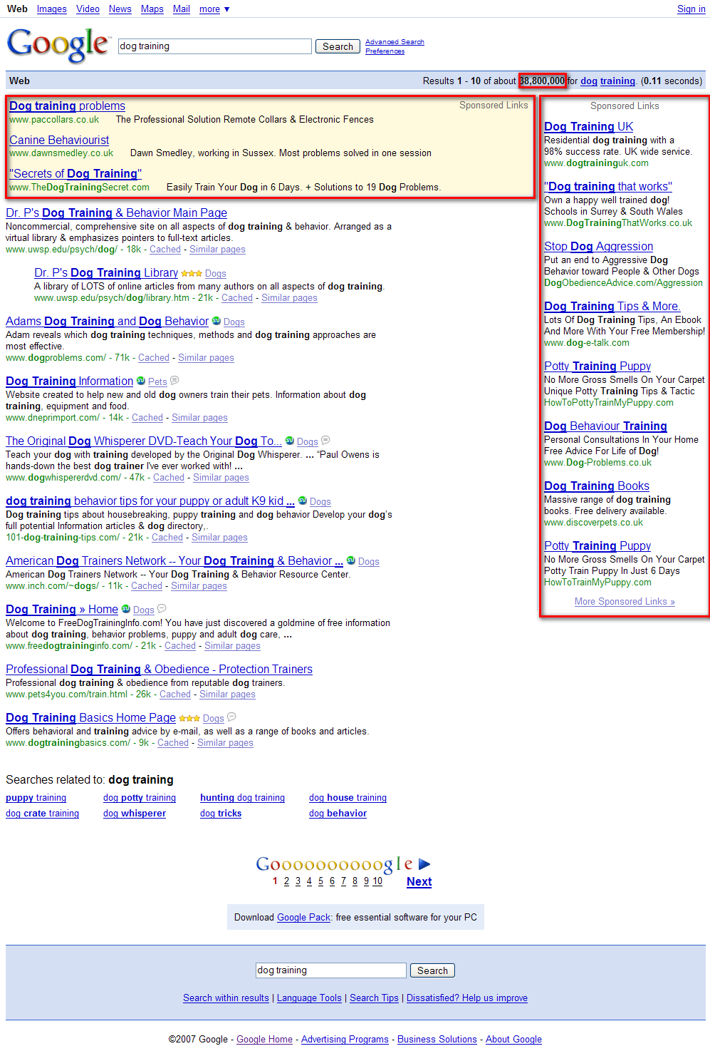

Once you have typed in your main phrase, the first thing you should look at is the number of search results the query has.

You can see from the example above I have highlighted the search results and there are 38,800,000 results for the phrase “dog training”.

This is a lot of results and that normally means there is a market there.

The next thing you should do is look at the number of adwords the phrase has.

I have highlighted the Adwords on the page and these are advertisements people place on Google for certain phrases. What we are interested in is how many competing ads there are and what sort of price they are paying to be there.

Basically, the more profitable a market, the more people will bid to place their ads.

So all you need to do now is type each one of the five phrases you picked earlier and make a note of:

- The number of search results

- How many people are paying to be their on Google Adwords

The next thing we need to do as mentioned above is get a rough idea of how much people are willing to pay to be there on Google Adwords as this is a good indicator of how much money is in a niche!

Also make a note of what the Adwords are selling as this is a good indicator of WHAT people are buying in the niche and this can help you with your product creation.

For instance what is the top Adword Ad?

For the dog training niche it is:

Dog Training Problems
The Professional Solution
Remote Collars & Electrical Fences

Bear in mind this is not necessarily the best product to copy, although it will give you an idea of what people are selling in the niche.

However, the above is just something to bear in mind. When you have checked out the search results for each one of your phrases and the competing ads, we need to know how much people are paying and for this we will use a site called:

http://www.spyfu.com/

Spyfu is a site that lets you see what sort of money people are spending on Google Adwords for their phrases.

Once you go to the Spyfu site you will see this screen:
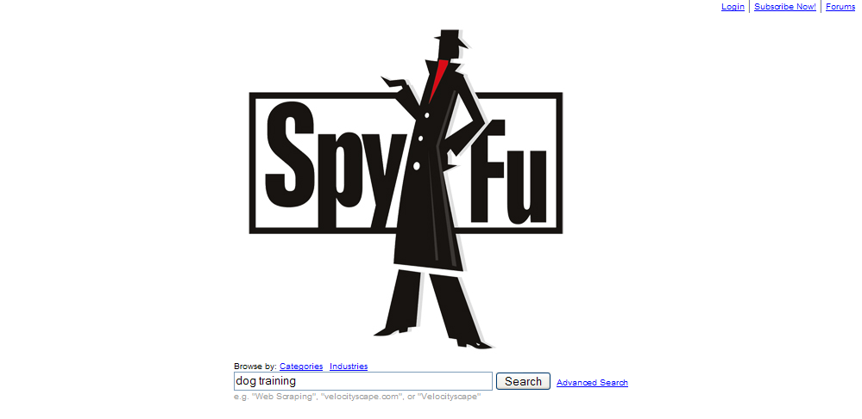

All you need to do is type in your main phrase into the Spyfu search bar and it will display the information we want.

You will need to do this with each of your phrases, but I will go through the process with my example phrase, “dog training”.

This is the info that SpyFu brought up for the phrase “dog training”:

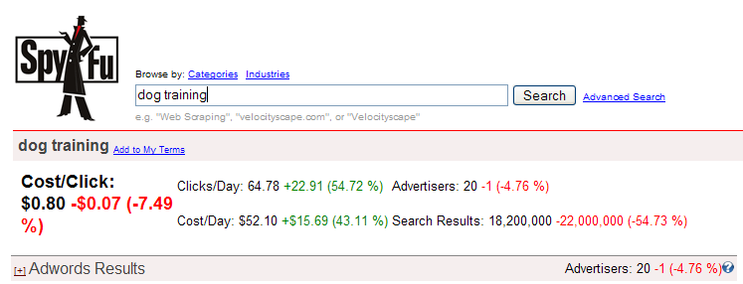

You will receive more info showing the Google Adwords ads, but we are only interested in the top bit as shown above.

Let me explain what this data means and how it is relevant:

Cost/Click: This tells us the average cost to the advertiser per click, so you can see that the average advertiser is spending $0.80 per each click. The higher the amount is, the better. If they are spending a lot of money per click they must be getting sales (normally anyway!).

Click/Day: This shows us the average number of clicks per day an advertiser is getting on that phrase. If this is high, it is better also as it means people are searching for information on that phrase.

Advertisers: This shows the number of advertisers bidding on this phrase. Ideally this number should be lower than 20 as it means that there is more than 20 different competing Google Adwords and if you can find a good niche with low competition, then this is better. Don't worry too much about this though because if it is high, you can get people to promote your product!

Cost/Day: This shows the total daily cost to all advertisers that bought this keyword/phrase. This shows you how much an advertiser is prepared to pay to stay at the top. Normally the more the better; if the advertiser is willing to pay more, then they must think the keyword is profitable!

So all you need to do is go through each of your 5 keywords and see the results using this tool.

Ideally you will be looking for all the figures to be high and the competition low (lower than 10 competing ads can be a goldmine!).

However as long as people are spending money and there is a market there you will make money 99% of the time!

Also you should now start thinking about narrowing down your niche for product creation using this tool.

For example, I have been focusing on the keyword “Dog Training”, however, it is a good idea to focus on an actual topic within a subject, like “Dog Potty Training” in my example.

This is not always the case, but it does mean you can focus in on one point and it will be easier when creating your product and also more targeted.

Here are the results for “Dog Potty Training”:

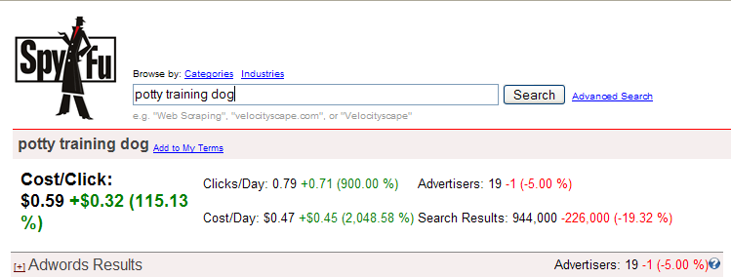

As you can see from the example above, this phrase is a lot more focused and is still very competitive.

However, although it is saying we would only receive 0.79 clicks per day, if you created a product on how to potty train your dog, you would get more sales than if you created the same guide and bid on just the phrase “dog training”.

Does that make sense?

You should find a niche like this that tells people how to solve a problem or offer some solution.

So for this example, I will settle on the topic “Dog Potty Training”.

Also don't get too caught up on this. Just take each of your 5 phrases, type them into Spyfu, and note the results and see how much people are spending to be there.

Then select a phrase that solves a problem or that is more focused!

So I have settled on the phrase “Dog Potty Training”.

The next step will show you how to get started creating your product.

Step 4: How To Create Your Killer Product
With The Least
Amount Of Fuss!

Ok, so by now you should have a market that is profitable and all you need to do is create a product.

There are lots of different products that you can create, but for the purposes of this report we will create an ebook and I will show you how to write a brilliant one, even if you do not have a clue about the topic!

The reason that you should create an ebook as your first project is it is without a doubt in my opinion, the easiest product to get started with!

If your niche really takes off, you can always come back and create an “add-on” product like educational videos, or an online course as an upsell, but to start off with, focus on an ebook.

The first thing we need for our eBook is topics that we can put into chapters. How do you know what chapters to put in your ebook?

Well you need to know what people want answers to within your niche, so for this we head over to Yahoo Answers.

http://answers.yahoo.com/

Yahoo Answers is an excellent resource to see what people are wanting answers to within a market.

It is an awesome tool to find out what the chapters or sections of your ebook should be.

All you do is type in the market phrase you have decided on into the search bar. For instance, mine is “Dog Potty Training”, so I will type this in. Here is what comes up for me:

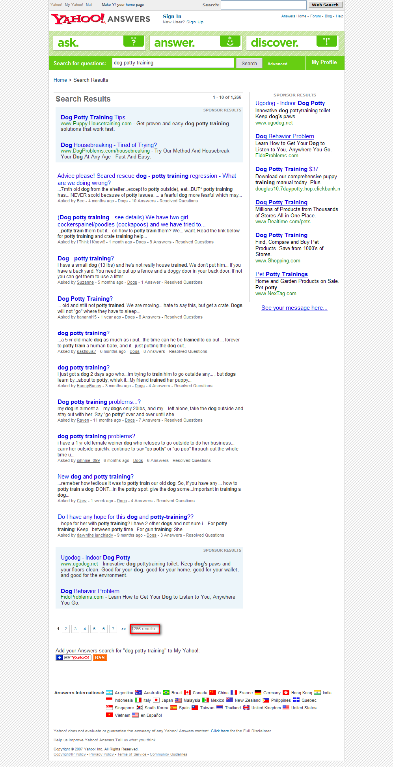

From the example it is hard to see, but there are 1,266 results for the phrase “Dog Potty Training”.

What you need to do now is search through the results and see what the main questions or subjects that are bought up are.

For instance, for my example one of the topics that comes up a lot within “Dog Potty Training” is the question, “Should I smack my dog when potty training?”

The answer to this question by almost everyone is a big resounding NO!

So taking the example, I would think about entitling one my chapters, “The 4 Reasons Why You Shouldn't Smack Your Dog While Potty Training!”.

The amount of chapters you pick for your ebook is dependant on how many different questions are being asked, but you should aim for about 5 or 6 chapters with good content.

More on how to get the content in the next chapter. For now, find 5 or 6 questions that are being asked and make a note of them as these will be the chapters of your ebook.

The top 5 issues I found for “Dog Potty Training” was:

- Should I Smack My Dog When Potty Training?

- Is It Right To Shout At My Dog When Potty Training?

- Should You Use A Crate When Dog Potty Training?

- What's The Best Routines To Potty Train My Dog?

- What Is The Best Way To Potty Train An Older Dog?

There was actually a lot more for “Dog Potty Training”, but for your first product, just focus on 5 or 6 main questions and save the questions in a notepad file and put them in the folder you made earlier.

These will be the main subjects or chapters for your ebook and all you need to do now is make a good title for each chapter and obviously add content to each chapter.

For the beginning of your ebook, always start with an introduction where you can tell them who you are and what you are going to tell them.

This does not have to be too long, however a nice little story will go down well.:)

For the title of your chapters, I find that catchy titles following the top reasons routine works well.

So for instance, you could entitle the first chapter:

“The Top 10 Reasons Why You Should Not Smack Your Dog While Potty Training And The REAL Secrets You Must Know To Do Successful Potty Training!”

As with every other step, do not get too caught up on the titles of the chapters. As you start to put content in your Ebook you can always go back and change them.

I find these three guidelines help:

- Try to think of a catchy title that grabs the reader’s attention.

- Use words like “Secrets” or “Never Revealed Before” To spark interest.

- Also use the top 10 reasons methods or 10 things NOT to do when training your dog, as it is easier when you go to write your book!

So to recap, you should now have 5 or 6 questions that your product is going to answer and have thought of how to put them into catchy chapter names.

As I said, this does not have to be a masterpiece. Just think of 5 or 6 chapter titles that you are going to use to tell them answers to the questions, as it will give you a focus for your content that you are going to do next.

Once you have your chapter titles, you are ready to start writing your guide and the next step will show you how with ease.

All being well, you are now ready to begin writing your first product.

Don't worry, it isn't as hard as it sounds!

Step 5: The Secrets To Writing The Content For Your Ebook With Ease!

Ok, you are now ready to begin writing the content for your ebook. A lot of people find this very daunting, but it does not have to be!

This step will explain how I find good solid content for my ebooks and how you can get them written and have a killer product within one day!

Want to know the secret to creating your own product super fast?

ALL THE RESEARCH HAS BEEN DONE FOR YOU!

You do not need to spend hours of painstaking research to write your next best seller as all the research has been done for you!

All you need to do to find good quality content for your ebook is know where to find it!

The first place you should go is Ezine Articles:

http://www.ezinearticles.com

Ezine Articles has thousands of articles that you can use for the content of your product.

Bear in mind you should not copy people's articles, but you can by all means take the main points from an article and re-write them in your own words.

The only hard part is a lot of writing, but stay on track and you should be fine!

Ok, the first thing you should do is go to the Ezine Articles homepage.

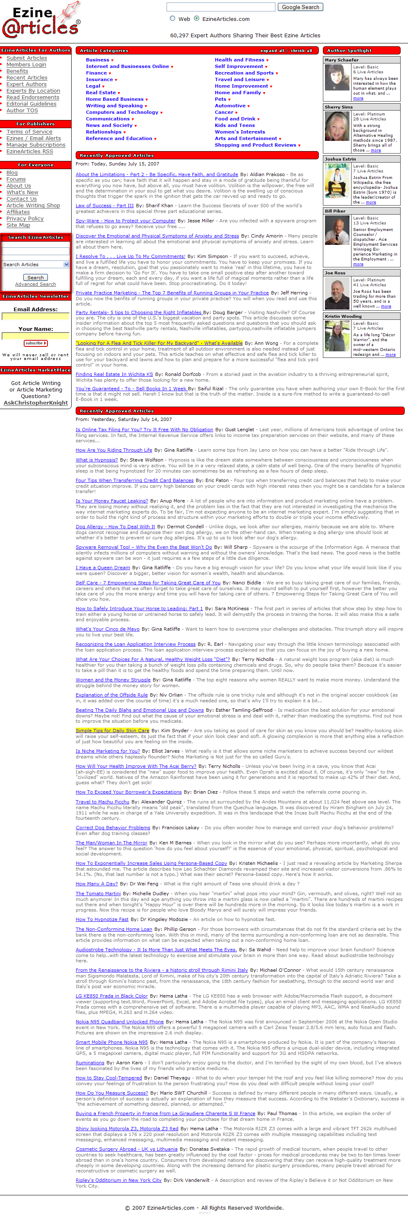

It is a bit of a bad picture, but you should see a box on the side of the page about halfway down that has a search feature.

Click on the “Advanced Search” feature and it will take you to a screen like this:

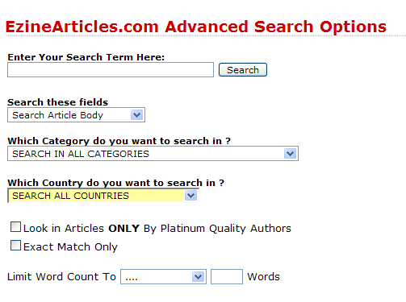

All you have to do then is type your search term in the box and it will return all the articles in the database.

Try to use the exact phrase of your main keyword, for instance, I typed in “Dog Potty Training” and Ezine articles returned these results:

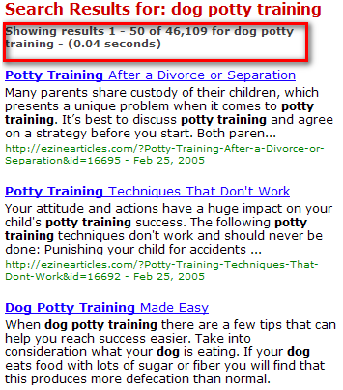

As you can see where I have highlighted on the picture above there are 46,109 articles on this topic!

I could write thousands of chapters if I wanted too, but you only need 5 or 6.

Already in this search we can see articles entitled “Potty Training Techniques That Don't Work” and so on.

You should search through and find 3-4 articles for each chapter and copy them each into a separate notepad file.

As I said, you should not copy someone’s article word for word, but you can use ideas from them.

In the folder you created earlier create a separate sub folder for each of your chapters and copy and paste 4-5 articles for each chapter that you can use content from.

All you need to do is start writing your ebook using the articles that you have found.

If you did not find much on Ezine articles, here are some more top article sites:

http://www.goarticles.com

http://www.articledashboard.com

http://www.searchwarp.com

You can also find more specialized info by performing a forum search in Google for your niche.

This will bring up all the forums to do with your niche, so if you are looking for some more in-depth info, you can find it there. Here is how you do a forum search:

- Go to http://www.google.com .

- Type in your phrase/chapter and “forums” in the search box.

For instance, I typed in “Dog Potty Training Forums” and this is what Google bought back:

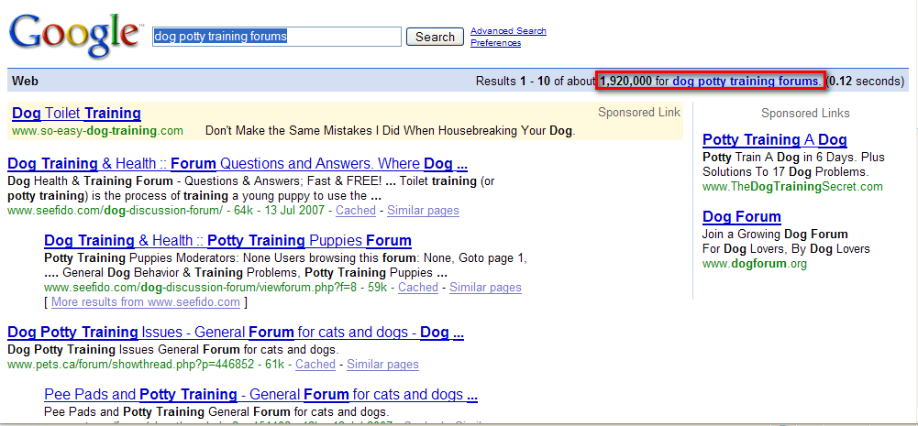

As you can see, there are 1,920,000 results which should be plenty enough for every chapter for a Dog Potty Training product!

You can also use forums if you need a specific answer to a problem that you cannot find anywhere else.

All you need to do is sign up as a member of the forum and ask your question and you will get answers!

P.S It is a good idea to say hello and introduce yourself and add a bit of content first.

It does not need to be anything special. Just tell them about your “dogs” or whatever subject it is.

Using the above methods you should have more than enough info to write your book and in the bonus section next, I will give you a few pointers on how to put the info together!

Bonus Section: Putting It All Together

I thought I would create this bonus section to give you a few pointers when you are putting together your product.

So you have allocated a folder for each of your chapters and put a copy of the articles you are going to use in each folder, 4-5 articles for each chapter.

All you need to do is put it all together and to do this the best advice I can give you is just start writing.

The product does not have to be a Charles Dickens masterpiece. Just write how you speak. As long as you are putting in good, solid content, people will appreciate that more than any fancy words or “filler” content.

All you need to do is take 4-5 articles for each chapter that fit the title of the chapter. For this example, my first chapter would be something like:

Chapter 1: The Do's And Don'ts Of Dog Potty Training

Take the MAIN points of your 4-5 articles and start writing. Take the main tips and put them in your own words.

Of course you do need to write the ebook, so like mentioned below, you could start off with:

“In this chapter I thought I would cover the main Do's and Don'ts of Dog Potty Training so you can get a rough idea of what you should (and shouldn't!) be doing!

These tips are from my own personal experience and can really help you get started on the right track.

Here are the things you should make sure you are doing for effective dog potty training, an explanation of each method, and how it helps:

Tip 1/ Explanation

Tip 2/ Explanation

Summary of chapter”

So as you can see from the example above, all you need to do is arrange the information and make sure it is in your own words as well!

A good way to construct each chapter is:

- Start off telling them what you want to tell them.

- Then tell them and put in your main content, tips and advice.

- At the end of the chapter tell them what you have just told them (summarize) and tell them what you are going to tell them in the next chapter.

The best thing to do is just get started and write down your first thoughts and then go back over your work and improve afterwards.

So there you have it!

If you have followed the steps above you will be well on your way to having your very own profitable product!

