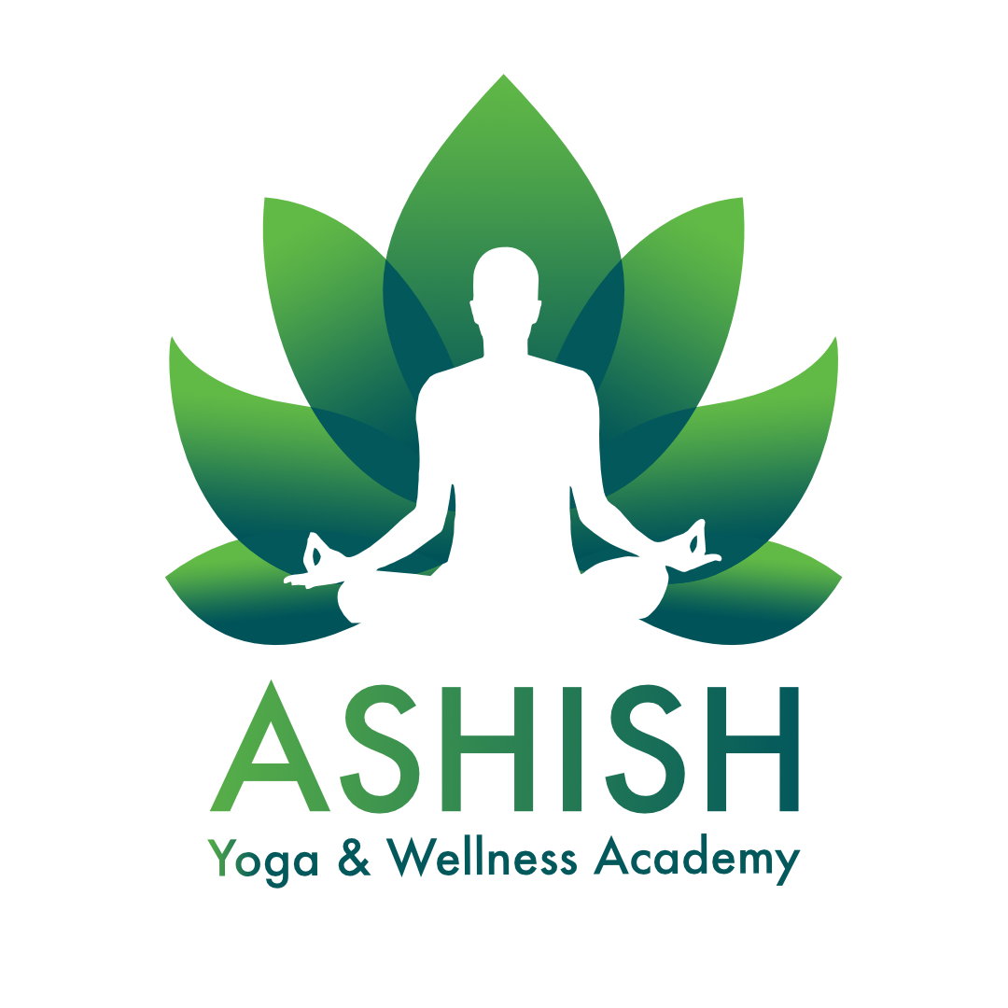

**Ashish Yoga & Wellness Academy  
200-Hour Hatha Yoga Teacher Training Curriculum**

# Techniques, Training & Practice - 75 Hours

In this core component, students will be guided through daily practice and instruction in asana, pranayama, kriyas, chanting, mantra, meditation, and other traditional yoga techniques. This includes alignment-based learning, hands-on adjustments, and cueing principles.

# Anatomy & Physiology - 30 Hours

This section covers both human anatomy and physiology, including the skeletal, muscular, respiratory, cardiovascular, endocrine, and digestive systems, as they relate to the practice of yoga. Students will also learn biomechanics, types of joints and muscle contractions, and how yoga influences the nervous system with emphasis on polyvagal theory and stress response.

# Yoga Humanities - 30 Hours

Students will explore yoga's historical and philosophical roots, including an in-depth look at the Yoga Sutras of Patanjali, Bhagavad Gita, Hatha Yoga Pradipika, and foundational Sanskrit terminology. Topics such as the eight limbs of yoga, chakras, koshas, gunas, nadis, and subtle body anatomy will also be discussed.

# Professional Essentials - 50 Hours

This section develops teaching skills such as cueing, sequencing, theming, time management, and student observation. It also includes practicum teaching, class planning, and feedback sessions. Ethical commitments and professional responsibilities of a yoga teacher are emphasized.

# Elective - 15 Hours

Elective hours include exploration into areas such as restorative yoga, prenatal considerations, trauma-informed teaching, and specialty topics chosen by the school to enrich the learning experience.

# Special Ayurveda Module

As a unique addition to this training, students will receive a dedicated session on the foundational principles of Ayurveda. This class introduces the concept of doshas (Vata, Pitta, Kapha), daily and seasonal routines (Dinacharya & Ritucharya), dietary guidelines based on body constitution, and Ayurvedic lifestyle for wellness. Participants will learn how to integrate Ayurvedic understanding into yoga teaching and self-care practices, aligning with the Yoga Alliance emphasis on holistic health education.

Website: ashishyoga.in

Mobile: +91 9886002029