Foreword

Once upon a time …
“So it’s a fairy tale,” you might say.
And in a way you’d be right. It is about The Adventures of Pinocchio by Carlo Collodi, a story that feels like a fairy tale.
But in another way, you’d be wrong. I won’t tell you a children’s story about Pinocchio. I’ll tell you the truth, as I’ve learned to read it.
So let’s begin again.
Once upon a time, there was a little boy made of wood. His nose had a strange life of its own. It grew when he told lies. He longed to become human, and in the end, he did. His story was told to children all over the world.
One day, however, it became clear that this story was not meant for children alone. The boy’s nose grew for another reason, as we’ll see in a moment. Collodi’s tale carries secrets that touch us all.
Almost one hundred and fifty years have passed since Pinocchio’s adventures were first published. The deeper meaning of the story has yet to be brought to light.
To find it, we must set out on a journey into our cultural heritage: the Bible, Egyptian and Greek mythology, and the wisdom of the East. All of this lies quietly concealed within Pinocchio.
Along the way, we’ll meet other stories that belong to the wider Pinocchio universe. How might Prometheus escape the punishment for stealing fire? Jesus has an idea. What remained in Pandora’s box and troubles our lives to this day? And what exactly happened in Paradise, in that moment that changed everything?
These and many other stories beyond time and space invite reflection. They open unexpected perspectives on who we are, where we come from, and where we may be going.
For years, I read Pinocchio again and again, following every clue, turning every detail upside down. In doing so, I came to know a quiet, transformative power, one that is accessible to us all. It carried me through a difficult time and led me to a realization that could hardly be more profound: every lasting change begins within us. That understanding brings responsibility, but also freedom and happiness.
And so, while this book is about Pinocchio’s secrets and other thought-provoking stories, at its heart it is also a mirror. Perhaps, if you are on your own journey, you may find that this mirror has been quietly waiting for you.
What will you see?

Part One

How could a little boy made of wood become human?
You may know the line often attributed to Albert Einstein: "No problem can be solved from the same level of consciousness at which it was created.“ That’s exactly how Pinocchio’s world works, as this book will gradually reveal.
In Pinocchio’s world, consciousness is not an abstract idea but a creative force. It determines what he sees, what form his body takes, and even what happens around him. In his world, reality itself is shaped by consciousness and free will.
And now let’s look at Pinocchio’s nose. In the entire story, it grows only twice when he lies. Just as often, it grows when he doesn’t lie. More than once he lies without anything happening at all.
Should that not make us pause?
As we’ll discover, Pinocchio’s nose doesn’t grow because of lies. It grows when he’s caught in an unconscious pattern, running entirely on autopilot.

But let’s go to where it all began …

1. Born an Egoist
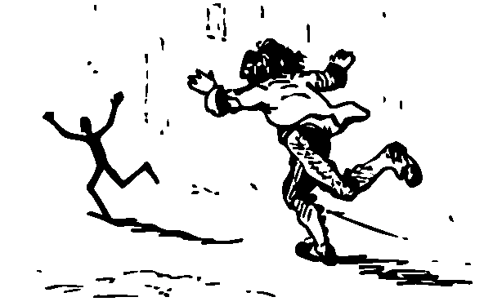

Pinocchio’s story begins in the workshop of Master Cherry, a carpenter. At this point Pinocchio is still just “a simple piece of wood.” We know almost nothing about him: from which tree did he come? What happened to that tree? How did this piece of wood end up in Master Cherry’s shop?
We can imagine Master Cherry as a no-nonsense woodworker, perhaps with a drinking problem. After all, his nickname comes from the color of his nose: “always shiny and purple, like a ripe cherry.”
Master Cherry is searching for wood to make a table leg. When he finds this particular piece, he’s pleased. He raises his tools to start working on it. But again and again, he hears noises no piece of wood should be making: “Don’t hit me so hard!” “Ow! That hurt!” “Stop that! You’re tickling me!”
The carpenter, unsettled, searches his surroundings for the voice, even checking a cupboard that’s always locked. Just as he sits on the floor of his workshop, utterly confused, Geppetto enters the scene. The woodcarver is looking for material to carve into a puppet. Master Cherry gladly hands him the mysterious piece of wood. But first, the two friends get into a fight, not once but twice. The “simple piece of wood” has set them against each other and seems to enjoy the drama.
Once carved into a puppet, Pinocchio bursts into the world like a whirlwind, testing Geppetto’s patience at every turn. The puppet cares only for his own amusement and follows his impulses wherever they lead. Perhaps that’s why Collodi draws on the animal world to describe his first exploits: Pinocchio “hopped like a hare,” “skipped like a kid goat,” “panted like a hunting dog” as he ran to the next village, and returned “soaked like a chick in the rain.”
Such impulsive behavior has consequences. When Geppetto tries to discipline the reckless puppet, he ends up spending a night in prison. A talking cricket fares even worse: when it points out Pinocchio’s misbehavior, he lashes out in anger and strikes it down with a wooden mallet.
As night falls, a winter storm rages outside. Pinocchio falls asleep in Geppetto’s room. But the tragedy isn’t over: He doesn’t realize his feet are slowly burning away in the fire …

Is this really the cherished little puppet we think we know?
Pinocchio allowed Geppetto to carve him into a puppet, yet shows no trace of gratitude. On the contrary, we encounter a Pinocchio who is impulsive and deeply inconsiderate. He even kills the cricket in a moment of rage, without the slightest sign of remorse.
Let’s try to understand Pinocchio’s behavior more clearly. He has had a body for just a few hours. For the first time, he can move and explore the world. Collodi has endowed him with emotions that closely mirror our own: Pinocchio can feel joy, hunger, fear, despair, sadness, anger, or stomp his feet in frustration.
But has his consciousness kept pace with these physical changes? He has had no social contact so far. How could he possibly be ready for that? On the day of his “birth,” is he even capable of seeing beyond his own needs?
I believe Pinocchio’s mind still needs time to build the internal wiring required for social interaction. He has to gather experiences, as many as he can, in order to grow. Also the cricket’s final words suggest that, above all, the freshly carved puppet now needs to develop his mind:
“Poor Pinocchio! I really feel sorry for you.”
“Why do you feel sorry for me?”
“Because you’re a puppet – and worse than that, you’ve got a wooden head.”
For me, these lines capture the core theme of the story. The “simple piece of wood” has become a puppet, but that’s only the beginning of the journey. Pinocchio must now lose his wooden head.

Doesn’t Pinocchio’s first day of life resemble our own?
When we’re born, we also begin a journey. We too must gather experiences throughout our lives. It’s the only way we begin to understand the world and ourselves.
When a small child sees a cricket for the first time, it might excitedly point at the little insect and shout “Fly!” The parents might then explain that it’s actually a cricket, and how crickets differ from flies. In that moment, the child has a new experience and can learn from it.
Our ability to learn from experience is almost limitless. The human brain has around 100 billion neurons, each connected to about 5,000 others. The possible states our brains can take on are beyond imagination. Well into old age we can form and reshape the circuits we need to perceive, think, and interact with the world.
Pinocchio too can grow beyond his wooden head. He can now gather experiences and, thanks to his free will, he can learn from them. The next chapter will show how quickly he does so.

