PARALLAX CYBER ACADEMY  Space Systems Security Engineering Professional  (S3EP) Certification Program  APPLICANT INFORMATION FORM | 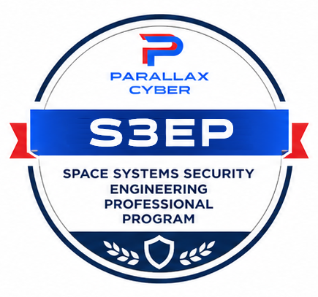

Section 1 — Applicant Personal Information

First Name: | Middle Initial: | Last Name:

Email Address: | Phone Number:

Confirm Email Address:

Section 2 — Certification Level
Select the S3EP certification level for which you are applying:
 | AS3EP |  | DSS3EP |  | DGS3EP |  | CS3EP |  | ES3EP

Section 3 — Current Relevant Certifications
List any current certifications related to cybersecurity or the space profession.

Certification #1
Certification Name: | Certifying Organization:

Certification #2
Certification Name: | Certifying Organization:

Certification #3
Certification Name: | Certifying Organization:

Section 4 — Space Cybersecurity Training
Have you completed a training course on the subject of space cybersecurity? If yes, provide details below.

Course #1
Course Name: | Hosting Organization: | Date Completed:

Course #2
Course Name: | Hosting Organization: | Date Completed:

Note: Completion of a space cybersecurity course is not required, but supports knowledge required for a successful certification exam.

Section 5 — Certification Exam Registration

Date of scheduled PCA S3EP certification exam, if registered:

Section 6 — Additional Information
Please provide any additional information you would like considered as part of your application:

U.S. TRADE COMPLIANCE
Initial | Parallax Cyber LLC is in full compliance with all applicable trade, economic, and financial sanctions laws and regulations enforced by the United States government, including those administered by the Office of Foreign Assets Control (OFAC).  Specifically Parallax Cyber LLC represents and warrants that:  1. Restricted Nations: It does not conduct, and will not engage in, any business, trade, or financial transactions with or involving comprehensively embargoed nations, regions, or governments (including but not limited to Cuba, Iran, North Korea, Syria, and the Crimea, Donetsk, and Luhansk regions of Ukraine).  2. Prohibited Persons: Neither the company nor its subsidiaries are listed on, or owned/controlled (50% or more) by persons listed on, OFAC's Specially Designated Nationals (SDN) list or any other U.S. restricted party lists.  3. No Facilitation: It will not engage in any transaction that causes a U.S. person to violate OFAC regulations or that facilitates prohibited transactions by non-U.S. persons.  4. Due Diligence: Parallax Cyber LLC maintains an active compliance program and conducts regular screening to ensure that no items, technology, or services are provided to, or sourced from, sanctioned locations.

LEGAL RELEASE FROM LIABILITY, WAIVER OF RIGHT TO SUE, AND HOLD HARMLESS AGREEMENT
By submitting this S3EP Certification Application, I acknowledge that participation in a professional certification program and associated training, while the risk is low, could include potentially hazardous activities involving a possible risk of serious bodily injury or death. I agree to abide by all safety rules and any decision of the Parallax Cyber LLC staff relative to my ability to safely participate. I freely assume all risks associated with participating in this certification program and associated professional training including risk of bodily injury or death or any other damage arising as a result of my participation in these programs, all such risks being known and appreciated by me. Having read this waiver and knowing these facts and in consideration of you accepting my participation in this certification program and associated training I, for myself, and anyone entitled to act on my behalf, hereby release from liability, waive any rights to sue and hold harmless the following: Parallax Cyber LLC, its employees, volunteers, program providers, and cooperating facilities from all claims or liabilities of any kind arising out of my participation in this certification program and associated training. In case of an emergency, I hereby give my permission to the program employees and volunteers to administer or secure necessary first aid treatment, including emergency medical services for the below named participant and hereby expressly waive any and all claims of any nature arising from such treatment.

Printed First Name: | Printed Last Name:

Signature: | Date:

SUBMISSION INSTRUCTIONS
After completing this form, email the document to: certifications@parallax-cyber.com
Complete payment for application processing at the payment website listed below:
https://www.paypal.com/ncp/payment/MX9L7N4PCNHLW
(Payment website URL)

