12 week ‘Sub 3’ Plan
Run Coaching UK
An important aspect of marathon training is extension of endurance or the ability to run for longer at the same pace. To help you with this I have put together a 12 week marathon training programme. This is designed to prepare you with adequate specificity and training progression in the final build up to your marathon race. During this final 12 week block of training, you will use a combination of sessions, long steady runs, or long runs with MP intervals. The aim is to teach your body to adapt to the endurance requirements of the distance, and to increase running economy whilst running fast. You should be ‘fit to train’ going into this block of training, that means you have been running consistently for at least 3 months, are injury free and with your current fitness level, you should be capable of running the following times:
5k - 19 mins, 10k - 39 mins, Half Marathon – 1 hr 26.
1. The Weekly Structure.
2 sessions, 3 or 4 easy runs.
- Monday: Easy run
- Tuesday: Easy to moderate run
- Wednesday: 400m - 2km reps at 5k to threshold pace.
- Thursday: Easy run
- Friday: Easy to moderate run.
- Sat or Sun: Long run with MP reps, or long continuous steady run.
2. Training Paces. (paces are estimates based on 18.45 5k)
- Interval (I) pace 3.35 - 4.00 min/km
- Threshold (T) pace 4:00 - 4:05 min/km
- Half Marathon (HMP) pace 4.05 - 4.10 min/km
- Marathon (MP) pace 4.10 - 4.15 min/km
- Easy (E) pace as you feel, breathing must be easy, recovery is the aim.

Link To Training Paces

I work from the ‘Stephen Seiller’ 5 Intensity Zones model below. (This can vary depending on which zone model you use.) The sessions should be completed at the intensities described. DO NOT run all sessions at max effort pace, that is asking for injury or may lead to over training. The programme is about sustainable progression of volume at 5k to threshold pace, MP reps in the long run, or longer continuous sections at MP in the long run. All other running is either very easy recovery running or easy to moderate pace running.
The weekend long runs in this block are not base building, they are specific to race performance with the assumption that you have already completed your base phase of long easy runs.
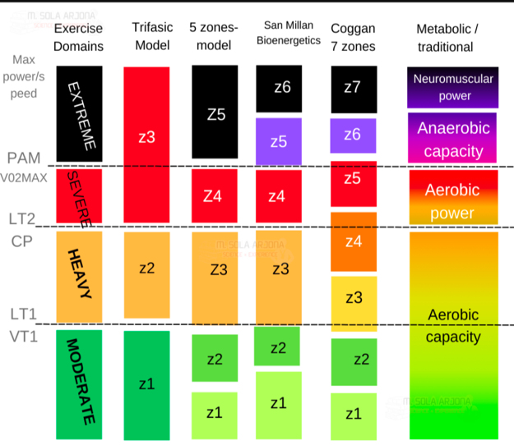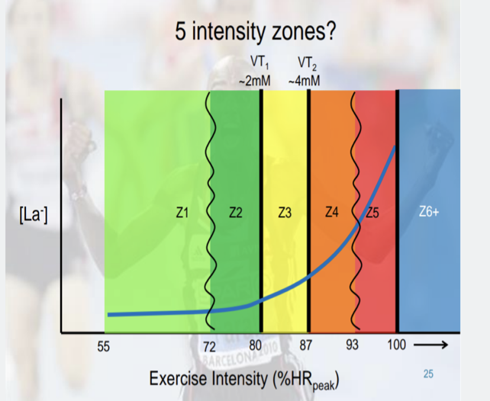

3. The Sessions.

Midweek:

- Session: 400m to 2km reps at 5k to threshold intensity. (3.35-4.05 min/km).
- Rest: 60/90 secs easy jog depending on session
- Aim: To train at and push the threshold/LT2 level higher.

Sat or Sun:
- Workout 1: Continuous long run with 15 to 20km @ MP, or long run with reps of 4k to 5k @ MP. 5k to 10km easy before and after reps, total volume to max at 35k.
- Workout 2: Alternate weeks, building continuous run from 25k to 35k over the duration of the programme at around 4.20-30min/km.
- Aim: Training specificity for the event/extension of endurance. This teaches your body to run at around race pace for progressively longer periods of time. Sub threshold support running @ MP & HMP

Adaptation and recovery is key and you may not be a fit as you estimated and may need extra rest. Change the plan accordingly and do NOT push on through with tiredness
Easy days. Easy or moderate paced recovery runs around 60 mins.

Day  Week | Wed  3k w/up & c/down | Sat/Sun
1 | 8x1k T off 90 jog | 25k MP + 10/15s km
2 | 4x400 @ 5k pace off 60 jog  2 mins easy  4x1.5k T off 90 jog | 10k E, 12k MP, 5k E
3 | 2x400 @ 5k pace off 60 jog  2 mins easy  8x1k T off 90 jog | 28k MP + 10/15s km
4 | 2x400 @ 5k pace off 60 jog  2 mins easy  10x800 T off 90 jog | 10k E, 4x3k MP off 2 mins, 5k E
5 | 4x400 @ 5k pace off 60 jog  2 mins jog  4x2k T off 90 jog | 30k MP +10/15s km
6  Medium week | 5k E 5x1k T off 90 jog  5k E | 5k E 15k MP 5k E
7 | 4x400 @ 5k pace off 60 jog  2 mins easy  8x1k T off 90 jog | 8k E, 4x4k MP off 2 mins, 5k E
8 | 2x400 @ 5k pace off 60  2 mins jog  5x2k T off 90 jog | 32k MP + 10/15s km
9 | 2x400 @ 5k pace off 60  2 mins easy  10x1k T off 90 jog | 8k E, 3x5k @ MP off 2 mins, 8k E
10 | 2x400 @ 5k pace off 60  2 mins easy  3x3k T off 90 jog | 35K MP + 10/15s km
11 | 4x400 @ 5k pace off 60  2 min jog  6x1k T off 90 jog | 5k E, 10k MP, 5k E
12 | 4k E 3x1k T off 90 4k E | RACE  DAY

Weeks 1 to 10 easy runs 60 mins
Week 11 easy runs 45/50 mins
Week 12 easy runs 35/40 mins

