🔬 The Core Science: Lactate vs. H+ Ions

1. The "Lactic Acid" Myth
- Lactic acid does not exist in significant quantities in the human body.
- At physiological pH (around 7.4 in blood and 7.0 in resting muscle), the molecule immediately dissociates into a lactate ion and a free hydrogen proton (H+).
- Timeline: This dissociation happens on a nanosecond to microsecond scale.

2. The Real Cause of "The Burn" (Acidosis)
- The burning sensation is caused by Metabolic Acidosis, which is the accumulation of H+ ions (protons).
- These protons are released when your body breaks down ATP for energy faster than the mitochondria can keep up.
- Lactate is the Hero: The chemical reaction that creates lactate from pyruvate actually consumes a hydrogen ion, helping to delay the burn rather than causing it.

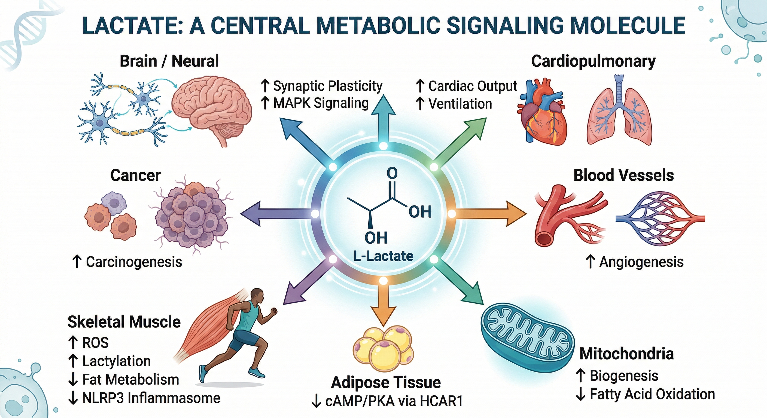
Inigo San Millan, 2020

3. The "Lactate-First" Model
- Modern research (Rogatzki et al. 2015) shows that lactate is the primary end-product of glycolysis, not pyruvate.
- Because the enzyme LDH is so efficient, lactate is produced directly to keep the energy cycle spinning.

🚛 The Transport System: MCTs and the Shuttle

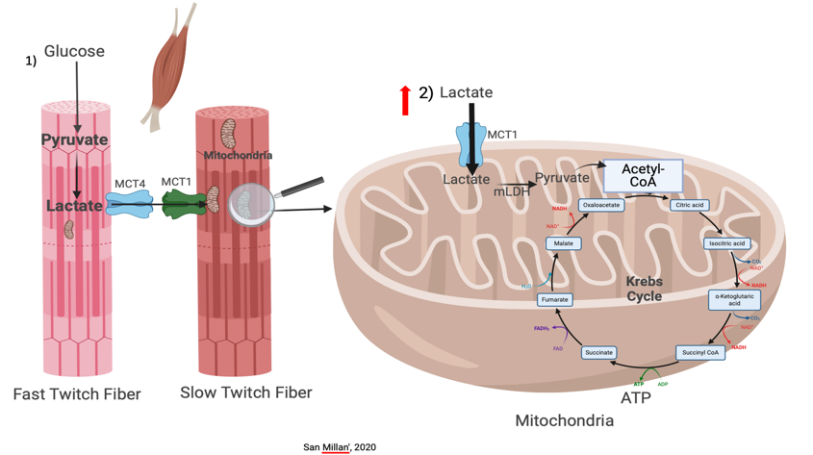

1. The "Escort" System (MCTs)
Lactate and hydrogen ions are transported out of or into muscle fibers in a 1:1 ratio by Monocarboxylate Transporters (MCTs).
- MCT4 (The Exit): Found mostly in fast-twitch (Type IIb) fibers; it kicks Lactate and H+ out into the blood.
- MCT1 (The Entry): Found in slow-twitch (Type I) fibers and the heart; it pulls Lactate and H+ in to be burned.
2. The Mitochondrial Lactate Oxidation Complex (mLOC)
- Brooks discovered the mLOC, proving that mitochondria have specialized "docking stations" to suck up lactate directly.
- The heart and non-active muscles are primary consumers of lactate, using it as a high-octane fuel during exercise.

🏃‍♂️ Coaching Application: Training the "Hybrid Engine"
Instead of "flushing waste," training focuses on improving shuttling, buffering, and clearance.
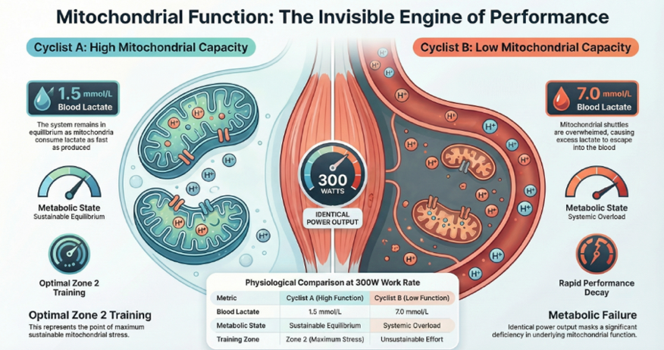
Inigo San Millan, 2020

1. Training Zones & Physiological Targets
Training Type | Primary Target | The "Big Win"
Zone 2 (Base) | Mitochondrial Density & MCT1 | Builds a "vacuum" to clear H+ ions at all intensities.
LT2 (Threshold) | Mitochondrial Enzymes | Teaches the body to produce fewer H+ ions at race pace (Equilibrium).
HIIT (Sprints) | MCT4 & Buffering | Builds "exit doors" and increases carnosine to survive high acidity.

2. The "Self-Diagnosis" Table
Athletes can identify their metabolic weak link based on physical sensation:
If you feel... | Your Weak Link is... | Recommended Training
"Heavy legs" but breathing is fine. | Clearance (Not enough MCT1/Mitochondria). | Zone 2 / Base Miles
"Gasping for air" and burning eyes/lungs. | Buffering (Systemic pH is dropping too fast). | HIIT / Sprint Intervals

🏁 Summary for Recovery
- Lactate Clearance: It typically takes 30–60 minutes for blood lactate to return to baseline.
- Active Recovery: Light movement (cool down) is superior to standing still because it keeps the "Lactate Shuttle" moving, delivering fuel to the heart and liver for recycling.
- The "Flush" Myth: You cannot "flush lactic acid" the day after a race; it was recycled as fuel before you even finished your post-race meal.

