**SPONSORSHIP PACKAGES**

By becoming a sponsor of Hilltop FC you will become a valuable member of this local football club and family.

We can place your Company Identity in the local area through banners at our home grounds during games, on team shirts and apparel, on social media and on our website.

All our packages can be tailored to suit your needs

**Platinum Level ‐ £15,000**

* Company’s name/brand/logo on the **front** of all our teams home and away kits
* Company’s name/brand/logo on our matchday program
* Company’s name/brand/logo on social media, including matchday/fulltime posters
* Company’s name/brand/logo on our “Sponsors” page on our Website plus a link to your Company’s website.
* Invitation to our events
* 5 Season Tickets

**Gold Level ‐ £10,000**

* Company’s name/brand/logo on the our **Training wear**
* Company’s name/brand/logo on our matchday program
* Company’s name/brand/logo on social media, including matchday/fulltime posters
* Company’s name/brand/Logo on our “Sponsors” page on our Website plus a link to your Company’s website.
* Invitation to our events
* 5 Season Tickets

**Sleeve/Back Sponsor - £3000**

* Company’s name/brand on the  **back or left or right sleeve** of the home and away kit
* Company’s name/brand/logo on social media, including matchday/fulltime posters
* Company’s name/brand/logo on our matchday program
* Company’s Logo on our “Sponsors” page on our Website plus a link to your Company’s website.
* 3 Season Tickets

**Website/Advertisement Sponsor - £1000**

* Company’s name/brand/logo on our matchday program
* Company’s name/brand/logo on social media, including matchday/fulltime posters
* Company’s Logo on our “Sponsors” page on our Website plus a link to your Company’s website.
* 1 Season Tickets

**PROMOTE YOUR BRAND**

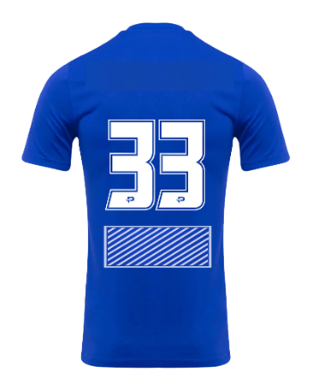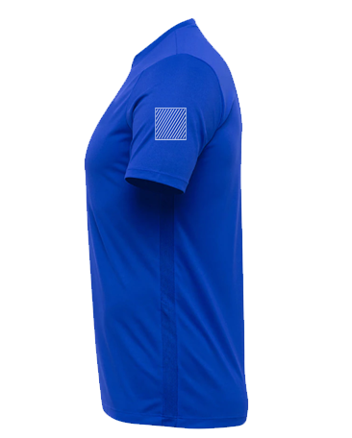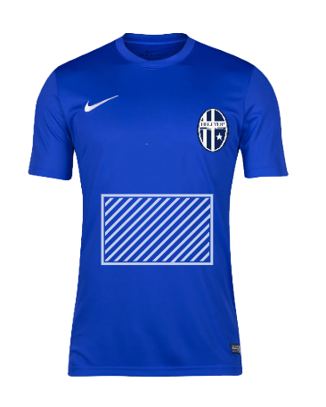**Matchday**

Back Sponsor Logo

Sleeve Sponsor Logo

Front Sponsor Logo

**Training**

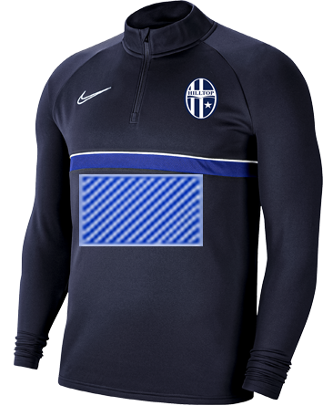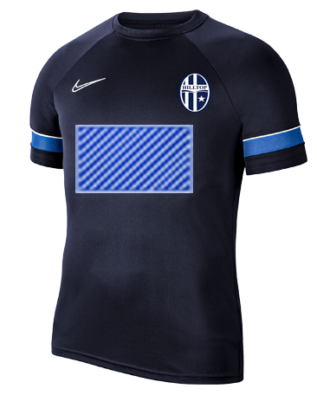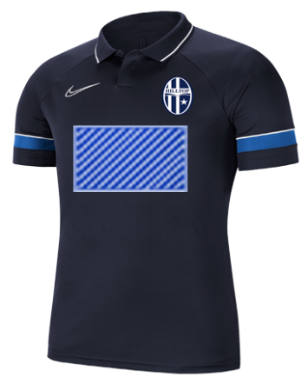

Front Sponsor Logo

Front Sponsor Logo

Front Sponsor Logo