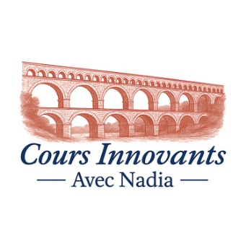
Cours Innovants.co.uk
Time and Price: September 26 – December 2026
Course Title : Français Faux Débutants / Almost Beginners
Wednesday 18:00- 19:30 Insole Court, Stable 2
Autumn term:
- 23rd September/30th September/7th October/14th October/ 21st October
- Half term 28th October (No class)
- 4th /11th /18th/25th November,
- 2nd /9^{th/ /}16th December
Number of Weeks: 12
Length of session: 1.5 hour
Total cost per course: £216
Please find below the payment details for the "French for Almost Beginners" course.
Name | Ms Nadia Nebot
Sort Code | 30-98-94
Account Number | 01466036
Prix pour 12 semaines | £216

To secure your place, please make payment by 2nd September. As places are limited, they will be allocated on a first-come, first-served basis.
If you have any questions, please don't hesitate to get in touch.
I very much look forward to welcoming you in September for what I hope will be a lively, engaging, and enjoyable course, made all the richer by your participation.
Bien cordialement,
Nadia Nebot

