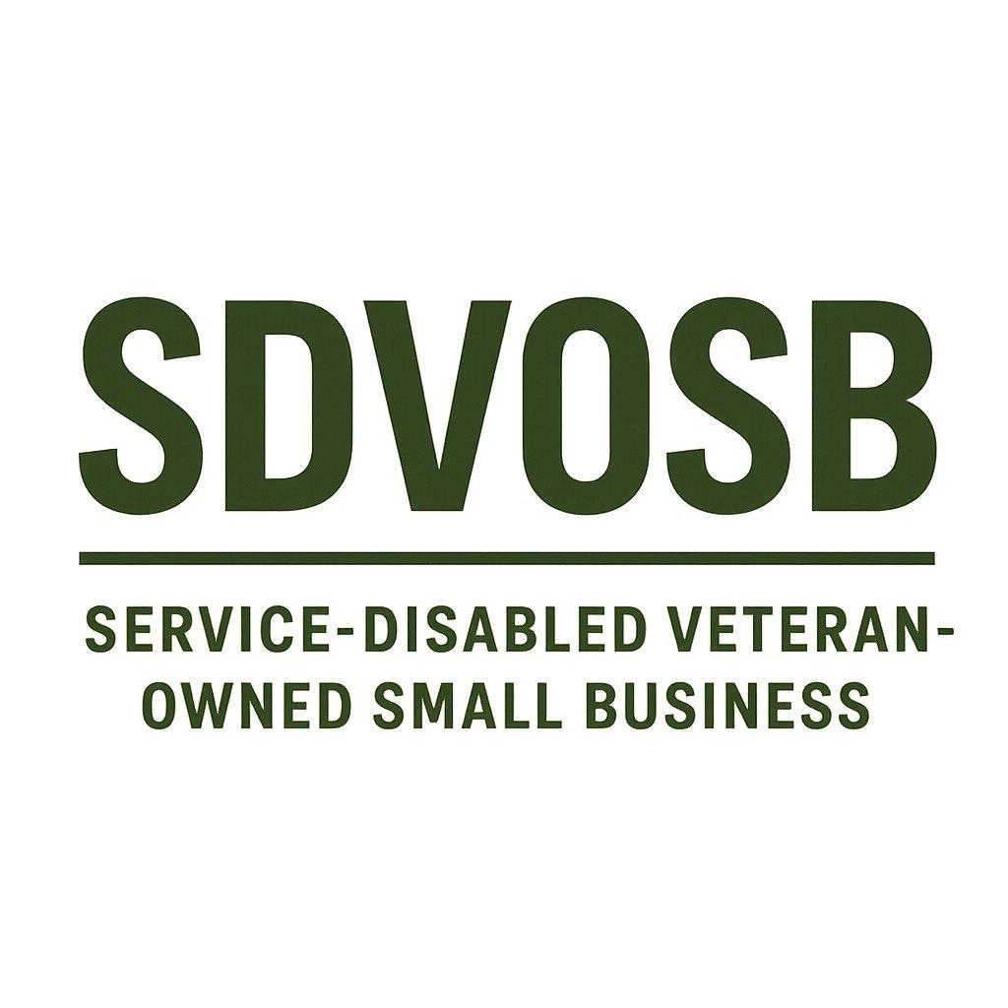CORE COMPETENCIES  • AI-Driven Real-Time Translation: Patent-pending emotional fidelity translation (tone, intent, assertiveness, context).  • Linguist/Translation Services: Full-spectrum support through AI + linguist NAICS classification.  • AI Emotional Intelligence: Multimodal emotion recognition (audio, text, video, facial micro-expressions).  • GovCloud & Secure Deployments: AWS GovCloud, FedRAMP, NIST SP 800-171, HIPAA, NATO compliance.  • R&D in Emerging Technologies: AI agents, AR/VR, LiDAR integration, biotechnology interfaces.  • CRM & Enterprise Integration: Seamless API/SDK integration for CRM, healthcare, defense, and enterprise systems.  • Training & Support: End-user and enterprise training in AI, translation, and emotional analytics systems.  DIFFERENTIATORS  • Patented Emotional Translation Technology (real-time AI maintaining emotional fidelity).  • Veteran-Owned (SDVOSB), CAGE: 14A63, UEI: UYNDLDZMPWK9.  • Security-First Architecture: AES-256 encryption, offline adaptive learning, FIPS 140-3 cryptography.  • Hardware + Software Integration: Ruggedized offline Model A + cloud-native Models A/B + AR glasses.  • Blue Ocean Strategy: Unique market positioning in emotional translation for defense, healthcare, CRM, and entertainment.  • Global Expansion Readiness: Patent expansion to EU, UK, Japan, South Korea, Canada, GCC, and beyond. | CORPORATE DATA  Company Name: Yellowstone Bio LLC  Business Size: Small, Service-Disabled Veteran-Owned Small Business (SDVOSB)  UEI: UYNDLDZMPWK9  CAGE Code: 14A63  NAICS Codes:  • 513210 – Software Publishers  • 541511 – Custom Computer Programming Services  • 541512 – Computer Systems Design Services  • 541519 – Other Computer Related Services  • 541930 – Translation and Interpretation Services  • 518210 – Computing Infrastructure Providers, Data Processing, Web Hosting  • 541715 – R&D in Physical, Engineering, and Life Sciences  • 541714 – R&D in Biotechnology (except Nanobiotech)  • 611420 – Computer Training  • 611430 – Professional and Management Development Training  CONTACT  Audi (Corporal) Veras – CEO & Inventor  Yellowstone Bio LLC – Brockton, MA  Email: info@yellowstone.bio  Website: www.yellowstone.bio

