Introduction to Advertising

SYBAMMC

SEM III
Revised syllabus
2025-26

30 marks

CHAPTER –I
Introduction to Advertising

Purpose, Features, Advantages, Role, and 5 M's of Advertising
1. Purpose of Advertising
Advertising facilitates large-scale marketing. It is a medium of mass communication. Manufacturers supply information about new products through it. The fact that companies spend millions of dollars on it through TV, radio, the internet, and newspapers indicate its benefits in sales promotion.
Advertising: Advertising is within the scope of a promotion, which is one element in the marketing mix. It is getting popularity in the present highly competitive and consumer-oriented marketing. All products old and new, consumer and durable, cheap and costly need extensive advertising for sales promotion and customer support. Latest communication techniques now are used for making it more attractive and agreeable.
The main purpose of advertising is to:
- Give information,
- Attract attention,
- Create awareness, and
- Influence the buying behavior of consumers.

Advertising is crucial in marketing but is also equally important and essential to social, cultural and political aspects of our lives. The term ‘Advertising’ originates from the Latin word ‘Advertere’ which means “to turn the mind towards?” The dictionary meaning of the term advertising is “to give public notice or to announce publicity.”
Advertising acts as a marketing vehicle and is useful for drawing the attention of people (prospects) towards a particular product or service. Advertising is defined differently by various authorities and the institutions dealing with its subject.
The American Marketing Association (AMA) defines advertising as, “Any paid form of non-personal presentation and promotion of ideas, goods or services by an identified sponsor.”
AMA's definition of advertising suggests:
- Advertisement is a paid form of communication.
- Advertiser exercises a control over it.
- It is non-personal selling.
- It is a medium of mass communication for large-scale selling.
- It acts as a valuable marketing tool for presentation and promotion of ideas, goods and services.
- It needs the sponsor of the message known.
- Advertising will be meaningless if the advertiser is unidentified.
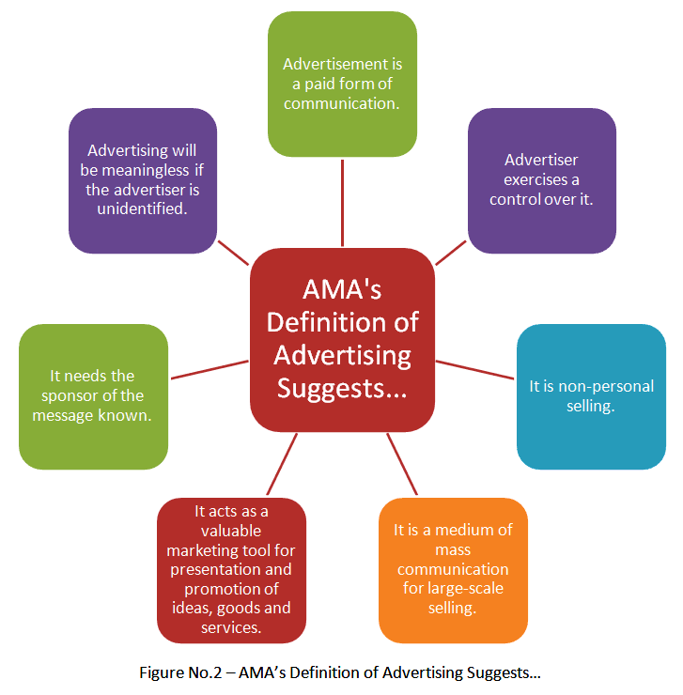

2. Features of Advertising
The nine main features of advertising:
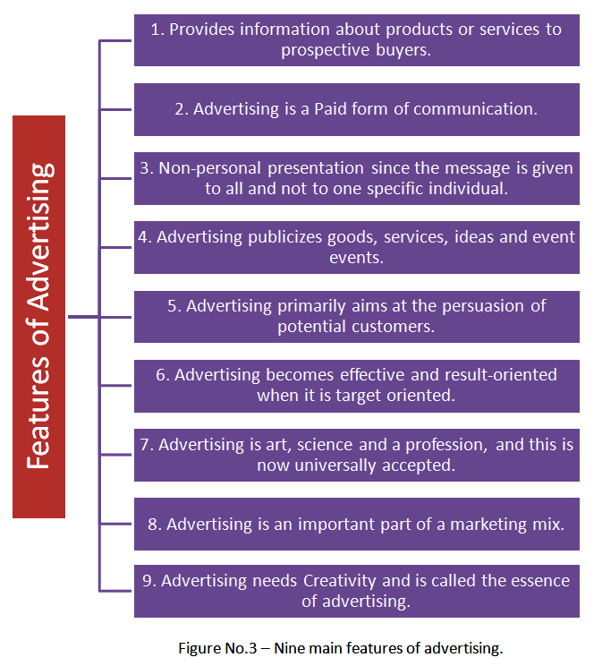
- Provides information: Advertising's primary purpose is to provide information about products or services to prospective buyers. The details of products such as features, uses, prices, benefits, manufacturer's name, so on; are in the advertisements. The key message and brand name are also there. The information supplied educate and guide consumers and facilitate them to make a correct choice while buying a product.
- Paid communication: Advertising is a form of paid communication. The advertiser pays to the media for giving publicity to his AD message. He also decides the size, slogan, etc. given in the advertisement.
- Non-personal presentation: Advertising is non-personal in character as against salesmanship, which is a personal or face to face communication. Here, the message is given to all and not to one specific individual. This rule is applicable to all media including the press. However, even in it, target consumers or target market can be selected for making an AD appeal.
- Publicity: Advertising publicizes goods, services, ideas and event events. It is primarily for giving information to consumers. This information is related to the features and benefits of goods and services of different types. It offers new ideas to customers as its contents are meaningful. The aim is to make the popularize ideas and thereby promote sales. For example, an advertisement for family planning, family welfare, and life insurance is useful for placing new ideas before the people.
- Primarily for Persuasion: Advertising aims at the persuasion of potential customers. It attracts attention towards a particular product, creates a desire to have it, and finally induces consumers to visit the market and purchase the same. It has a psychological impact on consumers. It influences their buying decisions.
- Target oriented: Advertising becomes effective and result-oriented when it is target oriented. A targeted advertisement intensively focuses on a specific market or particular groups of customers (like teenagers, housewives, infants, children, etc.). Here, the selection of a particular market is called a target market.
- Art, science and profession: Advertising is art, science and a profession, and this is now universally accepted. It is an art as it needs creativity for raising its effectiveness. It is a science as it has its principles or rules. It is also a profession as it has a code of conduct for its members and operates within standards set by its organized bodies. In its field, AD Agencies and space brokers function as professionals.
- The element of a marketing mix: Advertising is an important part of a marketing mix. It supports the sales promotion efforts of the manufacturer. It makes a positive contribution to sales promotion provided other elements in the marketing mix are reasonably favorable. It is alone inadequate for promoting sales. Many companies now spend huge funds on advertisements and public relations.
- Creativity: Advertising is a method of presenting a product in an artistic, attractive and agreeable manner. It is possible through the element of creativity. The creative people (professionals) introduce creativity in advertisements. Without it, the Ads won't succeed. Therefore, creativity is called the ‘Essence of Advertising.’

3. Advantages of Advertising
The advertising benefits two main groups, namely:
- Manufacturers, and
- Consumers.
The advantages of advertising for manufacturers:
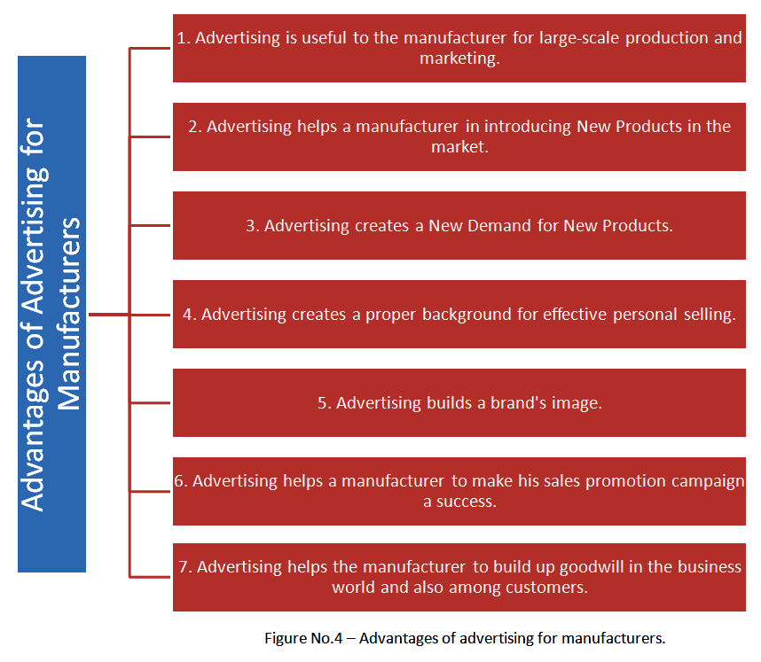
- Large-scale production and marketing: Advertising is useful as a sales promotion technique. It gives information to consumers and encourages them to purchase more. Manufacturers expand their production base due to a higher market demand created through advertisements.
- Introducing new products: Advertising facilitates the introduction of new products. Due to it, information about new products is given to the people (prospects). A demand generates because of this, and the manufacturer can sell new products along with the existing ones.
- Creates new demand: Advertising spreads information and encourages consumers to purchase new products. It creates a new demand. Customers are offered various concessions in the initial period. It generates positive responses from them, and soon new customers also respond. Thus, advertisement creates new demand from non-users.
- Effective personal selling: Advertising creates a proper background for personal selling. It gives advance information to the prospects. They visit the shop in order to purchase a particular product that they know through advertisements in media. The job of a salesman becomes easy as consumers develop an affinity for advertised products. In brief, it supports and supplements personal selling.
- Builds brand image: Advertising build brand image and this develops consumer loyalty towards a specific brand. Manufacturers introduce branding to popularize their products with a distinct personality. Brands get popular through advertisements. As a result, buyers develop loyalty towards a specific brand.
- Reduces cost of production: Advertising creates demand and promotes sales. It enables a manufacturer to conduct production on a large scale. It leads to a reduction in the cost of production and distribution. As a result, the profit margin of the manufacturer increases.
- Facing competition: Advertising aids a manufacturer to deal with market competition effectively. It helps him to promote and popularize his products. He can remove misunderstanding among consumers about his products through appropriate advertisements.
- Sales promotion: A manufacturer can make his sales promotion campaign successful by using the support of advertising. He can prepare a proper background for the success of such an ad-campaign as it facilitates direct communication with consumers.
- Goodwill builder: A manufacturer can build up goodwill in the business world and also among the group of customers through advertising. The social welfare programs and community service activities can get wide publicity through advertisements. The public can notice even the progress of the organization through it.

The benefits of advertising for consumers:
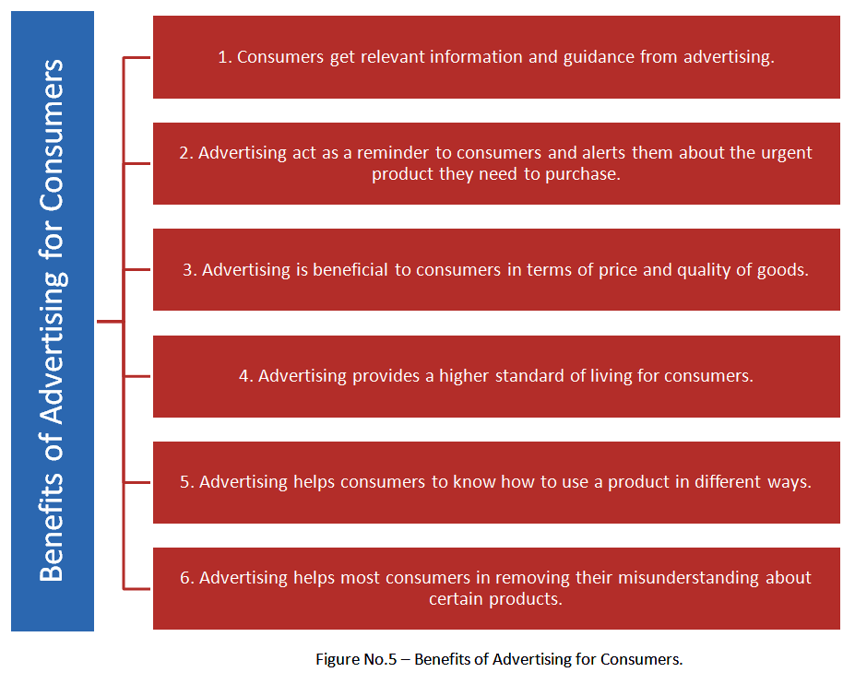
- Information and guide: Consumers get information and guidance from advertising. They can study the advertisements of competitors and select the appropriate products that are best suited and profitable to them. It helps to avoid their cheating and exploitation at the hands of middlemen.
- Acts as a reminder: Advertising act as a reminder to consumers and alerts them about the urgent product they need to purchase.
- Attracts customers: Advertising leads to competition among manufacturers and retailers. They have to offer something special in order to attract buyers. Such attraction offers benefits to consumers. For example, manufacturers have to bring down the price in order to attract customers. They have to supply quality goods in order to attract them more. All this is beneficial to consumers in terms of price and quality of goods.
- Raises living standards: Advertising raises the standard of living of people by supplying information about goods and services, which can offer convenience and pleasure to them. It guides consumers in the selection of most suitable products for their daily life. Thus, it provides a higher standard of living to consumers as a social group.
- Efficient product use: Consumers get information about uses or benefits of different products through advertising. They also get guidance as regards the right manner of using the product and helps to avoid any possible damage from the use of a purchased product. The information supplied through advertisements helps to know how to use a product in different ways.
- Removes misunderstanding: Advertising helps most consumers in removing their misunderstanding about certain products. They change their attitudes towards products and services due to it.

4. Role of Advertising in Consumer Durable
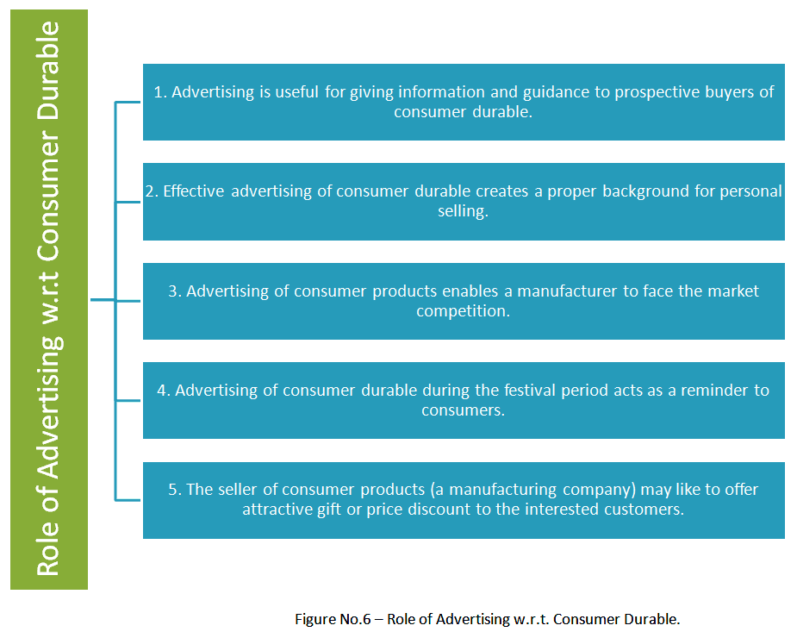
- Advertising is useful for giving information and guidance to prospective buyers of consumer durable. Here, it gives the details of special features, benefits, price discount, and other concessions offered, etc. to the purchasers of consumer durable. It encourages interested customers to take the initiative in purchasing the durable articles.
- Effective advertising of consumer durable creates a proper background for personal selling. It creates an attraction in the minds of consumers, and they are encouraged to visit a retail shop in order to see the article or look at the demonstration of its working. Here, the salesman can use his skills to sell an article to his visitors.
- Advertising of consumer products enables a manufacturer to face the market competition. He can mention special features of his product and also suggest how his product is superior to that of his competitors. It is useful for sales promotion of consumer durable. Even consumers can make an appropriate selection of a suitable product by studying the advertisements of competitors.
- Advertising of consumer durable during the festival period acts as a reminder to consumers. They remember to purchase a useful product on the Eve of the Festival. This technique facilitates a sales promotion during the festival period.
- The seller of consumer products (a manufacturing company) may like to offer attractive gift or price discount to the interested customers. Here, advertising can be made effectively. It encourages them to purchase a durable product. Such advertisements are common during festivals. Even local dealer may offer certain concessions to potential buyers. He can make a suitable AD of such concessions for large-scale selling at the local level.
Effective advertising of consumer durable is necessary and useful for:
- Regular selling,
- Providing information and guidance to consumers, and
- Finally for sales promotion.
The types of advertising media with examples:
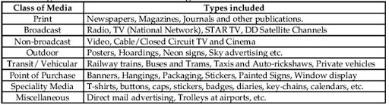
- Print: Magazines, Newspapers, Journals, Periodicals, etc.
- Broadcast: Satellite TV Channels and Radios.
- Non-broadcast: Cinema, CCTV, local cable TV, etc.
- Outdoor: Hoardings or Billboards, Posters, Neon light sign board, etc.
- Transit or vehicular: Railways, Public transport buses and Tramps, etc.
- The point of purchase: Hangings on stores, Banners, Pamphlets, Stickers, Window Display, Painted signs, etc.
- Specialty media: Calenders, T-shirts, badges, caps, keychains, Diaries, etc.
- Virtual media: Online Blogs, forums, social media websites, email ads, etc.
- Miscellaneous: Direct mail advertising, Trolleys at the airport, Carts in departmental stores, etc.
These advertising media have their unique features, merits, limitations and suitability. An advertiser has to consider his ad budget and then select the most appropriate media to run his ad campaigns.
While undertaking advertising for consumer goods, durable or industrial products concerned company has to take appropriate decisions and adjust the ad campaigns activities accordingly.
5. Five M's of Advertising
The decision making in advertising is a five-step process. It is called ‘Five M's of Advertising.’ It consists of:
- Mission,
- Money,
- Message,
- Media, and
- Measurement.
Evaluation and broad decisions need to be taken in regard to these five areas while organizing an advertising program or campaign.
The five M's of Advertising on which an advertiser has to make decisions:
5 Ms of advertising
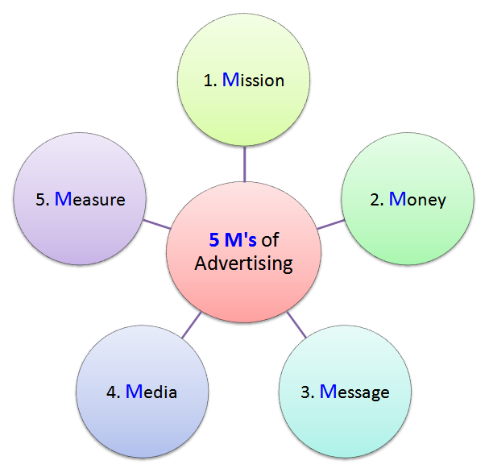
- Mission:Mission refers to the purpose or objective of advertising.
These goals vary in character and mainly include:
Sales promotion,Information and guidance to consumers, developing brand loyalty,Market goodwill,Facing market competition effective,Making the products popular or successful, and the introduction of a new product in the market.
The decision in regard to mission or objective is a basic one, and all other decisions get adjusted according to it. For consumer products like chocolate, toothpaste, soap, etc., the mission or objective includes facing market competition, sales promotion and to make a product successful in the market.
- Money:Money refers to the finance provided for advertising purpose. It makes an AD budget. It means the budget allocation made by the company for running the entire operation of AD Campaign. Money provided is a limiting factor because the effectiveness of advertising, media used, coverage of advertising, etc. are all related to the funds provided for running advertisements. Advertising is a costly affair, and companies have to spend millions of dollars on it. It should always be within the limits of funds provided. Naturally, decisions in selecting an advertising package should be properly adjusted to the allocated AD budget.
Consumer products like toothpastes or chocolates are highly competitive with many substitutes readily available in the market. Naturally, extensive advertising on TV, newspapers, radio, etc. is required. These media are costly. So, the manufacturing or marketing company will have to provide huge money for advertising purpose.
- Message:The message gets delivered through the text of an advertisement. It is passed through written words, pictures, slogans, and signs. It is for the information, guidance and motivation of prospective buyers. Attractive and meaningful messages give positive results, and the advertising becomes result-oriented. For this, the services of creative writers, artists, etc., are used to give an appealing message to the consumers.Here, the advertiser has to decide:
- How to deliver the message?
- Which media to use for communicating the message?
- What would be the extent of creativity?
- Which specific customer group be targeted with the message, so on.

The AD message is related to the decisions taken in regards to the mission, and money provided for the purpose of advertising.
For advertising consumer product like chocolate, the message is important for its success. Chocolate is favored mainly by children and teenagers. The message should be such that it is beneficial and appealing to the younger minds. It must have a promise of a taste pleasure and satisfaction as expected by the younger generation. The AD message should be simple and easily understandable with the help of a picture or slogan. It should also be attractive and agreeable to the younger generation. The pictures or slogans used should be short and impressive.
- Media:The advertiser has to take a crucial decision about selecting a proper media for an advertising purpose. Media differ as regards to cost, coverage, effectiveness or impact, etc. The selection of media depends on the budget provided, products getting advertised, and features of prospective buyers, so on. A wrong decision on media may make entire advertising ineffective and money spent on it will be wasted. Therefore, a media should be properly selected, and decision in this regard is essential and critical.
For advertising popular and extensively used consumer items like chocolate, the media should be selected properly. Cartoon TV channels, comic books, newspapers supplement meant for kids, etc., should be preferred.
- Measurement:Measure relates to the effectiveness of advertising. An advertiser will like to evaluate advertisement in order to judge its effectiveness. If an advertisement is not effective, it will be modified or withdrawn. It is necessary for avoiding expenditure on the advertisement that is not purposeful or is not likely to give any positive results. An advertiser has to measure the effectiveness of his ad program or campaign and take suitable decisions. This decision-making as regards effectiveness of advertisements is equally important and essential. Such testing facilitates an introduction of appropriate remedial measures if required.
- For measuring effectiveness of chocolate advertising, the post advertising sale is one major consideration. Demand creation in new market segments or new age groups is another factor in the measurement of an ad effectiveness. Even the success of a sales promotion program is useful for measuring the effectiveness of an advertisement.

In brief, like other areas of marketing management, decision-making is necessary for advertising. It relates to Five M's - Mission, Money, Message, Media and Measurement.
DIFFERENT TYPES OF ADVERTISING
What is Consumer Advertising?
Consumer advertising is messages paid for by companies and delivered through mass media. The objective is to inform or persuade consumers of the merits of your brand and products. Consumers are a large and common target of ads presented through several traditional types of media.
Consumer advertising is advertising that is directed and intended for domestic markets such as individuals and families. This is in contrast to industrial advertising, which is specifically directed and marketed toward businesses. The goal of consumer advertising is to introduce, or sometimes re-introduce, products and services to families and private individuals for daily use and consumption. These can be automobiles for family use, household appliances, home electronic devices, clothes, books, movies, and just about anything else commonly found in an individual or family household.
Advertising is, generally, the practice of creating print, audio, and video messages intended to reveal or display a product or service and to show features meant to entice a customer into purchasing that product or service. Consumer advertising is a specific field of advertising, which focuses on the needs and desires of households rather than businesses. These types of advertisements are often focused even more narrowly on a specific demographic or target audience to increase effectiveness and message penetration among that audience.
A demographic is a specific portion of the population and is based on particular common features, beliefs, practices, or ideologies. These can be separated according to age groups, gender, religious beliefs, income ranges, education, profession, and a number of other specifically targetable aspects of modern life. Consumer advertising often seeks to find ways to relate to either the entire population or more commonly a specific demographic and appeal to people’s sense of consumer desire.
What is Industrial Advertising?
Industrial advertising, otherwise known as business to business advertising, is a form of advertising to other businesses. It can include the advertising of parts or raw materials for their products or equipment used in their manufacturing process.
How it Works
Every business is a consumer and needs to enlist the services of other businesses for at least a few things. An office would need to hire a cleaning company, a restaurant needs to hire someone to deliver the raw materials they need to make their food, and a zoo would need to enlist the services of a vet. Most of these people need business cards as well and may need to hire someone to make them. A company selling coffee will likely need to purchase their coffee powder from a different company, their cups from yet another, and so on. A large company may manufacture all of that themselves, but most do not.
Industrial advertising is what anyone who hires themselves out to a business rather than an individual needs to do.
The Role of Industrial Advertising: The role of industrial advertising is to minimize the hunt for buyers, increase sales, make more distribution channels, and spread awareness of the company's brand, all while helping the company run more efficiently.
Media Types of Industrial Advertising: Any company needing to advertise their product or service to other companies needs to research their competitors and identify their target market when doing so, but not every company's industrial advertising tactics will be the same.
Print media and direct marketing are two of the usual channels of any company's advertising campaigns, and industrial advertising is no exception. When advertising in print media, a product or service marketed towards other businesses should be simple and legible in a plain font, and the highlight of it should be the product or service and not the company offering it. That is the easiest way for it to be seen by the target audience. It also needs to have the contact information of the company, so that the consumer can immediately order the product or service.
Direct marketing includes any way of reaching the customer directly, whether over the phone or by email or mail. Brochures and cold calling are some examples. Trade shows and fairs are also ways that an industrial advertising campaign can go forth. The important thing to consider is the fact that reaching other businesses in the hopes of selling them something and making them regular customers is not going to be done the same way as targeting individuals.The people who make decisions about the logistics of a business are not going to get their information the same way as individuals do. Paper cups for coffee shops to order in bulk are not typically advertised on television or the internet because the people working for a business that needs something like that will not be watching television regularly. Instead, they are more likely to read the newspaper or be on the lookout for that service at a trade show.

What is Institutional advertising?
Sometimes organisations aim at enhancing the image of the company. They focus more on the brand image than selling of the product. Such advertising covers all the products or services of the company under a single brand name. This is known as institutional advertising. Eg.WIPRO has been using 'applying thought' for all of its business , thereby promoting the company as well.Other companies which have been using institutional advertising include ' British Airways', 'Hyatt Group', ITC and so on.
It is any type of advertising intended to promote a company, corporation, business, institution, organization or other similar entity. Such advertising does not attempt to sell anything directly. The promotional message aimed at creating an image, enhancing reputation, building goodwill, or advocating an idea or the philosophy of an organization, instead of sales promotion. When employed by an organization to market itself (instead of its products), it is called corporate advertising. Public service announcements and community outreach programs are examples of institutional advertising. These types of advertising promotions are designed to foster goodwill between a company and its present or potential customers. For example, a tobacco company can use institutional advertising to produce an antismoking commercial that warns consumers of the dangers of its products. Beer and liquor companies can also run commercials that warn consumers of the dangers of drinking and driving.
Many companies use indirect institutional advertising campaigns to alert the public of their benevolent contributions. For example, an oil company might create a public statement, commercial or documentary about its ongoing efforts to ensure that its actions, products or services do not harm the local, regional, national or global environment.
Some companies, such as pork farmers, release institutional advertising commercials about the nutrients found in their food products. These companies can also disclose their commitment to not injecting their products with antibiotics or other chemicals that can initiate health problems in humans.
Institutional advertising is also done via community outreach programs. Some examples of this type of company promotion include blood drives, canned food drives, AIDS awareness events, cancer screenings and holiday gift giving or food delivery drives for homeless individuals.

What is classified advertising: Classified advertising is a form of advertising which is particularly common in newspapers, online and other periodicals which may be sold or distributed free of charge. Classified advertisements are much cheaper than larger display advertisements used by businesses, although display advertising is more widespread.
Small messages grouped under a specific heading (classification) such as automobiles, employment, real estate, in a separate section of a newspaper or magazine. These relatively inexpensive ads are usually a column wide, do not include any graphics, and are typeset (see typesetting) by the printer or publisher of the publication.
What is National advertising? Advertising which is aimed at a National Market, as opposed to Local Advertising. The term national advertising has a special connotation that it is not confined to any geographic area within the nation. This type of advertising is undertaken mostly by the marketer of a branded product or service sold through different outlets in the distribution channel, wherever they may be located. Apparently the term national advertising conveys mass marketing effort. In reality this does not necessarily mean that the product is sold nationwide. The objective of national advertising is to inform or remind consumers about a company or brand. The ad may intend to communicate brand features, benefits, advantages or uses and to create or reinforce its image so that the consumers will be predisposed to buy it. This type of advertising is done by a manufacturer and is in contrast to that done by a retailer whose objectives are totally different.

National advertising often identifies a specific target audience and attempts to create an image for the product. For example, the ad for Mercedes-E class is targeting a specific segment in the Indian market. When a new manufacturer with lesser money muscle, limited production capacity and limited distribution know-how, etc., appears on the business scene, he does not usually decide for national distribution. Instead, he tries to sell his output in limited markets and then gradually with improved conditions, gradually spreads in the remaining markets. Even well established companies often introduce new products in some selected markets only.

National advertisers realize that, under some conditions, it is better to advertise in regional or local media rather than mass media. As more and more national advertisers are able to identify and reach narrowly defined market segments there would appear more regional or local advertising. For example, they may select regional/local newspapers, television stations, radio, or outdoor media because of differences in the regional language. The advertiser would still be classified as national advertiser as the purpose of the ads is to encourage purchase of the advertised product at any outlet carrying the item. In the short-term, however, national advertising will continue to introduce new brands and emphasize brand loyalty to established ones. In effect, the message in national advertising says, “buy our brand.”

"What is Generic advertising": The promotion of a particular commodity without reference to a specific producer, brand name or manufacturer. Producers join together to expand total demand for the commodity, thereby helping their own sale. When a product is in the introductory stage or when the demand for a product in general is promoted, it is called Primary Demand advertising, for example, ‘Sunday Ho Ya Monday, Roz Khao Ande’. The Milk Association of India when says, “Piyo glass full doodh”, is an ad promoting the drinking of milk by people in general and is not brand specific.

AIDA Model
The AIDA Model is a classic marketing and advertising framework used to guide consumer behavior from awareness to the point of purchase. The acronym stands for Attention, Interest, Desire, and Action—the four stages a consumer typically goes through before making a buying decision. The model helps marketers craft effective messages and campaigns by addressing the psychological and emotional stages a consumer experiences.

Stages of the AIDA Model
- Attention (Awareness):
  - The first stage involves capturing the consumer's attention. In a world filled with constant advertising and information, marketers need to make their message stand out.
  - Goal: Create brand or product awareness and make consumers take notice.
  - Tactics:
    - Use striking visuals, bold headlines, or creative advertising formats to grab attention.
    - Leveraging social media influencers, TV commercials, or online banners can help reach a large audience.
    - Emotional appeals (e.g., humor, surprise, empathy) or content that speaks directly to the target audience’s needs and problems also work well.
  - Examples:
    - A flashy, visually stimulating commercial for a new smartphone.
    - A catchy billboard or social media ad that uses vibrant colors, unique imagery, or compelling taglines.
- Interest:
  - After gaining the consumer's attention, the next step is to build interest in the product or service. This is where the marketer offers more information to make the consumer curious about the brand and what it offers.
  - Goal: Keep the consumer engaged by demonstrating how the product solves a problem or fulfills a need.
  - Tactics:
    - Highlight the features, benefits, or unique selling points (USPs) of the product.
    - Use educational content such as blog posts, videos, tutorials, or product demonstrations.
    - Social proof like customer reviews, testimonials, or case studies can also build trust and interest.
  - Examples:
    - A video that explains how a new tech gadget works, showing its unique features.
    - A website landing page detailing the benefits of an eco-friendly product and why it’s superior to alternatives.
- Desire:
  - Once interest is established, the goal is to move the consumer from interest to desire. At this stage, the marketer must make the consumer want the product or service by demonstrating how it can benefit their life or solve a particular problem.
  - Goal: Create an emotional connection between the consumer and the product, shifting them from “I like it” to “I want it.”
  - Tactics:
    - Emotional appeals are often effective here, such as emphasizing how the product can make life easier, more enjoyable, or successful.
    - Exclusive offers, limited-time discounts, or promotions can create a sense of urgency.
    - Highlighting how the product enhances the user’s lifestyle, image, or status also triggers desire.
  - Examples:
    - A luxury car ad showing the car in a scenic, aspirational setting, tapping into the consumer’s dreams of status or freedom.
    - An ad campaign showing before-and-after results of a fitness program, creating desire by showing real-life success stories.
- Action:
  - The final step is to encourage the consumer to take action—this could be making a purchase, signing up for a service, or taking another step that brings them closer to conversion.
  - Goal: Get the consumer to act on their desire, completing the conversion.
  - Tactics:
    - Include clear Calls to Action (CTAs) such as “Buy Now,” “Sign Up,” “Click Here for 10% Off.”
    - Offering additional incentives like free shipping, a discount on the first purchase, or a limited-time offer can spur immediate action.
    - Streamlining the process (e.g., easy checkout, minimal form fields, or one-click purchasing) makes it easier for the consumer to act.
  - Examples:
    - A limited-time offer in an email with a clear CTA that says “Claim your discount today.”
    - An online shopping site with a “Buy Now” button that directs consumers to a quick checkout page.

How the AIDA Model Works in Practice
Let’s apply the AIDA Model to a real-life marketing scenario for an online clothing retailer launching a new collection:
- Attention: The retailer uses Instagram and Facebook ads featuring high-quality, striking images of models wearing the new collection in vibrant, eye-catching settings. They use bold, creative captions to make users stop and notice.
- Interest: Once the consumer clicks on the ad, they are taken to a landing page that provides more information about the collection. This page includes a video showcasing the product’s quality, craftsmanship, and fashion-forward designs, keeping the user engaged.
- Desire: To move the consumer to the desire stage, the retailer highlights the exclusivity of the collection, noting that it is a limited release. They also showcase testimonials from fashion influencers praising the collection’s design and quality, creating a sense of aspiration.
- Action: To drive conversions, the retailer offers a limited-time discount with a prominent “Shop Now” button. They also provide free shipping for the first order, removing potential barriers and encouraging immediate purchase.

Benefits of Using the AIDA Model
- Focuses Marketing Efforts: The AIDA model helps marketers focus on the consumer journey, ensuring that each stage—from awareness to purchase—is effectively addressed.
- Improves Campaign Effectiveness: By addressing each stage of the buying process, marketers can create more effective advertising and marketing campaigns that resonate with consumers at different points in their decision-making process.
- Streamlines Communication: AIDA ensures that marketing communication is clear and purposeful, with each message tailored to the consumer's current state of mind—whether they are just learning about a product or ready to buy.
- Aligns Marketing Channels: The model helps align various marketing channels (social media, email, ads, etc.) to ensure a cohesive experience that guides the consumer from one stage to the next.

What Is the Role of an Advertising Agency?
As part of an overall marketing strategy, some companies turn to an advertising agency to develop an advertising campaign. Ad agencies combine their creative and research expertise with the input of the client to develop a campaign that appeals to customers. When used properly, an ad agency can save you the time of creating your own campaign, can provide market and industry expertise, and can help you increase revenue or improve brand recognition.
An effective advertising campaign can help in increasing sales, develop brand loyalty and build brand equity. All of which contribute to increase in profits and market share. Similarly, without advertising customers stop buying products and services which lead to decrease in sales and eventually minimizes the profit. Therefore, the role of an advertising agency is highly crucial for the success of organization.
The relationship between an advertising agency and a client is like two partners in a tennis match, without one the other cannot win. The client brings an advertising assignment to the advertising agency then the agency work with the client and comes up with a solution that would meet the objectives of its client and finally the solution is then implemented through print ads, television and radio commercials and through other advertising media.

Functions of advertising agency
Advertising agency is an independent service-rendering organization. It delivers various services and performs many functions for its clients, who are advertisers. It is mainly involved in activities like planning, preparing and placing of ads in media. It also performs non-advertising functions for them. It offers them advisory and creative services. It does so to make a profit
Functions of Advertising Agencies
Today advertising agencies are found in virtually every major city on the world and their role in stimulating economic growth is solidly established. To understand advertising, we need to examine the functions of an Ad Agency. These are: -
- Talent & Creative productions: The basic function of an Ad Agency is providing talent. The creative efforts of the art director, the detailed analysis of the research director and the political understanding of the campaign director, are just a few examples of the many abilities of Ad Agency personal have to offer. A business organization or person will contract the services of an ad agency to help market a product. This function involves processing the information collected from the client and through research and designing communication material in the form of advertisements and other publicity material. This also includes planning creative strategies, copy or script writing, visualization, designing, layout, shooting of films, editing, giving music, etc.
- Research: The second function of an Ad agency is research. In order to distribute the message to the public successfully, the agency must first know all that it can about the product. One of the first jobs is to research the product and the company, one must learn, one possibly can about both. The research must even take one close to the heart of the firm’s inner operations. Ad agencies use research as a tool to test consumer reactions to products and services.
- Advertising planning: Advertising agency plans the entire ad campaign of its client. Advertising planning is a primary function of an ad agency. It is done when its research function is completed. That is, after analyzing the client's product, its competitors, market conditions, etc. It is done by experts who use their professional experience to make a result-oriented advertising-plan. After making the advertising plan, it is shown to the client. If the client likes and approves it, then the plan is executed (put into action).
- Creative function: Advertising agency put the advertising-plan into action under its creative function. Creation of ads is the most important function of an ad agency. Generally, it involves activities like: Copy writing, drawing photographs, Making illustrations, layouts, an effective ad message, etc. These jobs are done by experts like copy writers, artists, designers, etc. These people are highly skilled and creative. They make an advertisement more appealing. Attractive ads help to increase the sales of the product. The ad agency must always use fresh ideas for creating ads. It must neither use old tactics nor copy the ad-campaign of other products.
- Media selection: Advertising agency helps an advertiser to select a proper media (ad platform) to promote his advertisement effectively. Media selection is a highly specialized function of an ad agency. It must select the most suitable media for its client's ad. It must choose media, which has a potential to give best results for the lowest cost. It must select more than one media for the ad. For example, an advertisement can be put on television, the Internet, newspapers, magazines, etc. After selecting the media, the ad agency must maintain goods contacts with the media.
- Advertising budget: Advertising agency helps an advertiser to prepare his ad budget. It helps him to use his budget economically and make the best use of it. Without a proper advertising budget, there is a risk of client's funds getting wasted or lost. If an advertiser suffers a loss, he may not bring new projects. As a result, there is a possibility of losing a potential client that can bring more business to an ad agency.
- Distribution & Media planning: The third important function of an ad agency is distribution. Here you decide what type of message you will create for the company and what media will be most helpful in sending this message to the public. On the basis of the media habits (access and exposure) of the target audience, agency people prepare a media plan. This plan includes which media to be used, which part of the media to be used, when to place the ads and for how long to place the ads, etc. media planners keep track of the viewer ship, listener ship and readership of all kinds of media.
- Monitoring Feedback: By monitoring consumer feedback, a decision on whether to revise the message, the medium, the target audience or all of them can be made. Ad agencies are developing to reach the target audience. As information is the backbone of all advertising, to prepare ads, one requires information about the product, its competitors, the market situation and trends, information about the audiences (their likes and dislikes and media habits) also need to be collected. Some of the most effective advertising includes advertisement written in their native language. All of these specialized campaigns are creating new demands on agencies and are requiring new talents for people who work in advertising

Structure of an ad agency
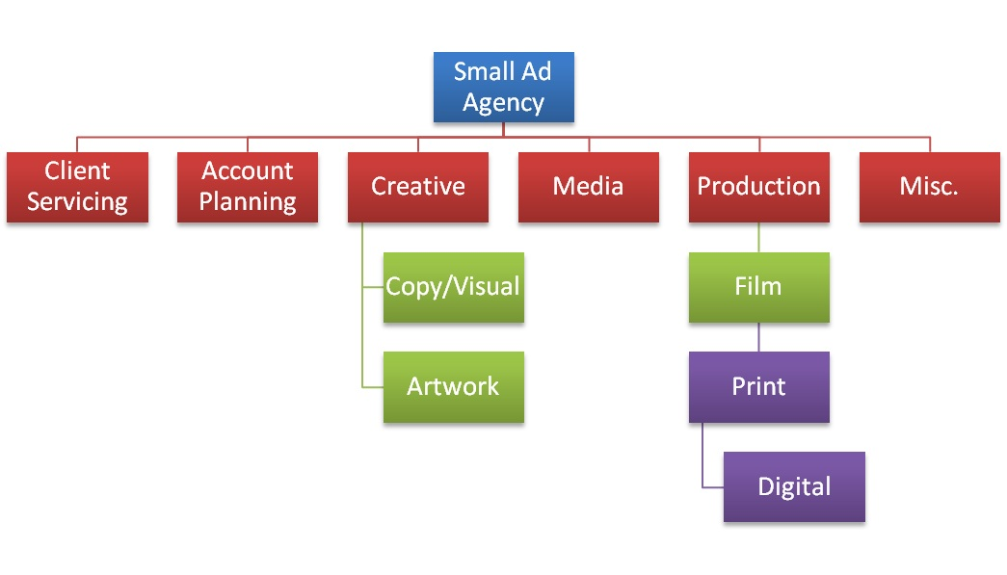

- Account service department: The account service, or the account management department, is the link between the ad agency and its clients. Depending upon the size of the account and its advertising budget one or two account executives serve as liason to the client. The account executive’s job requires high degree of diplomacy and tact as misunderstanding may lead to loss of an account. The account executive is mainly responsible to gain knowledge about the client’s business, profit goals, marketing problems and advertising objectives. The account executive is responsible for getting approved the media schedules, budgets and rough ads or story boards from the client. The next task is to make sure that the agency personnel produce the advertising to the client’s satisfaction. The biggest role of the account executive is keeping the agency ahead of the client through follow-up and communications.
- Account Planning department:Account planning encompasses three phases: strategy development, creative development and evaluation of effectiveness. Account planners function as a liaison between the account exec and the creative department as well as between the creative department and the consumer. In this sense, account planners are both fully integrated members of the account team and advisers to the creative team.
- Media department: The responsibility of the agency’s media department is to develop a media plan to reach the target audience effectively in a cost effective manner. The staff analyses, selects and contracts for media time or space that will be used to deliver the ad message. This is one of the most important decisions since a significantly large part of the client’s money is spent on the media time and/or space. The media department has acquired increasing importance in an agency’s business as large advertisers seem to be more inclined to consolidate media buying with one or few agencies thereby saving money and improving media efficiency.
- Creative department:To a large extent, the success of an ad agency depends upon the creative department responsible for the creation and execution of the advertisements. The creative specialists are known as copywriters. They are the ones who conceive ideas for the ads and write the headlines, subheads and the body copy. They are also involved in deciding the basic theme of the advertising campaign, and often they do prepare the rough layout of the print ad or the commercial story board. Creation of an ad is the responsibility of the copywriters and the art department decides how the ad should look.
- Production department: After the completion and approval of the copy and the illustrations the ad is sent to the production department. Generally agencies do not actually produce the finished ads; instead they hire printers, photographers, engravers, typographers and others to complete the finished ad. For the production of the approved TV commercial, the production department may supervise the casting of actors to appear in the ad, the setting for scenes and selecting an independent production studio. The production department sometimes hires an outside director to transform the creative concept to a commercial.
- Finance and accounting department: An advertising agency is in the business of providing services and must be managed that way. Thus, it has to perform various functions such as accounting, finance, human resources etc. it must also attempt to generate new business. Also this department is important since bulk of the agency’s income approx. 65% goes as salary and benefits to the employees.

Integrated marketing communication and tools

An integrated marketing communications program can be built on the foundation pro-vided by the communications model. Some marketing scholars argue that the integrated marketing communications (IMC) approach is a recent phenomenon. Others suggest the name is new, but the concept has been around for a long time. They note that the value of effectively coordinating all marketing functions and promotional activities has been men-tioned in marketing literature for many years.

Although IMC programs have been described in several ways, the consensus is to define them as follows: Integrated marketing communications (IMC) is the coordination and integration of all marketing communication tools, avenues, and sources within a company into a seamless program that maximizes the impact on consumers and other end users at a minimal cost. This integration affects all of a firm’s business-to-business, marketing channel, customer-focused, and internally directed communications.

Before further examining the IMC concept, first consider the traditional ramework of marketing from which it originated. The marketing mix is the starting point. As shown in Figure 1.3, promotion is one of the four components of the mix. For years the traditional view was that promotional activities included advertising, sales promotions, and personal selling activities. Sales promotions actually includes both sales and trade promotions, with sales promotions aimed at end users or consumers of goods and services, and trade promotions directed toward distributors and retailers. This traditional view has changed some, due to the accountability issue that was discussed earlier in this chapter. The need to integrate all promotional efforts has expanded beyond the three traditional elements of advertising, sales promotions, and personal selling. Now, promotion also includes activities such as database marketing, direct marketing, sponsorship marketing, Internet marketing, and public relations. A complete IMC plan incorporates every element of the marketing mix: products, prices, distribution methods, and promotions.

Integrated marketing is based on a master marketing plan. This plan should coordinate efforts in all components of the marketing mix. The purpose of the marketing plan is to achieve harmony in relaying messages to customers and other publics. The same plan integrates all promotional efforts. The idea is to keep the company’s total communication program in synch.

Figure 1.4 lists the steps required to complete a marketing plan. The first step is a situational analysis, which is the process of examining factors from the organization’s internal and external environments. The analysis identifies marketing problems and opportunities present in the external environment as well as internal company strengths and weaknesses.

When the situation is fully understood, the second step is to define primary marketing objectives. These objectives normally include targets such as higher sales, an increase in market share, a new competitive position, or desired customer actions, such as visiting the store and making a purchase.

Based on the marketing objectives, a marketing budget is prepared and marketing strategies are finalized. Marketing strategies apply to all the ingredients of the marketing mix plus any positioning, differentiation, or branding strategies the marketing team wishes to add.

Integrated Marketing Communication

Integrated marketing is based on a master marketing plan. This plan should coordinate efforts in all components of the marketing mix. The purpose of the marketing plan is to achieve harmony in relaying messages to customers and other publics. The same plan integrates all promotional efforts. The idea is to keep the company’s total communication program in synch.

Figure 1.4 lists the steps required to complete a marketing plan.
- Situational analysis: The first step is a situational analysis, which is the process of examining factors from the organization’s internal and external environments. The analysis identifies marketing problems and opportunities present in the external environment as well as internal company strengths and weaknesses.
- Marketing Objectives: When the situation is fully understood, the second step is to define primary marketing objectives. These objectives normally include targets such as higher sales, an increase in market share, a new competitive position, or desired customer actions, such as visiting the store and making a purchase.
- Marketing Budget: Based on the marketing objectives, a marketing budget is prepared and marketing strategies are finalized.
- Marketing strategies Marketing strategies apply to all the ingredients of the marketing mix plus any positioning, differentiation, or branding strategies the marketing team wishes to add.
- Marketing Tactics : From these strategies, marketing tactics guide the day-by-day activities necessary to support marketing strategies.
- Evaluate performance: The final step in the marketing plan is stating how to evaluate performance.

These six steps of the marketing plan are similar to those used in creating management strategies. Both are designed to integrate all company activities into one consistent effort. Also, both provide guidance to company leaders and marketing experts as they try to ensure that the firm’s total communications package is fully integrated. Once the marketing plan has been established, the firm can prepare its integrated marketing communications program.

ComponentsofIMC:

Promotion is the communications part of marketing. It is the way we tell the world our product. Promotion provides consumers with information and knowledge in an informative and persuasive manner. This, we hope, will sooner or later result in sales of our services or products. The information and knowledge can be communicated using one or more of the five promotional techniques - Advertising, Personal selling, Sales promotion, Direct marketing, and Public relations. Taken together, these techniques are referred to as the promotional mix.
Goals of Promotion
The ultimate purpose of promotion is to modify behavior through communication. This requires helping customers at the various buying process stages so they eventually purchase or repurchase a particular service. Promotion achieves this by informing,persuading, and reminding - the three principal goals of promotion. Promotions usually fit into one of these categories; they are either informative, persuasive, or reminders.
  - Informative promotions work best with new services or products (early product-life-cycle stages) and with customers in early buying process stages (need awareness and information search). These types of promotions tend to communicate data or ideas about the key features of services.
  - Persuasive promotionsare harder. They are aimed at getting customers to select one particular company or “brand” over those of competitors, and to actually make the purchase. Advertisements that compare one company’s services to another, and most sales promotions, fit into this category. Persuasive promotions work best in intermediate/late stages of product life cycle (growth and maturity) and the buying process (evaluation of alternatives and purchase).
  - Reminder promotions are used to push customers’ memories about advertising they may have seen, and to stimulate repurchases. They are most effective in the late product-life-cycle (maturity and decline) and buying process stages (postpurchase evaluation).

The five IMC Components

- Advertising
- Sales promotion
- Direct Marketing
- Public relations (PR)
- Personal selling

1. Advertising
Advertising is defined as any paid form of non-personal communication about an organization, product, service, or idea by an identified sponsor. The paid aspect of this definition reflects the fact that the space or time for an advertising message generally must be bought. An occasional exception to this is the public service announcement (PSA), whose advertising space or time is donated by the media.

The nonpersonal component means that advertising involves mass media (e.g., TV, radio, magazines, newspapers) that can transmit a message to large groups of individuals, often at the same time. The nonpersonal nature of advertising means that there is generally no opportunity for immediate feedback from the message recipient (except in direct-response advertising). Therefore, before the message is sent, the advertiser must consider how the audience will interpret and respond to it.

Advertising is the best-known and most widely discussed form of promotion, probably because of its pervasiveness. It is also a very important promotional tool, particularly for companies whose products and services are targeted at mass consumer markets. There are several reasons why advertising is such an important part of many marketers’ promotional mixes. First, it can be a very cost-effective method for communicating with large audiences. For example, the average 30-second spot on the four major networks during prime-time network television reaches nearly 10 million households. The cost per thousand households reached is around $14. Advertising can be used to create brand images and symbolic appeals for a company or brand, a very important capability for companies selling products and services that are difficult to differentiate on functional attributes.

Another advantage of advertising is its ability to strike a responsive chord with consumers when differentiation across other elements of the marketing mix is difficult to achieve. Popular advertising campaigns attract consumers’ attention and can help generate sales. These popular campaigns can also sometimes be leveraged into successful integrated marketing communications programs.

2. Sales Promotion
The next variable in the promotional mix is sales promotion, which is generally defined as those marketing activities that provide extra value or incentives to the sales force, the distributors, or the ultimate consumer and can stimulate immediate sales. Sales promotion is generally broken into two major categories:
- Consumer-oriented and trade-oriented activities: Consumer-oriented sales promotionis targeted to the ultimate user of a product or service and includes couponing, sampling, premiums, rebates, contests, sweepstakes various point-of-purchase materials. These promotional tools encourage consumers to make an immediate purchase and thus can stimulate short-term sales.
- Trade-oriented sales promotion is targeted toward marketing intermediaries such as wholesalers, distributors, and retailers. Promotional and merchandising allowances, price deals, sales contests, and trade shows are some of the promotional tools used to encourage the trade to stock and promote a company’s products.

Among many consumer packaged-goods companies, sales promotion is often 60 to 70 percent of the promotional budget. In recent years many companies have shifted the emphasis of their promotional strategy from advertising to sales promotion. Reasons for the increased emphasis on sales promotion include declining brand loyalty and increased consumer sensitivity to promotional deals. Another major reason is that retailers have become larger and more powerful and are demanding more trade promotion support from companies.

3.Direct Marketing:
One of the fastest-growing sectors of the Indian economy is direct marketing in which organizations communicate directly with target customers to generate a response and/or a transaction. Traditionally, direct marketing has not been considered an element of the promotional mix. However, because it has become such an integral part of the IMC program of many organizations and often involves separate objectives, budgets, and strategies, we view direct marketing as a component of the promotional mix.

Direct marketing is much more than direct mail and mailorder catalogs. It involves a variety of activities, including database management, direct selling, telemarketing, and direct response ads through direct mail, the Internet, and various
broadcast and print media.

One of the major tools of direct marketing is direct response advertising, whereby a product is promoted through an ad that encourages the consumer to purchase directly from the manufacturer. Traditionally, direct mail has been the primary medium for direct-response advertising, although television and magazines have
become increasingly important media.
Direct-response advertising and other forms of direct marketing have become very popular over the past two decades, owing primarily to changing lifestyles, particularly the increase in two-income households. This has meant more discretionary income but less time for in-store shopping. The availability of credit cards and toll-free phone numbers has also facilitated the purchase of products from direct-response ads. More recently, the rapid growth of the Internet is fueling the growth of direct marketing. The convenience of shopping through catalogs or on a company’s website and placing orders by mail, by phone, or online has led the tremendous growth of direct marketing.

Direct-marketing tools and techniques are also being used by companies that distribute their products through traditional distribution channels or have their own sales force. Direct marketing plays a big role in the integrated marketing communications programs of consumer-product companies and business-to-business marketers. These companies spend large amounts of money each year developing and maintaining databases containing the addresses and/or phone numbers of present and prospective customers.

They use telemarketing to call customers directly and attempt to sell them products and services or qualify them as sales leads. Marketers also send out direct mail pieces ranging from simple letters and flyers to detailed brochures, catalogs, and videotapes to give potential customers information about their products or services. Direct-marketing techniques are also used to distribute product samples or target users of a competing brand.

4. Public Relations (PR)
Another important component of an organization’s promotional mix is Public relations.
Public relationrefers to non-personal communications regarding an organization, product, service, or idea not directly paid for or run under identified sponsorship. It usually comes in the form of a news story, editorial, or announcement about an organization and/or its products and services. Like advertising, publicity involves non- personal communication to a mass audience, but unlike advertising, publicity is not directly paid for by the company. The company or organization attempts to get the media to cover or run a favorable story on a product, service, cause, or event to affect awareness, knowledge, opinions, and/or behavior. Techniques used to gain publicity include news releases, press conferences, feature articles, photographs, films, and videotapes.

An advantage of public relation over other forms of promotion is its credibility. Consumers generally tend to be less skeptical toward favorable information about a product or service when it comes from a source they perceive as unbiased. For example, the success (or failure) of a new movie is often determined by the reviews it receives from film critics, who are viewed by many moviegoers as objective evaluators.

Another advantage of publicity is its low cost, since the company is not paying for time or space in a mass medium such as TV, radio, or newspapers. While an organization may incur some costs in developing publicity items or maintaining a staff to do so, these expenses will be far less than those for the other promotional programs. Publicity is not always under the control of an organization and is sometimes unfavorable. Negative stories about a company and/or its products can be very damaging.

5. Personal Selling
The final element of an organization’s promotional mix is personal selling, a form of person-to-person communication in which a seller attempts to assist and/or persuade prospective buyers to purchase the company’s product or service or to act on an idea. Unlike advertising, personal selling involves direct contact between buyer and seller, either face-to-face or through some form of telecommunications such as telephone sales. This interaction gives the marketer communication flexibility; the seller can see or hear the potential buyer’s reactions and modify the message accordingly. The personal, individualized communication in personal selling allows the seller to tailor the message to the customer’s specific needs or situation. Personal selling also involves more immediate and precise feedback because the impact of the sales presentation can generally be assessed from the customer’s reactions. If the feedback is unfavorable, the salesperson can modify the message. Personal selling efforts can also be targeted to specific markets and customer types that are the best prospects for the company’s product or service.

